**PROJECT OVERVIEW**

***Team* Task/Subtask Table**

|  |  |  |  |  |
| --- | --- | --- | --- | --- |
|  | *Tasks on the schedule for this quiz are the presentation of already completed Tasks #1 through #12. You, as a team, may break these tasks further down into subtasks as needed. All the members in the team need to agree on the subtasks. This table is common for the members of the team.* | Percent contributed | Percent contributed | Total percent |
| # | *Subtask* Description | Diego Alonso | Jaime Vega |  |
| 1 | Design & create DB tables in PaaS | 0% | 100% | 100% |
| 2 | Create DB tables in PaaS | 0% | 100% | 100% |
| 3 | Populate DB tables with “example” data to help in developing other parts of the project | 0% | 100% | 100% |
| 4 | Implement Android App screen (labels & SwitchCompats) to show status of the sensors & actuators | 100% | 0% | 100% |
| 5 | Implement sensors (SW1, SW2, . . .) and actuators (LED1, LED2, . . .) on breadboard and test their functionality with RPi locally | 100% | 0% | 100% |
| 6 | Interface & test the functionality of sensors and actuators between DB tables & RPi | 50% | 50% | 100% |
| 7 | Simulate the functionality of SwitchCompats between DB tables & Android using RPi (create a sync_android_data.php, similar to sync_rpi_data.php, on 000webhost.com, but trigger it from RPi to get all the bugs out. Later, sync_android_data.php will be triggered from Android. It is important to do this step since later if there is an issue, you just need to look at the Android Kivy side | 50% | 50% | 100% |
| 8 | Program Android App to interact with DB tables in PaaS | 50% | 50% | 100% |
| 9 | Test interaction between Android App and RPi through DB tables in PaaS | 50% | 50% | 100% |
| 10 | Design website | 50% | 50% | 100% |
| 11 | Interface website components with the DB tables | 50% | 50% | 100% |
| 12 | Collect real data and test the overall functionality of the project | 50% | 50% | 100% |

1. Submit complete documentation (Tasks 1 through 12) regarding your final project. *Include the following in your submission (please, follow the guidelines provided earlier to you for a crisp and clear documentation of your project):*

TASK 1: Design & create DB tables in PaaS;

TASK 2:Create DB tables in PaaS

TASK 3: Populate DB tables with “example” data to help in developing other parts of the project

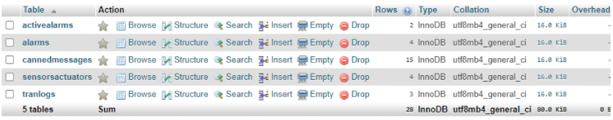

SQL:

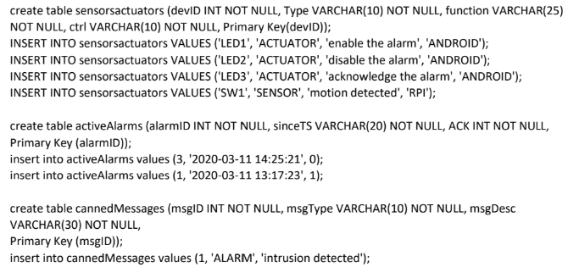

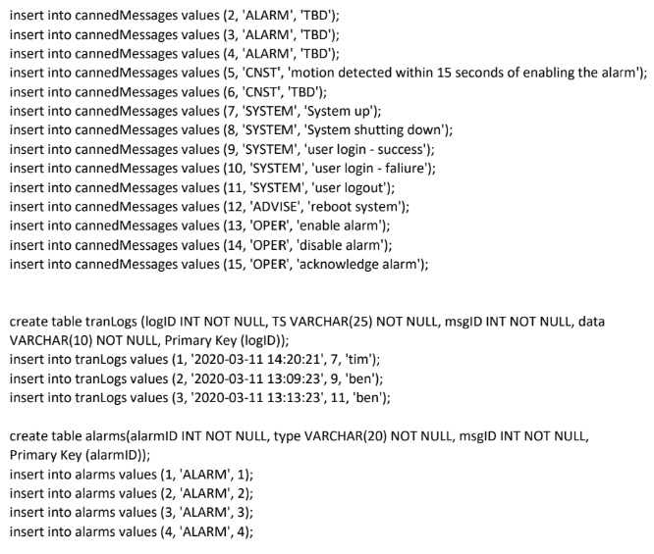

TASK 4: Implement Android App screen (labels & SwitchCompats) to show status of the sensors & actuators

TASK 5: Implement sensors (SW1, SW2, . . .) and actuators (LED1, LED2, . . .) on breadboard and test their functionality with RPi locally

Screenshot of Android App switches:

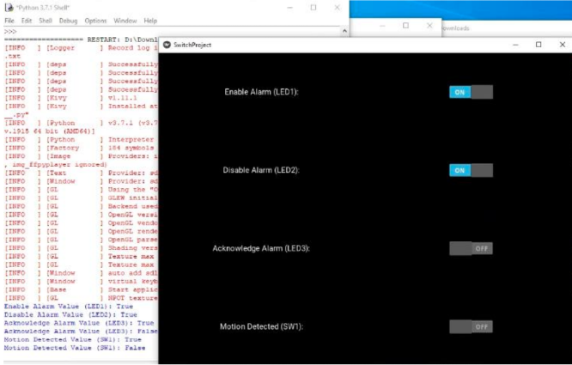

Kivy code for the above App:

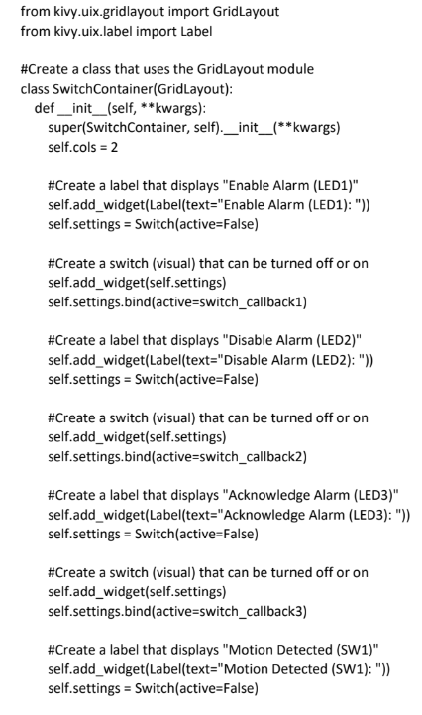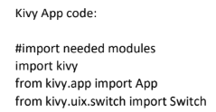

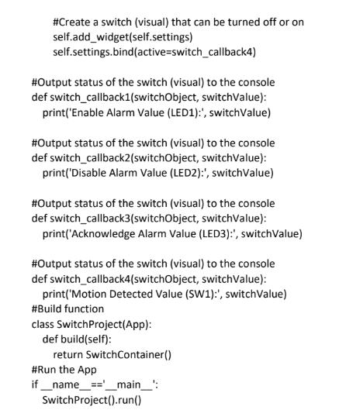

Task 6: Interface & test the functionality of sensors and actuators between DB tables & RPi

*in Video Task 12*

Task 7: Simulate the functionality of SwitchCompats between DB tables & Android using RPi (create a sync_android_data.php, similar to sync_rpi_data.php, on 000webhost.com, but trigger it from RPi to get all the bugs out. Later, sync_android_data.php will be triggered from Android. It is important to do this step since later if there is an issue, you just need to look at the Android Kivy side

*All in Task 10*

Task 8: Program Android App to interact with DB tables in PaaS

Python kivy code for Android App.

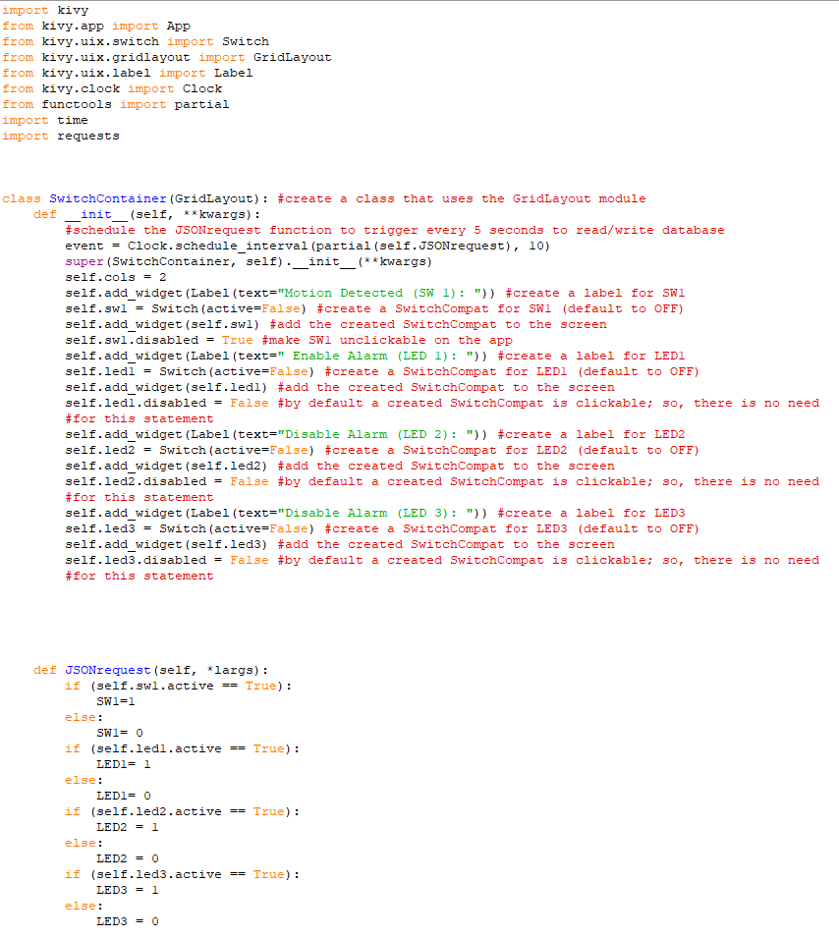

Screenshot of the Kivy App:

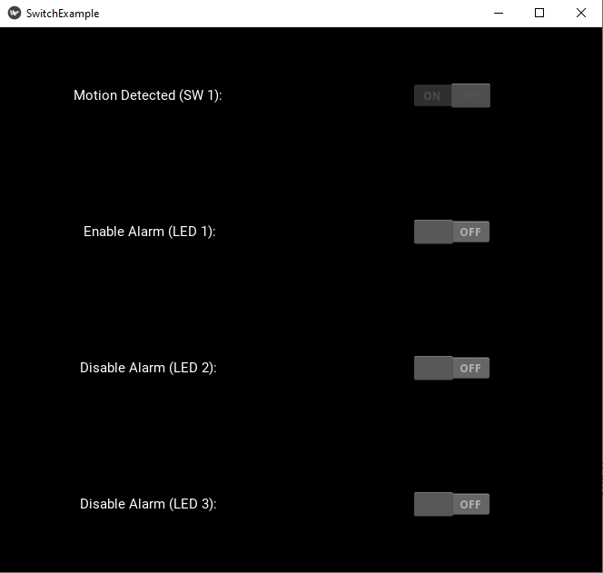

.Php json request code:

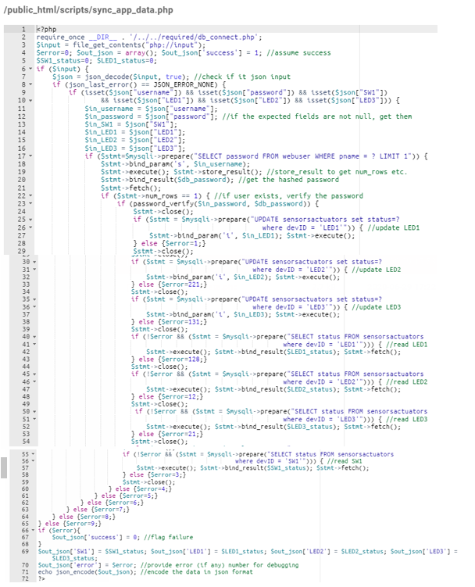

Task 9: Test interaction between Android App and RPi through DB tables in PaaS

Interaction with the database:

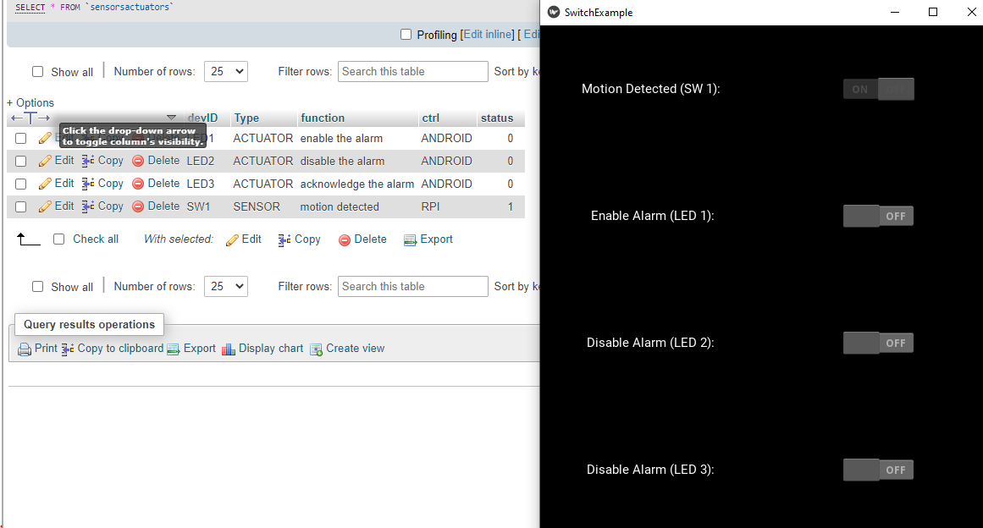

Changing OFF to ON through the App:

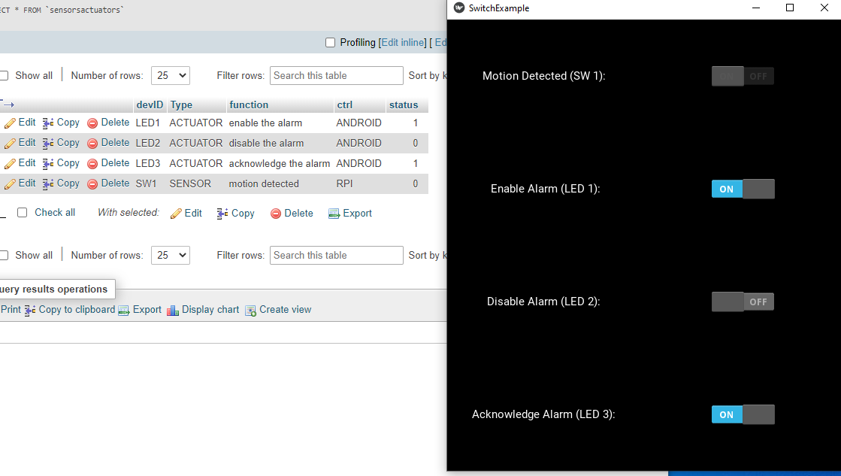

Changing SW1 0 to 1 in the DB:

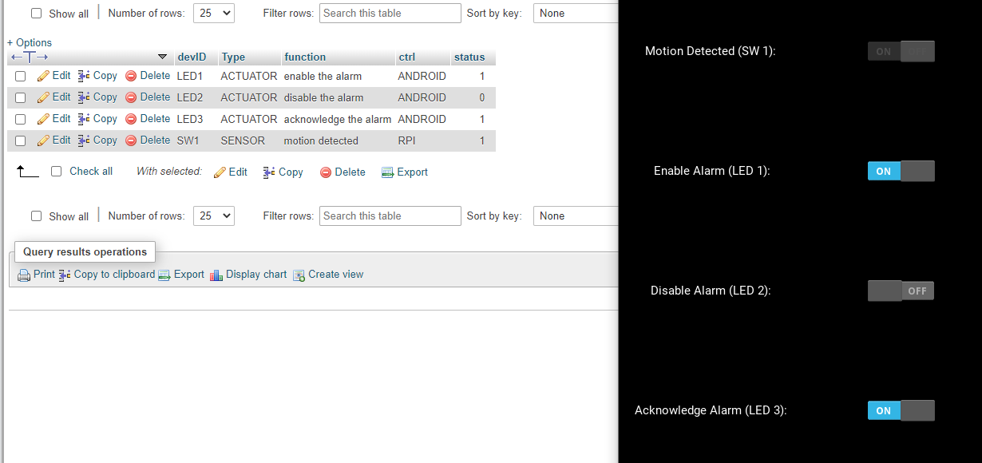

Task 10: Design website

Log-in Page:

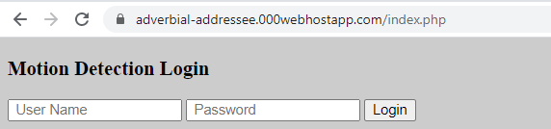

Log-in Page Code (check for credentials):

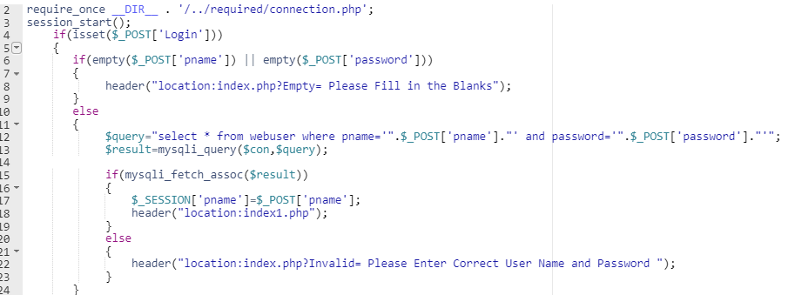

Main Page for Website:

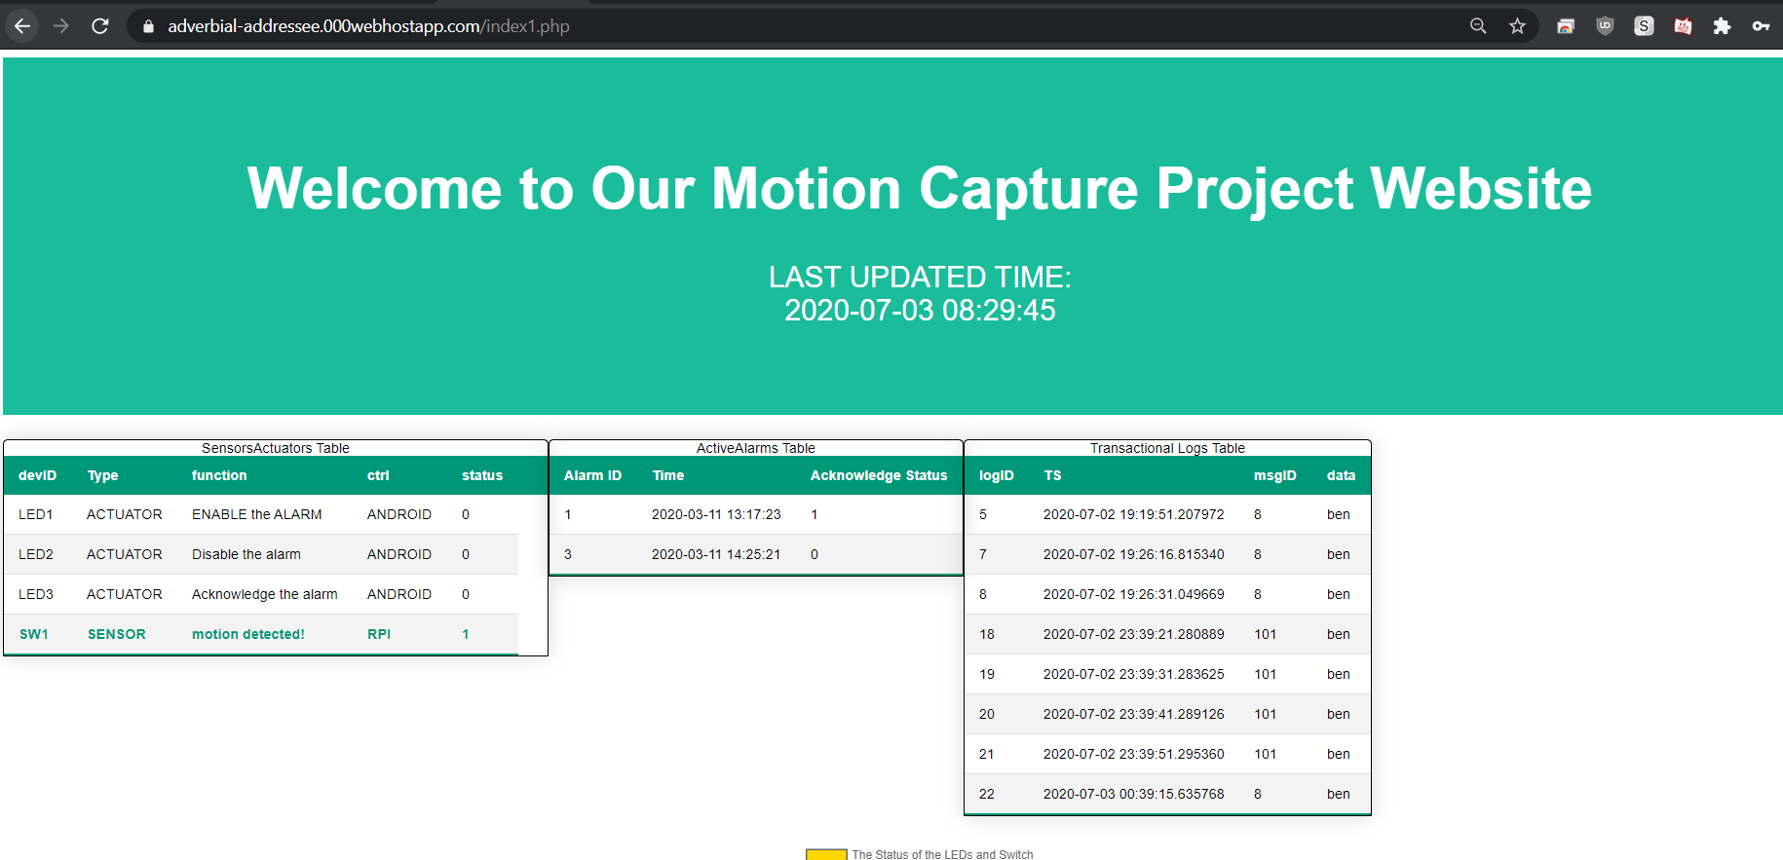

Main Page code:

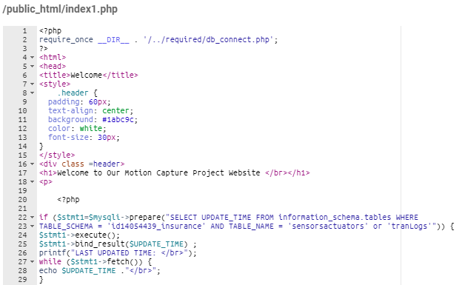 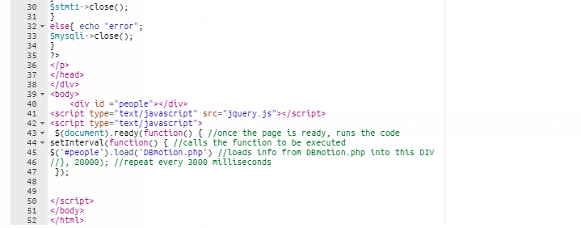

DBmotion.php(mainpage calls and refreshes) code

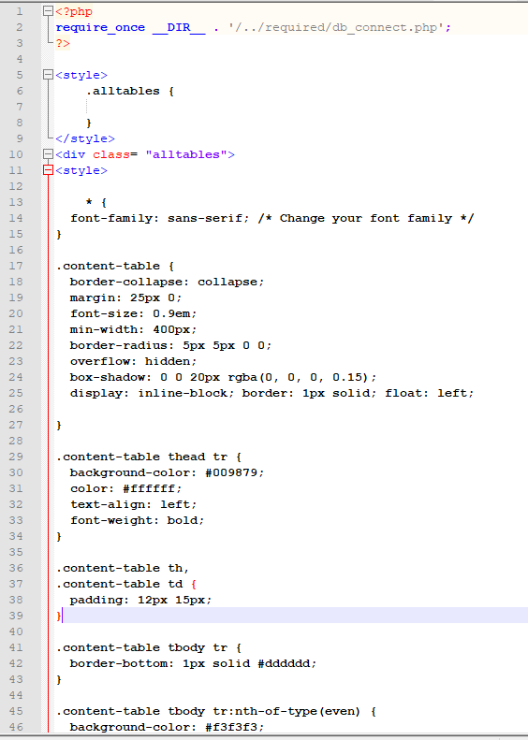

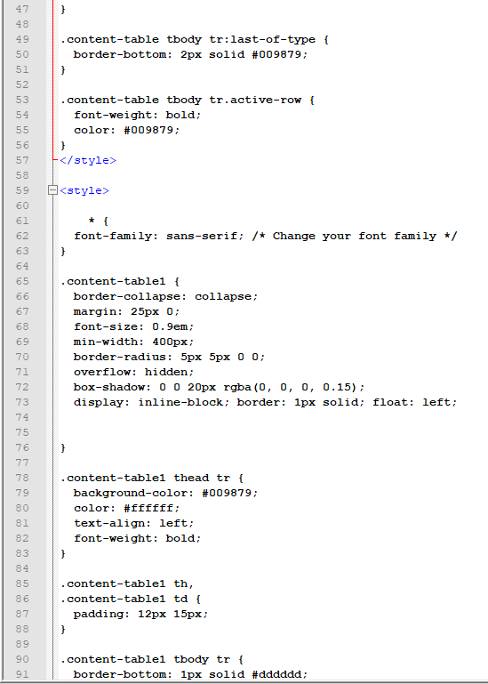

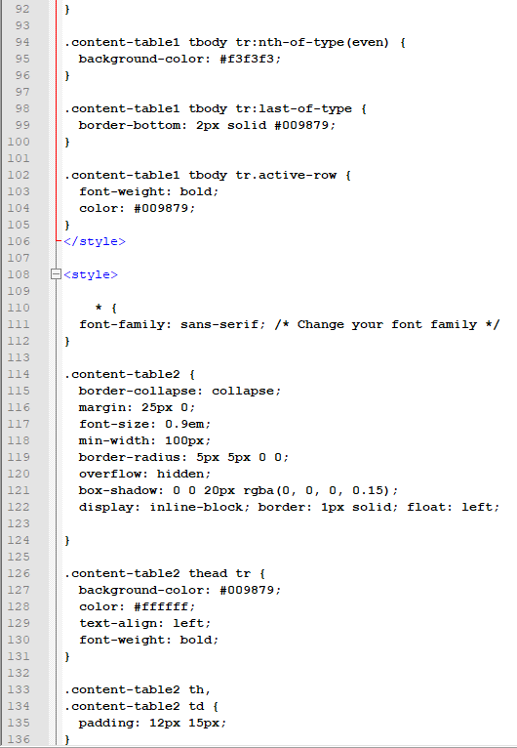

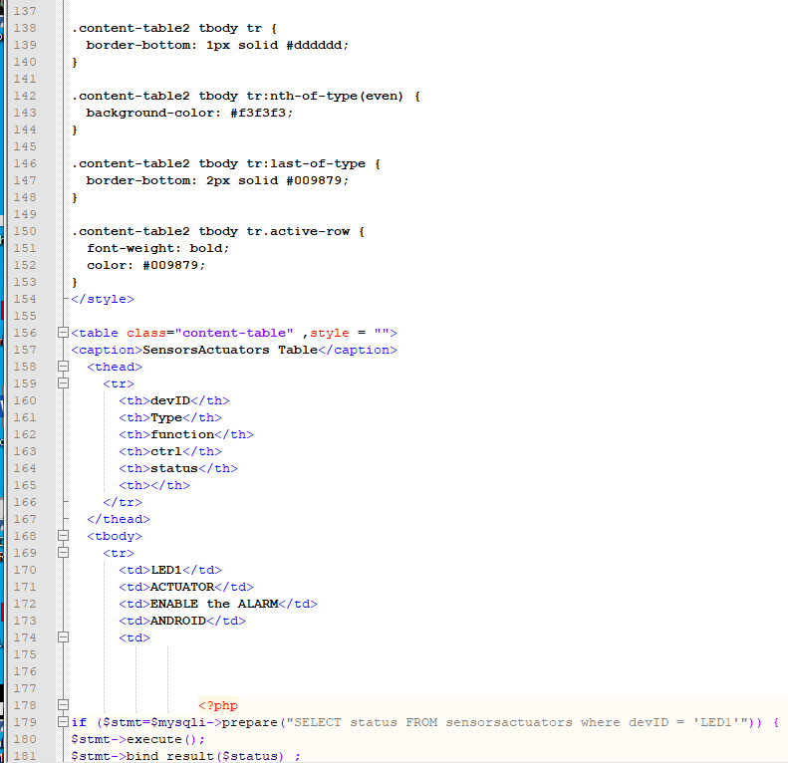

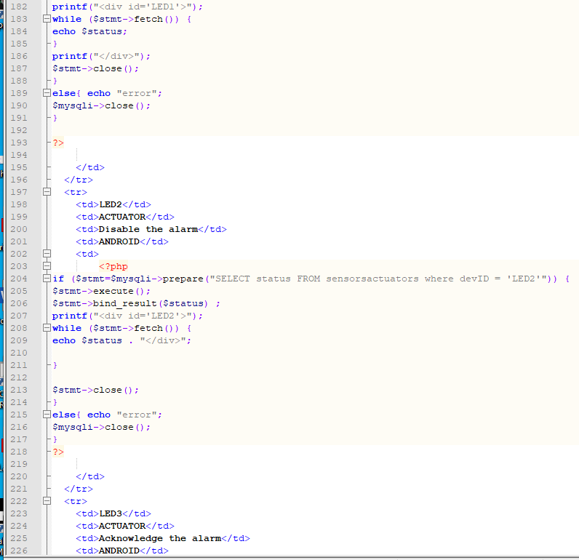

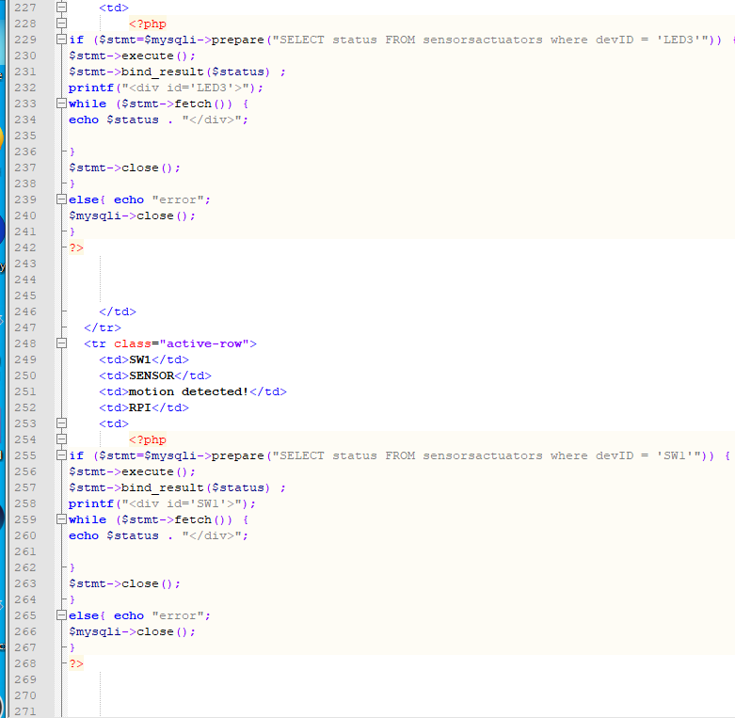

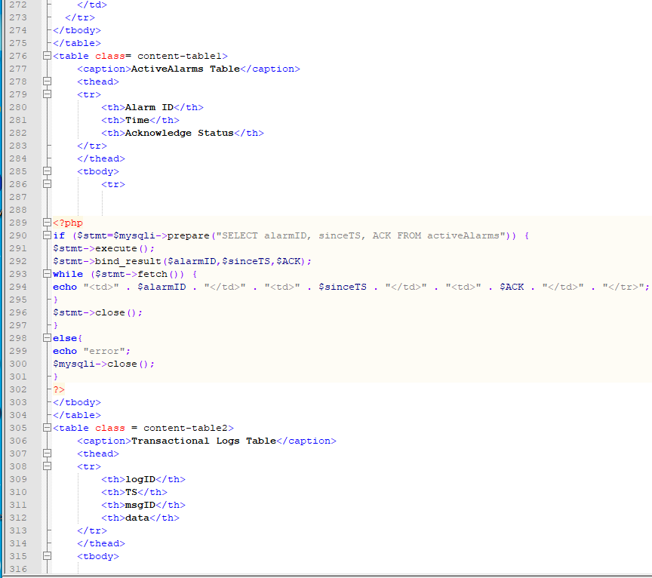

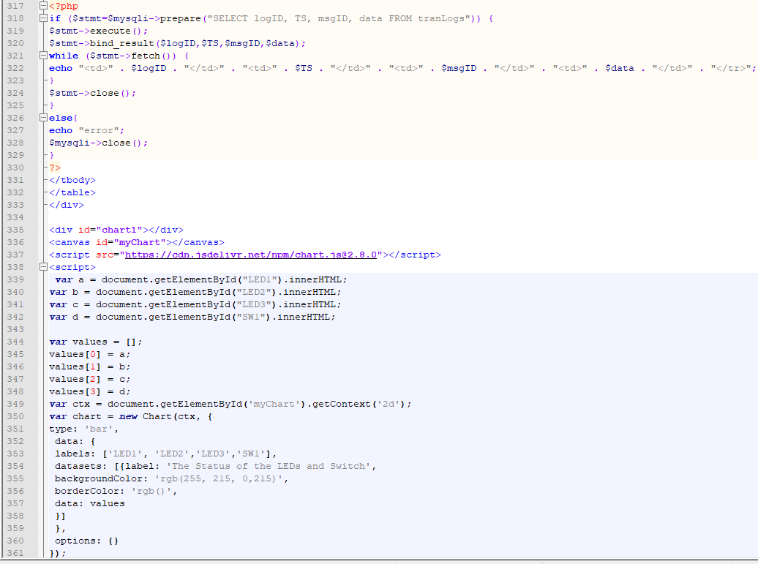

Task 11: Interface website components with the DB tables

Website:



SensorsActuators table & Transactional Logs Table

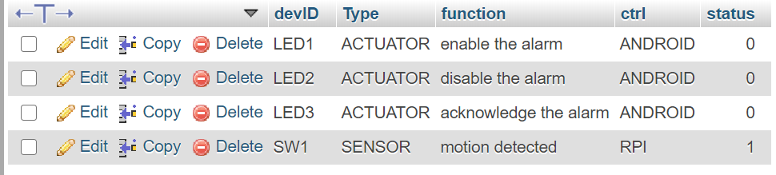

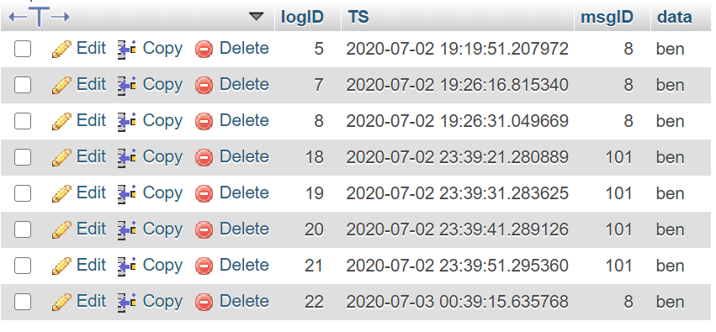

Task 12: Collect real data and test the overall functionality of the project

*In Video* *Video Link also included in the Presentation*

<https://www.youtube.com/watch?v=rx8Wtm9KRl8>