IPSO Smart Objects
IoT Semantic Interoperability Workshop 2016
IPSO Smart Object Committee - 8.2.2016

Table of Contents

1. Introduction 1
2. IPSO Smart Objects Data Model Components 2
3. Linking of Objects 4
4. Examples and Extended References 5
4.3. Smart Objects - Starter Pack 8
4.4. Smart Objects - Expansion Pack 8
4.5. Smart Objects - Application Specific Objects 9
5. References 10

Introduction
Standards for constrained devices are rapidly consolidating. The availability of Internet Protocol (IP) on constrained devices has enabled at the network level towards the Internet. The IETF has also specified a set of standard protocols for such IP-enabled devices to work in a Web-like fashion. One of such protocols is the Constrained Application Protocol (RFC 7252) [1] that provides similar methods, URIs, Discovery mechanisms, etc. as HTTP but for the constrained environment.

On top of such Application Protocols there is a need for structuring of the data shared between the devices, mainly due to originally CoAP not providing a proper resource structure.

IPSO Smart Objects provide a common design pattern, an object model, to provide high level interoperability between Smart Object devices and connected software applications on other devices and services. IPSO Objects are agnostic of the application protocol and thus do not mandate CoAP-like protocols by default although they are widely used.

The Object model is based on the Open Mobile Alliance Lightweight Specification (OMA LWM2M) [2], which is a set of management interfaces built on top of CoAP in order to enable device management operations (bootstrapping, firmware updates, error reporting, etc.). While LWM2M uses objects with fixed mandatory resources, IPSO Smart Objects use a more reusable design.

As already mentioned, the object model can optionally be used with any protocol, for example http, that supports the web standard content types and REST methods defined in the HTTP specification (RFC 2616) [3]. Other usage examples are with more publish/subscribe type of protocols such as MQTT or DDS, thus encapsulating the objects and publishing them under some topic.

Data Model Components
The data model for IPSO Smart Objects consists of 5 parts:

- Class Hierarchy
- Schema
- Data types
- Operations
- Content formats

  - Class hierarchy

The URI template defines an implicit class hierarchy consisting of Objects and Resources; The Object class is further split into ID and Instance subclasses.

Objects are typed containers, which define the semantic type of instances. Instances inherit the type of their parent object, and allow Smart Object endpoints to expose multiple sensors and actuators of a particular type. Object instances are themselves containers for resources, which are the observable properties of an object.

This simple class hierarchy enables application software to consume device APIs using a simple, well known state machine and mapping structure. For complex objects, we allow linking of an object to another object through an object link resource. This enables the recursion to be handled at the object level, using design patterns similar to web linking. An application client can consume a device’s API without knowing it’s structure and attributes a priori.

IPSO Smart Objects define behaviour at the Object and instance scope, for example the tracking of minimum and maximum values, reset of accumulated values

  - Schema

    - URI Template
The URI Template defined in LWM2M is used for IPSO Smart Objects consists of three unsigned 16-bit integers separated by the character `/`:

<object ID>/<object instance ID>/<resource ID>

Semantically, the object type represents a single measurement, actuation, or control point, for example a temperature sensor, a light (actuator), or an on-off switch (control point).

The semantic meaning of a resource specifies a particular view or active property of an object. For example, a temperature sensor object might expose the current value (most recent reading), also the minimum and maximum possible reading, the minimum and maximum reading in an interval, and attributes like engineering units and application type.

For example, a temperature sensor example URI would be `3303/0/5700`:

3300 -> Temperature Sensor
0 -> instance 0 of a Temperature Sensor
5700 -> resource having the current value or a most recent reading

    - Attributes
Attributes describe the metadata configuration, settings, and state of an object or resource, and are discoverable by reading the link-format data of an object or resource. Multiple attributes may be serialized in the link-format descriptors that a Smart Object exposes.

Some attributes are immutable for a given object or resource type, for example the static read, write, and execute capability attributes are derived from a Smart Object’s definition file, while other like the LWM2M Notification Attributes are used to dynamically configure a particular object instance or resource.

Attributes are represented using IETF CoRE Link-Format (RFC 6690) or equivalent mapping to other content formats e.g. application/json+ld

  - Data types

There are 7 data types, same as the ones defined in OMA LWM2M [2].

- String: A UTF-8 string, the minimum and/or maximum length of the String MAY be defined.
- Integer: An 8, 16, 32 or 64-bit signed integer. The valid range of the value for a Resource SHOULD be defined. This data type is also used for the purpose of enumeration.
- Float: A 32 or 64-bit floating point value. The valid range of the value for a Resource SHOULD be defined.
- Boolean: An integer with the value 0 for False and the value 1 for True.
- Opaque: A sequence of binary octets, the minimum and/or maximum length of the String MAY be defined.
- Time: Unix Time. A signed integer representing the number of seconds since Jan 1st, 1970 in the UTC time zone.
- Object Link: The object link is used to refer an Instance of a given Object. An Object link value is composed of two concatenated 16-bits unsigned integers following the Network Byte Order convention.

  - Operations
IPSO Objects and their resources have the same operations as their counterparts in [2] with the same semantics.
* Resource values: Read, Write, Execute (restricted by the Access Type field)
* Object Instances: Create, Delete (restricted by the Multiple Instances field)
* Objects and their instances: Read, Write
* Attributes: Set, Discover

  - Content formats
Content formats are those specified by the LWM2M Technical Specification [2]:
* Resource values: text/plain, tlv
* Objects: text/senml+json, application/cbor, binary/tlv
* Attributes: link-format, link-format+json

Linking of Objects
To create composite Objects, the object may be of a single reusable type “generic composite object” with one ID, and the resources may be of a generic reusable link type, also using a single ID, with multiple instances allowed, e.g. 4000/0/6700/0 where 4000 is “composite object” and 6700 is “generic object link”.

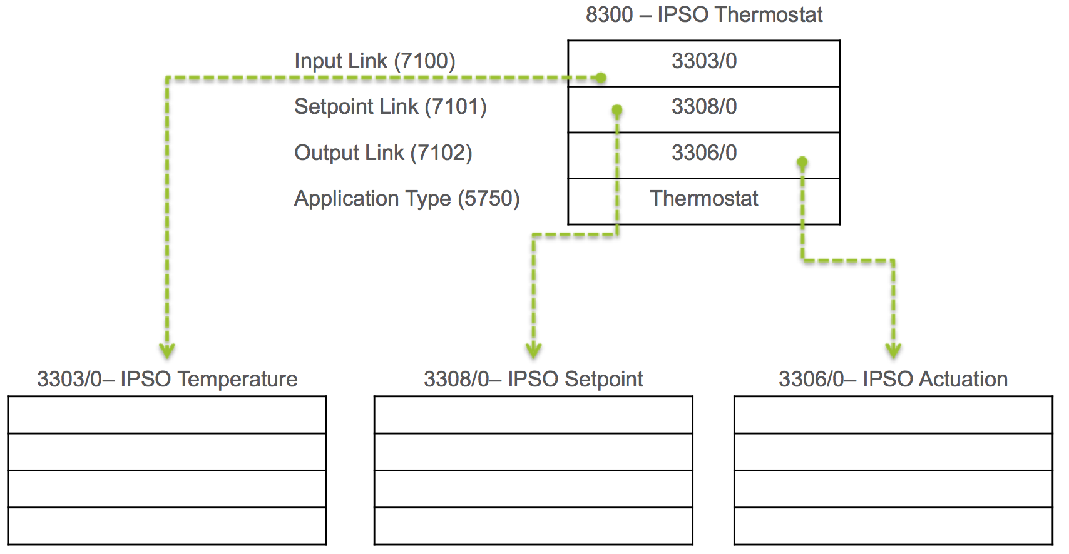

Examples and Extended References

  - Definition documents

For practical purposes we require a format for representing the objects in an unambiguous fashion. IPSO has used XML to the XML Schema in Appendix A, either hand-written or automatically generated from other sources. In the XML version, Integers, Floats and Time values must be represented as in the above subsection. Binary (Opaque) values must be represented in Base64-encoded form. Booleans must be represented using the lower-case strings true and false. XML definition documents may reference other XML definition documents using Include [5].

  - Humidity Sensor

The following is an example of a humidity sensor that contains the sensor value, units, min and max measured values, min and max range values and a resets for those.
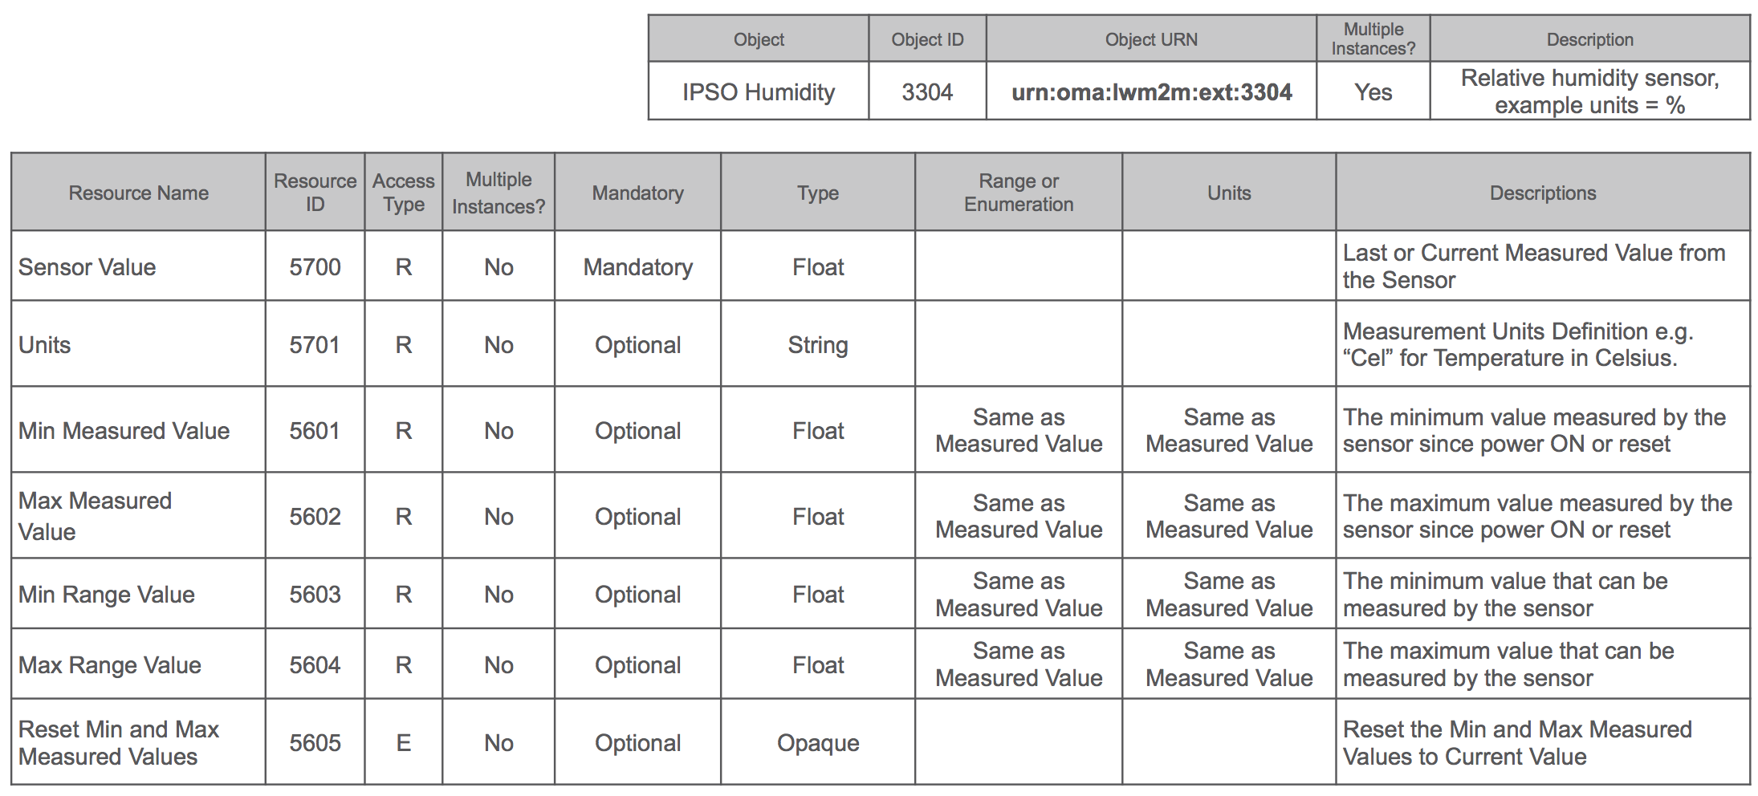

The following is the definition document for the Humidity Object in XML.

<?xml version="1.0" encoding="utf-8"?>
<LWM2M>
<Object ObjectType="MODefinition">
<Name>Humidity</Name>
<Description1>Description: This IPSO object should be used with a humidity sensor to report a humidity measurement. It also provides resources for minimum/maximum measured values and the minimum/maximum range that can be measured by the humidity sensor. An example measurement unit is relative humidity as a percentage (ucum:%).</Description1>
<ObjectID>3304</ObjectID>
<ObjectURN>urn:oma:lwm2m:ext:3304</ObjectURN>
<MultipleInstances>Multiple</MultipleInstances>
<Mandatory>Optional</Mandatory>
<Resources>
<Item ID="5700">
<Name>Sensor Value</Name>
<Operations>R</Operations>
<MultipleInstances>Single</MultipleInstances>
<Mandatory>Mandatory</Mandatory>
<Type>Float</Type>
<RangeEnumeration></RangeEnumeration>
<Units>Defined by “Units” resource.</Units>
<Description>Last or Current Measured Value from the Sensor</Description>
</Item>
<Item ID="5601">
<Name>Min Measured Value</Name>
<Operations>R</Operations>
<MultipleInstances>Single</MultipleInstances>
<Mandatory>Optional</Mandatory>
<Type>Float</Type>
<RangeEnumeration></RangeEnumeration>
<Units>Defined by “Units” resource.</Units>
<Description>The minimum value measured by the sensor since power ON or reset</Description>
</Item>
<Item ID="5602">
<Name>Max Measured Value</Name>
<Operations>R</Operations>
<MultipleInstances>Single</MultipleInstances>
<Mandatory>Optional</Mandatory>
<Type>Float</Type>
<RangeEnumeration></RangeEnumeration>
<Units>Defined by “Units” resource.</Units>
<Description>The maximum value measured by the sensor since power ON or reset</Description>
</Item>
<Item ID="5603">
<Name>Min Range Value</Name>
<Operations>R</Operations>
<MultipleInstances>Single</MultipleInstances>
<Mandatory>Optional</Mandatory>
<Type>String</Type>
<RangeEnumeration></RangeEnumeration>
<Units>Defined by “Units” resource.</Units>
<Description>The minimum value that can be measured by the sensor</Description>
</Item>
<Item ID="5604">
<Name>Max Range Value</Name>
<Operations>R</Operations>
<MultipleInstances>Single</MultipleInstances>
<Mandatory>Optional</Mandatory>
<Type>Float</Type>
<RangeEnumeration></RangeEnumeration>
<Units>Defined by “Units” resource.</Units>
<Description>The maximum value that can be measured by the sensor</Description>
</Item>
<Item ID="5701">
<Name>Sensor Units</Name>
<Operations>R</Operations>
<MultipleInstances>Single</MultipleInstances>
<Mandatory>Optional</Mandatory>
<Type>String</Type>
<RangeEnumeration></RangeEnumeration>
<Units></Units>
<Description>Measurement Units Definition e.g. “Cel” for Temperature in Celsius.</Description>
</Item>
<Item ID="5605">
<Name>Reset Min and Max Measured Values</Name>
<Operations>E</Operations>
<MultipleInstances>Single</MultipleInstances>
<Mandatory>Optional</Mandatory>
<Type>Opaque</Type>
<RangeEnumeration></RangeEnumeration>
<Units></Units>
<Description>Reset the Min and Max Measured Values to Current Value</Description>
</Item>
</Resources>
<Description2></Description2>
</Object>
</LWM2M>

Smart Objects - Starter Pack
This first IPSO Smart Object Guideline describes 18 Smart Object types, including a temperature sensor, a light controller, an accelerometer, a presence sensor, and other common sensor and actuator types representing a variety of use case domains. It is intended as a “Starter Pack” and example of how IPSO Smart Objects can be built to address some application specific use cases.

This first object set is to be used as a starting place from which to build more objects and object sets, in order to address vertical application segments and new functional requirements for Smart Objects. The IPSO Alliance is committed to making it easy for people to create new objects based on their use case needs, while promoting reusable and cross-domain standards to as great an extent as is practical.

Object | Object ID
Digital | 3200
Digital Output | 3201
Analogue Input | 3202
Analogue Output | 3203
Generic Sensor | 3300
Illuminance Sensor | 3301
Presence sensor | 3302
Temperature Sensor | 3303
Humidity Sensor | 3304
Power Measurement | 3305
Actuation | 3306
Set Point | 3308
Load Control | 3310
Light Control | 3311
Power Control | 3312
Accelerometer | 3313
Magnetometer | 3314
Barometer | 3315

Smart Objects - Expansion Pack

To complement the initial set of objects, this new IPSO Smart Object Expansion Pack was created. The Expansion Pack covers a new set of 16 Common Template sensors, 6 Special template sensors, 5 Actuators and 6 Control switch types.

Some of the new objects are generic in nature, such as voltage, altitude or percentage, while others are more specialized like the Color Object or the Gyrometer Object. New Actuators and Controllers are defined such as timer or buzzer and Joystick and Level. All of these objects were found to be necessary on a variety of use case domains.

Object | Object ID
Voltage | 3316
Current | 3317
Frequency | 3318
Depth | 3319
Percentage | 3320
Altitude | 3321
Load | 3322
Pressure | 3323
Loudness | 3324
Concentration | 3325
Acidity | 3326
Conductivity | 3327
Power | 3328
Power Factor | 3329
Rate | 3346
Distance | 3330
Energy | 3331
Direction | 3332
Time | 3333
Gyrometer | 3334
Color | 3335
GPS Location | 3336
Positioner | 3337
Buzzer | 3338
Audio Clip | 3339
Timer | 3340
Addressable Text Display | 3341
On/Off Switch | 3342
Push Button | 3347
Level Control | 3343
Up/Down Control | 3344
Multistate Selector | 3348
Multiple Axis Joystick | 3345

Smart Objects - Application Specific Objects

Apart from the basic object sets IPSO provide Objects sets from reusing existing Resources tailored to other use cases. Anyone can create new Objects from various Resources.

References

[1] The Constrained Application Protocol (CoAP): https://tools.ietf.org/html/rfc7252
[2] Open Mobile Alliance Ltd., Lightweight Machine-to-Machine Technical Specification, 2014.
[3] R. Fielding, J. Gettys, J. Mogul, H. Frystyk, L. Masinter, P. Leach and T. Berners-Lee, „Hypertext Transfer Proocol - HTTP/1.1” RFC 2616, June 1999.
[4] Smart Objects Design Guidelines: https://github.com/IPSO-Alliance/SmartObjectGuidelines/tree/master/SmartObjectDesignGuide
[5] Constrained RESTful Environments (CoRE) Link Format: https://tools.ietf.org/html/rfc6690

