API Details and Task Description

# APIs

## 1. Get and Post Request

API: https://driversonhire.com/api/enquiry/drivers/

Methods: GET, POST

## 2. Patch, Delete and Single Driver Profile

API: https://driversonhire.com/api/enquiry/drivers/id/

Methods: PATCH, DELETE, GET (Single Driver Profile)

## Task for Get and Post Request

This API is responsible for fetching all drivers and adding new driver details.

Tasks:

1. Fetch all drivers using a GET request.

2. Add a new driver using a POST request. Make sure to validate the driver data.

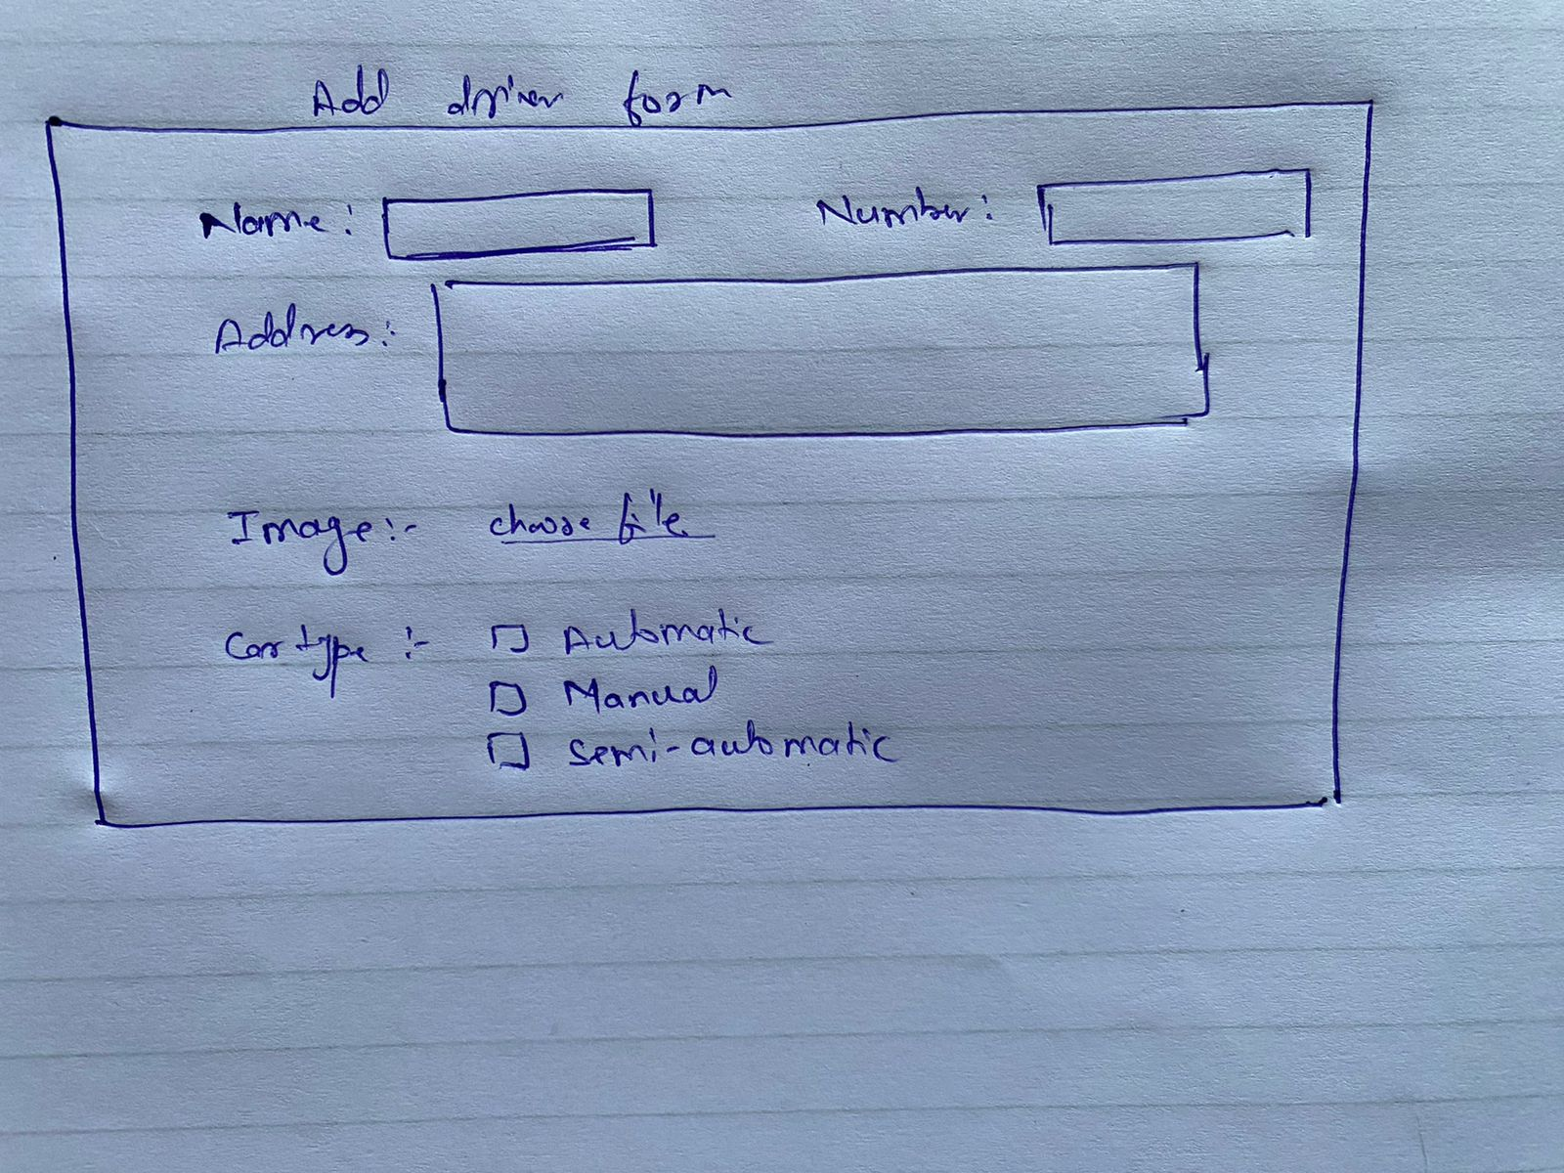

## Task for Patch, Delete, and Single Driver Profile

This API allows updating, deleting, and retrieving a single driver's profile.

Tasks:

1. Update a driver's profile using a PATCH request. Ensure only relevant fields are updated.

2. Delete a driver's profile using a DELETE request.

3. Fetch a specific driver's profile using a GET request with the driver's ID.

