**Date:** 23/03/2021

**Roll No. :** 20BCE503

**Name:** Jaimik Chauhan

**Course Code and Name:** 2CS405 (Web Technologies)

**Practical No.:** 2

**AIM:**

1. [Design a home page to display your resume using the HTML table tag.](https://jaimik64.github.io/WT-LAB/)
2. <html>
4. <head>
5. <title>Resume </title>
6. <style>
7. body {
8. height: auto;
9. width: auto;
10. }
12. h3 {
13. text-align: center;
14. }
16. .contact {
17. border: 2px solid black;
18. width: auto;
19. margin: 1%;
20. padding: 5px;
21. background-color: antiquewhite;
22. height: max-content;
23. text-align: center;
24. }
26. .contact a {
27. text-align: right;
28. }
30. a {
31. text-decoration: none;
32. }
34. .title {
35. margin: 2%;
36. color: rgb(104, 104, 241);
37. font-size: large;
38. text-align: center;
39. height: fit-content;
40. width: auto;
41. }
43. .summary p {
44. text-align: left;
45. margin: 2%;
47. }
49. .table {
50. width: auto;
51. }
53. .edu {
54. padding: 1%;
55. }
57. .skills {
58. font-size: 18px;
59. }
61. .h3 {
62. font-size: 16px;
63. background-color: antiquewhite;
64. text-align: left;
65. margin: 1%;
66. color: grey;
67. padding: 0.5%;
68. }
70. .link {
71. text-align: left;
72. }
74. .link:hover {
75. text-decoration: none;
76. }
78. img {
79. vertical-align: baseline;
80. }
82. .space {
83. margin: 15px;
84. }
85. </style>
86. <!-- Latest compiled and minified CSS -->
87. <link **rel**="stylesheet" **href**="https://maxcdn.bootstrapcdn.com/bootstrap/3.3.7/css/bootstrap.min.css"
88. **integrity**="sha384-BVYiiSIFeK1dGmJRAkycuHAHRg32OmUcww7on3RYdg4Va+PmSTsz/K68vbdEjh4u" **crossorigin**="anonymous">
90. <!-- Latest compiled and minified JavaScript -->
91. <script **src**="https://maxcdn.bootstrapcdn.com/bootstrap/3.3.7/js/bootstrap.min.js"
92. **integrity**="sha384-Tc5IQib027qvyjSMfHjOMaLkfuWVxZxUPnCJA7l2mCWNIpG9mGCD8wGNIcPD7Txa"
93. **crossorigin**="anonymous"></script>
94. <meta **name**="viewport" **content**="width=device-width, initial-scale=1.0">
95. </head>
97. <body>
99. <div **class**="contact">
101. <h3 **style**="text-align: center;">Jaimik Chauhan</h3>
102. <hr />
103. <a **class**="link" **href**="tel:8401563076"><img **src**="https://img.icons8.com/android/24/000000/phone.png"
104. **height**="20px" **width**="20px" /></a>
105. <a **class**="link" **href**="mailto:jaimikchauhan10@gmail.com"><img
106. **src**="https://img.icons8.com/material-sharp/24/000000/important-mail.png" **height**="20px"
107. **width**="20px" /></a>
108. <a **class**="link" **href**="https://www.linkedin.com/in/jaimikchauhan64/"><img
109. **src**="https://img.icons8.com/android/24/000000/linkedin.png" **height**="20px" **width**="20px" />
110. </a>
111. <a **class**="link" **href**="https://github.com/jaimik64"><img
112. **src**="https://img.icons8.com/material-sharp/24/000000/github.png" /></a>
113. <a **class**="link" **href**="https://twitter.com/Jaaimik"><img
114. **src**="https://img.icons8.com/android/24/000000/twitter.png" /></a>
115. </div>
116. <div **class**="skills">
117. <h4 **class**="h3" **style**="background-color: blanchedalmond;">Career Objective </h4>
119. <ul>
120. <li>Seeking a Position to utilize my skills and abillities in the Information Technology Industry that offer
121. profesional growth while being resourseful, innovative and flexible.</li>
122. </ul>
123. </div>
125. <h4 **class**="h3" **style**="background-color: blanchedalmond;">Education </h4>
126. <div **class**="edu">
127. <!--         <caption style="background-color: blanchedalmond;">Education </caption> -->
128. <div **class**="table-responsive-sm">
129. <table **class**="table">
130. <thead>
131. <tr>
132. <th **scope**="col">Qualification</th>
133. <th **scope**="col">Institution</th>
134. <th **scope**="col">Year</th>
135. </tr>
136. </thead>
137. <tbody>
138. <tr>
139. <td>SSC</td>
140. <td>Shree V.R.Karve HighSchool, Mehsana</td>
141. <td>2017</td>
142. </tr>
143. <tr>
144. <td>Diploma In Computer Engineering</td>
145. <td>Bhailalbhai Bhikhabhai Institute Of Technology, V.V.Nagar, Anand</td>
146. <td>2020</td>
147. </tr>
148. </tbody>
149. </table>
150. </div>
151. </div>
153. <h4 **class**="h3" **style**="background-color: blanchedalmond;">Projects </h4>
154. <div **class**="edu">
155. <div **class**="table-responsive-sm">
156. <table **class**="table">
157. <!--                 <caption style="background-color: blanchedalmond;">Projects </caption> -->
158. <thead>
159. <tr>
160. <th **scope**="col">Project Name</th>
161. <th **scope**="col">Project-Site</th>
162. <th **scope**="col">Technology Used</th>
163. <th **scope**="col">Role</th>
164. </tr>
165. </thead>
166. <tbody>
167. <tr>
168. <td>Donation Management System</td>
169. <td><a **href**="https://scratchiest-pulse.000webhostapp.com/">Donation System</a></td>
170. <td>PHP, HTML, Bootstrap, JavaScript</td>
171. <td>Team Leader</td>
172. </tr>
173. <tr>
174. <td>Yajman Restaurant</td>
175. <td><a **href**="https://yajmanrestaurant.com/">Yajman Restaurant & Banquet</a> </td>
176. <td>PHP, HTML, Bootstrap, JavaScript</td>
177. <td>Team Leader</td>
178. </tr>
179. </tbody>
180. </table>
181. </div>
182. </div>
183. <div **class**="skills">
184. <h3 **class**="h3" **style**="background-color: blanchedalmond;">Skills </h3>
186. <ul>
187. <li>PHP</li>
188. <li>Database Manager</li>
189. <li>HTML</li>
190. <li>CSS</li>
191. <li>Bootstrap</li>
192. <li>JavaScript</li>
193. </ul>
194. </div>
196. <div **class**="skills">
197. <h3 **class**="h3" **style**="background-color: blanchedalmond;">Hobbies </h3>
199. <ul>
200. <li>Reading</li>
201. <li>Learning Languages</li>
202. <li>Listening To Music</li>
203. </ul>
204. </div>
205. </body>
207. </html>

**Output :**

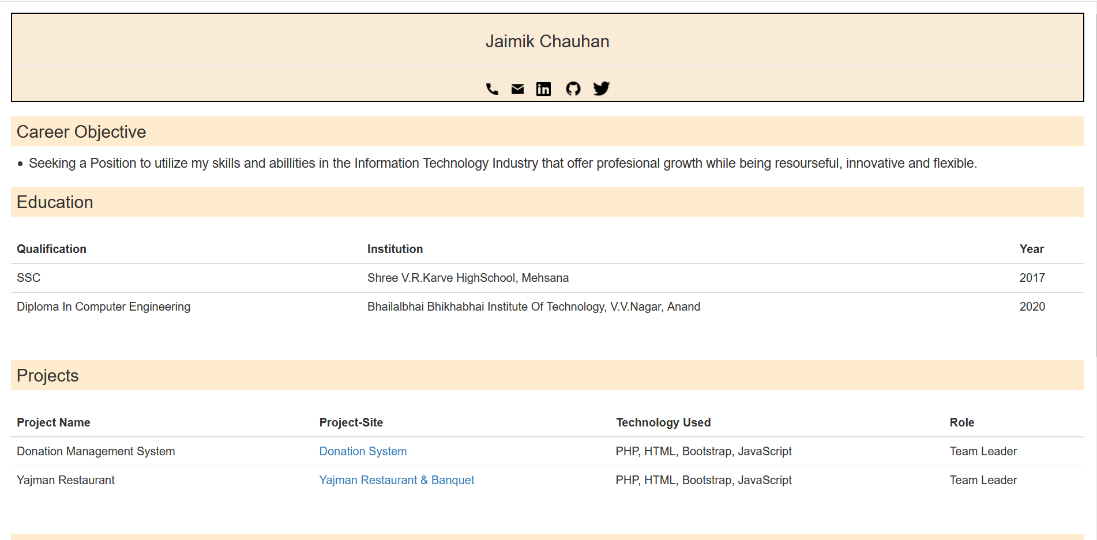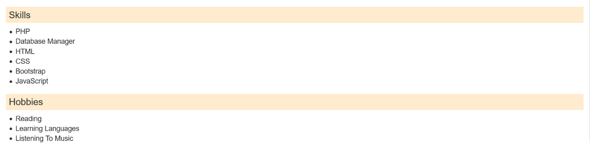

1. [Create an HTML Page which contains the two frameset tag. One frame contains navigation links for web pages and the second frame displays the information about the respective web pages when navigation link of a particular web page is clicked.](https://jaimik64.github.io/WT-LAB/NavLinkFrame.html)

**Code** :

* Index.html :

1. <!DOCTYPE html>
3. <html>
5. <head>
6. <title>Frame Tag</title>
7. <meta **name**="viewport" **content**="width=device-width, initial-scale=1.0">
8. <script **src**="https://ajax.googleapis.com/ajax/libs/jquery/3.5.1/jquery.min.js"></script>
9. </head>
11. <frameset **cols**="15%,*" **id**="link" **border**="2px solid black">
12. <frame **name**="f1" **scroll**="no" **id**="hde" **src**="f1.html" />
13. <frame **name**="f2" **src**="f2.html" />
14. </frameset>
15. <script>
16. $(document).ready(function () {
17. $("#hde").click(function () {
18. $("#drp").toggle();
19. });
20. });
21. </script>
23. </html>

* F1.html :

1. <html>
3. <head>
4. <title>Frame 1</title>
5. <script **src**="https://ajax.googleapis.com/ajax/libs/jquery/3.5.1/jquery.min.js"></script>
7. <style>
8. body {
9. background-color: antiquewhite;
10. }
12. a {
13. display: block;
14. text-decoration: none;
15. padding: 2%;
16. }
18. a:hover {
19. color: black;
20. text-decoration: none;
21. }
23. a::after {
24. color: antiquewhite;
26. }
28. footer {
29. color: white;
30. height: max-content;
31. width: auto;
32. margin: 1%;
33. padding: 5px;
34. text-align: center;
35. }
37. #menu {
38. height: 65%;
39. width: auto;
40. }
42. #drp {
43. text-align: left;
44. }
45. </style>
47. <meta **name**="viewport" **content**="width=device-width, initial-scale=1.0">
49. </head>
51. <body>
52. <div **id**="menu" **function**="he">
53. <h2>Menu</h2>
54. <a **target**="f2" **href**="p1.html">View Practical-1</a>
55. <a **target**="f2" **href**="resume.html">View Practical-2 </a>
56. <a **target**="f2" **href**="https://scratchiest-pulse.000webhostapp.com/">View Project-1</a>
57. <a **href**="#" **id**="drop">View Imprtant Links</a>
58. <div **id**="drp">
59. <ul>
60. <a **target**="f2" **href**="https://lms.nirmauni.ac.in/">
61. <li>LMS</li>
62. </a>
64. <a **target**="f2" **href**="https://erp.nirmauni.ac.in/nirmalive">
65. <li>ERP</li>
66. </a>
67. </ul>
68. </div>
69. </div>
70. <script>
71. $(document).ready(function () {
72. $("#drp").hide();
73. $("#drop").click(function () {
74. $("#drp").toggle();
75. });
76. });
77. </script>
78. <footer>
79. <hr>
80. <a **class**="link" **target**="blank" **href**="tel:8401563076"><img
81. **src**="https://img.icons8.com/android/24/000000/phone.png" **height**="20px" **width**="20px" /></a>
82. <a **class**="link" **target**="blank" **href**="mailto:jaimikchauhan10@gmail.com"><img
83. **src**="https://img.icons8.com/material-sharp/24/000000/important-mail.png" **height**="20px"
84. **width**="20px" /></a>
85. <a **class**="link" **target**="blank" **href**="https://www.linkedin.com/in/jaimikchauhan64/"><img
86. **src**="https://img.icons8.com/android/24/000000/linkedin.png" **height**="20px" **width**="20px" />
87. </a>
88. <a **class**="link" **target**="blank" **href**="https://github.com/jaimik64"><img
89. **src**="https://img.icons8.com/material-sharp/24/000000/github.png" /></a>
90. <a **class**="link" **target**="blank" **href**="https://twitter.com/Jaaimik"><img
91. **src**="https://img.icons8.com/android/24/000000/twitter.png" /></a>
92. </footer>
93. </body>
95. </html>

* F2.html :

1. <html>
3. <head>
4. <title>Frame 2</title>
5. <style>
6. body {
7. text-align: center;
8. background-color: antiquewhite;
10. }
12. h2 {
13. font-size: 40px;
14. }
16. h3 {
17. font-size: 32px;
18. }
19. </style>
20. </head>
22. <body>
23. <div>
24. <h2>Welcome to Website</h2>
25. </div>
26. <h3><strong>Note : </strong>
27. Click Side Menu To Explore Website</h3>
28. </body>
29. <script>
30. $(document).ready(function () {
31. $("#drp").hide();
32. $("#drop").click(function () {
33. $("#drp").toggle();
34. });
35. });
36. </script>
38. </html>

**Output :**

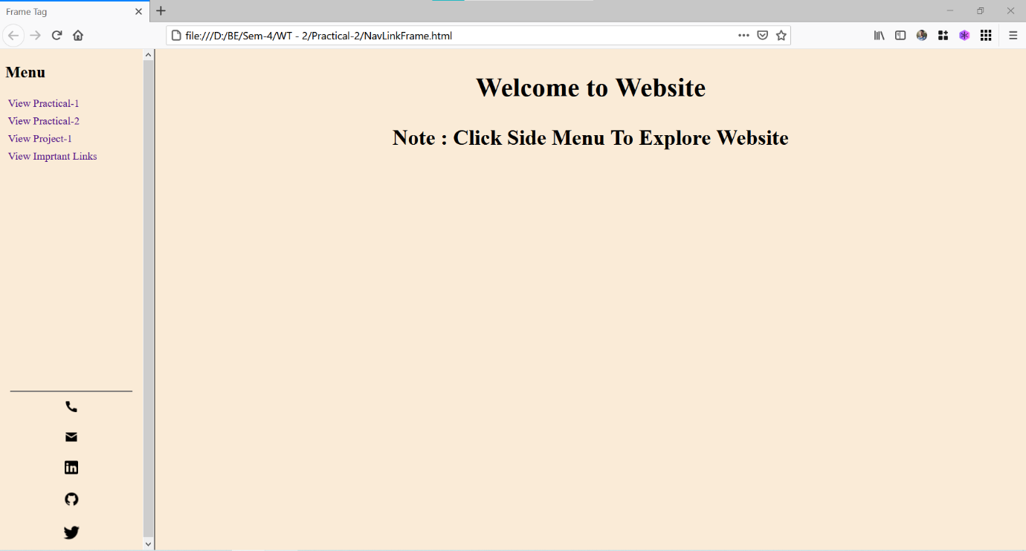

**Conclusion :**  Learn New Tags To Create Table in HTML, Create Multiple Frame In HTML.

How to Use Bootstrap in Website.