**Date:** 23/03/2021

**Roll No. :** 20BCE503

**Name:** Jaimik Chauhan

**Course Code and Name:** 2CS405 (Web Technologies)

**Practical No.:** 3

**AIM:**

1. [Demonstrate an image map in HTML.](https://jaimik64.github.io/WT-LAB/Practical-3/)

* **S21.css**

1. .main {
2. text-align: center;
3. }
5. .title{
6. text-align: center;
7. font-size: 48px;
8. }
10. .homeImg {
11. height: 584px;
12. width: 1000px;
13. }
15. .s21 .s21p{
16. height: auto;
17. width: auto;
18. float: left;
19. }
21. .img {
22. height: auto;
23. width: auto;
24. margin: 3%;
25. }
26. .menu {
27. border: 2px solid black;
28. }
29. .s21u {
30. height: auto;
31. width: auto;
32. float: left;
33. margin-right: 5%;
34. }
36. .ft {
37. background-color: black;
38. color: white;
39. text-align: center;
40. padding: 2%;
41. margin-top: 7%;
42. width: auto;
43. }
45. .ft a {
46. color: white;
47. }
49. .ft img {
50. height: 20px;
51. width: 20px;
52. }
54. .ft span {
55. margin: 6px;
56. display: block;
57. }

* **index.html**

1. <html>
3. <head>
4. <title>
5. View Mobile Details
6. </title>
8. <meta **name**="viewport" **content**="width=device-width, initial-scale=1">
9. <link **rel**="stylesheet" **href**="https://maxcdn.bootstrapcdn.com/bootstrap/4.5.2/css/bootstrap.min.css">
10. <script **src**="https://ajax.googleapis.com/ajax/libs/jquery/3.5.1/jquery.min.js"></script>
11. <script **src**="https://cdnjs.cloudflare.com/ajax/libs/popper.js/1.16.0/umd/popper.min.js"></script>
12. <script **src**="https://maxcdn.bootstrapcdn.com/bootstrap/4.5.2/js/bootstrap.min.js"></script>
13. <!-- Latest compiled and minified CSS -->
14. <link **rel**="stylesheet" **href**="https://maxcdn.bootstrapcdn.com/bootstrap/3.3.7/css/bootstrap.min.css"
15. **integrity**="sha384-BVYiiSIFeK1dGmJRAkycuHAHRg32OmUcww7on3RYdg4Va+PmSTsz/K68vbdEjh4u" **crossorigin**="anonymous">
17. <!-- Latest compiled and minified JavaScript -->
18. <script **src**="https://maxcdn.bootstrapcdn.com/bootstrap/3.3.7/js/bootstrap.min.js"
19. **integrity**="sha384-Tc5IQib027qvyjSMfHjOMaLkfuWVxZxUPnCJA7l2mCWNIpG9mGCD8wGNIcPD7Txa"
20. **crossorigin**="anonymous"></script>
22. <link **href**="s21.css" **rel**="stylesheet" />
23. <script>
25. $('#s21').tooltip('toggle')
26. $('#s21u').tooltip('toggle')
27. $('#s21p').tooltip('toggle')
28. </script>
29. </head>
31. <body **class**="main">
32. <h2 **class**="title">Image-Map</h2>
33. <div **class**="img">
34. <img **src**="image-map/allthree-2.jpg" **class**="homeImg" **usemap**="#image-map" **alt**="Loading...." />
36. <map **name**="image-map">
37. <area **shape**="rect" **id**="s21u" **coords**="78,78,270,527" **alt**="S21 Ultra" **href**="s21ultra.html"
38. **class**="btn btn-secondary" **data-toggle**="tooltip" **data-placement**="top" **title**="Samsung S21 Ultra">
39. <area **shape**="rect" **id**="s21p" **coords**="372,88,579,530" **alt**="S21 Ultra" **href**="s21plus.html"
40. **class**="btn btn-secondary" **data-toggle**="tooltip" **data-placement**="top" **title**="Samsung S21 Plus">
41. <area **shape**="rect" **id**="s21" **coords**="676,110,870,522" **alt**="S21 Ultra" **href**="s21.html"
42. **class**="btn btn-secondary" **data-toggle**="tooltip" **data-placement**="top" **title**="Samsung S21">
43. </map>
44. </div>
45. <p><strong><mark **color**="yellow">Note : </mark></strong>Cick Image To Know More.</p>
47. <footer **class**="ft">
48. <span>Created By : Jaimik Chauhan</span>
49. <span>Roll Call : <a **href**="mailto:20bce503@nirmauni.ac.in">20BCE503</a></span>
50. <a **class**="link" **href**="https://www.linkedin.com/in/jaimikchauhan64/"><img **src**="image-map/linkedin.png" />
51. </a>
52. <a **class**="link" **href**="https://github.com/jaimik64"><img **src**="image-map/GitHub-Mark-Light-32px.png" /></a>
54. <a **class**="link" **href**="https://twitter.com/Jaaimik"><img **src**="image-map/twitter.png" /></a>
55. </footer>
56. </body>

* **S21.html**

1. <html>
3. <head>
4. <title>
5. S21 Details
6. </title>
8. <meta **name**="viewport" **content**="width=device-width, initial-scale=1">
9. <link **rel**="stylesheet" **href**="https://maxcdn.bootstrapcdn.com/bootstrap/4.5.2/css/bootstrap.min.css">
10. <script **src**="https://ajax.googleapis.com/ajax/libs/jquery/3.5.1/jquery.min.js"></script>
11. <script **src**="https://cdnjs.cloudflare.com/ajax/libs/popper.js/1.16.0/umd/popper.min.js"></script>
12. <script **src**="https://maxcdn.bootstrapcdn.com/bootstrap/4.5.2/js/bootstrap.min.js"></script>
13. <!-- Latest compiled and minified CSS -->
14. <link **rel**="stylesheet" **href**="https://maxcdn.bootstrapcdn.com/bootstrap/3.3.7/css/bootstrap.min.css"
15. **integrity**="sha384-BVYiiSIFeK1dGmJRAkycuHAHRg32OmUcww7on3RYdg4Va+PmSTsz/K68vbdEjh4u" **crossorigin**="anonymous">
17. <!-- Latest compiled and minified JavaScript -->
18. <script **src**="https://maxcdn.bootstrapcdn.com/bootstrap/3.3.7/js/bootstrap.min.js"
19. **integrity**="sha384-Tc5IQib027qvyjSMfHjOMaLkfuWVxZxUPnCJA7l2mCWNIpG9mGCD8wGNIcPD7Txa"
20. **crossorigin**="anonymous"></script>
22. <!-- External stylesheet -->
23. <link **rel**="stylesheet" **href**="s21.css" />
24. <script>
25. $(document).ready(function () {
26. $(".col").slideDown(40000);
27. $(".camera_details").hide();
28. $(".spec").hide();
30. $("#camera").click(function () {
31. $(".camera_details").fadeToggle(2000);
32. $(".spec").hide();
33. $(".note").hide();
34. });
36. $(".specs").click(function () {
37. $(".spec").slideToggle(5000);
38. $(".camera_details").hide();
39. $(".note").hide();
40. });
41. });
42. </script>
44. </head>
46. <body>
47. <div **class**="card text-center" **style**="background-color:lightgray;">
48. <div **class**="card-header">
49. <ul **class**="nav nav-tabs card-header-tabs">
50. <li>
51. <a **class**="nav-item" **href**="Practical-3.html">Home</a>
52. </li>
53. <li **class**="nav-item">
54. <a **class**="nav-link" **href**="s21ultra.html">S21 Ultra</a>
55. </li>
56. <li **class**="nav-item">
57. <a **class**="nav-link" **href**="s21plus.html">S21 Plus</a>
58. </li>
59. <li **class**="nav-item">
60. <a **class**="nav-link active" **href**="s21.html">S21</a>
61. </li>
63. </ul>
64. </div>
65. </div>
66. <div **class**="container">
67. <div **class**="row justify-content-md-center">
68. <div **class**="col col-md">
69. <h2>S21 Details</h2>
70. <div **class**="s21">
72. <img **src**="image-map/s21_image.jpg" **class**="rounded-float-left" **usemap**="#imap" **height**="700px"
73. **width**="565px" />
75. <map **name**="imap">
76. <area **shape**="rect" **id**="camera" **coords**="37,43,115,222" **alt**="Camera" **href**="#Camera"
77. **class**="btn btn-secondary" **data-toggle**="tooltip" **data-placement**="top" **title**="Camera Details">
78. <area **shape**="rect" **class**="specs" **coords**="124,38,526,676" **alt**="Specification" **href**="#features"
79. **class**="btn btn-secondary" **data-toggle**="tooltip" **data-placement**="top" **title**="Specification">
80. <area **shape**="rect" **class**="specs" **coords**="28,231,115,662" **alt**="Specification" **href**="#features"
81. **class**="btn btn-secondary" **data-toggle**="tooltip" **data-placement**="top" **title**="Specification">
83. </map>
85. </div>
86. </div>
87. <div **class**="col col-md">
88. <div **class**="camera_details">
89. <h3>Camera Details</h3>
90. <img **src**="image-map/s21_camera.jpg" **height**="100%" **class**="img-fluid rounded-float-right" **width**="100%"
91. **alt**="Loading..." />
92. <img **src**="image-map/s21_camera_details.jpg" **style**="margin-top: 3%;" **height**="50%" **width**="100%"
93. **alt**="Loading..." />
94. </div>
96. <div **class**="spec">
97. <h3 **style**="margin-bottom: 5%;">Specification</h3>
98. <a **href**="image-map/s21_s21p_specs.jpg" **download**="true" **class**="btn btn-secondary"
99. **data-toggle**="tooltip" **data-placement**="top" **title**="Download Image"><img
100. **class**="img-fluid float-right" **src**="image-map/s21_s21p_specs.jpg" **width**="100%" **height**="100%"
101. **alt**="Loading..." /></a>
102. </div>
104. <div **class**="note">
105. <h3><b>Note : </b>Click on Image to Know More.</h3>
106. </div>
107. </div>
108. </div>
109. </div>
110. <footer **class**="ft">
111. <span>Created By : Jaimik Chauhan</span>
112. <span>Roll Call : <a **href**="mailto:20bce503@nirmauni.ac.in">20BCE503</a></span>
113. <a **class**="link" **href**="https://www.linkedin.com/in/jaimikchauhan64/"><img **src**="image-map/linkedin.png" />
114. </a>
115. <a **class**="link" **href**="https://github.com/jaimik64"><img **src**="image-map/GitHub-Mark-Light-32px.png" /></a>
117. <a **class**="link" **href**="https://twitter.com/Jaaimik"><img **src**="image-map/twitter.png" /></a>
118. </footer>
120. </body>
122. </html>

* **S21Plus.html**

1. <html>
3. <head>
4. <title>
5. S21 Ultra Details
6. </title>
8. <meta **name**="viewport" **content**="width=device-width, initial-scale=1">
9. <link **rel**="stylesheet" **href**="https://maxcdn.bootstrapcdn.com/bootstrap/4.5.2/css/bootstrap.min.css">
10. <script **src**="https://ajax.googleapis.com/ajax/libs/jquery/3.5.1/jquery.min.js"></script>
11. <script **src**="https://cdnjs.cloudflare.com/ajax/libs/popper.js/1.16.0/umd/popper.min.js"></script>
12. <script **src**="https://maxcdn.bootstrapcdn.com/bootstrap/4.5.2/js/bootstrap.min.js"></script>
13. <!-- Latest compiled and minified CSS -->
14. <link **rel**="stylesheet" **href**="https://maxcdn.bootstrapcdn.com/bootstrap/3.3.7/css/bootstrap.min.css"
15. **integrity**="sha384-BVYiiSIFeK1dGmJRAkycuHAHRg32OmUcww7on3RYdg4Va+PmSTsz/K68vbdEjh4u" **crossorigin**="anonymous">
17. <!-- Latest compiled and minified JavaScript -->
18. <script **src**="https://maxcdn.bootstrapcdn.com/bootstrap/3.3.7/js/bootstrap.min.js"
19. **integrity**="sha384-Tc5IQib027qvyjSMfHjOMaLkfuWVxZxUPnCJA7l2mCWNIpG9mGCD8wGNIcPD7Txa"
20. **crossorigin**="anonymous"></script>
22. <!-- External stylesheet -->
23. <link **rel**="stylesheet" **href**="s21.css" />
24. <script>
25. $(document).ready(function () {
26. $(".camera_details").hide();
27. $(".spec").hide();
29. $("#camera").click(function () {
30. $(".camera_details").fadeToggle(2000);
31. $(".spec").hide();
32. $(".note").hide();
33. });
35. $(".specs").click(function () {
36. $(".spec").slideToggle(5000);
37. $(".note").hide();
38. $(".camera_details").hide();
39. });
40. });
41. </script>
43. </head>
45. <body>
46. <div **class**="card text-center" **style**="background-color:lightgray;">
47. <div **class**="card-header">
48. <ul **class**="nav nav-tabs card-header-tabs">
49. <li>
50. <a **class**="nav-item" **href**="Practical-3.html">Home</a>
51. </li>
52. <li **class**="nav-item">
53. <a **class**="nav-link" **href**="s21ultra.html">S21 Ultra</a>
54. </li>
55. <li **class**="nav-item">
56. <a **class**="nav-link active" **href**="s21plus.html">S21 Plus</a>
57. </li>
58. <li **class**="nav-item">
59. <a **class**="nav-link" **href**="s21.html">S21</a>
60. </li>
62. </ul>
63. </div>
64. </div>
66. <div **class**="container">
67. <div **class**="row justify-content-md-center">
68. <div **class**="col col-md">
69. <h2>S21 Plus Details</h2>
70. <div **class**="s21p">
72. <img **src**="image-map/s21Plus_image.jpg" **usemap**="#imap" **height**="700px" **width**="565px" />
74. <map **name**="imap">
75. <area **shape**="rect" **id**="camera" **coords**="36,38,104,209" **alt**="Camera" **href**="#Camera"
76. **class**="btn btn-secondary" **data-toggle**="tooltip" **data-placement**="top" **title**="Camera Details">
77. <area **shape**="rect" **class**="specs" **coords**="118,36,502,682" **alt**="Camera" **href**="#Features"
78. **class**="btn btn-secondary" **data-toggle**="tooltip" **data-placement**="top" **title**="Specification">
79. <area **shape**="rect" **class**="specs" **coords**="27,219,118,661" **alt**="Camera" **href**="#Features"
80. **class**="btn btn-secondary" **data-toggle**="tooltip" **data-placement**="top" **title**="Specification">
81. </map>
82. </div>
83. </div>
84. <div **class**="col col-md">
85. <div **class**="camera_details">
86. <h3>Camera Details</h3>
87. <img **src**="image-map/s21Plus_camera.jpg" **height**="50%" **width**="100%" **alt**="Loading..." />
89. <img **src**="image-map/s21_camera_details.jpg" **style**="margin-top: 3%;" **height**="50%" **width**="100%"
90. **alt**="Loading..." />
91. </div>
93. <div **class**="spec">
94. <h3 **style**="margin-bottom: 5%;">Specification</h3>
95. <a **href**="image-map/s21_s21p_specs.jpg" **download**="true" **class**="btn btn-secondary"
96. **data-toggle**="tooltip" **data-placement**="top" **title**="Download Image"><img
97. **class**="img-fluid float-right" **src**="image-map/s21_s21p_specs.jpg" **width**="100%" **height**="100%"
98. **alt**="Loading..." /></a>
99. </div>
100. <div **class**="note">
101. <h3><b>Note : </b>Click on Image to Know More.</h3>
102. </div>
103. </div>
104. </div>
105. </div>
106. <footer **class**="ft">
107. <span>Created By : Jaimik Chauhan</span>
108. <span>Roll Call : <a **href**="mailto:20bce503@nirmauni.ac.in">20BCE503</a></span>
109. <a **class**="link" **href**="https://www.linkedin.com/in/jaimikchauhan64/"><img **src**="image-map/linkedin.png" />
110. </a>
111. <a **class**="link" **href**="https://github.com/jaimik64"><img **src**="image-map/GitHub-Mark-Light-32px.png" /></a>
113. <a **class**="link" **href**="https://twitter.com/Jaaimik"><img **src**="image-map/twitter.png" /></a>
114. </footer>
115. </body>
117. </html>

* **S21 Ultra (s21Ultra.html)**

1. <html>
3. <head>
4. <title>
5. S21 Ultra Details
6. </title>
8. <meta **name**="viewport" **content**="width=device-width, initial-scale=1">
9. <link **rel**="stylesheet" **href**="https://maxcdn.bootstrapcdn.com/bootstrap/4.5.2/css/bootstrap.min.css">
10. <script **src**="https://ajax.googleapis.com/ajax/libs/jquery/3.5.1/jquery.min.js"></script>
11. <script **src**="https://cdnjs.cloudflare.com/ajax/libs/popper.js/1.16.0/umd/popper.min.js"></script>
12. <script **src**="https://maxcdn.bootstrapcdn.com/bootstrap/4.5.2/js/bootstrap.min.js"></script>
13. <!-- Latest compiled and minified CSS -->
14. <link **rel**="stylesheet" **href**="https://maxcdn.bootstrapcdn.com/bootstrap/3.3.7/css/bootstrap.min.css"
15. **integrity**="sha384-BVYiiSIFeK1dGmJRAkycuHAHRg32OmUcww7on3RYdg4Va+PmSTsz/K68vbdEjh4u" **crossorigin**="anonymous">
17. <!-- Latest compiled and minified JavaScript -->
18. <script **src**="https://maxcdn.bootstrapcdn.com/bootstrap/3.3.7/js/bootstrap.min.js"
19. **integrity**="sha384-Tc5IQib027qvyjSMfHjOMaLkfuWVxZxUPnCJA7l2mCWNIpG9mGCD8wGNIcPD7Txa"
20. **crossorigin**="anonymous"></script>
21. <!-- External stylesheet -->
22. <link **rel**="stylesheet" **href**="s21.css" />
23. <script>
24. $(document).ready(function () {
25. $(".camera_details").hide();
26. $(".spec").hide();
28. $("#camera").click(function () {
29. $(".camera_details").fadeToggle(2000);
30. $(".spec").hide();
31. $(".note").hide();
32. });
34. $(".specs").click(function () {
35. $(".spec").slideToggle(5000);
36. $(".note").hide();
37. $(".camera_details").hide();
38. });
39. });
40. </script>
42. </head>
44. <body>
46. <div **class**="card text-center" **style**="background-color:lightgray;">
47. <div **class**="card-header">
48. <ul **class**="nav nav-tabs card-header-tabs">
49. <li>
50. <a **class**="nav-item" **href**="Practical-3.html">Home</a>
51. </li>
52. <li **class**="nav-item">
53. <a **class**="nav-link active" **href**="s21ultra.html">S21 Ultra</a>
54. </li>
55. <li **class**="nav-item">
56. <a **class**="nav-link" **href**="s21plus.html">S21 Plus</a>
57. </li>
58. <li **class**="nav-item">
59. <a **class**="nav-link" **href**="s21.html">S21</a>
60. </li>
61. </ul>
62. </div>
63. </div>
64. <div **class**="container">
65. <div **class**="row justify-content-md-center">
66. <div **class**="col col-md">
67. <h2>S21 Ultra Details</h2>
68. <div **class**="s21u">
70. <img **src**="image-map/s21Ultra_image.jpg" **usemap**="#imap" **height**="700px" **width**="565px" />
72. <map **name**="imap">
73. <area **shape**="rect" **id**="camera" **coords**="38,26,166,238" **alt**="Camera" **href**="#Camera"
74. **class**="btn btn-secondary" **data-toggle**="tooltip" **data-placement**="top" **title**="Camera Details">
75. <area **shape**="rect" **class**="specs" **coords**="166,26,527,688" **alt**="Camera" **href**="#Details"
76. **class**="btn btn-secondary" **data-toggle**="tooltip" **data-placement**="top" **title**="Specification">
77. <area **shape**="rect" **class**="specs" **coords**="30,245,166,673" **alt**="Camera" **href**="#Details"
78. **class**="btn btn-secondary" **data-toggle**="tooltip" **data-placement**="top" **title**="Specification">
79. </map>
81. </div>
82. </div>
83. <div **class**="col col-md">
84. <div **class**="camera_details">
85. <h3>Camera Details</h3>
86. <img **src**="image-map/s21Ultra_camera_detail.png" **height**="50%" **width**="100%" />
87. <img **src**="image-map/s21Ultra_camer_details.jpg" **style**="margin-top: 3%;" **height**="50%" **width**="100%"
88. **alt**="Loading..." />
89. </div>
90. <div **class**="spec">
91. <h3 **style**="margin-bottom: 5%;">Specification</h3>
92. <a **href**="image-map/s21Ultra_specs.jpg" **download**="true"><img **class**="img-fluid float-right"
93. **src**="image-map/s21Ultra_specs.jpg" **width**="100%" **height**="100%" **alt**="Loading..." /></a>
94. </div>
96. <div **class**="note">
97. <h3><b>Note : </b>Click on Image to Know More.</h3>
98. </div>
99. </div>
100. </div>
101. </div>
102. <footer **class**="ft">
103. <span>Created By : Jaimik Chauhan</span>
104. <span>Roll Call : <a **href**="mailto:20bce503@nirmauni.ac.in">20BCE503</a></span>
105. <a **class**="link" **href**="https://www.linkedin.com/in/jaimikchauhan64/"><img **src**="image-map/linkedin.png" />
106. </a>
107. <a **class**="link" **href**="https://github.com/jaimik64"><img **src**="image-map/GitHub-Mark-Light-32px.png" /></a>
109. <a **class**="link" **href**="https://twitter.com/Jaaimik"><img **src**="image-map/twitter.png" /></a>
110. </footer>
111. </body>
113. </html>

Output :

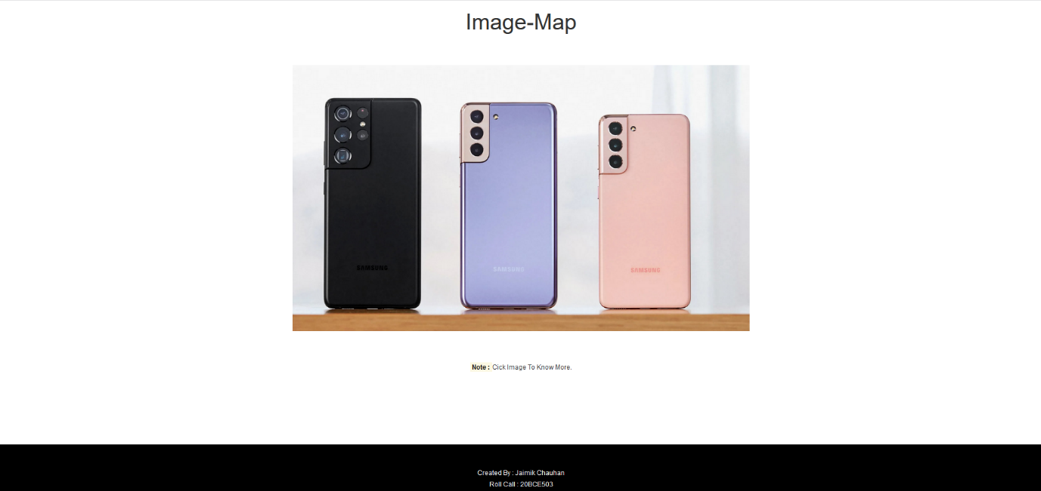

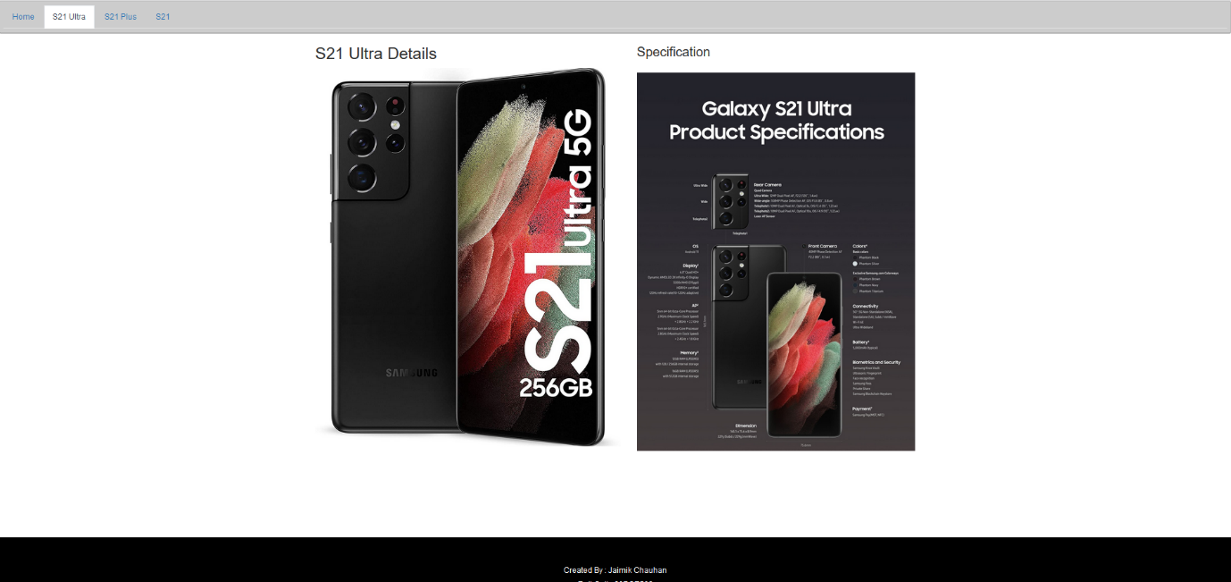

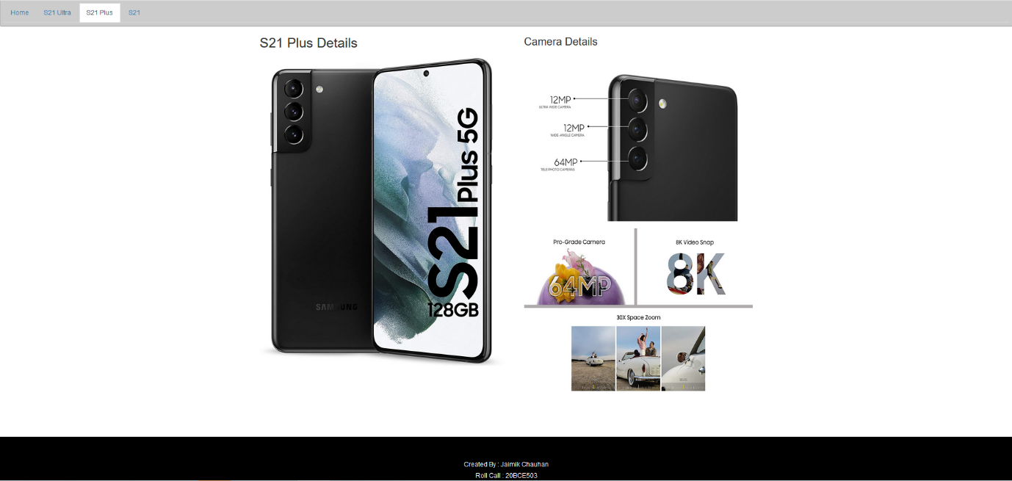

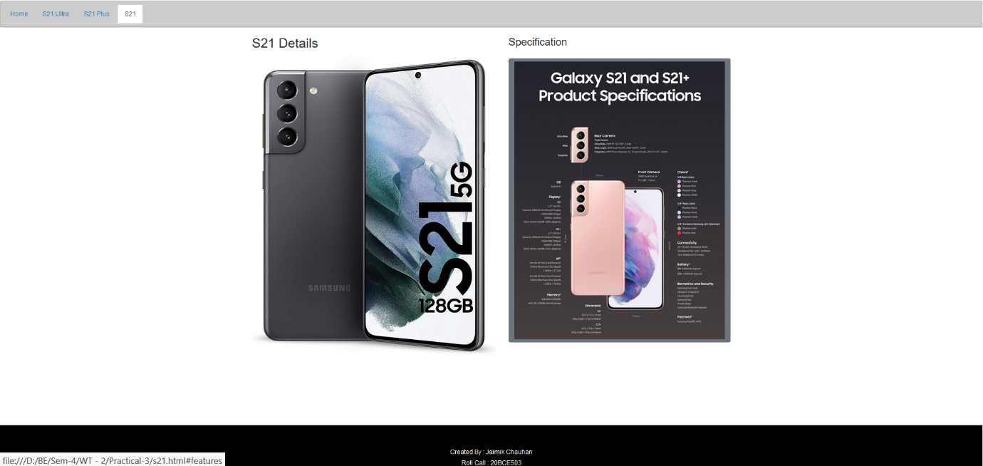

1. **Create a webpage for on-line student registration form using HTML**

* **form.css**

1. main {
2. border: 2px dashed black;
3. border-radius: 20px;
4. margin: 5%;
5. padding: 2%;
6. }
8. .bt {
9. text-align: center;
10. }
12. .margin {
13. margin: 1%;
14. }
16. footer a {
17. color: white;
18. }
20. footer img {
21. height: 20px;
22. width: 20px;
23. }
25. footer span {
26. margin: 6px;
27. display: block;
28. }
30. footer {
31. background-color: black;
32. color: white;
33. text-align: center;
34. padding: 2%;
35. width: auto;
36. margin-top: 8%;
37. }
39. h2 {
40. padding: 2%;
41. margin: 2%;
42. text-align: center;
43. background-color: black;
44. color: white;
45. }
47. @media only screen and (max-width: 400px) {
48. main {
49. padding: 5%;
50. }
51. }

* **Form.html**

1. <html>
3. <head>
4. <meta **name**="viewport" **content**="width=device-width, initial-scale=1">
5. <link **rel**="stylesheet" **href**="https://maxcdn.bootstrapcdn.com/bootstrap/4.5.2/css/bootstrap.min.css">
6. <script **src**="https://ajax.googleapis.com/ajax/libs/jquery/3.5.1/jquery.min.js"></script>
7. <script **src**="https://cdnjs.cloudflare.com/ajax/libs/popper.js/1.16.0/umd/popper.min.js"></script>
8. <script **src**="https://maxcdn.bootstrapcdn.com/bootstrap/4.5.2/js/bootstrap.min.js"></script>
9. <script **src**="https://ajax.googleapis.com/ajax/libs/jquery/3.5.1/jquery.min.js"></script>
10. <!-- Latest compiled and minified CSS -->
11. <link **rel**="stylesheet" **href**="https://maxcdn.bootstrapcdn.com/bootstrap/3.3.7/css/bootstrap.min.css"
12. **integrity**="sha384-BVYiiSIFeK1dGmJRAkycuHAHRg32OmUcww7on3RYdg4Va+PmSTsz/K68vbdEjh4u" **crossorigin**="anonymous">
14. <!-- Latest compiled and minified JavaScript -->
15. <script **src**="https://maxcdn.bootstrapcdn.com/bootstrap/3.3.7/js/bootstrap.min.js"
16. **integrity**="sha384-Tc5IQib027qvyjSMfHjOMaLkfuWVxZxUPnCJA7l2mCWNIpG9mGCD8wGNIcPD7Txa"
17. **crossorigin**="anonymous"></script>
18. <link **rel**="stylesheet" **href**="form.css" />
19. <meta **name**="viewport" **content**="width=device-width, initial-scale=1">
20. </head>
22. <body>
24. <main>
25. <h2>Student Registration Form</h2>
26. <hr **style**="background-color: black; color: black;" />
27. <form>
28. <div **class**="form-row margin">
29. <div **class**="col">
30. <div **class**="form-group">
31. <label **for**="exampleInputEmail1">First Name <span **style**="color: red;">*</span></label>
32. <input **type**="text" **class**="form-control" **id**="exampleInputEmail1" **aria-describedby**="emailHelp"
33. **placeholder**="Enter First Name" **required**>
34. </div>
35. </div>
36. <div **class**="col">
37. <div **class**="form-group">
38. <label **for**="exampleInputEmail1">Last Name <span **style**="color: red;">*</span></label>
39. <input **type**="text" **class**="form-control" **id**="exampleInputEmail1" **aria-describedby**="emailHelp"
40. **placeholder**="Enter Last Name" **required**>
41. </div>
42. </div>
43. </div>
45. <div **class**="form-group margin">
46. <label **for**="exampleInputEmail1">Enrollment-No <span **style**="color: red;">*</span></label>
47. <input **type**="text" **class**="form-control" **id**="exampleInputEmail1" **aria-describedby**="emailHelp"
48. **placeholder**="Enter Enrollment-No/ Roll-No" **required** />
49. </div>
51. <div **class**="Form-row margin">
52. <div **class**="col">
53. <div **class**="form-group">
54. <label **for**="exampleInputEmail1">Contact No:</label>
55. <input **type**="tel" **class**="form-control" **id**="exampleInputEmail1" **aria-describedby**="emailHelp"
56. **placeholder**="Enter Contact Number(India Only)" />
57. </div>
58. </div>
59. <div **class**="col">
60. <div **class**="form-group mb-3">
61. <label **for**="exampleInputEmail1">Mail-Id <span **style**="color: red;">*</span></label>
62. <input **type**="mail" **class**="form-control" **id**="exampleInputEmail1" **aria-describedby**="emailHelp"
63. **placeholder**="Enter Institute Mail-Id" **required** />
64. </div>
65. </div>
66. </div>
68. <div **class**="form-group margin">
69. <label **for**="exampleInputEmail1">Street Address</label>
70. <textarea **class**="form-control" **id**="exampleInputEmail1" **placeholder**="Enter Enrollment-No/ Roll-No">
71. </textarea>
72. </div>
74. <div **class**="Form-row margin">
75. <div **class**="col">
76. <div **class**="form-group">
77. <label **for**="exampleInputEmail1">Area</label>
78. <input **type**="text" **class**="form-control" **id**="exampleInputEmail1" **aria-describedby**="emailHelp"
79. **placeholder**="Enter Area" />
80. </div>
81. </div>
82. <div **class**="col">
83. <div **class**="form-group">
84. <label **for**="exampleInputEmail1">City</label>
85. <input **type**="text" **class**="form-control" **id**="exampleInputEmail1" **aria-describedby**="emailHelp"
86. **placeholder**="Enter City" />
87. </div>
88. </div>
89. <div **class**="col">
90. <div **class**="form-group">
91. <label **for**="exampleInputEmail1">State</label>
92. <input **type**="text" **class**="form-control" **id**="exampleInputEmail1" **aria-describedby**="emailHelp"
93. **placeholder**="Enter State" />
94. </div>
95. </div>
96. </div>
98. <div **class**="Form-row margin">
99. <div **class**="col">
101. <label>Gender</label>
102. <div **class**="form-check">
104. <input **class**="form-check-input" **type**="radio" **name**="gender" **id**="exampleRadios1" **value**="Male">
105. <label **class**="form-check-label" **for**="exampleRadios1" **style**="margin-left: 3%;">
106. Male
107. </label>
108. </div>
109. <div **class**="form-check">
110. <input **class**="form-check-input" **type**="radio" **name**="gender" **id**="exampleRadios2" **value**="Female">
111. <label **class**="form-check-label" **for**="exampleRadios2" **style**="margin-left: 3%;">
112. Female
113. </label>
114. </div>
115. </div>
116. <div **class**="col">
117. <div **class**="form-group col-md-4">
118. <label **for**="inputState">State</label>
119. <select **id**="inputState" **class**="form-control">
120. <option **selected**>Select Qualification</option>
121. <option **value**="SSC">SSC</option>
122. <option **value**="HSC">HSC</option>
123. <option **value**="Diploma">Diploma</option>
124. <option **value**="Degree">Degree</option>
125. <option **value**="Other">Other</option>
126. </select>
127. </div>
128. </div>
129. </div>
131. <label>Smartphone You're Interested In:</label>
132. <div **class**="col-auto" **style**="display: inline;">
133. <div **class**="form-check mb-2" **style**="display: inline;">
134. <input **class**="form-check-input" **type**="checkbox" **id**="autoSizingCheck">
135. <label **class**="form-check-label" **for**="autoSizingCheck" **style**="margin-left: 1.5%;">
136. S21
137. </label>
138. </div>
139. </div>
141. <div **class**="col-auto " **style**="display: inline;">
142. <div **class**="form-check mb-2" **style**="display: inline;">
143. <input **class**="form-check-input" **type**="checkbox" **id**="autoSizingCheck">
144. <label **class**="form-check-label" **for**="autoSizingCheck" **style**="margin-left: 1.5%;">
145. S21 Plus
146. </label>
147. </div>
148. </div>
149. <div **class**="col-auto" **style**="display: inline;">
150. <div **class**="form-check mb-2" **style**="display: inline;">
151. <input **class**="form-check-input" **type**="checkbox" **id**="autoSizingCheck">
152. <label **class**="form-check-label" **for**="autoSizingCheck" **style**="margin-left: 1.5%;">
153. S21 Ultra
154. </label>
155. </div>
156. </div>
158. <div **class**="form-group margin" **style**="margin-top: 2%;">
159. <label **for**="exampleInputEmail1">Twitter Username <span **style**="color: red;">*</span></label>
160. <input **type**="text" **class**="form-control" **id**="exampleInputEmail1" **aria-describedby**="emailHelp"
161. **placeholder**="Twitter Username (xyz)" **required** />
162. </div>
164. <div **class**="bt margin">
165. <button **class**="btn btn-primary">Submit</button>
166. </div>
167. </form>
168. </main>
169. <script>
171. $("button").click(function () {
172. console.log("response received")
173. alert('response received')
174. });
175. </script>
176. <footer>
177. <span>Created By : Jaimik Chauhan</span>
178. <span>Roll Call : <a **href**="mailto:20bce503@nirmauni.ac.in">20BCE503</a></span>
179. <a **class**="link" **href**="https://www.linkedin.com/in/jaimikchauhan64/"><img **src**="image-map/linkedin.png" />
180. </a>
181. <a **class**="link" **href**="https://github.com/jaimik64"><img **src**="image-map/GitHub-Mark-Light-32px.png" /></a>
183. <a **class**="link" **href**="https://twitter.com/Jaaimik"><img **src**="image-map/twitter.png" /></a>
184. </footer>
185. </body>
187. </html>

Output :

