

**INSTITUTE OF TECHNOLOGY,**

**NIRMA UNIVERSITY**

**2CSDE86 Application Development Framework**

**PRACTICAL 2**

**Name :** Jaimik S. Chauhan

**Roll No. :** 20BCE503

**Semester :** 7th

**Teacher’s Signature :**

**Aim : Hands on for understanding Django Project Structrue and Application Structure. Sample Hello World Webpage.**

1. Creating Project

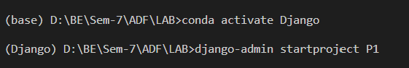

### Creating App



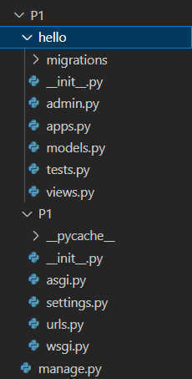

### Registering App with Settings.py

### 

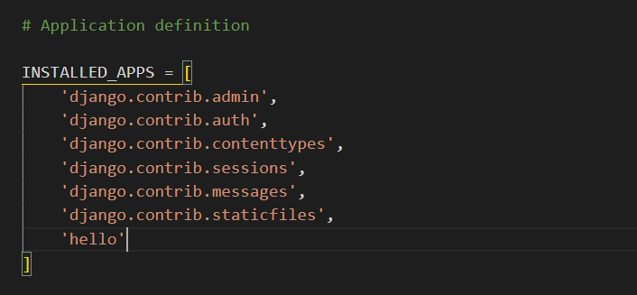

1. Editing **Hello/view.py** File

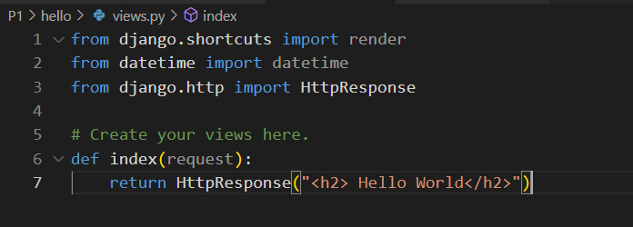

1. Editing **Hello/urls.py** File

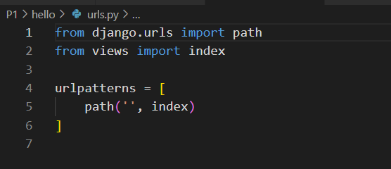

1. Editing **P1/Urls.Py** File, Including App’s URL File

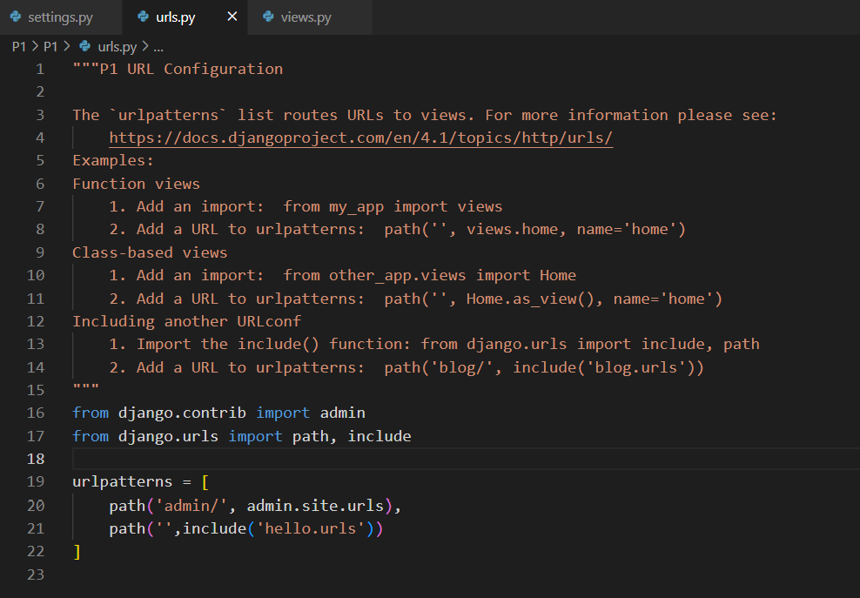

### Starting the Web Server

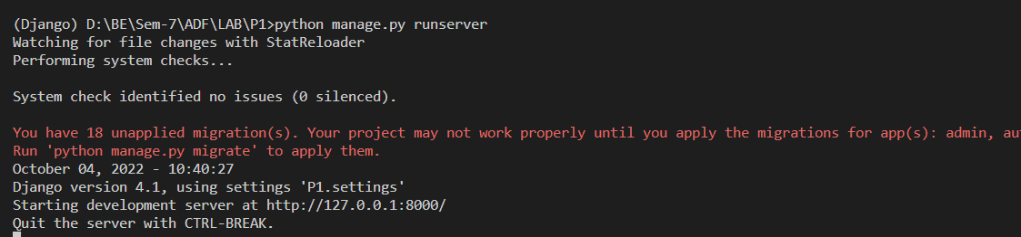

1. Home Page

