

**INSTITUTE OF TECHNOLOGY,**

**NIRMA UNIVERSITY**

**2CSDE86 Application Development Framework**

**PRACTICAL 3**

**Name :** Jaimik S. Chauhan

**Roll No. :** 20BCE503

**Semester :** 7th

**Teacher’s Signature :**

**Aim :**

Design model for a new social media platform registration

page using Django. Register the model to built-in admin app

of Django. Ensure appropriate fields are selected for the

registration page.

1. 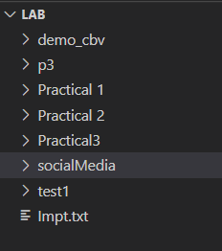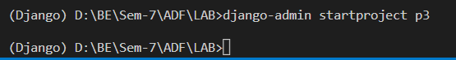Creating Project

### Creating App

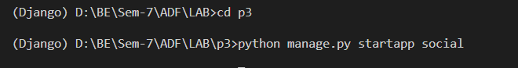

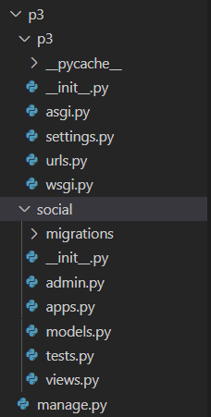

### Registering App with Settings.py

### 

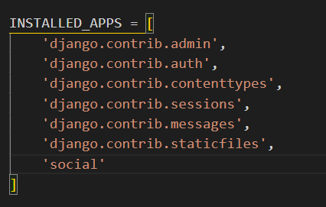

### Inside Newly Created App/Model.py, specify the Fields

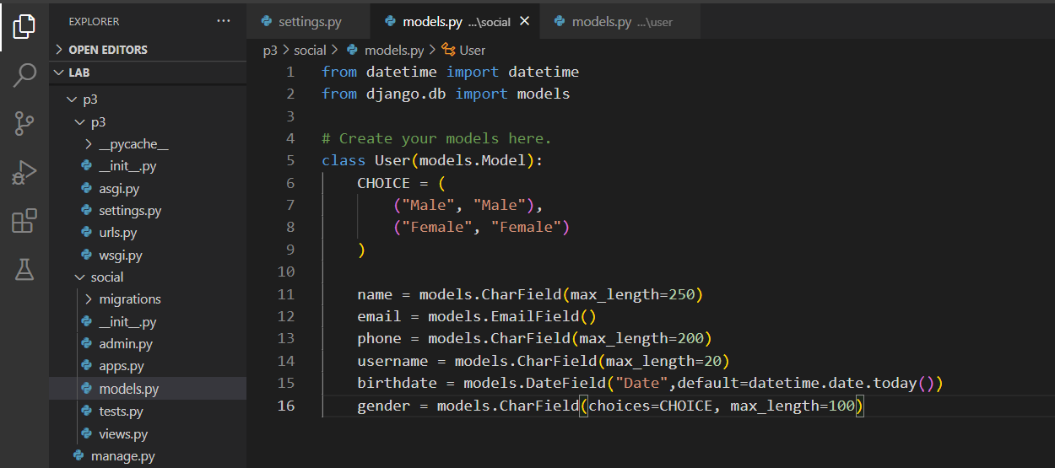

### Run MakeMigration Command

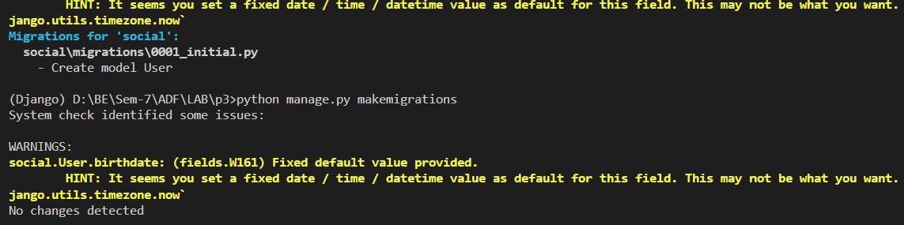

### Execute migrate

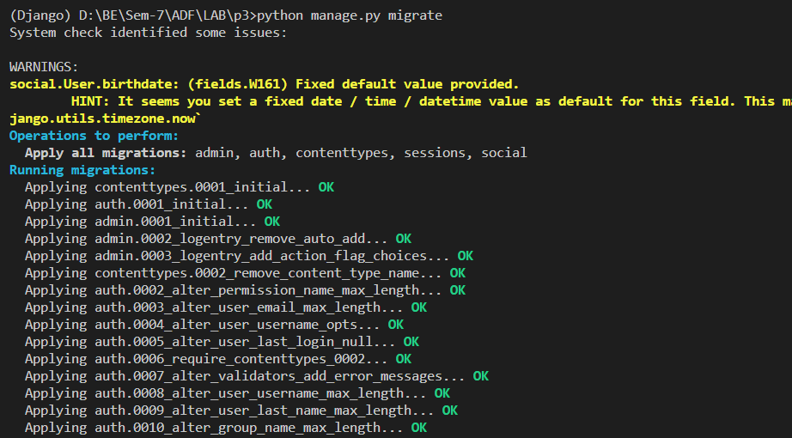

### SQLite File

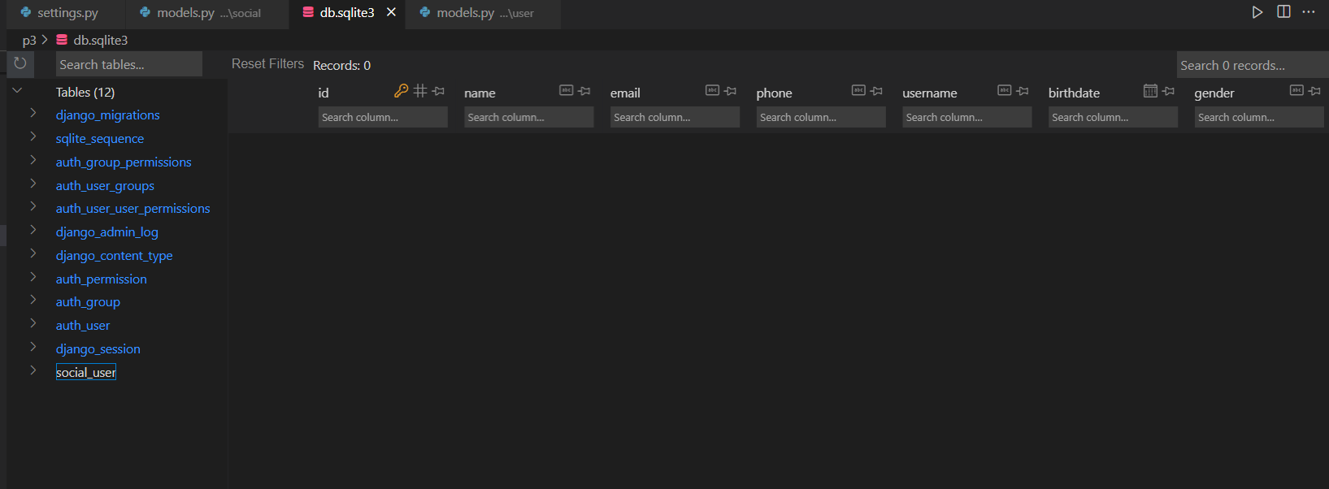

### Register Model with Admin.py

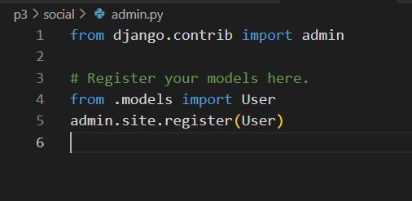

### Create Super user

### 

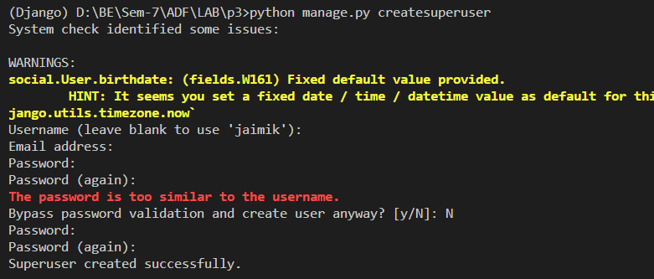

### Start the Server

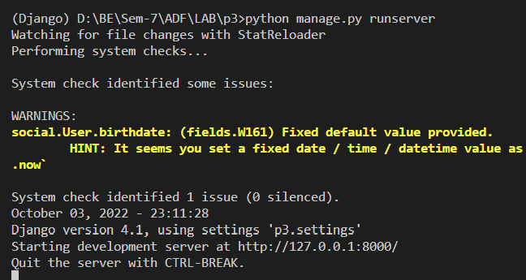

### Access Admin Interface, enter registered User Id and Password created in step-9

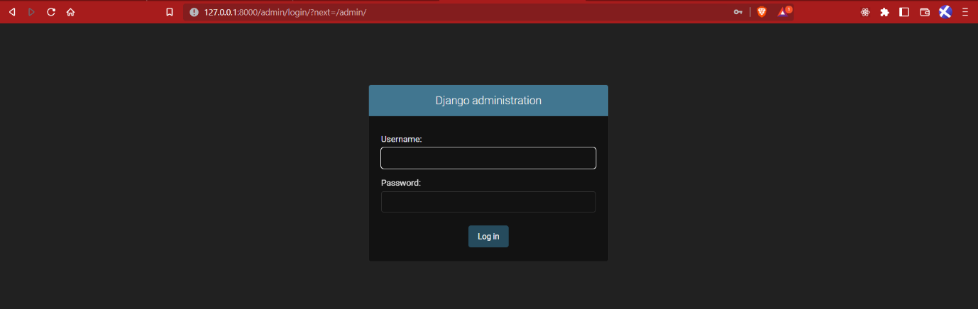

### Admin Home Page

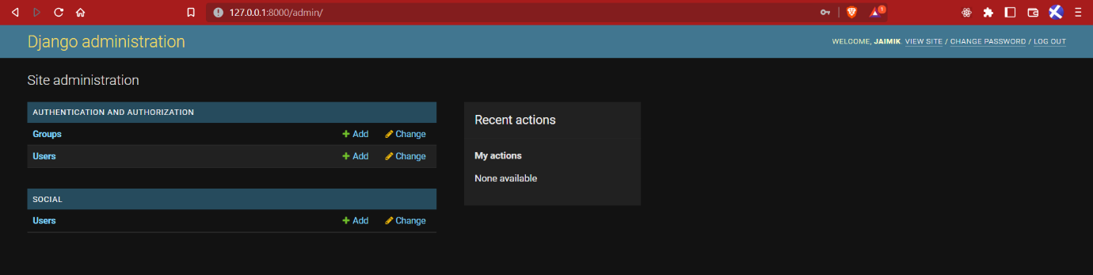

### Admin Add User Page

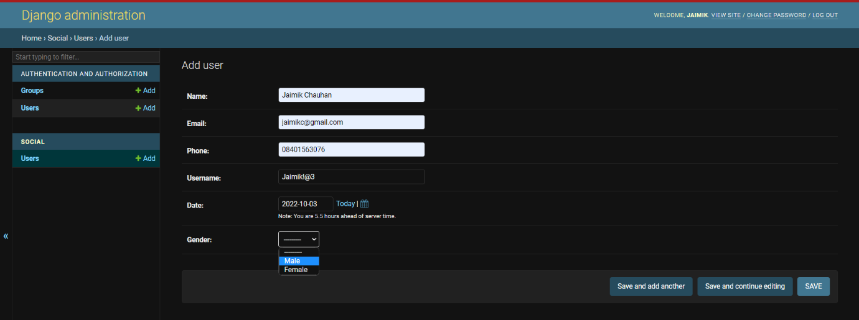

### Inserted Record

