STUDENT INFORMATION
Name | Jaimin Khambhaliya
Student ID | 25CE047
Subject Code | ITUE203
Subject | Web Development Frameworks
Department | CSPIT-CE
University | CHARUSAT

Aim
To understand the Document Object Model (DOM) and handle user events in the StudentHub web application so that page content can be read, created, updated and react to user actions without reloading the page.
Tools / Technology to be Used
- HTML5 pages with elements that can be selected and updated.
- JavaScript DOM APIs: getElementById and createElement.
- DOM properties innerText, innerHTML, value and className.
- Event handling with addEventListener for input, change, click and submit.
- Google Chrome Developer Tools (Console and Elements).
Theory : Core Concept of Practical
The DOM represents the HTML page as a tree of objects that JavaScript can read and modify. In this project JavaScript selects elements with getElementById, creates new elements with createElement and writes content using innerText and innerHTML. Events such as input, change, click and submit are attached with addEventListener so that the interface updates as the user interacts with it. The events page builds cards dynamically and the form scripts validate data live, which shows the DOM being updated at runtime.
Code
File: data/events.html
<!DOCTYPE html>
<html lang="en">
<head>
<meta charset="UTF-8">
<meta name="viewport" content="width=device-width, initial-scale=1.0">
<title>StudentHub Events</title>
<link rel="stylesheet" href="events.css">
</head>

<body>

<div id="header">
<h1 align="center">STUDENTHUB</h1>
</div>

<br>

<div class="header3" align="center">
<a href="../home.HTML"><button type="button">Home</button></a>
<a href="../profile.HTML"><button type="button">Profile</button></a>
<a href="../events.HTML"><button type="button">Events</button></a>
<a href="../Attendance.HTML"><button type="button">Attendance</button></a>
<a href="../result.HTML"><button type="button">Result</button></a>
<a href="../timetable.html"><button type="button">TimeTable</button></a>
<a href="../feedback.HTML"><button type="button">FeedBack</button></a>
</div>

<hr>

<br>

<div align="center">
<h2>Events</h2>

<input
type="text"
id="searchEvent"
placeholder="Search event"
>

<select id="categoryFilter">
<option value="all">All Categories</option>
<option value="Technical">Technical</option>
<option value="Sports">Sports</option>
<option value="Cultural">Cultural</option>
<option value="Workshop">Workshop</option>
<option value="Academic">Academic</option>
<option value="Career">Career</option>
</select>

<select id="sortEvent">
<option value="default">Sort By</option>
<option value="nameAsc">Name A-Z</option>
<option value="nameDesc">Name Z-A</option>
<option value="dateAsc">Date Oldest-Newest</option>
<option value="dateDesc">Date Newest-Oldest</option>
</select>
</div>

<br>

<div id="loading" align="center">
Loading events...
</div>

<div id="error" align="center"></div>

<div id="eventsContainer"></div>

<br>

<div align="center">
<button type="button" id="previousBtn">Previous</button>

<span id="pageNumber">Page 1</span>

<button type="button" id="nextBtn">Next</button>
</div>

<br><br>

<div align="center">
<a href="../home.HTML">
<button type="button">BACK</button>
</a>
</div>

<hr>

<footer align="center">
<h4>@ 2026 Jaimin Khambhaliya</h4>
</footer>

<script src="events.js"></script>

</body>
</html>
File: data/events.css
body {
margin: 0;
padding: 16px;
font-family: Calibri, Arial, sans-serif;
background-color: #ffffff;
}

#header {
border: rgb(13, 17, 17) solid 5px;
background-color: rgb(144, 164, 165);
}

#header h1 {
margin: 12px 0;
}

button {
text-align: center;
border: rgba(199, 160, 110, 0.637) solid 2px;
padding: 8px;
border-radius: 8px;
box-shadow: 2px 2px rgb(144, 164, 165);
background-color: #ffffff;
cursor: pointer;
}

button:disabled {
opacity: 0.5;
cursor: not-allowed;
}

input,
select {
padding: 6px 8px;
border: 2px solid rgb(144, 164, 165);
border-radius: 6px;
font-family: Calibri, Arial, sans-serif;
margin: 4px;
}

.card {
border: 3px solid rgb(17, 8, 8);
border-radius: 8px;
padding: 15px;
margin-bottom: 20px;
background-color: #eaf4fc;
width: 500px;
max-width: 90%;
box-shadow: 3px 3px 3px 3px rgb(97, 121, 124);
}

#eventsContainer {
display: flex;
flex-direction: column;
align-items: center;
margin-top: 10px;
}

#eventsContainer .card {
text-align: left;
}

#eventsContainer .card h3 {
margin-top: 0;
}

#loading,
#error {
font-weight: bold;
color: rgb(97, 121, 124);
min-height: 1px;
}

#pageNumber {
display: inline-block;
margin: 0 12px;
font-weight: bold;
}

footer h4 {
margin: 12px 0;
}

@media (max-width: 600px) {
.card {
width: 90%;
padding: 12px;
}

#header h1 {
font-size: 22px;
}
}
File: data/events.js
let events = [];
let filteredEvents = [];
let currentPage = 1;
const eventsPerPage = 5;

const container = document.getElementById("eventsContainer");
const loading = document.getElementById("loading");
const error = document.getElementById("error");
const searchEvent = document.getElementById("searchEvent");
const categoryFilter = document.getElementById("categoryFilter");
const sortEvent = document.getElementById("sortEvent");
const previousBtn = document.getElementById("previousBtn");
const nextBtn = document.getElementById("nextBtn");
const pageNumber = document.getElementById("pageNumber");

fetch("data/events.json")
.then(response => {
if (!response.ok) {
throw new Error("Unable to load events.");
}

return response.json();
})
.then(data => {
events = data;
filteredEvents = [...events];

loading.innerText = "";

displayEvents();
})
.catch(errorMessage => {
loading.innerText = "";
error.innerText = "Error loading events.";
console.log(errorMessage);
});

function displayEvents() {

container.innerHTML = "";

const start = (currentPage - 1) * eventsPerPage;
const end = start + eventsPerPage;

const pageEvents = filteredEvents.slice(start, end);

if (pageEvents.length === 0) {
container.innerHTML = "<p align='center'>No events found.</p>";
updatePagination();
return;
}

pageEvents.forEach(event => {

const div = document.createElement("div");

div.className = "card";

div.innerHTML = `
<h3>${event.name}</h3>
<p>Date: ${event.date}</p>
<p>Location: ${event.location}</p>
<p>Category: ${event.category}</p>
`;

container.appendChild(div);
});

updatePagination();
}

function applyFilters() {

const searchText = searchEvent.value.toLowerCase();
const category = categoryFilter.value;

filteredEvents = events.filter(event => {

const matchesSearch =
event.name.toLowerCase().includes(searchText) ||
event.location.toLowerCase().includes(searchText);

const matchesCategory =
category === "all" ||
event.category === category;

return matchesSearch && matchesCategory;
});

applySorting();

currentPage = 1;

displayEvents();
}

function applySorting() {

const sortValue = sortEvent.value;

if (sortValue === "nameAsc") {
filteredEvents.sort((a, b) =>
a.name.localeCompare(b.name)
);
}

else if (sortValue === "nameDesc") {
filteredEvents.sort((a, b) =>
b.name.localeCompare(a.name)
);
}

else if (sortValue === "dateAsc") {
filteredEvents.sort((a, b) =>
new Date(a.date) - new Date(b.date)
);
}

else if (sortValue === "dateDesc") {
filteredEvents.sort((a, b) =>
new Date(b.date) - new Date(a.date)
);
}
}

searchEvent.addEventListener("input", function() {
applyFilters();
});

categoryFilter.addEventListener("change", function() {
applyFilters();
});

sortEvent.addEventListener("change", function() {
applyFilters();
});

previousBtn.addEventListener("click", function() {

if (currentPage > 1) {
currentPage--;
displayEvents();
}

});

nextBtn.addEventListener("click", function() {

const totalPages = Math.ceil(
filteredEvents.length / eventsPerPage
);

if (currentPage < totalPages) {
currentPage++;
displayEvents();
}

});

function updatePagination() {

const totalPages = Math.ceil(
filteredEvents.length / eventsPerPage
);

pageNumber.innerText =
"Page " + currentPage + " of " + (totalPages || 1);

previousBtn.disabled = currentPage === 1;

nextBtn.disabled =
currentPage >= totalPages || totalPages === 0;
}
File: register.js
const form = document.getElementById("eventForm");

form.addEventListener("submit", function(event) {

event.preventDefault();

const name = document.getElementById("username").value.trim();
const studentId = document.getElementById("studentId").value.trim();
const email = document.getElementById("email").value.trim();
const phone = document.getElementById("phone").value.trim();
const eventName = document.getElementById("event").value;

const nameError = document.getElementById("nameError");
const idError = document.getElementById("idError");
const emailError = document.getElementById("emailError");
const phoneError = document.getElementById("phoneError");
const eventError = document.getElementById("eventError");

nameError.innerText = "";
idError.innerText = "";
emailError.innerText = "";
phoneError.innerText = "";
eventError.innerText = "";

let valid = true;

const namePattern = /^[A-Za-z ]+$/;

if (name === "") {

nameError.innerText = "Name is required.";
valid = false;

}
else if (!namePattern.test(name)) {

nameError.innerText =
"Name can contain only alphabets and spaces.";

valid = false;
}

const idPattern = /^[0-9]{2}[A-Z]{2}[0-9]{3}$/;

if (studentId === "") {

idError.innerText = "Student ID is required.";
valid = false;

}
else if (!idPattern.test(studentId)) {

idError.innerText =
"Invalid ID. Example: 25CE047";

valid = false;
}

const emailPattern =
/^[^\s@]+@[^\s@]+\.[^\s@]+$/;

if (email === "") {

emailError.innerText = "Email is required.";
valid = false;

}
else if (!emailPattern.test(email)) {

emailError.innerText =
"Please enter a valid email address.";

valid = false;
}

const phonePattern = /^[0-9]{10}$/;

if (phone === "") {

phoneError.innerText =
"Phone number is required.";

valid = false;

}
else if (!phonePattern.test(phone)) {

phoneError.innerText =
"Phone number must contain exactly 10 digits.";

valid = false;
}

if (eventName === "") {

eventError.innerText =
"Please select an event.";

valid = false;
}

if (valid) {

alert("Event participation successful!");

form.reset();

}

});
Output
The styled events page with dynamically generated event cards, and the registration form whose messages are written into the page by JavaScript when the form is submitted.
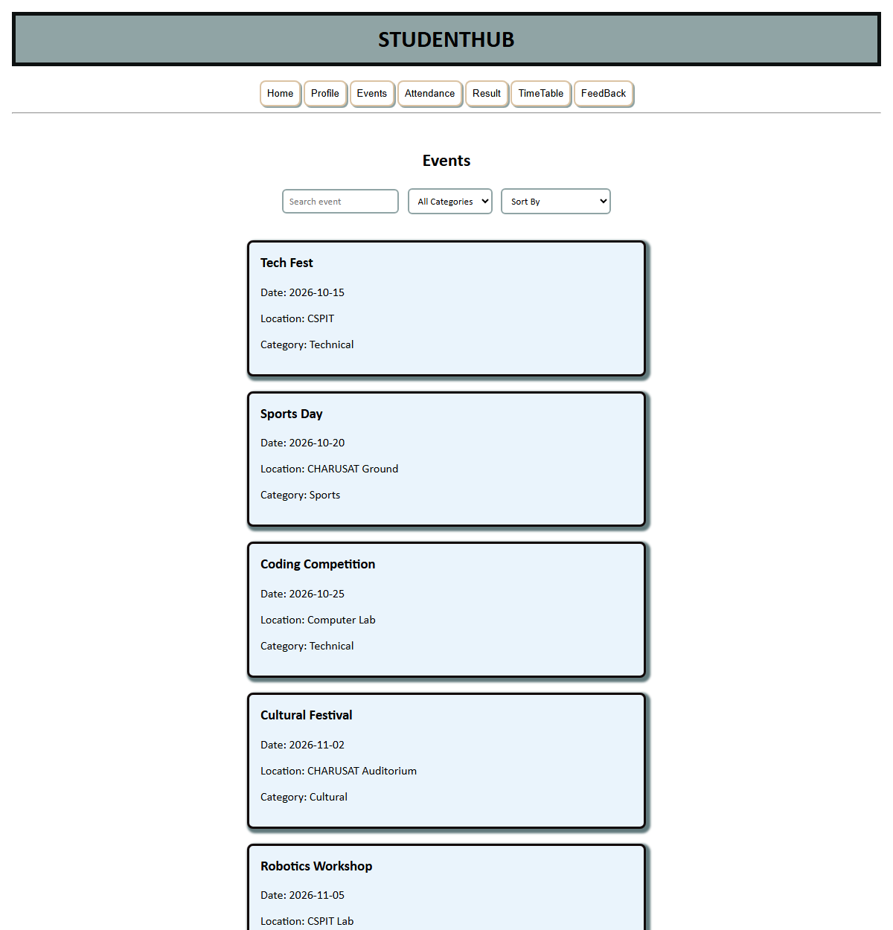
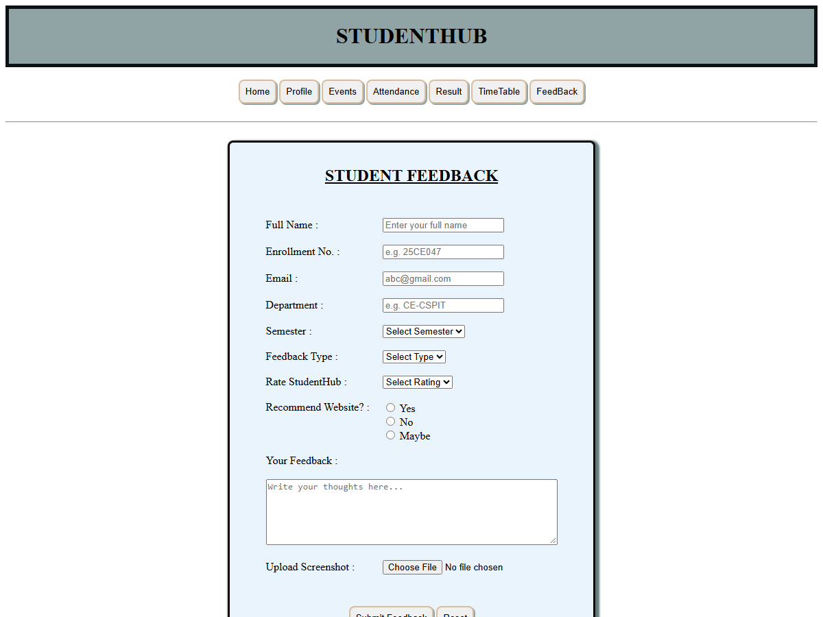
Question - Answer
Q: What is the DOM?
A: The DOM (Document Object Model) is a tree-like representation of an HTML page. JavaScript uses it to access and change elements, attributes and text after the page has loaded.
Q: What is the difference between innerText and innerHTML?
A: innerText works with the visible text content of an element, while innerHTML works with the raw HTML markup inside an element, so innerHTML can create new elements and tags.
Q: What is an event listener?
A: An event listener is a function registered with addEventListener that is executed when a specific event such as click, input, change or submit occurs on an element.
Q: How are new elements added to the page in this project?
A: The script creates a new element with document.createElement, fills it using innerHTML and then attaches it to the page with appendChild, so the cards appear without a page reload.
Conclusion
The project demonstrates the working of the DOM and events: elements are selected, new elements are created and content is updated in response to user actions. This confirms how JavaScript can make a web page interactive without reloading it.

