STUDENT INFORMATION
Name | Jaimin Khambhaliya
Student ID | 25CE047
Subject Code | ITUE203
Subject | Web Development Frameworks
Department | CSPIT-CE
University | CHARUSAT

Aim
To fetch event data from a JSON file using the JavaScript Fetch API and display it dynamically with search, category filter, sorting and pagination in the StudentHub events page.
Tools / Technology to be Used
- HTML5 page with search input, filter and sort select boxes and pagination buttons.
- JavaScript Fetch API with a promise chain (then / catch).
- JSON data stored in events.json.
- Array methods filter, sort and slice with the spread operator.
- DOM rendering using createElement, innerHTML and appendChild.
- Google Chrome browser and Developer Tools Network tab.
Theory : Core Concept of Practical
The Fetch API is used to request data from a server or local file and work with the response asynchronously. In this project fetch("data/events.json") returns a promise; the first then reads response.json() and the second then stores the array and renders the cards, while catch displays an error if the request fails. The applyFilters function uses the filter method to match the search text and category, applySorting orders the list, and slice with a page size of five shows one page at a time. Pagination buttons change the current page and updatePagination keeps the labels and button states correct.
Code
File: data/events.html
<!DOCTYPE html>
<html lang="en">
<head>
<meta charset="UTF-8">
<meta name="viewport" content="width=device-width, initial-scale=1.0">
<title>StudentHub Events</title>
<link rel="stylesheet" href="events.css">
</head>

<body>

<div id="header">
<h1 align="center">STUDENTHUB</h1>
</div>

<br>

<div class="header3" align="center">
<a href="../home.HTML"><button type="button">Home</button></a>
<a href="../profile.HTML"><button type="button">Profile</button></a>
<a href="../events.HTML"><button type="button">Events</button></a>
<a href="../Attendance.HTML"><button type="button">Attendance</button></a>
<a href="../result.HTML"><button type="button">Result</button></a>
<a href="../timetable.html"><button type="button">TimeTable</button></a>
<a href="../feedback.HTML"><button type="button">FeedBack</button></a>
</div>

<hr>

<br>

<div align="center">
<h2>Events</h2>

<input
type="text"
id="searchEvent"
placeholder="Search event"
>

<select id="categoryFilter">
<option value="all">All Categories</option>
<option value="Technical">Technical</option>
<option value="Sports">Sports</option>
<option value="Cultural">Cultural</option>
<option value="Workshop">Workshop</option>
<option value="Academic">Academic</option>
<option value="Career">Career</option>
</select>

<select id="sortEvent">
<option value="default">Sort By</option>
<option value="nameAsc">Name A-Z</option>
<option value="nameDesc">Name Z-A</option>
<option value="dateAsc">Date Oldest-Newest</option>
<option value="dateDesc">Date Newest-Oldest</option>
</select>
</div>

<br>

<div id="loading" align="center">
Loading events...
</div>

<div id="error" align="center"></div>

<div id="eventsContainer"></div>

<br>

<div align="center">
<button type="button" id="previousBtn">Previous</button>

<span id="pageNumber">Page 1</span>

<button type="button" id="nextBtn">Next</button>
</div>

<br><br>

<div align="center">
<a href="../home.HTML">
<button type="button">BACK</button>
</a>
</div>

<hr>

<footer align="center">
<h4>@ 2026 Jaimin Khambhaliya</h4>
</footer>

<script src="events.js"></script>

</body>
</html>
File: data/events.css
body {
margin: 0;
padding: 16px;
font-family: Calibri, Arial, sans-serif;
background-color: #ffffff;
}

#header {
border: rgb(13, 17, 17) solid 5px;
background-color: rgb(144, 164, 165);
}

#header h1 {
margin: 12px 0;
}

button {
text-align: center;
border: rgba(199, 160, 110, 0.637) solid 2px;
padding: 8px;
border-radius: 8px;
box-shadow: 2px 2px rgb(144, 164, 165);
background-color: #ffffff;
cursor: pointer;
}

button:disabled {
opacity: 0.5;
cursor: not-allowed;
}

input,
select {
padding: 6px 8px;
border: 2px solid rgb(144, 164, 165);
border-radius: 6px;
font-family: Calibri, Arial, sans-serif;
margin: 4px;
}

.card {
border: 3px solid rgb(17, 8, 8);
border-radius: 8px;
padding: 15px;
margin-bottom: 20px;
background-color: #eaf4fc;
width: 500px;
max-width: 90%;
box-shadow: 3px 3px 3px 3px rgb(97, 121, 124);
}

#eventsContainer {
display: flex;
flex-direction: column;
align-items: center;
margin-top: 10px;
}

#eventsContainer .card {
text-align: left;
}

#eventsContainer .card h3 {
margin-top: 0;
}

#loading,
#error {
font-weight: bold;
color: rgb(97, 121, 124);
min-height: 1px;
}

#pageNumber {
display: inline-block;
margin: 0 12px;
font-weight: bold;
}

footer h4 {
margin: 12px 0;
}

@media (max-width: 600px) {
.card {
width: 90%;
padding: 12px;
}

#header h1 {
font-size: 22px;
}
}
File: data/events.js
let events = [];
let filteredEvents = [];
let currentPage = 1;
const eventsPerPage = 5;

const container = document.getElementById("eventsContainer");
const loading = document.getElementById("loading");
const error = document.getElementById("error");
const searchEvent = document.getElementById("searchEvent");
const categoryFilter = document.getElementById("categoryFilter");
const sortEvent = document.getElementById("sortEvent");
const previousBtn = document.getElementById("previousBtn");
const nextBtn = document.getElementById("nextBtn");
const pageNumber = document.getElementById("pageNumber");

fetch("data/events.json")
.then(response => {
if (!response.ok) {
throw new Error("Unable to load events.");
}

return response.json();
})
.then(data => {
events = data;
filteredEvents = [...events];

loading.innerText = "";

displayEvents();
})
.catch(errorMessage => {
loading.innerText = "";
error.innerText = "Error loading events.";
console.log(errorMessage);
});

function displayEvents() {

container.innerHTML = "";

const start = (currentPage - 1) * eventsPerPage;
const end = start + eventsPerPage;

const pageEvents = filteredEvents.slice(start, end);

if (pageEvents.length === 0) {
container.innerHTML = "<p align='center'>No events found.</p>";
updatePagination();
return;
}

pageEvents.forEach(event => {

const div = document.createElement("div");

div.className = "card";

div.innerHTML = `
<h3>${event.name}</h3>
<p>Date: ${event.date}</p>
<p>Location: ${event.location}</p>
<p>Category: ${event.category}</p>
`;

container.appendChild(div);
});

updatePagination();
}

function applyFilters() {

const searchText = searchEvent.value.toLowerCase();
const category = categoryFilter.value;

filteredEvents = events.filter(event => {

const matchesSearch =
event.name.toLowerCase().includes(searchText) ||
event.location.toLowerCase().includes(searchText);

const matchesCategory =
category === "all" ||
event.category === category;

return matchesSearch && matchesCategory;
});

applySorting();

currentPage = 1;

displayEvents();
}

function applySorting() {

const sortValue = sortEvent.value;

if (sortValue === "nameAsc") {
filteredEvents.sort((a, b) =>
a.name.localeCompare(b.name)
);
}

else if (sortValue === "nameDesc") {
filteredEvents.sort((a, b) =>
b.name.localeCompare(a.name)
);
}

else if (sortValue === "dateAsc") {
filteredEvents.sort((a, b) =>
new Date(a.date) - new Date(b.date)
);
}

else if (sortValue === "dateDesc") {
filteredEvents.sort((a, b) =>
new Date(b.date) - new Date(a.date)
);
}
}

searchEvent.addEventListener("input", function() {
applyFilters();
});

categoryFilter.addEventListener("change", function() {
applyFilters();
});

sortEvent.addEventListener("change", function() {
applyFilters();
});

previousBtn.addEventListener("click", function() {

if (currentPage > 1) {
currentPage--;
displayEvents();
}

});

nextBtn.addEventListener("click", function() {

const totalPages = Math.ceil(
filteredEvents.length / eventsPerPage
);

if (currentPage < totalPages) {
currentPage++;
displayEvents();
}

});

function updatePagination() {

const totalPages = Math.ceil(
filteredEvents.length / eventsPerPage
);

pageNumber.innerText =
"Page " + currentPage + " of " + (totalPages || 1);

previousBtn.disabled = currentPage === 1;

nextBtn.disabled =
currentPage >= totalPages || totalPages === 0;
}
File: data/events.json
[
{
"id": 1,
"name": "Tech Fest",
"date": "2026-10-15",
"location": "CSPIT",
"category": "Technical"
},
{
"id": 2,
"name": "Sports Day",
"date": "2026-10-20",
"location": "CHARUSAT Ground",
"category": "Sports"
},
{
"id": 3,
"name": "Coding Competition",
"date": "2026-10-25",
"location": "Computer Lab",
"category": "Technical"
},
{
"id": 4,
"name": "Cultural Festival",
"date": "2026-11-02",
"location": "CHARUSAT Auditorium",
"category": "Cultural"
},
{
"id": 5,
"name": "Robotics Workshop",
"date": "2026-11-05",
"location": "CSPIT Lab",
"category": "Workshop"
},
{
"id": 6,
"name": "Web Development Workshop",
"date": "2026-11-10",
"location": "CSPIT Lab",
"category": "Workshop"
},
{
"id": 7,
"name": "Hackathon",
"date": "2026-11-15",
"location": "Innovation Center",
"category": "Technical"
},
{
"id": 8,
"name": "Photography Contest",
"date": "2026-11-18",
"location": "CHARUSAT Campus",
"category": "Cultural"
},
{
"id": 9,
"name": "Football Tournament",
"date": "2026-11-20",
"location": "CHARUSAT Ground",
"category": "Sports"
},
{
"id": 10,
"name": "AI Seminar",
"date": "2026-11-25",
"location": "Auditorium",
"category": "Technical"
},
{
"id": 11,
"name": "Quiz Competition",
"date": "2026-12-01",
"location": "CSPIT Hall",
"category": "Academic"
},
{
"id": 12,
"name": "Career Guidance",
"date": "2026-12-05",
"location": "Seminar Hall",
"category": "Career"
},
{
"id": 13,
"name": "Java Workshop",
"date": "2026-12-10",
"location": "Computer Lab",
"category": "Workshop"
},
{
"id": 14,
"name": "Annual Function",
"date": "2026-12-15",
"location": "CHARUSAT Auditorium",
"category": "Cultural"
},
{
"id": 15,
"name": "Project Exhibition",
"date": "2026-12-20",
"location": "CSPIT Exhibition Hall",
"category": "Academic"
}
]
Output
The styled events page showing loaded cards, the search result, the category filter, a sorted list, the next page and the error message when the JSON cannot be loaded.
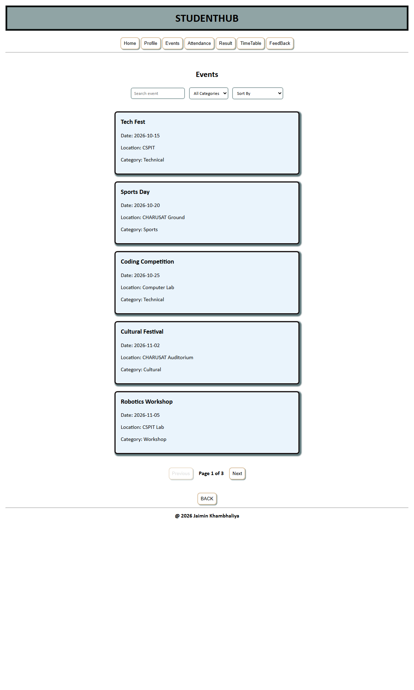
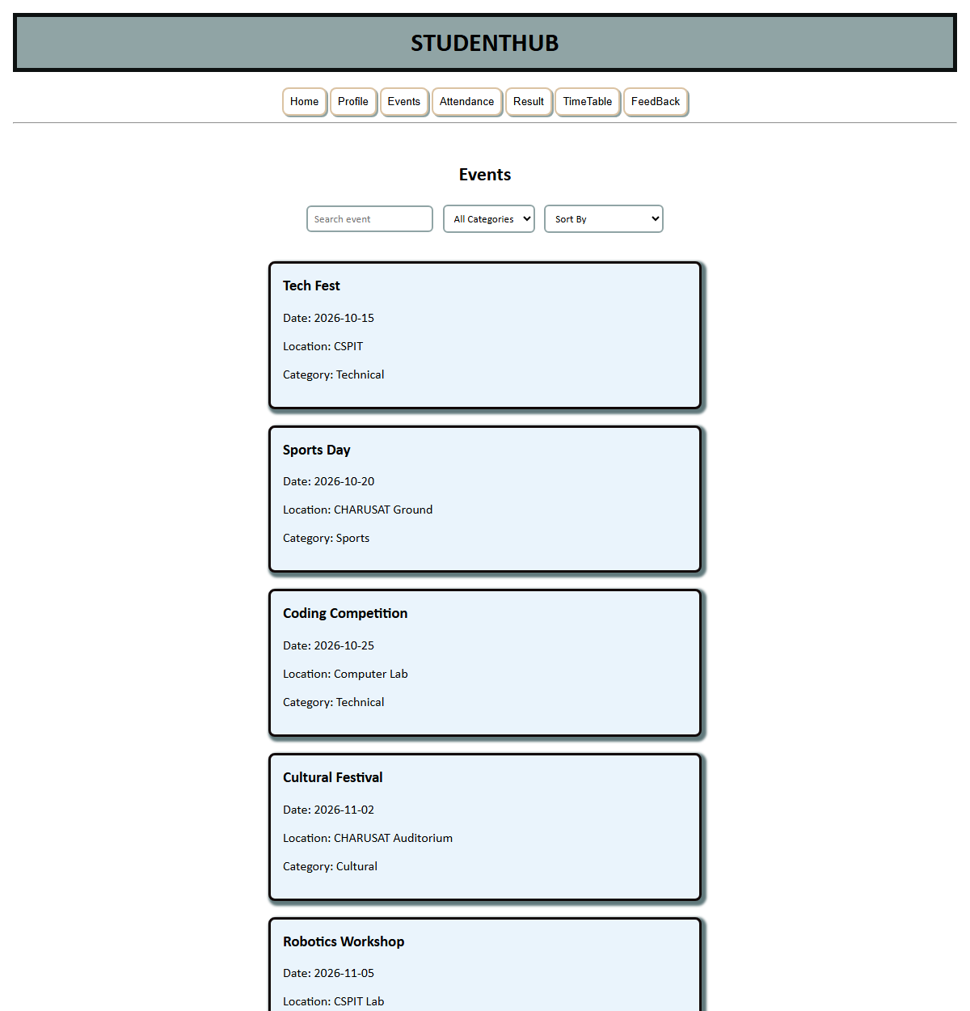
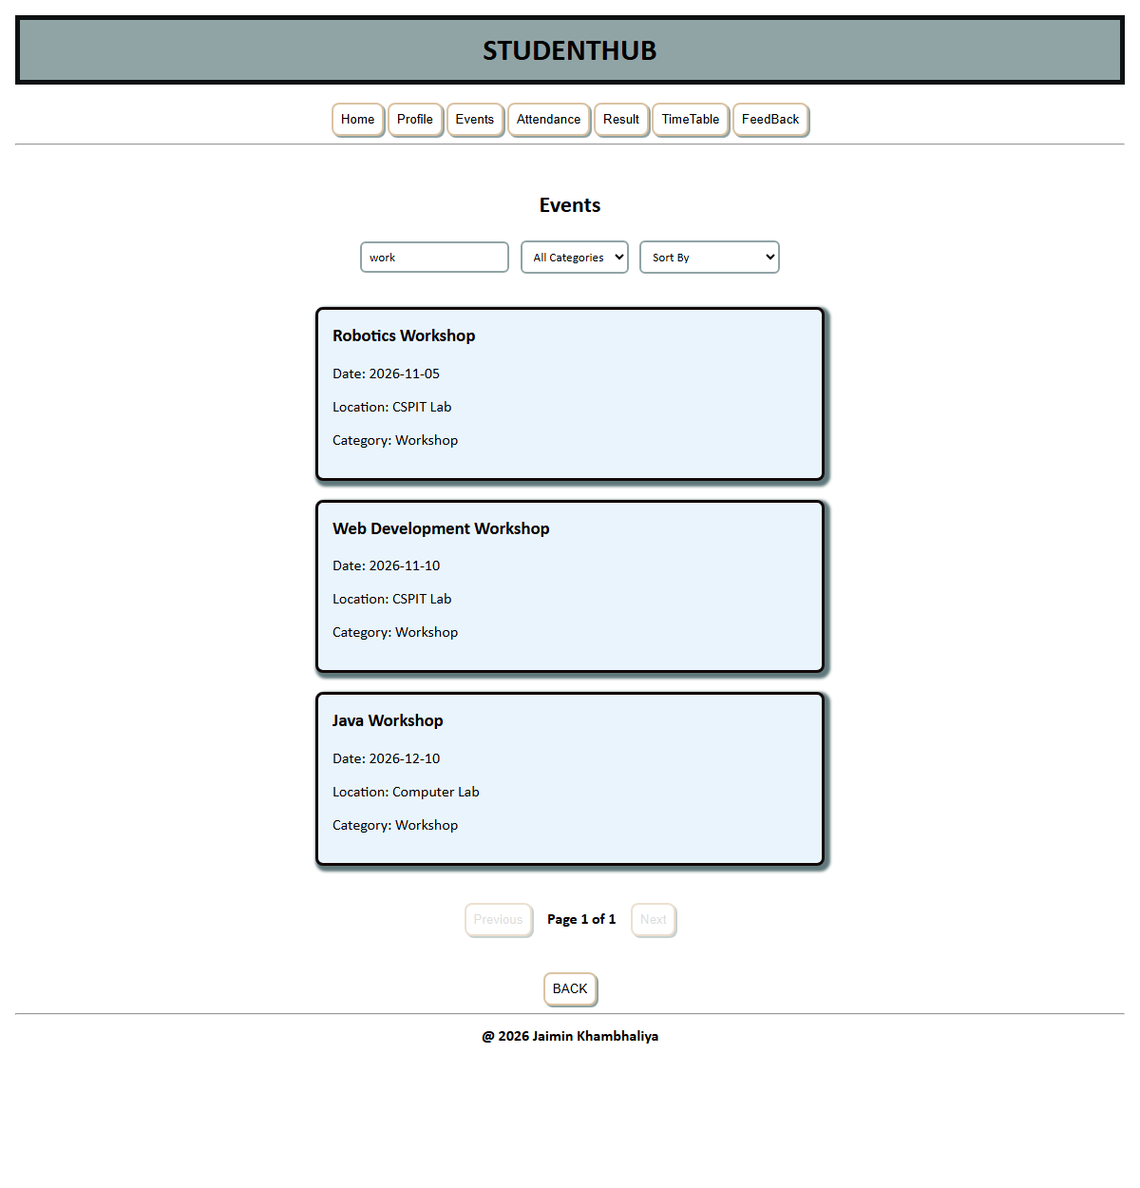
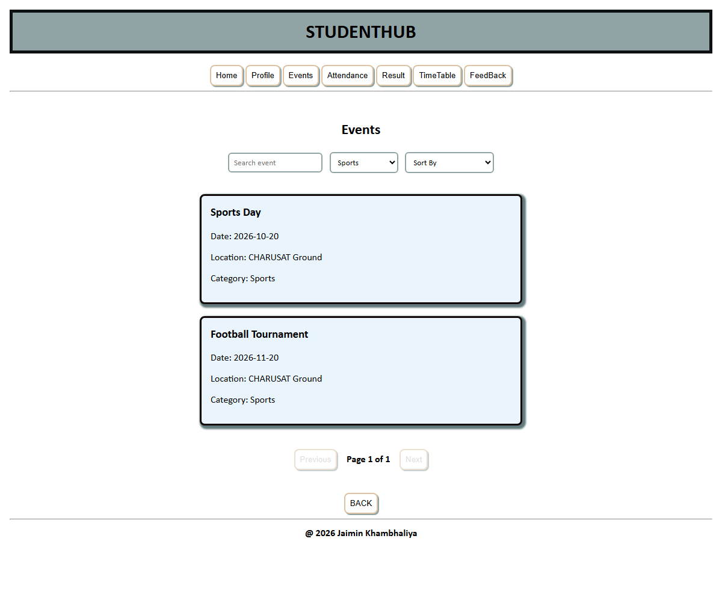
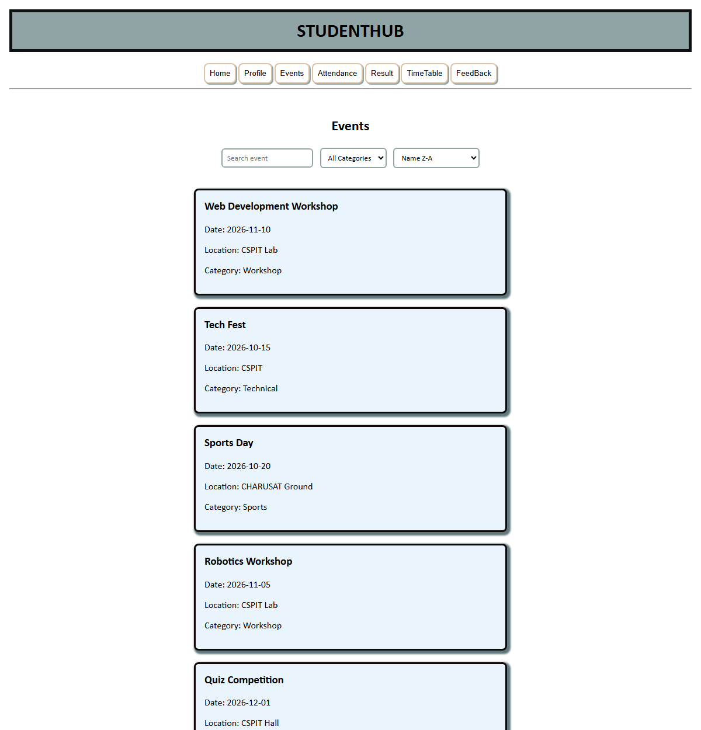

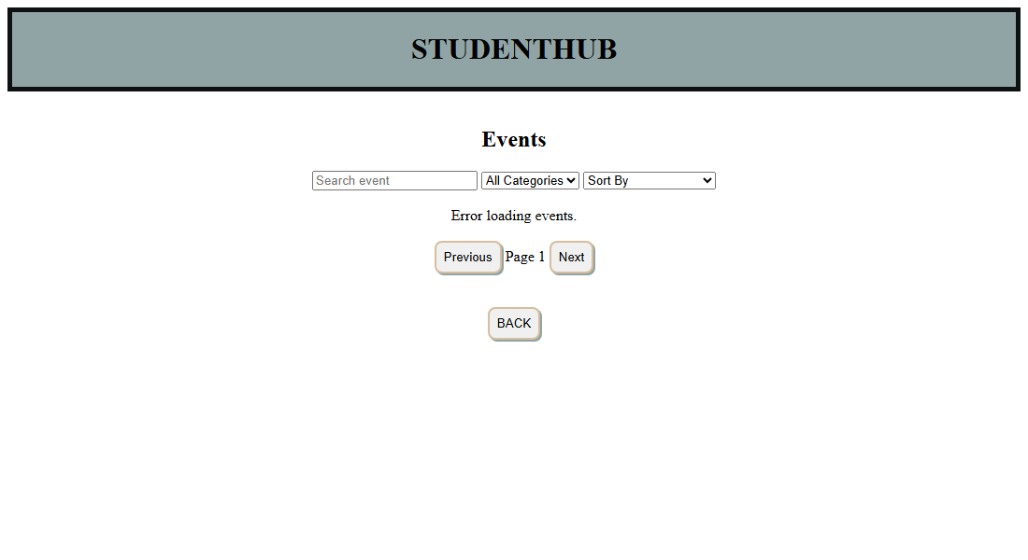
Question - Answer
Q: What is the Fetch API?
A: The Fetch API is a modern JavaScript interface used to make network requests. It returns a promise that resolves to a Response object, which can then be converted to JSON or text.
Q: What is the role of the then and catch methods here?
A: then methods handle the successful steps, first reading the response as JSON and then rendering the data, while catch handles any error that occurs during the request.
Q: How is the search implemented?
A: The input event calls applyFilters, which uses the filter method to keep only those events whose name or location contains the typed text, then re-renders the first page.
Q: How is sorting performed?
A: The sort select calls applySorting, which uses the sort method with localeCompare for name order and with Date objects for date order, in either ascending or descending direction.
Q: How is pagination achieved?
A: The page size is five, and the slice method returns only the records for the current page. The next and previous buttons change the page number and updatePagination updates the label and disables the buttons at the limits.
Conclusion
The events page successfully loads JSON data with the Fetch API and displays it dynamically. Search, category filter, sorting and pagination all work together, and the error state is handled by catch, showing how asynchronous data can be presented in a web page.

