STUDENT INFORMATION
Name | Jaimin Khambhaliya
Student ID | 25CE047
Subject Code | ITUE203
Subject | Web Development Frameworks
Department | CSPIT-CE
University | CHARUSAT

Aim
To design a responsive user interface for the StudentHub web application using HTML5 and a shared external CSS file so that the same pages adapt to desktop, tablet and mobile screen sizes.
Tools / Technology to be Used
- HTML5 for page structure and semantic layout.
- CSS3 through a single shared external stylesheet (style.css).
- A responsive <meta name="viewport"> tag on every page.
- Google Chrome browser and browser Developer Tools (device toolbar).
Theory : Core Concept of Practical
A responsive web interface shows the same content comfortably on different screen sizes. In this project every page declares the viewport meta tag so the browser maps the layout to the device width, and all pages link the same external file style.css, which keeps the visual design consistent and maintainable. The reused "card" and button classes control borders, colours, padding and shadows across the whole site. The pages therefore render correctly on desktop, tablet and mobile widths without rewriting each page separately.
Code
File: home.HTML
<!DOCTYPE html>
<html lang="en">
<head>
<meta charset="UTF-8">
<meta name="viewport" content="width=device-width, initial-scale=1.0">
<title>Document</title>
<link rel="stylesheet" href="style.css">

</head>
<body>

<div id="header">
<h1 align="center">
STUDENTHUB
</h1>
</div>

<br>
<div class="main-content">
<div align="center">

<tr>

<a href="home.HTML"><td><button>Home</button></td></a>
<a href="profile.HTML"><td><button>Profile</button></td></a>
<a href="events.HTML"><td><button>Events</button></td></a>
<a href="Attendance.HTML"><td><button>Attendance</button></td></a>
<a href="result.HTML"><td><button>Result</button></td></a>
<a href="timetable.html"><td><button>TimeTable</button></td></a>
<a href="feedback.HTML"><td><button>FeedBack</button></td></a>
<a href="login.HTML"><td><button>Logout</button></td></a>

<td></td><td></td><td></td><td></td>

</tr>

</div>
<br>
<hr>

<u><h2 align="center">Welcome to Student Hub Portal</h2></u>

<ul>
<li>
<p>StudentHub is designed to help students stay connected with their academic journey. Access your profile, check examination results, explore upcoming events, and receive important college announcements—all from one place.</p>

</li>
</ul>

<br></br>

<br></br>
<hr>
<br></br>
<br></br>

<footer align="center">
<h4>@ 2026 jaimin khambhaliya</h4>
</footer>
<h1 align="center">-----------</h1>
</div>

</body>
</html>
File: style.css
#header {
border: rgb(13, 17, 17) solid 5px;
background-color: rgb(144, 164, 165);
}

.header3
{
text-align: center;
padding: 8px;

}

button {
text-align: center;
border: rgba(199, 160, 110, 0.637) solid 2px;
padding: 8px;
border-radius: 8px;
box-shadow: 2px 2px rgb(144, 164, 165);

}

.card {
border: 3px solid rgb(17, 8, 8);
border-radius: 8px;
padding: 15px;
margin-bottom: 20px;
background-color: #eaf4fc;
width: 500px;
box-shadow: 3px 3px 3px 3px rgb(97, 121, 124);

}

.form-table td {
padding: 8px;
text-align: left;
}

#nav ul
{
nav ul a
{
display: inline-block;
}
}
Output
Home page at desktop, tablet and mobile widths, plus the other shared-layout pages that reuse the same stylesheet.
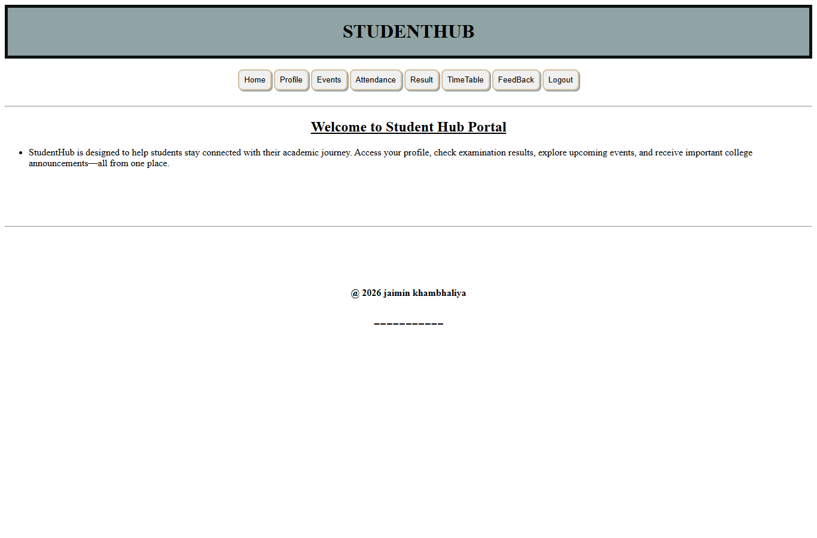
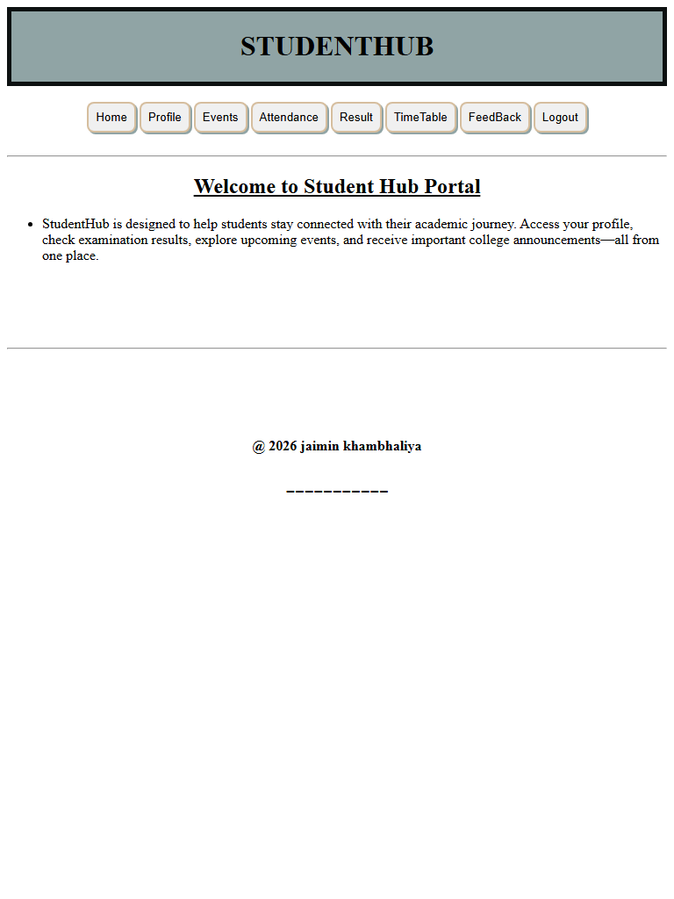
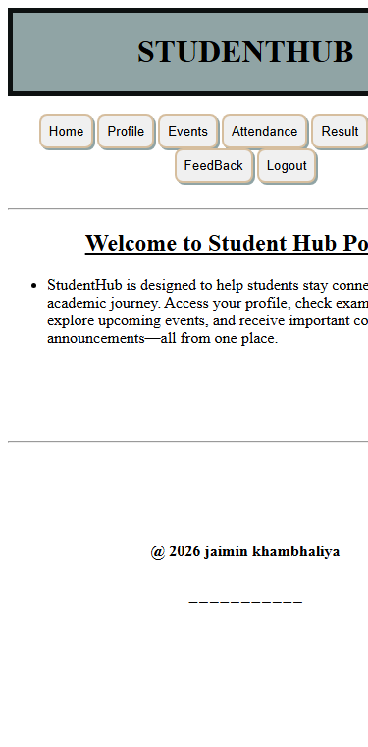
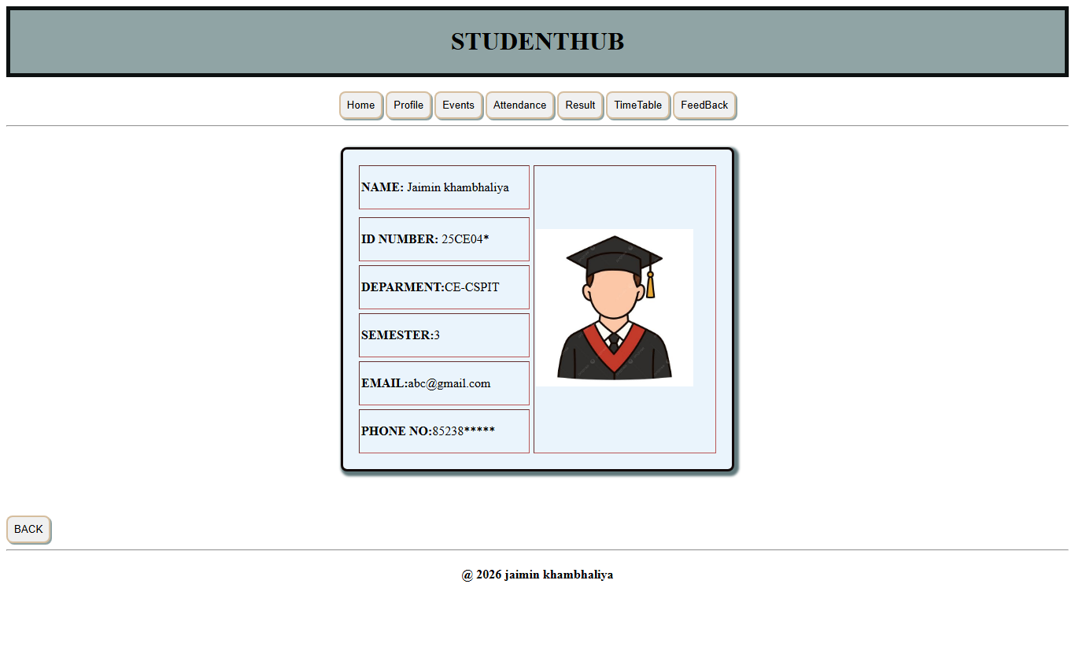
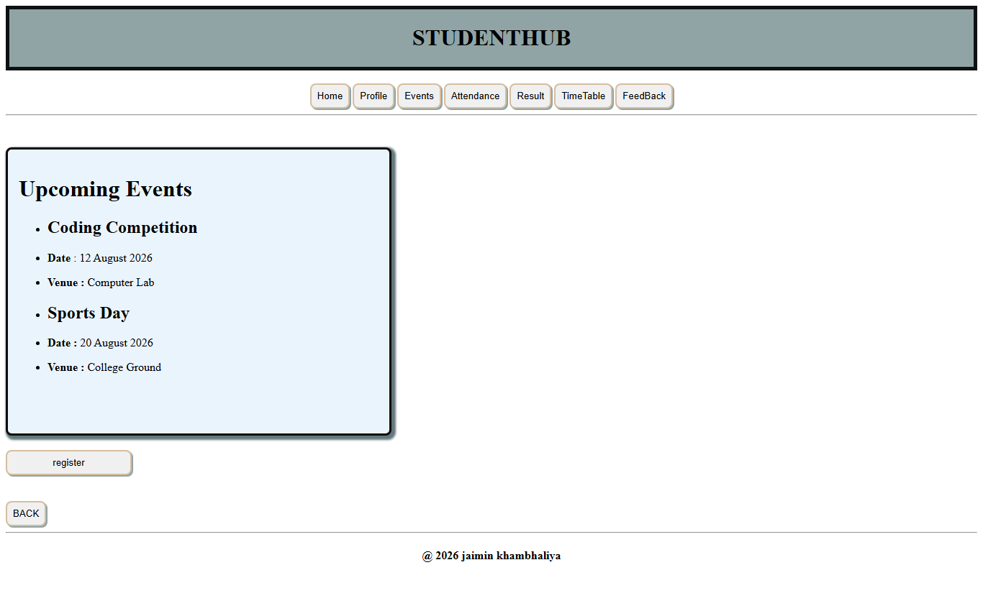
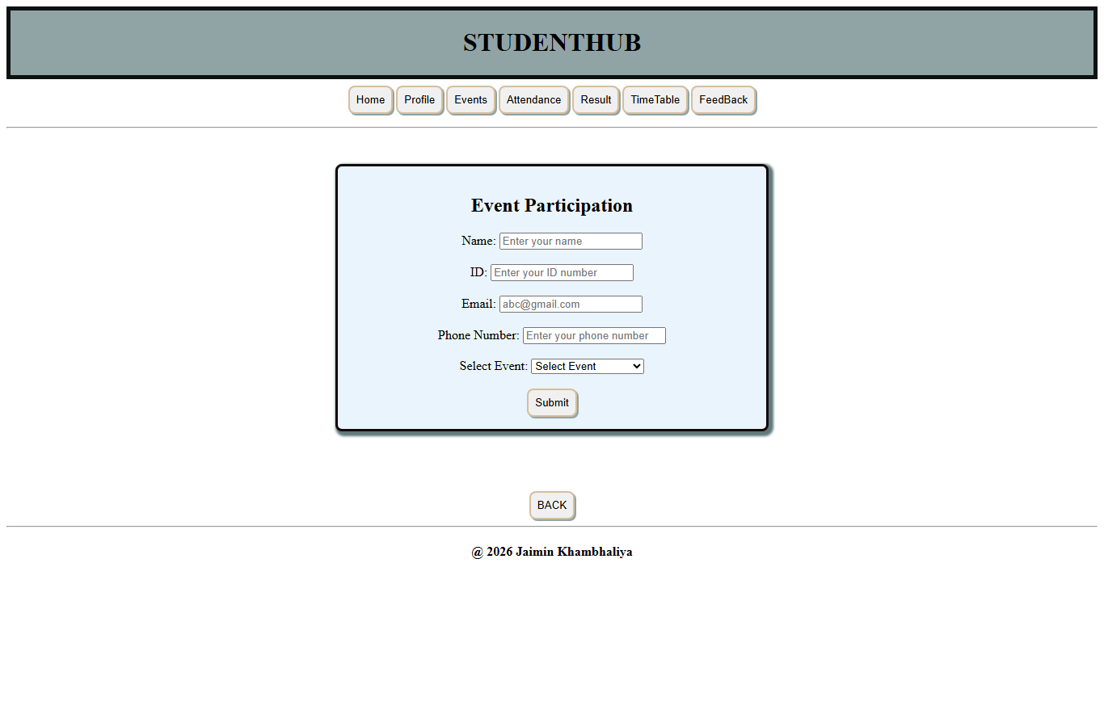
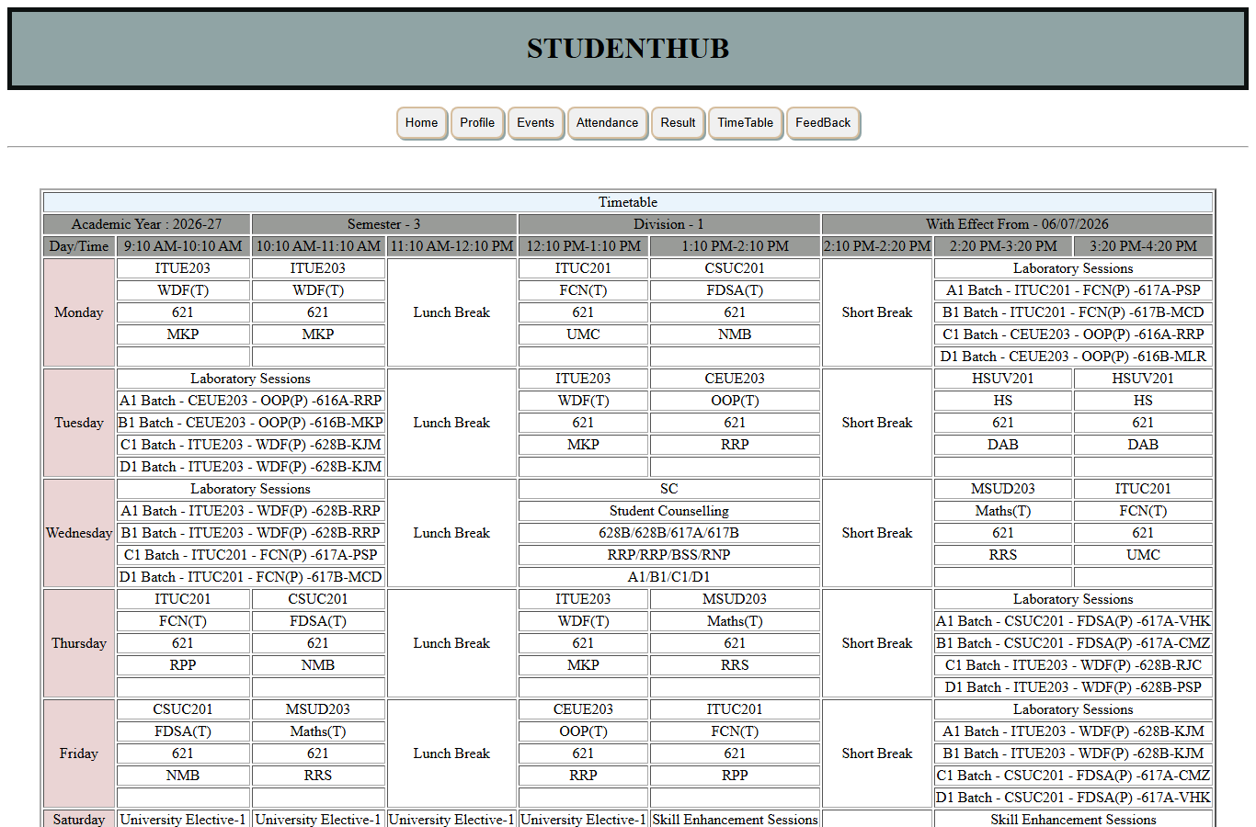
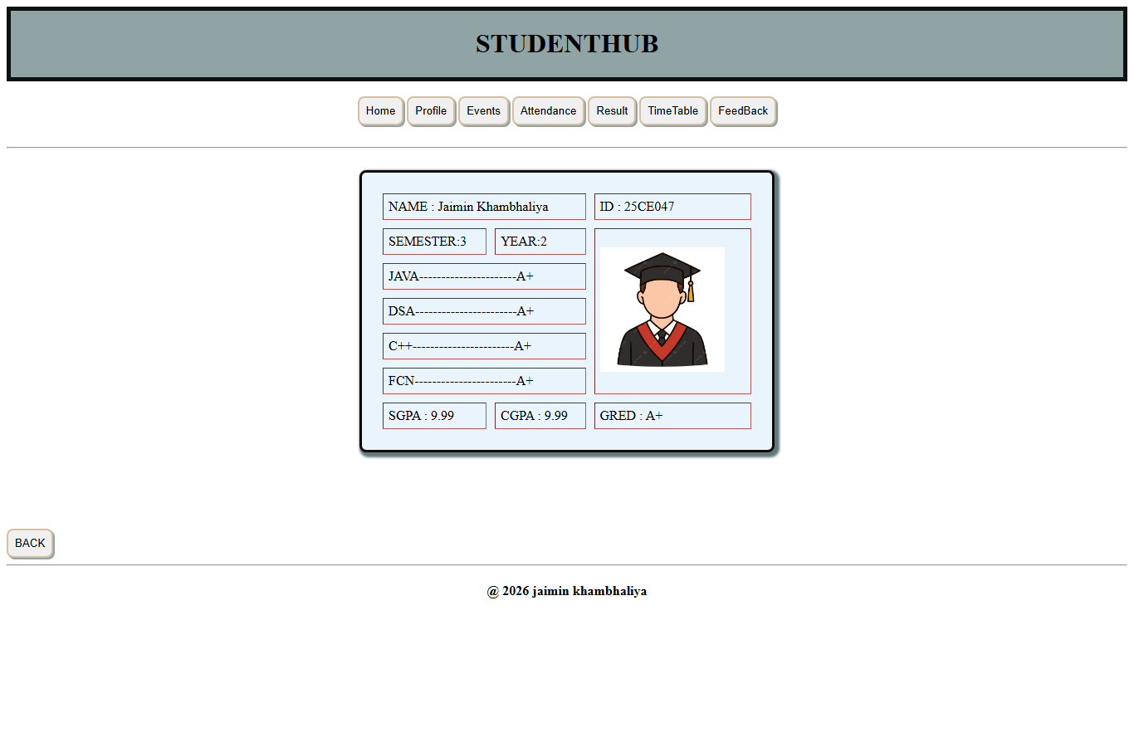
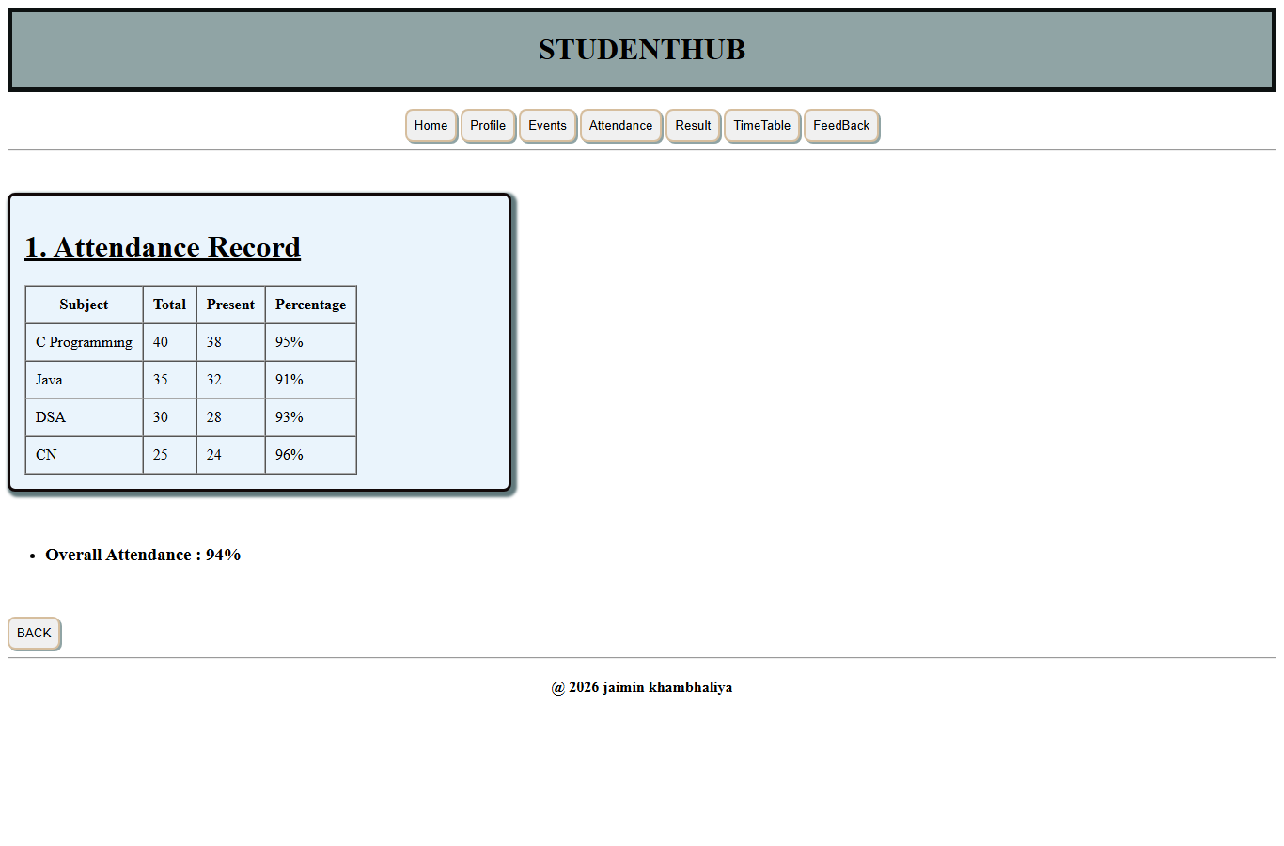
Question - Answer
Q: What is a responsive user interface?
A: A responsive user interface adjusts its layout and content to fit different screen sizes so that the page remains readable and usable on desktop, tablet and mobile devices.
Q: Which tag is used to make a page adapt to mobile screens?
A: The <meta name="viewport" content="width=device-width, initial-scale=1.0"> tag is used. It tells the browser to set the page width equal to the device width and keep the zoom at 1.
Q: Why is an external stylesheet used instead of inline styles?
A: A single external file style.css is linked by all pages, so the design stays consistent and a change in one file updates every page without editing each page individually.
Q: How does the project keep the design consistent across pages?
A: Every page links the same style.css and reuses the same classes such as the header block and the card container, so colours, borders and spacing look the same everywhere.
Conclusion
The StudentHub pages share one external stylesheet and each page declares the viewport meta tag, which makes the interface consistent and device-aware. The use of a single stylesheet keeps the design easy to maintain across all pages of the project.

