STUDENT INFORMATION
Name | Jaimin Khambhaliya
Student ID | 25CE047
Subject Code | ITUE203
Subject | Web Development Frameworks
Department | CSPIT-CE
University | CHARUSAT

Aim
To implement client-side form validation in the StudentHub web application using JavaScript so that user input is checked in the browser before the form is submitted.
Tools / Technology to be Used
- HTML5 forms with input, select, textarea and small error placeholders.
- JavaScript regular expressions (RegExp) for pattern matching.
- DOM event handling with the form submit event and event.preventDefault().
- DOM properties value, innerText and querySelector / querySelectorAll.
- Google Chrome browser for testing validation messages.
Theory : Core Concept of Practical
Form validation checks the data entered by a user before it is sent to the server. In this project each form listens for the submit event and calls event.preventDefault() to stop the default submission. The script reads values with getElementById, tests them against regular expressions such as the name pattern /^[A-Za-z ]+$/, the enrollment pattern /^[0-9]{2}[A-Z]{2}[0-9]{3}$/ and the email pattern, and writes a message into the related small element when a rule fails. A valid flag tracks whether every check passed, and the form is accepted only when all fields are correct.
Code
File: register.HTML
<!DOCTYPE html>
<html lang="en">

<head>
<meta charset="UTF-8">
<meta name="viewport" content="width=device-width, initial-scale=1.0">

<title>StudentHub - Event Participation</title>

<link rel="stylesheet" href="style.css">
</head>

<body>

<div id="header">
<h1 align="center">
STUDENTHUB
</h1>
</div>

<div class="header3">

<a href="home.HTML"><button type="button">Home</button></a>
<a href="profile.HTML"><button type="button">Profile</button></a>
<a href="events.HTML"><button type="button">Events</button></a>
<a href="Attendance.HTML"><button type="button">Attendance</button></a>
<a href="result.HTML"><button type="button">Result</button></a>
<a href="timetable.html"><button type="button">TimeTable</button></a>
<a href="feedback.HTML"><button type="button">FeedBack</button></a>

</div>

<hr>

<br><br>

<div align="center">

<form id="eventForm" class="card">

<h2>Event Participation</h2>

<label for="username">Name:</label>

<input
type="text"
id="username"
name="username"
placeholder="Enter your name"
pattern="[A-Za-z ]+"
title="Only alphabets and spaces are allowed"

>

<small id="nameError"></small>

<br><br>

<label for="studentId">ID:</label>

<input
type="text"
id="studentId"
name="id"
placeholder="Enter your ID number"
pattern="[0-9]{2}[A-Z]{2}[0-9]{3}"
title="Format: 25CE040"

>

<small id="idError"></small>

<br><br>

<label for="email">Email:</label>

<input
type="email"
id="email"
name="email"
placeholder="abc@gmail.com"

>

<small id="emailError"></small>

<br><br>

<label for="phone">Phone Number:</label>

<input
type="tel"
id="phone"
name="phone"
placeholder="Enter your phone number"
pattern="[0-9]{10}"
title="Enter a 10 digit phone number"

>

<small id="phoneError"></small>

<br><br>

<label for="event">Select Event:</label>

<select id="event" name="event" >

<option value="">Select Event</option>

<option value="Competition">
Coding Competition
</option>

<option value="Sports Day">
Sports Day
</option>

</select>

<small id="eventError"></small>

<br><br>

<button type="submit">
Submit
</button>

</form>

<br><br><br>

<a href="home.HTML">
<button type="button">BACK</button>
</a>

</div>

<hr>

<footer align="center">
<h4>@ 2026 Jaimin Khambhaliya</h4>
</footer>

<script src="register.js"></script>

</body>

</html>
File: register.js
const form = document.getElementById("eventForm");

form.addEventListener("submit", function(event) {

event.preventDefault();

const name = document.getElementById("username").value.trim();
const studentId = document.getElementById("studentId").value.trim();
const email = document.getElementById("email").value.trim();
const phone = document.getElementById("phone").value.trim();
const eventName = document.getElementById("event").value;

const nameError = document.getElementById("nameError");
const idError = document.getElementById("idError");
const emailError = document.getElementById("emailError");
const phoneError = document.getElementById("phoneError");
const eventError = document.getElementById("eventError");

nameError.innerText = "";
idError.innerText = "";
emailError.innerText = "";
phoneError.innerText = "";
eventError.innerText = "";

let valid = true;

const namePattern = /^[A-Za-z ]+$/;

if (name === "") {

nameError.innerText = "Name is required.";
valid = false;

}
else if (!namePattern.test(name)) {

nameError.innerText =
"Name can contain only alphabets and spaces.";

valid = false;
}

const idPattern = /^[0-9]{2}[A-Z]{2}[0-9]{3}$/;

if (studentId === "") {

idError.innerText = "Student ID is required.";
valid = false;

}
else if (!idPattern.test(studentId)) {

idError.innerText =
"Invalid ID. Example: 25CE047";

valid = false;
}

const emailPattern =
/^[^\s@]+@[^\s@]+\.[^\s@]+$/;

if (email === "") {

emailError.innerText = "Email is required.";
valid = false;

}
else if (!emailPattern.test(email)) {

emailError.innerText =
"Please enter a valid email address.";

valid = false;
}

const phonePattern = /^[0-9]{10}$/;

if (phone === "") {

phoneError.innerText =
"Phone number is required.";

valid = false;

}
else if (!phonePattern.test(phone)) {

phoneError.innerText =
"Phone number must contain exactly 10 digits.";

valid = false;
}

if (eventName === "") {

eventError.innerText =
"Please select an event.";

valid = false;
}

if (valid) {

alert("Event participation successful!");

form.reset();

}

});
File: signup.js
const form = document.getElementById("signupForm");

form.addEventListener("submit", function(event) {

event.preventDefault();

let valid = true;

document.getElementById("usernameError").innerText = "";
document.getElementById("emailError").innerText = "";
document.getElementById("passwordError").innerText = "";

const username = document.getElementById("username").value.trim();
const email = document.getElementById("email").value.trim();
const password = document.getElementById("password").value;

const namePattern = /^[A-Za-z ]+$/;
const emailPattern = /^[^\s@]+@[^\s@]+\.[^\s@]+$/;

if (username === "") {
document.getElementById("usernameError").innerText =
"Please enter your name.";
valid = false;
}
else if (!namePattern.test(username)) {
document.getElementById("usernameError").innerText =
"Only alphabets and spaces are allowed.";
valid = false;
}

if (email === "") {
document.getElementById("emailError").innerText =
"Please enter your email.";
valid = false;
}
else if (!emailPattern.test(email)) {
document.getElementById("emailError").innerText =
"Please enter a valid email.";
valid = false;
}

if (password === "") {
document.getElementById("passwordError").innerText =
"Please enter your password.";
valid = false;
}
else if (password.length < 8) {
document.getElementById("passwordError").innerText =
"Password must contain at least 8 characters.";
valid = false;
}

if (valid) {
alert("Signup successful!");

form.submit();
}

});
File: login.js
const form = document.getElementById("loginForm");

form.addEventListener("submit", function(event) {

event.preventDefault();

let valid = true;

document.getElementById("emailError").innerText = "";
document.getElementById("passwordError").innerText = "";

const email = document.getElementById("email").value.trim();
const password = document.getElementById("password").value;

const emailPattern = /^[^\s@]+@[^\s@]+\.[^\s@]+$/;

if (email === "") {
document.getElementById("emailError").innerText =
"Please enter your email.";
valid = false;
}
else if (!emailPattern.test(email)) {
document.getElementById("emailError").innerText =
"Please enter a valid email address.";
valid = false;
}

if (password === "") {
document.getElementById("passwordError").innerText =
"Please enter your password.";
valid = false;
}
else if (password.length < 8) {
document.getElementById("passwordError").innerText =
"Password must be at least 8 characters.";
valid = false;
}

if (valid) {
alert("Login successful!");
form.submit();
}

});
File: feedback.js
const form = document.getElementById("feedbackForm");

form.addEventListener("submit", function (event) {
event.preventDefault();

let valid = true;

document.querySelectorAll("small").forEach(function (error) {
error.innerText = "";
});

const fullname = document.getElementById("fullname").value.trim();
const enrollment = document.getElementById("enrollment").value.trim();
const email = document.getElementById("email").value.trim();
const department = document.getElementById("department").value.trim();
const semester = document.getElementById("semester").value;
const feedbackType = document.getElementById("feedback_type").value;
const rating = document.getElementById("rating").value;
const feedbackContent = document.getElementById("feedback_content").value.trim();

const recommend = document.querySelector(
'input[name="recommend"]:checked'
);

const fullnamePattern = /^[A-Za-z ]+$/;
const enrollmentPattern = /^[0-9]{2}[A-Z]{2}[0-9]{3}$/;
const emailPattern = /^[^\s@]+@[^\s@]+\.[^\s@]+$/;
const departmentPattern = /^[A-Za-z -]+$/;

if (fullname === "") {
document.getElementById("fullnameError").innerText =
"Please enter your full name.";
valid = false;
} else if (!fullnamePattern.test(fullname)) {
document.getElementById("fullnameError").innerText =
"Name should contain only letters and spaces.";
valid = false;
}

if (enrollment === "") {
document.getElementById("enrollmentError").innerText =
"Please enter your enrollment number.";
valid = false;
} else if (!enrollmentPattern.test(enrollment)) {
document.getElementById("enrollmentError").innerText =
"Example: 25CE040";
valid = false;
}

if (email === "") {
document.getElementById("emailError").innerText =
"Please enter your email.";
valid = false;
} else if (!emailPattern.test(email)) {
document.getElementById("emailError").innerText =
"Please enter a valid email address.";
valid = false;
}

if (department === "") {
document.getElementById("departmentError").innerText =
"Please enter your department.";
valid = false;
} else if (!departmentPattern.test(department)) {
document.getElementById("departmentError").innerText =
"Please enter a valid department.";
valid = false;
}

if (semester === "") {
document.getElementById("semesterError").innerText =
"Please select your semester.";
valid = false;
}

if (feedbackType === "") {
document.getElementById("feedbackTypeError").innerText =
"Please select feedback type.";
valid = false;
}

if (rating === "") {
document.getElementById("ratingError").innerText =
"Please select a rating.";
valid = false;
}

if (!recommend) {
document.getElementById("recommendError").innerText =
"Please select an option.";
valid = false;
}

if (feedbackContent === "") {
document.getElementById("feedbackError").innerText =
"Please enter your feedback.";
valid = false;
} else if (feedbackContent.length < 10) {
document.getElementById("feedbackError").innerText =
"Feedback must be at least 10 characters.";
valid = false;
}

if (valid) {
alert("Feedback submitted successfully!");
form.reset();
}
});
Output
The empty registration form and the same form after submitting invalid data, where each field shows its own validation message.
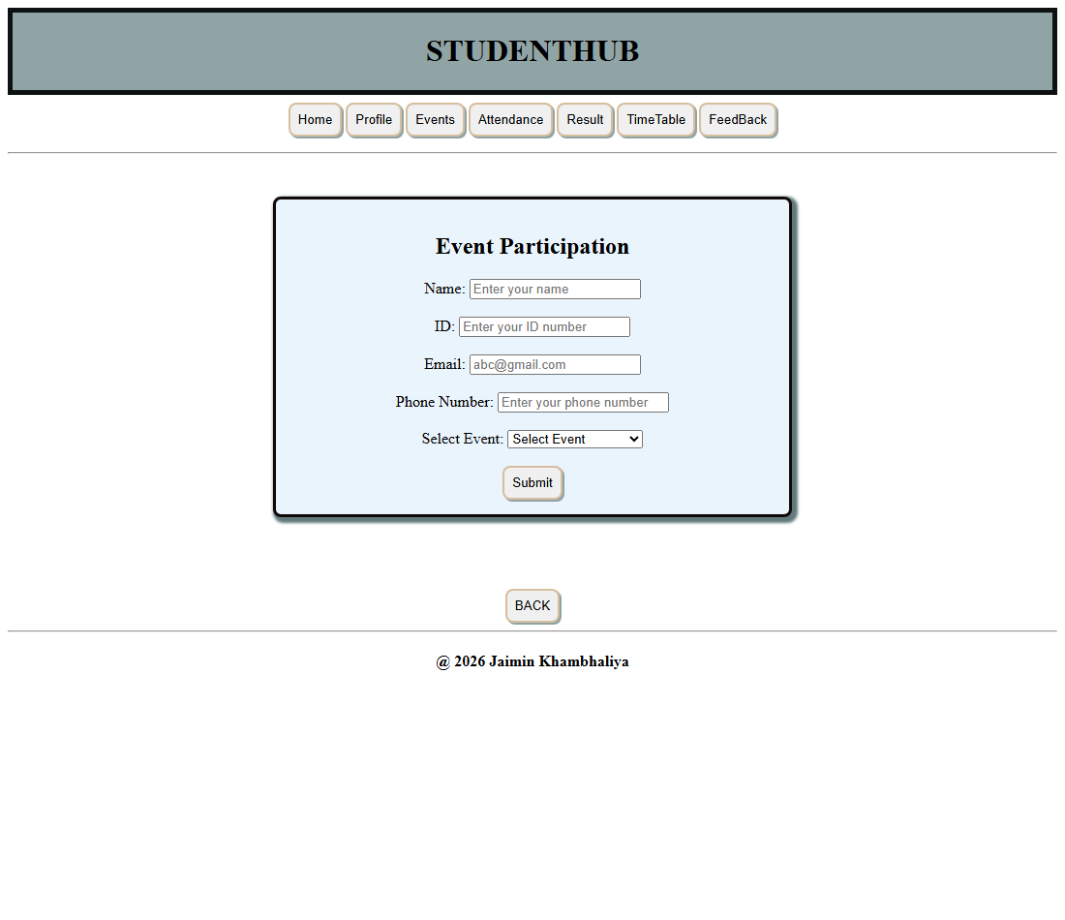
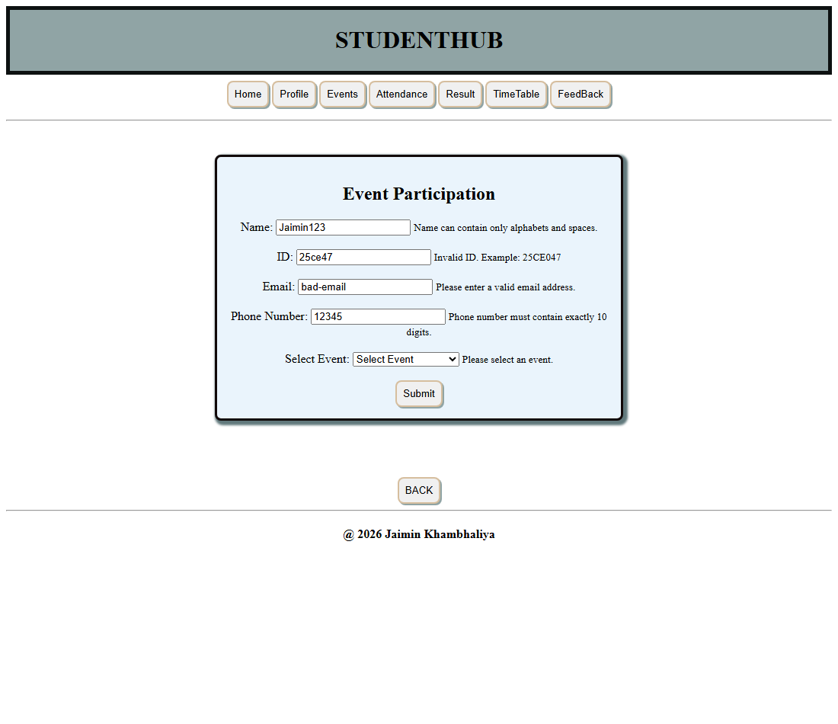
Question - Answer
Q: What is client-side form validation?
A: Client-side form validation is the checking of user input in the browser using JavaScript before the data is sent to the server. It gives fast feedback and reduces invalid requests.
Q: Why is event.preventDefault() used?
A: event.preventDefault() stops the browser from submitting the form in its default way, so the JavaScript validation code can run first and decide whether to continue.
Q: What is a regular expression?
A: A regular expression is a pattern used to test or match text. For example /^[A-Za-z ]+$/ accepts only letters and spaces, which is used to validate the name field.
Q: How is the Student ID validated in this project?
A: The Student ID is validated with the pattern /^[0-9]{2}[A-Z]{2}[0-9]{3}$/, which accepts two digits, two capital letters and three digits, such as 25CE047.
Q: How does the script decide the form is valid?
A: A variable named valid starts as true and is set to false whenever any rule fails. The form is accepted only when valid remains true after all checks.
Conclusion
The project implements client-side validation for registration, signup, login and feedback forms. Regular expressions and the submit event are used to check each field and display clear messages, which prevents invalid data from being submitted.

