**Institute of Computer Technology**

**B. Tech. Computer Science and Engineering**

**Sub: DS**

**Course Code: 2CSE302**

**Practical – 1**

**Name: Jaymin Gondaliya**

**Enrollment No: 23162171007**

**Sem - 3**

**Branch: CS**

**Class: A**

**Batch: 32**

**Problem Definition-1:**

In a company an employee is paid as under: Along with the basic salary, the employee would be given dearness allowance of 40% of his basic salary and house rent allowance of 20% of his basic salary. If the basic salary of an employee is received as input, write a program to find his/her gross salary.

**Code:**

#include <stdio.h>

int main()

{

    printf("Enter basic salary: ");

    float basic;

    scanf("%f", &basic);

    float d = 0.4 * basic;

    float r = 0.2 * basic;

    float gross = basic + d + r;

    printf("Gross salary: %f\n", gross);

    return 0;

}

**Output-**

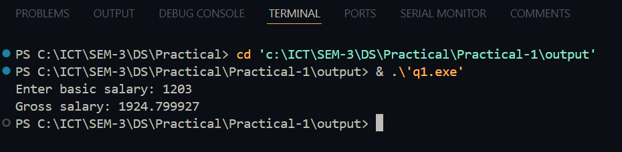

**Problem Definition-2:**

The distance between two cities (in km.) would be given by the user. Write a program to convert and print this distance in: 1. Feet. 2. Meters. 3. Inches. 4. Centimeters.

**Code:**

#include <stdio.h>

int main()

{

    printf("Enter Distence: ");

    float distence;

    scanf("%f", &distence);

    float feet = distence * 3280.84;

    float meters = distence * 1000;

    float inches = distence * 39370.1;

    float centimeters = distence * 100000;

    printf("Distence in Feet: %f\n", feet);

    printf("Distence in Meters: %f\n", meters);

    printf("Distence in Inches: %f\n", inches);

    printf("Distence in Centimeters: %f\n", centimeters);

    return 0;

}

**Output -**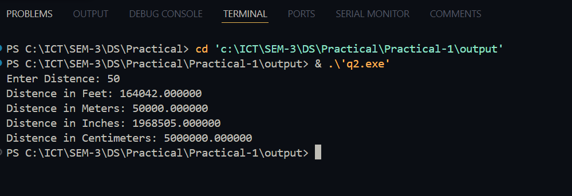

**Problem Definition-3:**

A student enters his/her marks of 5 subjects in a program. Assume that the maximum marks that can be obtained by a student in each subject to be 100. Write a program to calculate the aggregate marks of the student. Also, calculate the percentage marks obtained by the student.

**Code:**

#include<stdio.h>

int main() {

    int a,b,c,d,e;

    printf("Enter 5 numbers: ");

    scanf("%d %d %d %d %d",&a,&b,&c,&d,&e);

    int sum = a+b+c+d+e;

    float percentage = ((float)sum/500)*100;

    printf("Sum: %d\n", sum);

    printf("Percentage: %f\n", percentage);

    return 0;

}

**Output –**

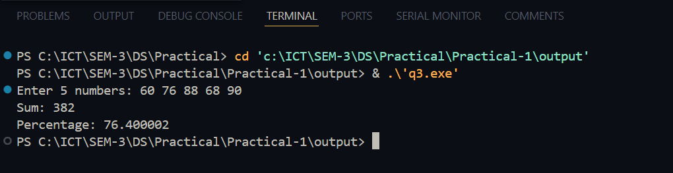

**Problem Definition-4:**

The user will enter a four-digit number. Write a program that calculates the sum of its digits. (Hint: Use the modulus operator ‘%’).

**Code:**

#include<stdio.h>

int main() {

    int num;

    printf("Enter a four-digit number: ");

    scanf("%d", &num);

    int sum = 0;

    sum += num % 10;

    num /= 10;

    sum += num % 10;

    num /= 10;

    sum += num % 10;

    num /= 10;

    sum += num % 10;

    printf("Sum of digits: %d\n", sum);

    return 0;

}

**Output –**

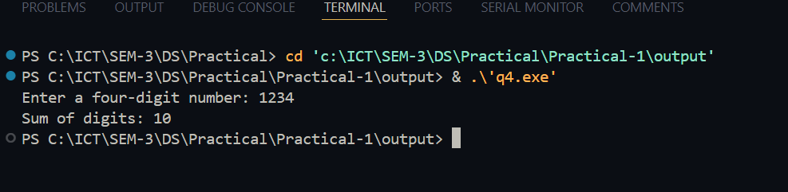

**Problem Definition-5:** Suppose a five-digit number is input by a user. Write a program to print a new number by subtracting one to each of its digits. For example if the number that is input is 12391 then the output should be displayed as 01280.

**Code:**

#include <stdio.h>

int main() {

    char num[6];

    printf("Enter five digit number: ");

    scanf("%s", num);

    printf("Output: ");

    for (int i = 0; i < 5; i++) {

        char dd = (num[i] == '0') ? '9' : num[i] - 1;

        printf("%c", dd);

    }

    printf("\n");

    return 0;

}

**Output –**

