**Institute of Computer Technology**

**B. Tech. Computer Science and Engineering**

**Sub: DS**

**Course Code: 2CSE302**

**Practical – 16**

**Name: Jaymin Gondaliya**

**Enrollment No: 23162171007**

**Sem - 3**

**Branch: CS**

**Class: A**

**Batch: 32**

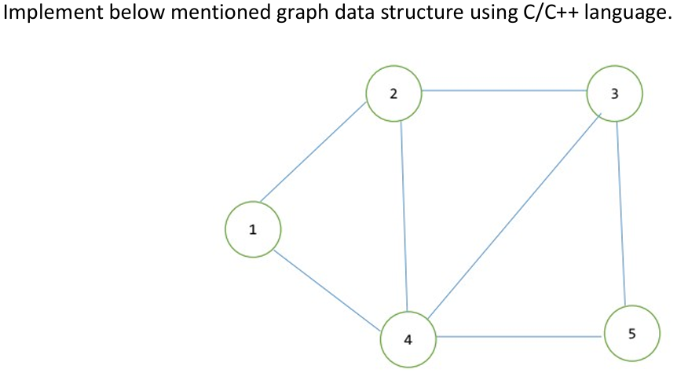

**Code:**

*#include* <stdio.h>

*#include* <stdlib.h>

*//* **Structure to represent a node in the adjacency list**

struct Node {

    int vertex;

    struct Node* next;

};

*//* **Structure to represent the graph**

struct Graph {

    int numVertices;

    struct Node** adjLists;*//* **Array of pointers to adjacency lists**

};

*//* **Function to create a new node**

struct Node* createNode(int *vertex*) {

    struct Node* newNode = (struct Node*)malloc(sizeof(struct Node));

    newNode->vertex = *vertex*;

    newNode->next = NULL;

*return* newNode;

}

*//* **Function to create a graph**

struct Graph* createGraph(int *vertices*) {

    struct Graph* graph = (struct Graph*)malloc(sizeof(struct Graph));

    graph->numVertices = *vertices*;

*//* **Create an array of adjacency lists**

    graph->adjLists = (struct Node**)malloc(*vertices* * sizeof(struct Node*));

*//* **Initialize each adjacency list as empty**

*for* (int i = 0; i < *vertices*; i++) {

        graph->adjLists[i] = NULL;

    }

*return* graph;

}

*//* **Function to add an edge to the graph**

void addEdge(struct Graph* *graph*, int *src*, int *dest*) {

*//* **Add an edge from src to dest**

    struct Node* newNode = createNode(*dest*);

    newNode->next = *graph*->adjLists[*src*];

*graph*->adjLists[*src*] = newNode;

*//* **Add an edge from dest to src (since the graph is undirected)**

    newNode = createNode(*src*);

    newNode->next = *graph*->adjLists[*dest*];

*graph*->adjLists[*dest*] = newNode;

}

*//* **Function to print the graph**

void printGraph(struct Graph* *graph*) {

*for* (int i = 0; i < *graph*->numVertices; i++) {

        struct Node* temp = *graph*->adjLists[i];

        printf("Vertex %d: ", i + 1);

*while* (temp) {

            printf("%d -> ", temp->vertex + 1);

            temp = temp->next;

        }

        printf("NULL\n");

    }

}

int main() {

    int vertices = 5;

*//* **Create the graph**

    struct Graph* graph = createGraph(vertices);

*//* **Add edges as per the graph in the image**

    addEdge(graph, 0, 1);*//* **Edge between 1 and 2**

    addEdge(graph, 0, 3);*//* **Edge between 1 and 4**

    addEdge(graph, 1, 2);*//* **Edge between 2 and 3**

    addEdge(graph, 1, 3);*//* **Edge between 2 and 4**

    addEdge(graph, 2, 3);*//* **Edge between 3 and 4**

    addEdge(graph, 2, 4);*//* **Edge between 3 and 5**

    addEdge(graph, 3, 4);*//* **Edge between 4 and 5**

*//* **Print the adjacency list**

    printGraph(graph);

*return* 0;

}

**Output:**

