**Institute of Computer Technology**

**B. Tech. Computer Science and Engineering**

**Sub: DS**

**Course Code: 2CSE302**

**Practical – 18**

**Name: Jaymin Gondaliya**

**Enrollment No: 23162171007**

**Sem - 3**

**Branch: CS**

**Class: A**

**Batch: 32**

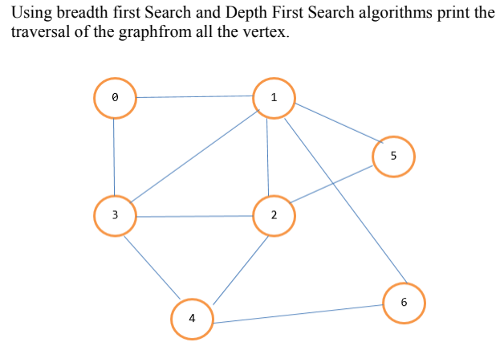

**Code:**

*#include* <stdio.h>

*#include* <stdlib.h>

*#include* <stdbool.h>

*#define* MAX 7*//* **Number of vertices in the graph**

*//* **Adjacency matrix representation of the graph**

int graph[MAX][MAX] = {

    {0, 1, 0, 1, 0, 0, 0},*//* **Connections from vertex 0**

    {1, 0, 1, 1, 0, 1, 0},*//* **Connections from vertex 1**

    {0, 1, 0, 1, 0, 0, 1},*//* **Connections from vertex 2**

    {1, 1, 1, 0, 1, 0, 0},*//* **Connections from vertex 3**

    {0, 0, 0, 1, 0, 0, 1},*//* **Connections from vertex 4**

    {0, 1, 0, 0, 0, 0, 1},*//* **Connections from vertex 5**

    {0, 0, 1, 0, 1, 1, 0}*//* **Connections from vertex 6**

};

*//* **BFS Function**

void bfs(int *startVertex*) {

    bool visited[MAX] = {false};*//* **Track visited vertices**

    int queue[MAX];*//* **Queue for BFS**

    int front = 0, rear = 0;*//* **Queue indices**

*//* **Start with the given vertex**

    visited[*startVertex*] = true;

    queue[rear++] = *startVertex*;

    printf("BFS Traversal: ");

*while* (front < rear) {

        int currentVertex = queue[front++];

        printf("%d ", currentVertex);

*//* **Enqueue all adjacent vertices of the current vertex**

*for* (int i = 0; i < MAX; i++) {

*if* (graph[currentVertex][i] && !visited[i]) {

                visited[i] = true;

                queue[rear++] = i;

            }

        }

    }

    printf("\n");

}

*//* **DFS Helper Function**

void dfsUtil(int *vertex*, bool *visited*[]) {

*visited*[*vertex*] = true;

    printf("%d ", *vertex*);

*//* **Visit all adjacent vertices of the current vertex**

*for* (int i = 0; i < MAX; i++) {

*if* (graph[*vertex*][i] && !*visited*[i]) {

            dfsUtil(i, *visited*);

        }

    }

}

*//* **DFS Function**

void dfs(int *startVertex*) {

    bool visited[MAX] = {false};*//* **Track visited vertices**

    printf("DFS Traversal: ");

    dfsUtil(*startVertex*, visited);

    printf("\n");

}

int main() {

    int startVertex = 0;*//* **Starting vertex for traversals**

*//* **Perform BFS and DFS**

    bfs(startVertex);

    dfs(startVertex);

*return* 0;

}

**Output:**

