**Institute of Computer Technology**

**B. Tech. Computer Science and Engineering**

**Sub: DS**

**Course Code: 2CSE302**

**Practical – 2**

**Name: Jaymin Gondaliya**

**Enrollment No: 23162171007**

**Sem - 3**

**Branch: CS**

**Class: A**

**Batch: 32**

**Problem Definition-1:**

Write a program that asks the user to enter two numbers, obtains them from the user and prints their sum, product, difference, quotient and remainder.

**Code:**

#include <stdio.h>

int main() {

    int num1, num2;

    printf("Enter the first number: ");

    scanf("%d", &num1);

    printf("Enter the second number: ");

    scanf("%d", &num2);

    int sum = num1 + num2;

    int product = num1 * num2;

    int difference = num1 - num2;

    int quotient = num1 / num2;

    int remainder = num1 % num2;

    printf("Sum: %d\n", sum);

    printf("Product: %d\n", product);

    printf("Difference: %d\n", difference);

    printf("Quotient: %d\n", quotient);

    printf("Remainder: %d\n", remainder);

    return 0;

}

**Output –**

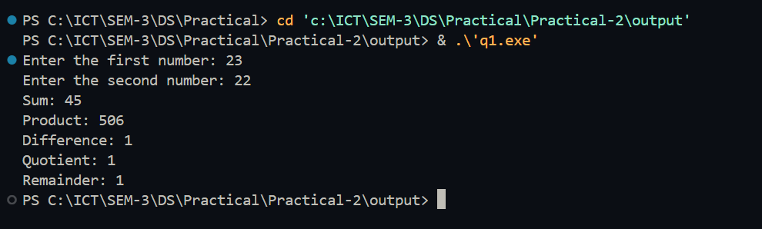

**Problem Definition-2:**

Suppose, a user enters the total selling price of 15 items and the profit earned on the total. Write a program to find out the cost price of one item.

**Code:**

#include <stdio.h>

int main() {

    float totalSellingPrice, profit, costPrice;

    printf("Enter the total selling price of 15 items: ");

    scanf("%f", &totalSellingPrice);

    printf("Enter the profit earned on the total: ");

    scanf("%f", &profit);

    costPrice = (totalSellingPrice - profit) / 15;

    printf("Cost price of one item: %.2f\n", costPrice);

    return 0;

}

**Output-**

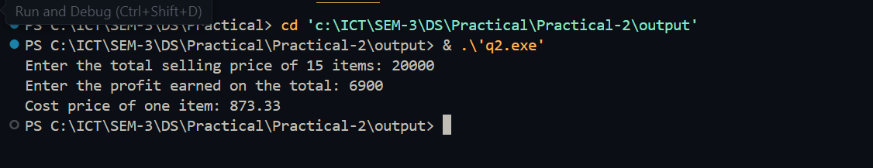

**Problem Definition-3:** Separating Digits in an Integer Write a program that inputs one five-digit number, separates the number into its individual digits and prints the digits separated from one another by three spaces each.

**Code:**

#include<stdio.h>

int main(){

    int a,b,c,d,e,f;

    printf("Enter A 5 Digit Number - ");

    scanf("%d",&a);

    f = a / 10000;

    b = a / 1000 % 10;

    c = a / 100 % 10;

    d = a / 10 % 10;

    e = a % 10;

    printf("%d %d %d %d %d ",f,b,c,d,e);

    return 0;

}

**Output-**

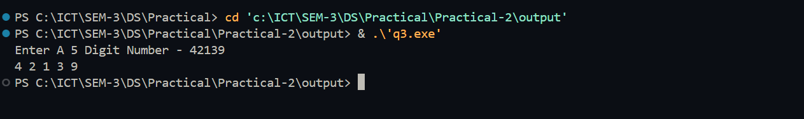

**Problem Definition-4:** Write a program that prints the following shapes with asterisks.

**Code:**

#include<stdio.h>

int main(){

    int size = 7,i,j;

    for ( i = 0; i < size; i++){

        for ( j = 0; j < size; j++){

            if (i == 0 || i == size - 1){

                printf("*");

            }

            else{

                if (j == 0 || j == size - 1){

                    printf("*");

                }

                else{

                    printf(" ");

                }

            }

        }

        printf("\n");

    }

}

**Output –**

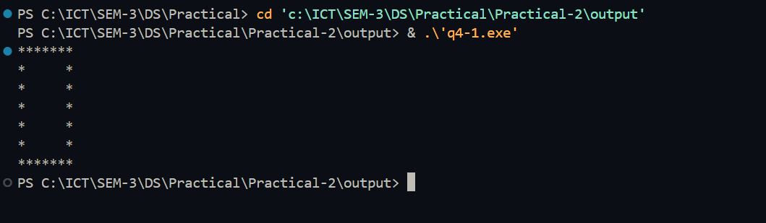

**Code:**

#include<stdio.h>

int main(){

    int size = 5,i,j,k;

    for ( i = 1; i <= size; i++){

        for ( j = size; j > i; j--){

            printf(" ");

        }

        for ( k = 0; k < i * 2 - 1; k++){

            if (k == 0 || k == 2 * i - 2){

                printf("*");

            }

            else{

                printf(" ");

            }

        }

        printf("\n");

    }

    for ( i = 1; i < size; i++){

        for ( j = 0; j < i; j++){

            printf(" ");

        }

        for ( k = (size - i) * 2 - 1; k >= 1; k--){

            if (k == 1 || k == (size - i) * 2 - 1){

               printf("*");

            }

            else{

                printf(" ");

            }

        }

        printf("\n");

    }

}

**Output-**

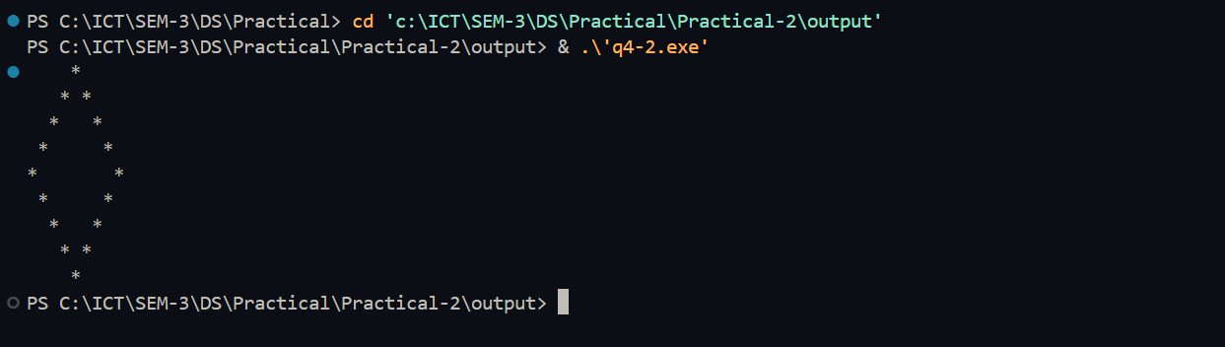

**Code:**

#include<stdio.h>

int main(){

    int i,j;

    for (i=1 ; i<=5 ; i++){

        for (j=0 ; j<i ; j++){

            printf("*");

        }

        printf("\n");

    }

    return 0;

}

**Output –**

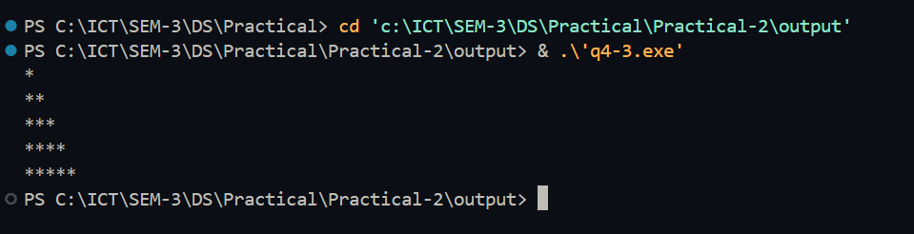

**Problem Definition-5:** Diameter, Circumference and Area of a Circle Write a program that reads in the radius of a circle and prints the circle’s diameter, circumference and area. Use the constant value 3.14159 for π.

**Code:**

#include <stdio.h>

int main() {

    float radius, diameter, circumference, area;

    const float pi = 3.14159;

    printf("Enter the radius of the circle: ");

    scanf("%f", &radius);

    diameter = 2 * radius;

    circumference = 2 * pi * radius;

    area = pi * radius * radius;

    printf("Diameter: %.2f\n", diameter);

    printf("Circumference: %.2f\n", circumference);

    printf("Area: %.2f\n", area);

    return 0;

}

**Output-**

