**Institute of Computer Technology**

**B. Tech. Computer Science and Engineering**

**Sub: ESFP – II**

**Course Code: 2CSE203**

**Practical – 5**

**Name: Jaymin Gondaliya**

**Enrollment No: 23162171007**

**Sem - 2**

**Branch: CS**

**Class: B**

**Batch: 25**

**Objective:**

To understand the concept of “using namespace std”, using std, and namespace in C++.

**Problem Definition-1:** Calculate the fare for the passengers traveling in a bus. When a Passenger enters in the bus, the conductor asks “What distance will you travel?” On knowing distance from the passenger (as an approximate integer), the conductor mentions the fare to the passenger according to following criteria.

**Code:**

#include<iostream>

using namespace std;

namespace root {

    int calc() {

        int dis;

        cout<<"Enter Distance: ";

        cin>>dis;

        if (dis>0 && dis<=20) {

            cout<<"Fare is 1 RS";

        }

        else if (dis>=21 && dis<=40) {

            cout<<"Fare is 2 RS";

        }

        else if (dis>=41 && dis<=60) {

            cout<<"Fare is 3 RS";

        }

        else if (dis>=61 && dis<=80) {

            cout<<"Fare is 4 RS";

        }

        else if (dis>=81 && dis<=100) {

            cout<<"Fare is 5 RS";

        }

        else if (dis>=101) {

            cout<<"Fare is 6 RS";

        }

        else {

            cout<<"Invalid Input";

        }

        return 0;

    }

}

int main() {

    root::calc();

    return 0;

}

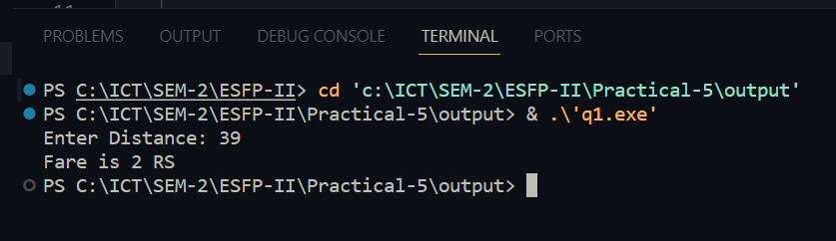

**Problem Definition-2:** Preform the following program using namespace.

1. Get a number from the user (upto 5 digit) 2. Check whether the number is palindrome or not. 3. Check whether the number is Armstrong number or not. 4. Display output for each operation performed with appropriate text.

**Code**:

#include <iostream>

namespace NumberOperations {

    int isPalindrome(int n) {

        int originalNumber = n;

        int reversedNumber = 0;

        while (n > 0) {

            int digit = n % 10;

            reversedNumber = reversedNumber * 10 + digit;

            n /= 10;

        }

        if (originalNumber == reversedNumber) {

            return 1;

        } else {

            return 0;

        }

    }

    int isArmstrong(int n) {

        int originalNumber = n;

        int sum = 0;

        while (n > 0) {

            int digit = n % 10;

            sum += (digit * digit * digit);

            n /= 10;

        }

        if (originalNumber == sum) {

            return 1;

        } else {

            return 0;

        }

    }

}

int main() {

    int num;

    std::cout << "Enter a number (up to 5 digits): ";

    std::cin >> num;

    if (num < 0 || num > 99999) {

        std::cout << "Invalid input! Please enter a number up to 5 digits." << std::endl;

        return 1;

    }

    if (NumberOperations::isPalindrome(num)) {

        std::cout << num << " is a palindrome." << std::endl;

    } else {

        std::cout << num << " is not a palindrome." << std::endl;

    }

    if (NumberOperations::isArmstrong(num)) {

        std::cout << num << " is an Armstrong number." << std::endl;

    } else {

        std::cout << num << " is not an Armstrong number." << std::endl;

    }

    return 0;

}

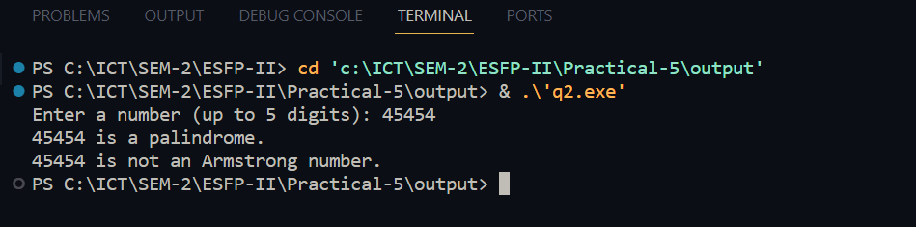

**Problem Definition-3:** Find out the error of the following program, correct it, and then write output of the program with justification.

#include <iostream>

using namespace std;

namespace A

{

    int a, b, c;

    void sum()

    {

        cout << "Enter two number:";

        cin >> a >> b;

        c = a + b;

        cout << "Sum of two number:" << c;

    }

}

int main()

{

    A::sum(); *//here*

    return 0;}

**Justification**: sum() function is being called directly without qualifying it with the namespace A. Since the sum() function is defined inside namespace A, it should be called using the scope resolution operator ::

**Output**:

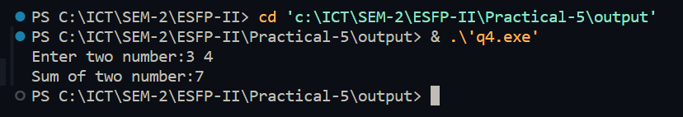

**2)**

#include <iostream>

int main()

{

*// using std::int;*

    using std::cout;

    using std::endl;

    using std::string;

    string collegeId = "GU-123";

    string uname = "Ganpat University";

    string caddress = "City Office: Ahmedabad";

    cout << collegeId << endl;

    cout << uname << endl;

    cout << caddress << endl;

    return 0;

}

**Justification:** int is a fundamental type, not a class or namespace, and it's not necessary to use std:: to qualify it. Additionally, int cannot be used as a type alias.

**Output**:

