**Portfolio Risk Analysis - Key Findings**

1. **Risk Contributions**

* **High-Risk Assets**: Major contributors to portfolio risk include Taiwan Semiconductor Manufacturing Co., Tencent Holdings, Samsung Electronics, and Alibaba Group.

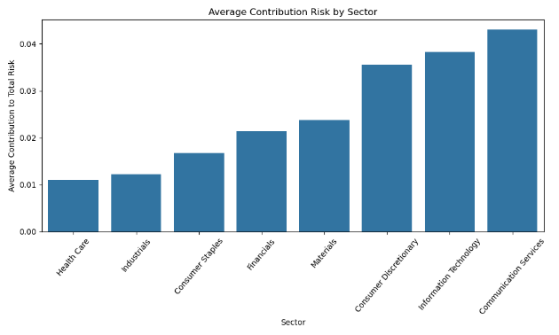

* **Sector Breakdown**: Although the healthcare sector exhibits the highest average total risk among the individual components of the portfolio, its overall contribution to the portfolio's total risk is minimal. This apparent paradox arises from the interplay of diversification effects and correlations between the healthcare sector and other assets within the portfolio. In essence, while healthcare assets may be volatile on their own, their risk does not translate significantly into the aggregate portfolio risk, likely due to low or negative correlations with other sectors.

* **Geographical Contributions**: A map analysis reveals significant risk exposure in countries like India, Taiwan, and South Korea, with varying levels of risk across regions.

1. **Portfolio Performance Dynamics**

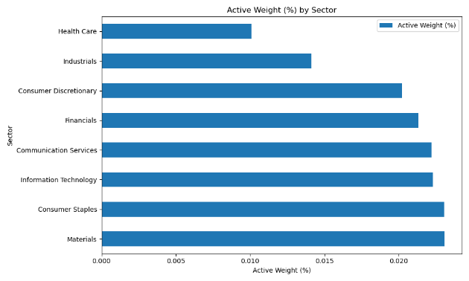

* **Tracking Error Analysis**: As demonstrated above, both consumer sectors have the highest average contribution to the portfolio's tracking error, despite having a lower active weight compared to other sectors in the portfolio. This suggests that these sectors are disproportionately influencing the portfolio's deviation from the benchmark. In other words, even though their allocation within the portfolio is relatively small, the consumer sectors are driving a significant portion of the tracking error due to factors such as higher volatility, distinctive return profiles, or greater deviations from the benchmark weights. This highlights the importance of closely monitoring these sectors, as their impact on the portfolio's active risk is not directly proportional to their allocation.

1. **ESG Metrics over time**

* **Overall Trends**: The weighted average ESG score steadily improved over time, reflecting progress in metrics that
* A graph of a number of different colored lines

  Description automatically generated with medium confidence**Component Breakdown**:
  + **Governance**: A key driver of improvement, with consistent gains throughout 2023 and 2024.
  + **Environment**: Fluctuating scores indicate uneven progress in environmental compliance.
  + **Social**: Scores showed slow but steady progress, suggesting incremental improvements in social responsibility.

* **Sector ESG Insights**: Variability across sectors highlights differing sustainability performances, with some sectors excelling in governance while others lag in environmental or social metrics.

1. **Correlation Between ESG and Risk**

* **Negative Correlation**: Assets with higher ESG scores exhibit lower total risk, underscoring the potential for ESG-focused investments to mitigate risk.

**5. ESG Score Distributions**

* **Density Analysis**: Kernel Density Estimation (KDE) plots reveal the distribution and variability of ESG scores, with governance scores typically higher than environmental and social scores.

