**Module (HTML) -1**

1. **Are the HTML tags and elements the same thing?**

**Ans: the HTML tags and elements are not same thing.** **A tag is a markup construct that begins with a less-than sign (<) and ends with a greater-than sign (>) element refers to the entire structure that comprises the opening tag, the content inside it, and the closing tag.**

**Ex. Tags: <b></b> Elements: <b> content </b>.**

1. **What are tags and attributes in HTML?**

**Ans: Tags are the building blocks of HTML. They are used to define different elements on a web page.**

**Attributes provide additional information about HTML elements and are specified within the opening tag Opening Tag: start of an element (e.g.<h1>)**

**Closing Tag: End of an element(e.g</h1)**

**E.g. id,class,src,href**

1. **What are void elements in HTML?**

**Ans: No End Tag, No Content, Attributes Only**

**E.g.**

**<!DOCTYPE html>**

**<html lang="en">**

**<head>**

**<meta charset="UTF-8">**

**<meta name="viewport" content="width=device-width, initial-scale=1.0">**

**<title>Document</title>**

**</head>**

**<body>**

**</body>**

**</html>**

1. **What are HTML Entities?**

**Ans:**

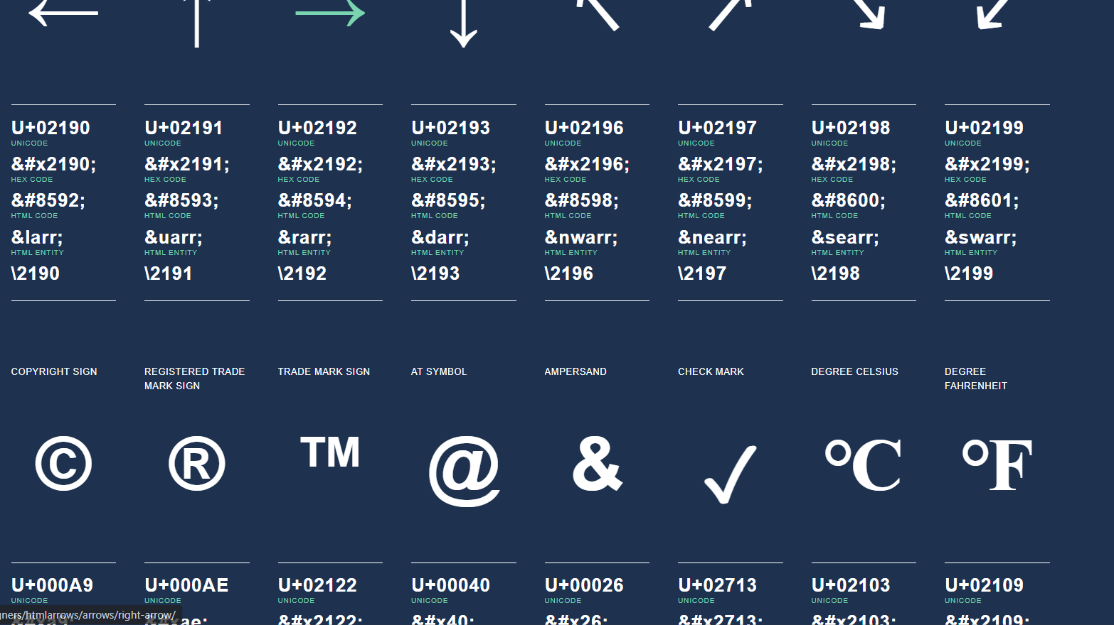

**This photo Shows all Entities .** **HTML entities are special codes used in HTML to represent characters that have a specific meaning in HTML syntax**

1. What are different types of lists in HTML?

Ans: There Are Three Type of Lists.

Li,ul,ol li= list item ol = Ordered list ul=Unordered list.

Ordered list is use to number,numeric and alphabet letters. Unordered list use to symbol and bullets.

E.g.

**<!DOCTYPE html>**

**<html lang="en">**

**<head>**

**<meta charset="UTF-8">**

**<meta name="viewport" content="width=device-width, initial-scale=1.0">**

**<title>Document</title>**

**</head>**

**<body>**

**<ul type="circle">**

**<li>menduvada</li>**

**<li>penda</li>**

**<li>vadapav</li>**

**<li>samosa</li>**

**</ul>**

**<ol>Shiv Shakti Hotel</ol>**

**<ul>**

**<ol>Menu**

**<li>Gujarati</li>**

**<li>Sak</li>**

**<li>DalBhat</li>**

**</ol>**

**<ul>**

**<li>South Indian</li>**

**<li>Dhosa</li>**

**<li>menduvada</li>**

**</ul>**

**<ol>**

**<h1>Fruits</h1>**

**<li>Apple</li>**

**<li>Banana</li>**

**<li>Mango</li>**

**<li>chiku</li>**

**</ol>**

**<ul>**

**<h1>Menu</h1>**

**<li>Gujarati</li>**

**<ol type="A">Mexican**

**<li>1</li>**

**<li>2</li>**

**<li>3</li>**

**<li>4</li>**

**</ol>**

**<li>Punjabi</li>**

**<li>South</li>**

**<ol>Chinese</ol>**

**</ul>**

**</body>**

**</html>**

**6)What is the ‘class’ attribute in HTML?**

**Ans:The class attribute in HTML is used to assign one or more class names to an HTML element. This attribute allows for the application of CSS styles and JavaScript functions to specific elements based on their class. By grouping elements with the same class name, you can style or manipulate them collectively without needing to target each one individually.**

**Syntax:<element class="class1 class2 class3">Content</element>**

**<!DOCTYPE html>**

**<html lang="en">**

**<head>**

**<meta charset="UTF-8">**

**<meta name="viewport" content="width=device-width, initial-scale=1.0">**

**<title>Class Attribute Example</title>**

**<style>**

**.highlight {**

**background-color: yellow;**

**}**

**.bold {**

**font-weight: bold;**

**}**

**</style>**

**</head>**

**<body>**

**<h1 class="highlight">This is a heading with a highlight</h1>**

**<p class="bold">This is a bold paragraph.</p>**

**<p class="highlight bold">This paragraph is both highlighted and bold.</p>**

**</body>**

**</html>**

**7)What is the difference between the ‘id’ attribute and the ‘class’ attribute of HTML elements?**

**Ans: Id: it is used to give style to specific single element, id can't be used more than 1 time, an element can't have more than 1 . <div class="blue-border rounded-border" id="special-div">**

**This is div tag**

**</div>**

**Class:** **it is used to give same style to multiple elements, a class can be used multiple times and an element can have multiple class . <p class="blue-border rounded-border">This is p tag</p>**

**8) What are the various formatting tags in HTML?**

**Ans: <b> bold tag</b>**

**<p> paragraph tag</p>**

**<h1>header tag</h1>**

**<Table>table tag</table>**

**Sementic Tag:**

**<b> </b> <strong></strong>**

**<div></div> <article></article>**

**9)** **How is Cell Padding different from Cell Spacing?**

**cellpadding attribute specifies the amount of space between the content of a cell and its border. Essentially, it defines the internal spacing within each cell of the table.**

**The cellspacing attribute defines the space between individual cells in a table. It sets the distance between the borders of adjacent table cells.**

**<table**

**border="1"**

**style="border-collapse: collapse"**

**cellspacing="5"**

**cellpadding="5"**

**>**

**10) How can we club two or more rows or columns into a single row or column in an HTML table?**

**Ans:**

**<table border="1">**

**<tr>**

**<td rowspan="2">Merged Row</td>**

**<td>Column 1</td>**

**</tr>**

**<tr>**

**<td>Column 2</td>**

**</tr>**

**</table>**

**<table border="1">**

**<tr>**

**<td colspan="2">Merged Column</td>**

**</tr>**

**<tr>**

**<td>Column 1</td>**

**<td>Column 2</td>**

**</tr>**

**</table>**

**11)** **What is the difference between a block-level element and an inline element?**

**Ans: Block-level elements start on a new line and take up the full width available by default (from the left edge to the right edge of their container).**

**E.g. <div>,<p>**

**Inline elements do not start on a new line. They only take up as much width as necessary and sit within the context of surrounding text.**

**E.g.<span>,<a>**

**12)** **How to create a Hyperlink in HTML?**

**Ans: The target attribute is used in anchor (<a>) elements and forms to specify where to open the linked document or the response from a form submission.**

**Syntax:<a href="https://www.google.com">Visit Google</a>**

**<a href="https://www.google.com" target="_blank">Visit Google in a new tab</a>**

**13)** **What is the use of an iframe tag?**

**Ans:** **The <iframe> tag in HTML is used to embed another HTML document within the current document. The name "iframe" stands for "inline frame." This tag allows you to include external content such as a web page, video, or other resources directly onto your webpage.**

**E.g.<iframe width="560" height="315" src="https://www.youtube.com/embed/video-id" frameborder="0" allowfullscreen></iframe>**

**14)** **What is the use of a span tag? Explain with example?**

**Ans: the <span> tag is an inline element used to group inline elements or text for styling purposes or to apply some changes without affecting the layout of the document. It does not inherently represent anything specific or have any semantic meaning, unlike other tags E.g.<p>, <div>, <h1>,**

**<p>This is a paragraph with a <span class="highlight">highlighted part</span> inside it.</p>**

**15)** **How to insert a picture into a background image of a web page?**

**Ans: use to image tag .**

**E.g.<!DOCTYPE html>**

**<html lang="en">**

**<head>**

**<meta charset="UTF-8">**

**<meta name="viewport" content="width=device-width, initial-scale=1.0">**

**<title>Background Image with Picture</title>**

**<link rel="stylesheet" href="styles.css">**

**</head>**

**<body>**

**<div class="background-container">**

**<img src="path/to/your/picture.jpg" alt="Picture" class="picture"/>**

**<h1>Your Content Here</h1>**

**</div>**

**</body>**

**</html>**

**16)** **How are active links different from normal links?**

**Ans: Normal Links: Typically, these links appear as text that is underlined and displayed in a different color (commonly blue) to indicate that they are clickable.**

**Active Links: An active link is a state that a link can have while it is being clicked. It may change appearance (e.g., color, background) to indicate to the user that the link is currently being selected or activated. This visual feedback can help improve user experience.**

**17)** **What are the different tags to separate sections of text?**

**Ans: Header tag: <h1>**

**Paragraph tag: <p>**

**Division tag: <div>**

**Image: <img>**

**List tage: <ul><ol><li>**

**Main tage: <main>**

18) What is SVG?

Ans: SVG is commonly used for icons, illustrations, logos, charts, and other graphics on the web.

19) What is difference between HTML and XHTML?

Ans: The HTML5 standard has made significant improvements and is the current widely accepted version of HTML.

XHTML 1.0 has three variants (Strict, Transitional, and Frameset), and XHTML 2.0 was never completed. Current best practices tend to favor HTML5.

20) What are logical and physical tags in HTML?

Ans: Logical tags: Logical tags (also referred to as semantic tags) convey meaning about the content they enclose. They describe the role or purpose of the content rather than its appearance. Logical tags help with search engine optimization (SEO) and accessibility.

E.g.<header>,<article>,<section>,<h1>-<h6>

Physical tags: Physical tags (also known as presentational tags) directly affect the styling or visual presentation of the content. These tags specify how content should be displayed, rather than conveying its meaning. While many of these tags are still present in HTML, the trend in modern web development is to use CSS for styling rather than relying on physical tags.

E.g.<b>,<i>,<u>,<center>