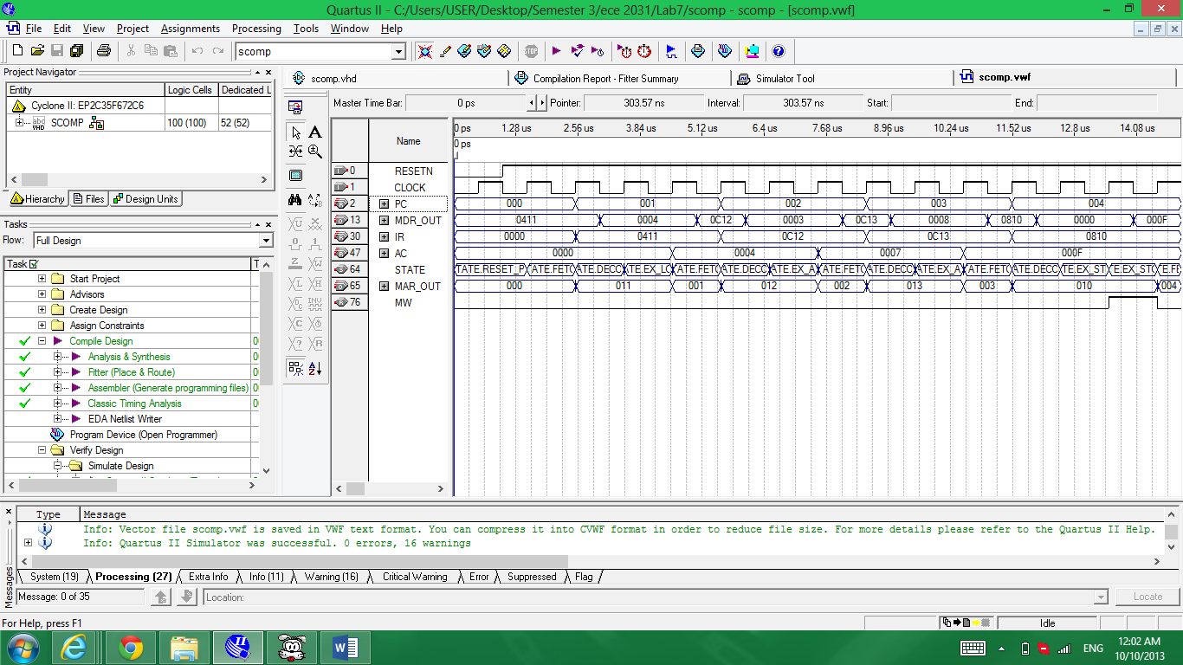

Total Logic Elements: 100 / 33,216 (<1%)

Total Pins: 80/475 (17%)

Total Memory Bits 16,384/483,840 (3%)