**BuddhiMed Technologies**

Hi,

I am Saurabh Gang wanted to thank you for giving this opportunity. Here are some insights I have taken from the application which I have developed which was asked in your assignment.

1.**Dashboard**:

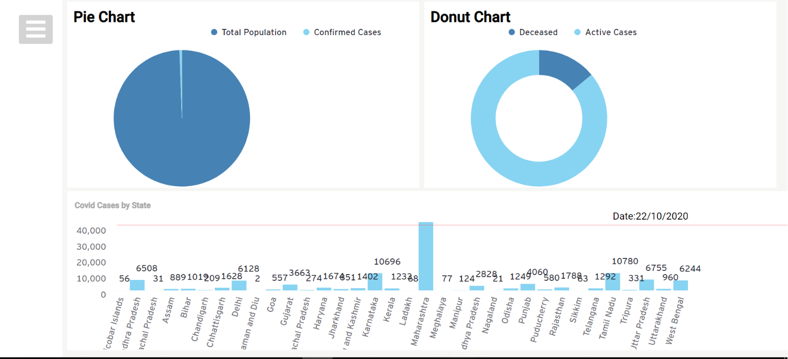

Fig:1

This is the landing page/dashboard for the application where I am representing three charts.

1. Pie Chart: Showing relation of Total Population vs Confirmed Cases.
2. Donut Chart: Showing relation of Deceased vs Active Cases.
3. Bar Chart: Showing relation between States and Numbers with the Risk Line (red colour).

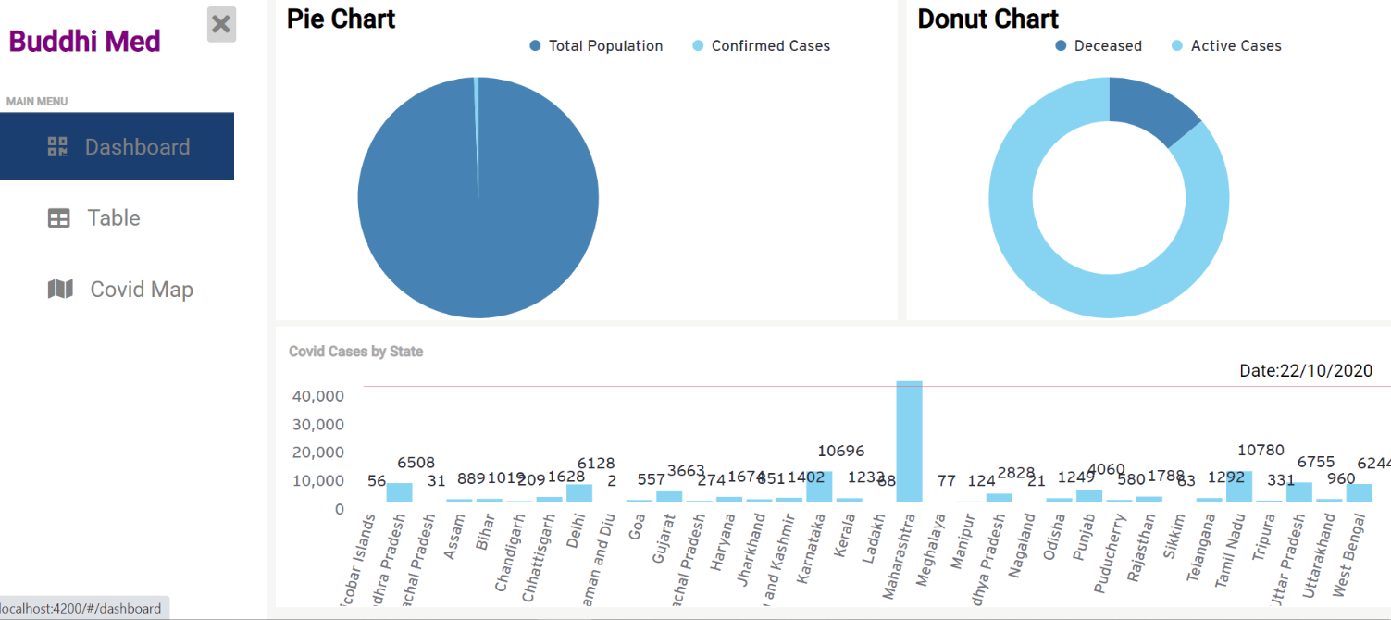

Fig:2

**Note**: You can also hover on charts to see the data.

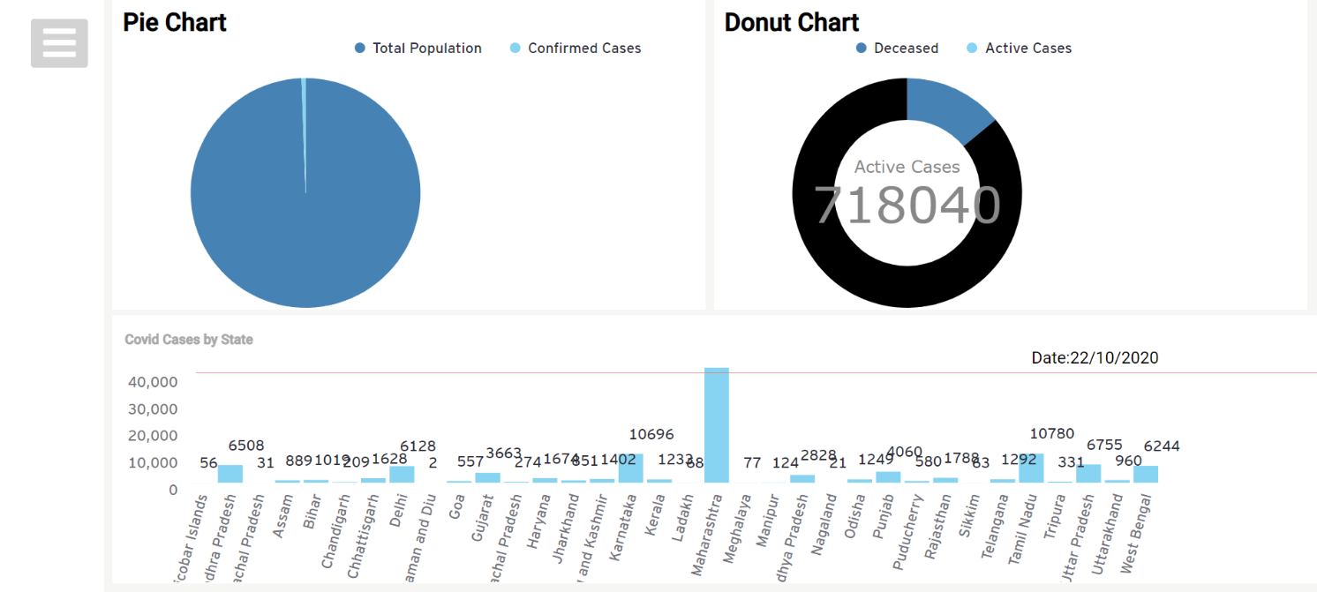

Fig:3

2. **Table:**

In table page I have created a table and filter option using Angular Material which showing State Wise Data.

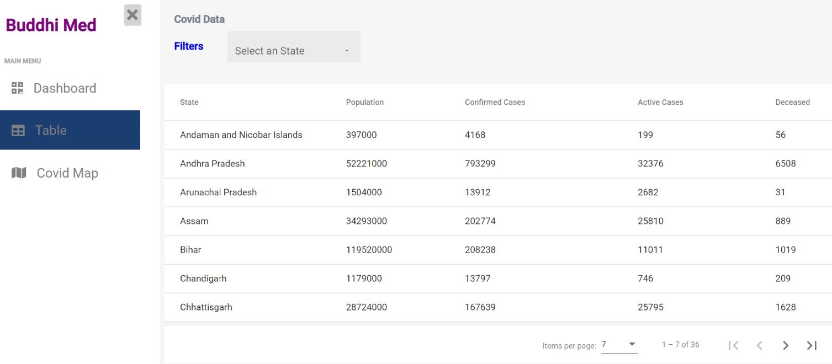

Fig:4

But to see District wise data, please select any state from filter section and for that state you can see District wise data. Each column of table can also be filtered.

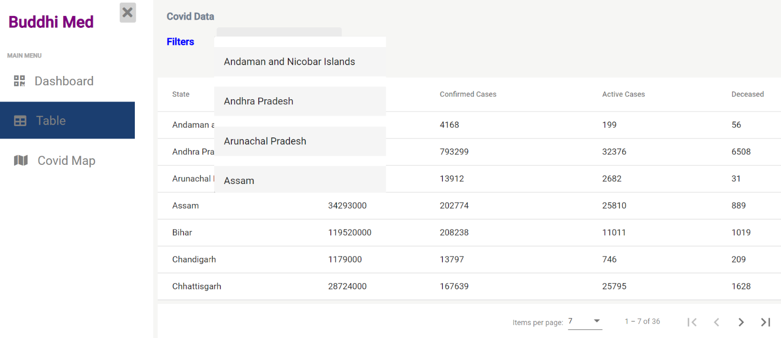 Fig:5

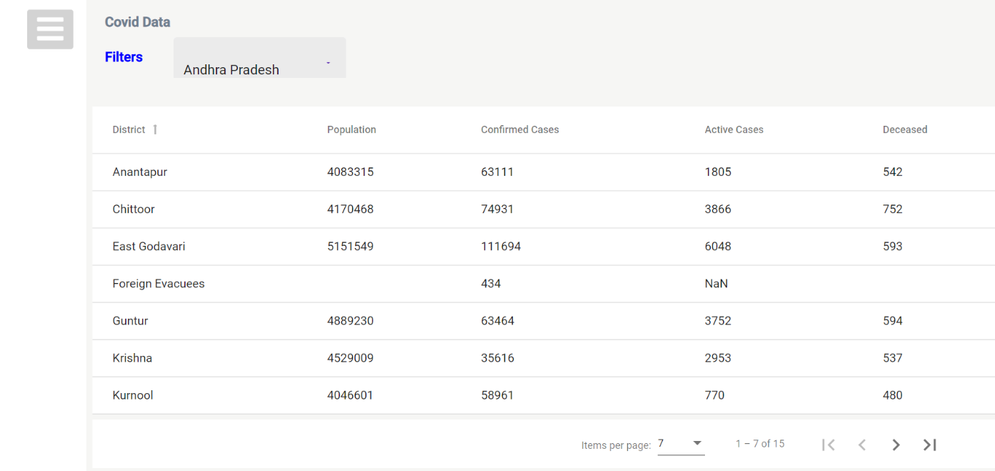

Fig:6

3.**Covid Map:**

I have also created a Covid Map (for India) where I am showing State VS Recovered Cases. You can also hover on states and see exact data of recovered cases.

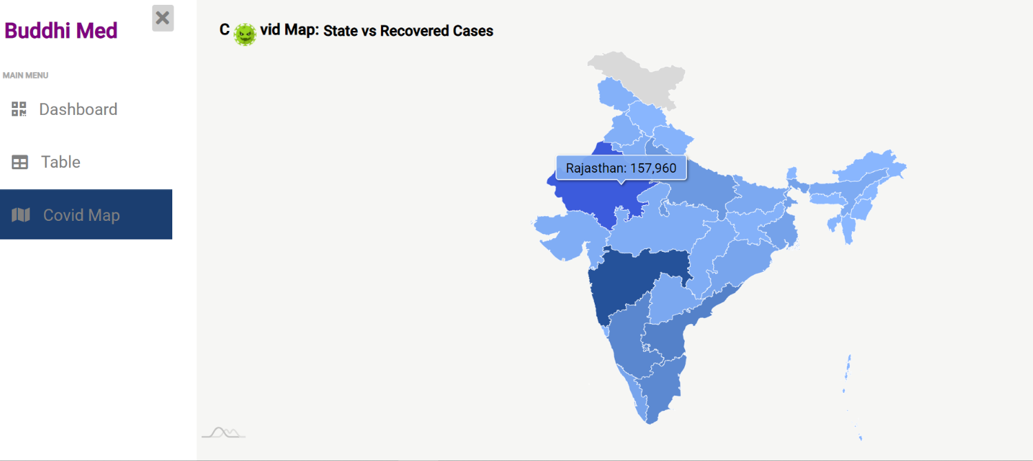

Fig:7

I am sharing you the zip file which contains code (excluding Node Modules).

Please share your feedback on this assignment.

Place: Pali (Rajasthan) Name: Saurabh Gang

Date: 22nd October, 2020