Initial screenshot from postgres admin tool

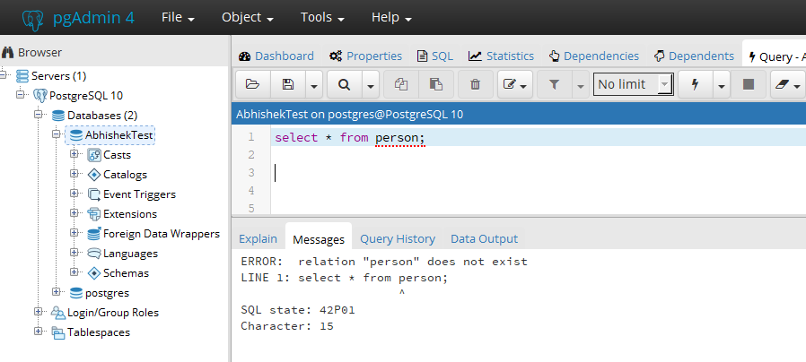

Now run repo code with mentioned steps under readme file.

You will get below output-

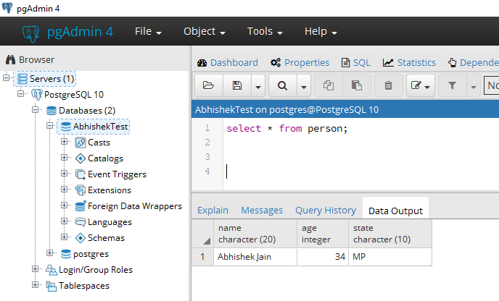

For your reference, adding IDE output also.

