**ASSIGNMENT-4**

**Create Stored procedure in Northwind database to insert or update a record in a table**

1. Create a stored procedure in the Northwind database that will calculate the average

value of Freight for a specified customer.Then, a business rule will be added that will

be triggered before every Update and Insert command in the Orders controller,and

will use the stored procedure to verify that the Freight does not exceed the average

freight. If it does, a message will be displayed and the command will be cancelled.

ANS.

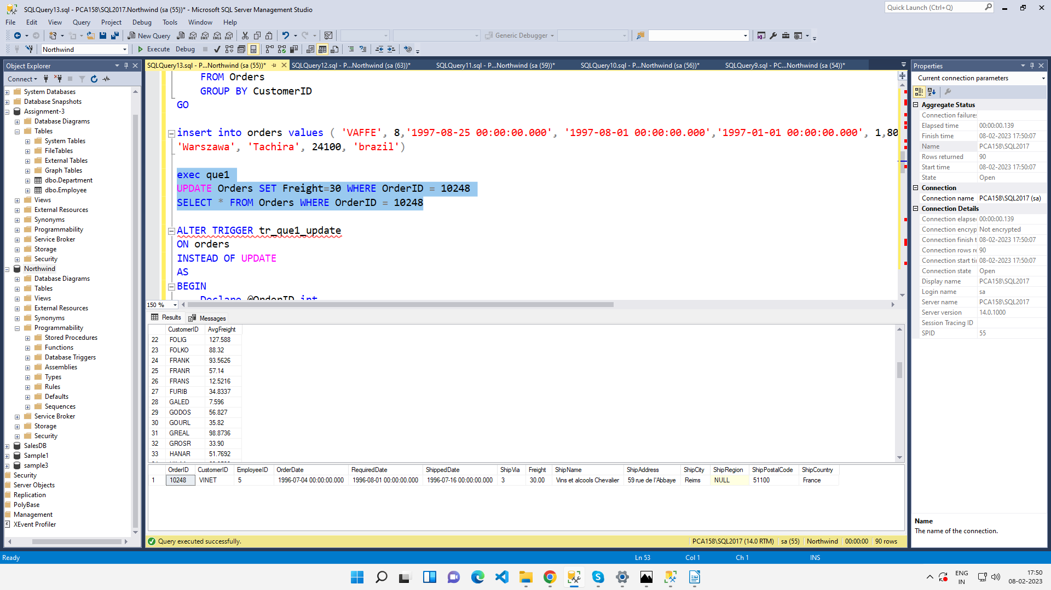

2. write a SQL query to Create Stored procedure in the Northwind database to retrieve Employee Sales by Country

ANS.

create procedure [dbo].[Employee Sales by Country]

@Beginning_Date DateTime, @Ending_Date DateTime AS

SELECT Employees.Country, Employees.LastName, Employees.FirstName, Orders.ShippedDate, Orders.OrderID, "Order Subtotals".Subtotal AS SaleAmount

FROM Employees INNER JOIN

(Orders INNER JOIN "Order Subtotals" ON Orders.OrderID = "Order Subtotals".OrderID)

ON Employees.EmployeeID = Orders.EmployeeID

WHERE Orders.ShippedDate Between @Beginning_Date And @Ending_Date

GO

EXECUTE [Employee Sales by Country] [1996-07-01], [1996-08-01]

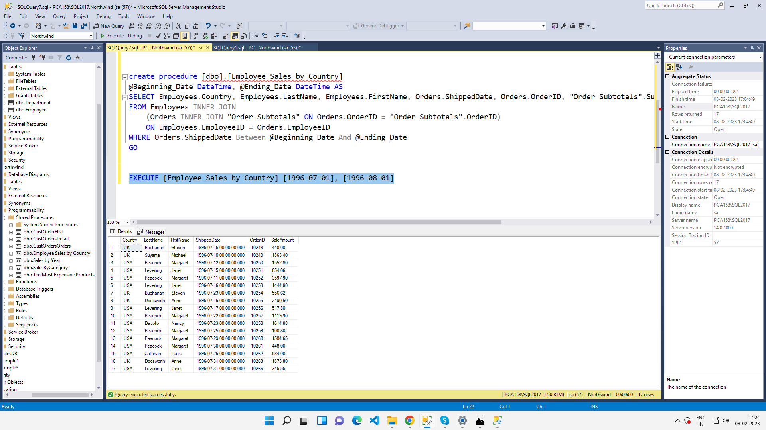

3. write a SQL query to Create Stored procedure in the Northwind database to retrieve

Sales by Year

ANS.

create procedure [dbo].[Sales by Year]

@Beginning_Date DateTime, @Ending_Date DateTime AS

SELECT Orders.ShippedDate, Orders.OrderID, "Order Subtotals".Subtotal, DATENAME(yy,ShippedDate) AS Year

FROM Orders INNER JOIN "Order Subtotals" ON Orders.OrderID = "Order Subtotals".OrderID

WHERE Orders.ShippedDate Between @Beginning_Date And @Ending_Date

GO

EXECUTE [Sales by Year] [1996-1-25], [1997-01-17]

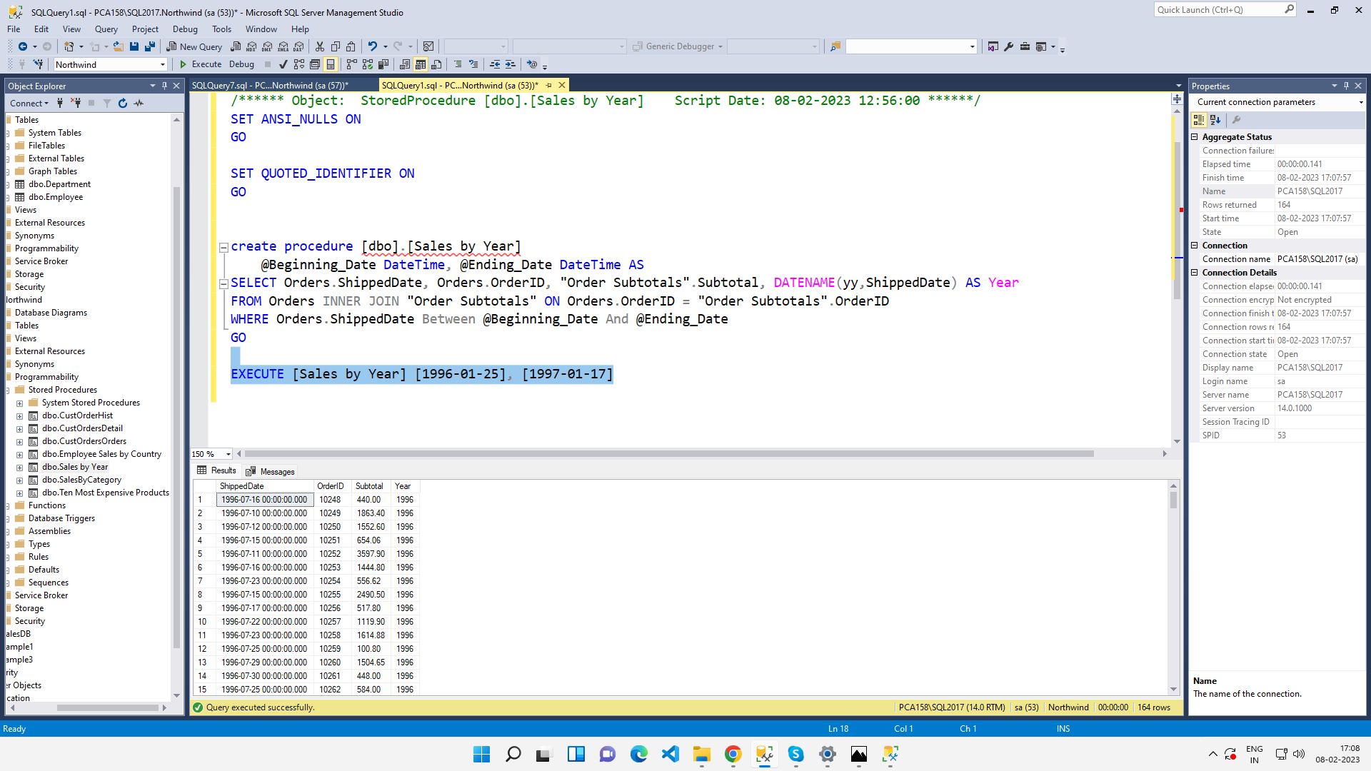

4. write a SQL query to Create Stored procedure in the Northwind database to retrieve

Sales By Category

ANS.

SELECT ProductName,

TotalPurchase=ROUND(SUM(CONVERT(decimal(14,2), OD.Quantity * (1-OD.Discount) * OD.UnitPrice)), 0)

FROM [Order Details] OD, Orders O, Products P, Categories C

WHERE OD.OrderID = O.OrderID

AND OD.ProductID = P.ProductID

AND P.CategoryID = C.CategoryID

AND C.CategoryName = @CategoryName

AND SUBSTRING(CONVERT(nvarchar(22), O.OrderDate, 111), 1, 4) = @OrdYear

GROUP BY ProductName

ORDER BY ProductName

GO

EXECUTE SalesByCategory BEVERAGES

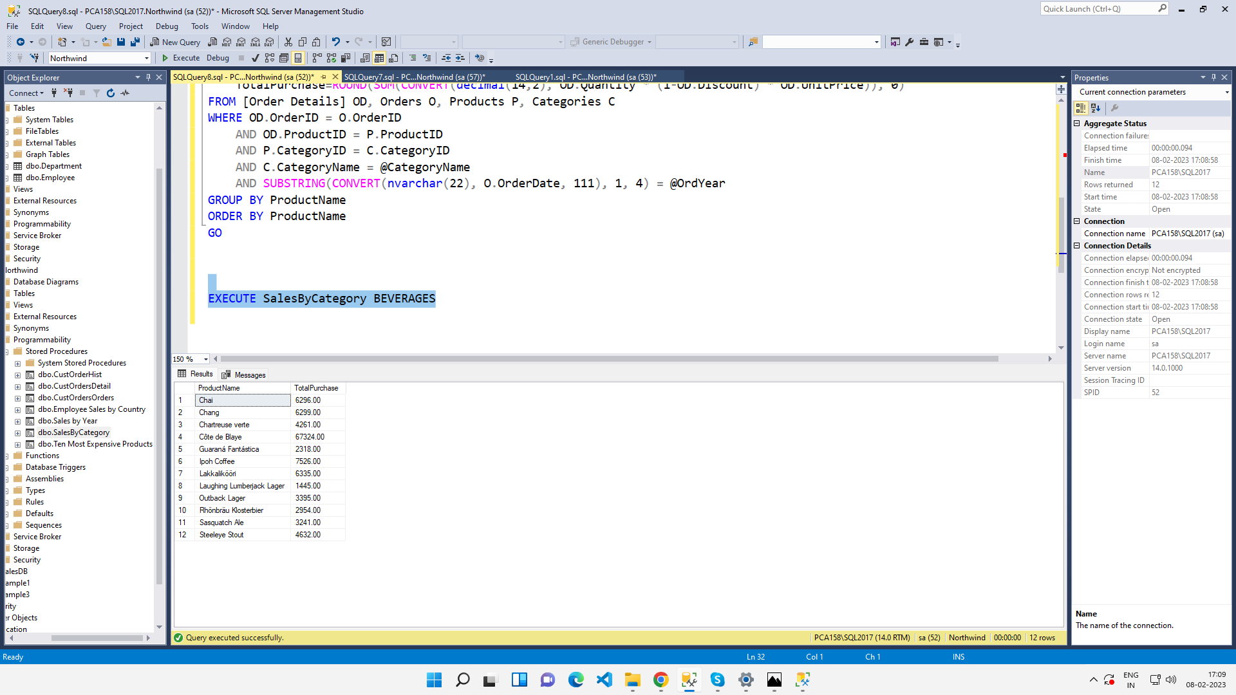

5. write a SQL query to Create Stored procedure in the Northwind database to retrieve

Ten Most Expensive Products

ANS.

create procedure [dbo].[Ten Most Expensive Products] AS

SET ROWCOUNT 10

SELECT Products.ProductName AS TenMostExpensiveProducts, Products.UnitPrice

FROM Products

ORDER BY Products.UnitPrice DESC

GO

EXECUTE [Ten Most Expensive Products]

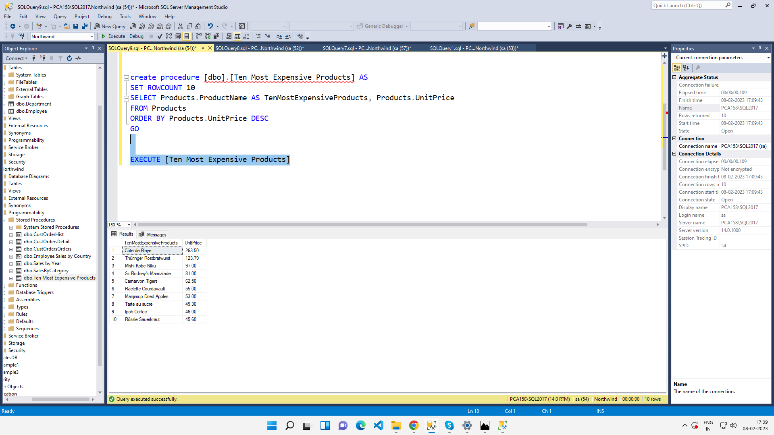

6. write a SQL query to Create Stored procedure in the Northwind database to insert

Customer Order Details

ANS.

CREATE PROCEDURE spInsert @ordID int, @pID int , @uPrice decimal(5,2), @totalitems int, @disc int

AS

BEGIN

INSERT INTO [Order Details] VALUES(@ordID, @pID, @uPrice, @totalitems, @disc)

END

EXECUTE spINSERT 10249,12,1,1,1

SELECT * FROM [Order Details];

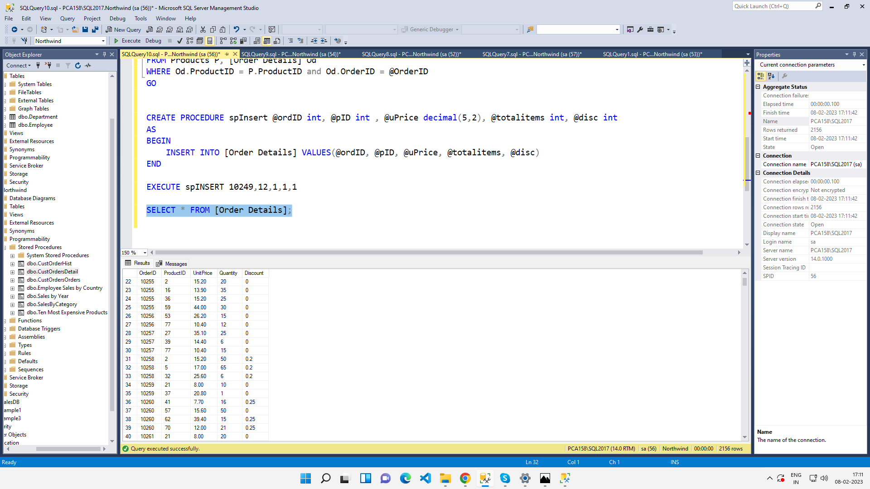

7. write a SQL query to Create Stored procedure in the Northwind database to update

Customer Order Details

ANS.

CREATE PROCEDURE spUpdate @ordID int, @pID int , @uPrice decimal(5,2), @totalitems int, @disc int

AS

BEGIN

UPDATE [Order Details]

SET UnitPrice = @uPrice, Quantity = @totalitems, Discount = @disc

WHERE OrderID = @ordID AND ProductID=@pID;

END

EXECUTE spUpdate 10248,1,10,10,0.85

SELECT * FROM [Order Details];

