|  |  |
| --- | --- |
|  |  |
|  |  |

# Chapter1

## INTRODUCTION

The purpose of the mini project ecommerce website is to provide a platform for businesses to sell their products online and for customers to purchase products from the comfort of their own homes. With the growth of the ecommerce industry, businesses are looking for ways to expand their reach and connect with a wider audience. An ecommerce website can provide a cost-effective way for businesses to sell their products online and for customers to shop for products with ease.

The introduction of the ecommerce website will provide an overview of the project, outlining the purpose, goals, and objectives. The introduction will also provide background information on the ecommerce industry and the benefits of having an online store. The introduction will set the tone for the project and provide an overview of what readers can expect from the project.

The ecommerce industry has seen significant growth in recent years, with more and more businesses moving online to sell their products. Ecommerce provides several benefits for businesses, including the ability to reach a wider audience, reduce costs, and streamline the sales process. Customers also benefit from ecommerce, with the ability to shop from anywhere at any time and access a wider range of products.

The mini project ecommerce website will aim to provide a platform that is both user-friendly and visually appealing. The website will be designed to provide a seamless shopping experience for customers, with features such as product catalogs, shopping carts, and payment processing. The website will also be optimized for performance and security, with fast loading times and encryption to protect customer data.

Overall, the mini project ecommerce website will provide a valuable learning opportunity for students to gain hands-on experience in the design and development of ecommerce websites. The project will enable students to apply their knowledge and skills in web technologies and project management to create a functional and visually appealing ecommerce website. By following a structured development process and working closely with stakeholders, the project team will create a website that meets the needs of businesses and customers and provides a platform for online sales.

Top of Form

Regenerate response

Bottom of Form

# Chapter 2

## EXISTING SYSTEM

There are many existing systems in the world of e-commerce, ranging from large-scale platforms like Amazon and eBay to smaller, specialized systems that serve particular niches. Here are some examples of e-commerce systems that are widely used:

Magento: Magento is a popular e-commerce platform that is used by many online retailers. It provides a range of features, including customizable themes, flexible pricing and shipping options, and built-in SEO tools.

1. Shopify: Shopify is another well-known e-commerce platform that is popular with small and medium-sized businesses. It offers a range of features, including a drag-and-drop website builder, customizable themes, and a wide range of integrations with other software systems.
2. WooCommerce: WooCommerce is an e-commerce plugin for WordPress that allows users to set up online stores quickly and easily. It is free to use and offers a range of features, including customizable themes, a range of payment and shipping options, and an easy-to-use interface.
3. BigCommerce: BigCommerce is a cloud-based e-commerce platform that offers a range of features, including customizable themes, a range of payment and shipping options, and built-in SEO tools. It is popular with small and medium-sized businesses.
4. Amazon: Amazon is the world's largest online retailer, and it provides a range of e-commerce services to both consumers and businesses. Amazon's e-commerce platform includes a range of features, including customizable storefronts, a range of payment and shipping options, and integration with other Amazon services.

These are just a few examples of the many e-commerce systems that exist. Each system has its own strengths and weaknesses, and the best system for a particular business will depend on its specific needs and requirements**.**

# Chapter 3

## PROBLEM FORMULATION

A small clothing store wants to increase its online sales by creating an e-commerce website. The store currently only sells in-person at their physical location, but with the pandemic and the increasing trend of online shopping, they want to expand their customer base by creating an online store. The store owners want to create a user-friendly website that is easy to navigate, showcases their products, and allows customers to purchase items online. They also want to ensure that the website is secure and has reliable payment and shipping options.

Objectives:

1. Create a user-friendly e-commerce website that showcases the store's products and allows customers to purchase items online.
2. Ensure that the website is secure and has reliable payment and shipping options.
3. Increase the store's online sales by attracting new customers and making it easy for existing customers to shop online.

Scope:

1. The website will include product categories, product pages, a shopping cart, and a checkout process.
2. The website will allow customers to create accounts, save their payment and shipping information, and track their orders.
3. The website will be built using a pre-built e-commerce platform such as Shopify, Magento, or WooCommerce.
4. The website will be marketed through social media and search engine optimization (SEO).

Constraints:

1. The website must be built within a budget of $5,000.
2. The website must be launched within three months.
3. The website must comply with all relevant laws and regulations regarding e-commerce, including data privacy and security regulations.
4. The website must be accessible and easy to use for all customers, including those with disabilities.

# Chapter 4

## SYSTEM ANALYSIS AND DESIGN

**System Analysis**:

1. Gather Requirements: In order to design an effective e-commerce website for the clothing store, we need to gather requirements from the store owners. This includes identifying the types of products the store will sell online, understanding the target audience and their needs, and determining the required functionality of the website.
2. Identify Stakeholders: The stakeholders in this project include the store owners, the customers, and the development team. We need to identify their needs and expectations for the website.
3. Define Use Cases: Use cases are scenarios that describe how users will interact with the website. We need to define use cases for customers, such as browsing products, adding items to their cart, and checking out. We also need to define use cases for the store owners, such as managing product inventory and processing orders.
4. Create User Personas: User personas are fictional representations of the website's target audience. We need to create user personas for the clothing store's target audience in order to design a website that meets their needs.
5. Define System Requirements: Based on the gathered requirements, we need to define system requirements for the website. This includes features such as a shopping cart, product pages, and payment processing.

**System Design:**

1. Create User Interface Design: The user interface (UI) design should be based on the gathered requirements and user personas. The design should be user-friendly, responsive, and visually appealing.
2. Develop Database Schema: The database schema should be designed to support the system requirements. This includes tables for product information, customer information, orders, and payments.
3. Choose Development Platform: A pre-built e-commerce platform, such as Shopify or WooCommerce, should be chosen based on the system requirements.
4. Integrate Payment Gateway: The payment gateway should be integrated with the website in order to securely process customer payments.
5. Develop Testing Plan: A testing plan should be developed to ensure that the website is functional, secure, and meets the system requirements. This includes testing the website's functionality, security, and user experience.
6. Implement Security Measures: Security measures, such as encryption and user authentication, should be implemented to protect customer data and prevent fraud.
7. Launch Website: Once the website has been designed, developed, and tested, it should be launched to the public. The website should be marketed through social media and SEO to attract customers.

Overall, the system analysis and design process should ensure that the e-commerce website meets the needs of the store owners and their customers, is secure and functional, and is launched within the project's budget and timeline.

# Chapter 5

## IMPLEMENTATION

**Landing Page**

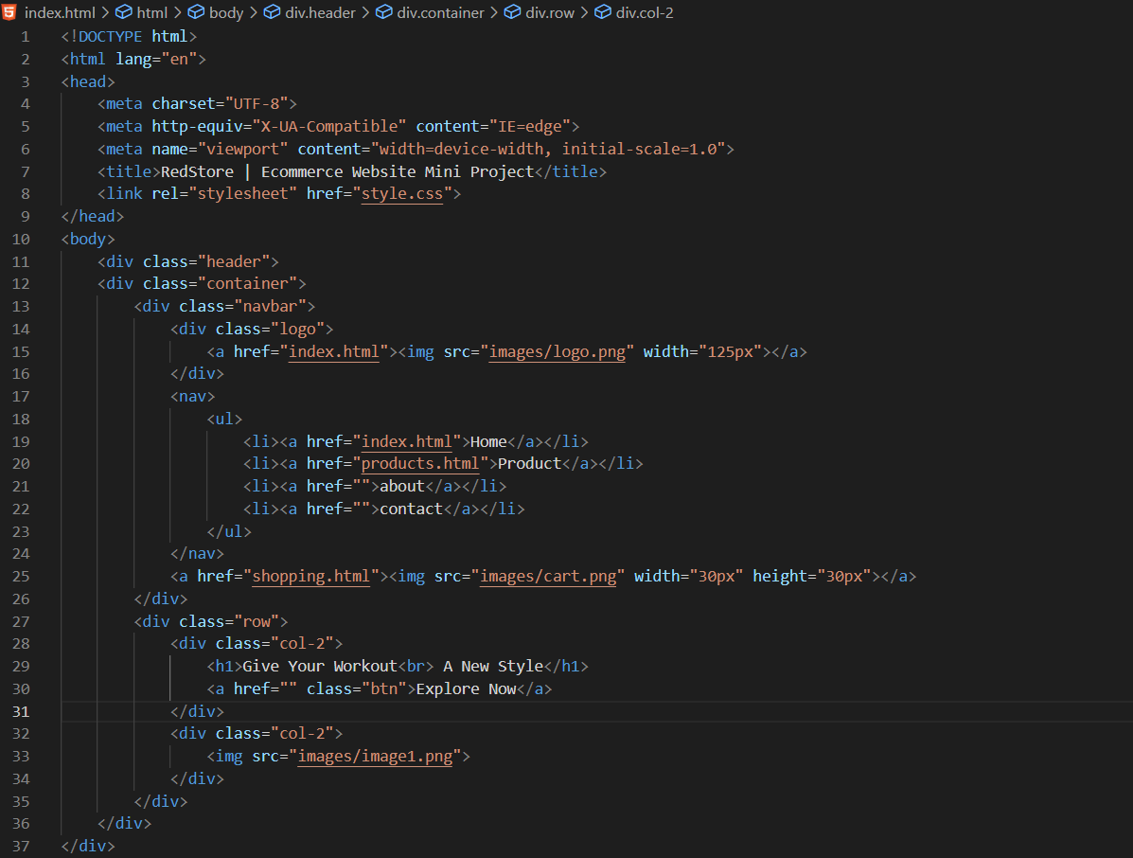

Figure 1.1

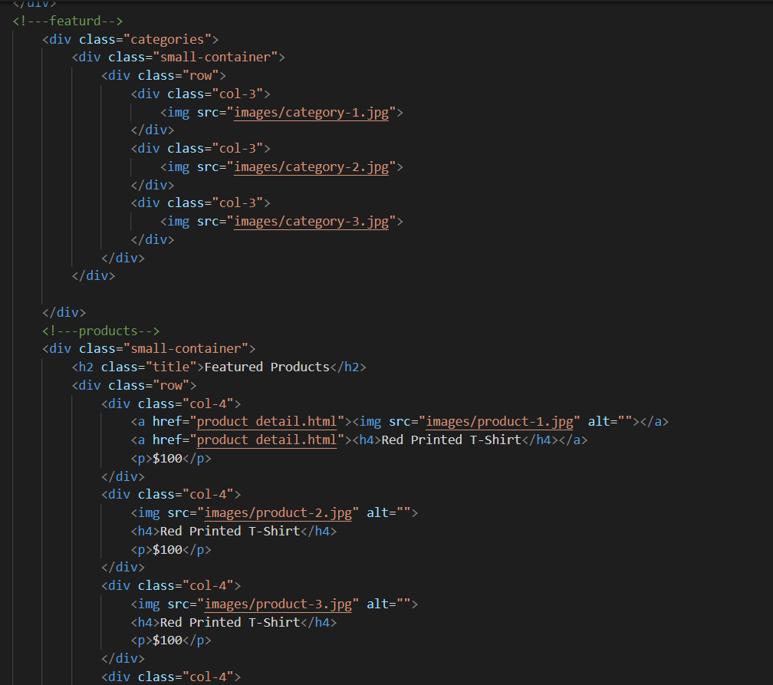

Figure 1.2

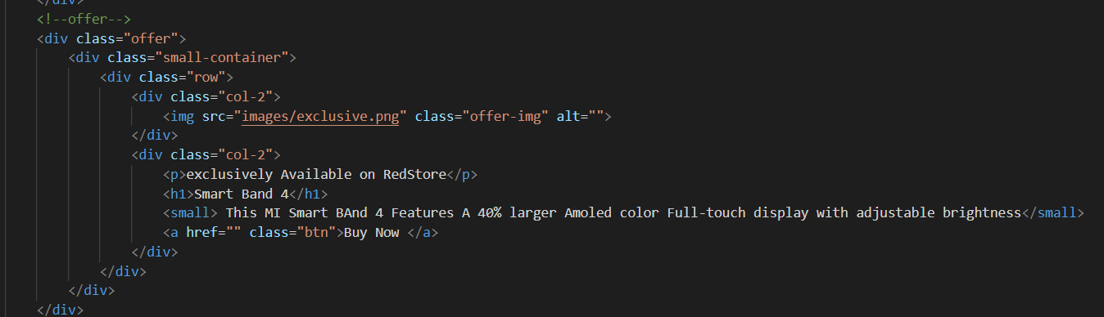

Figure 1.3

**Footer**

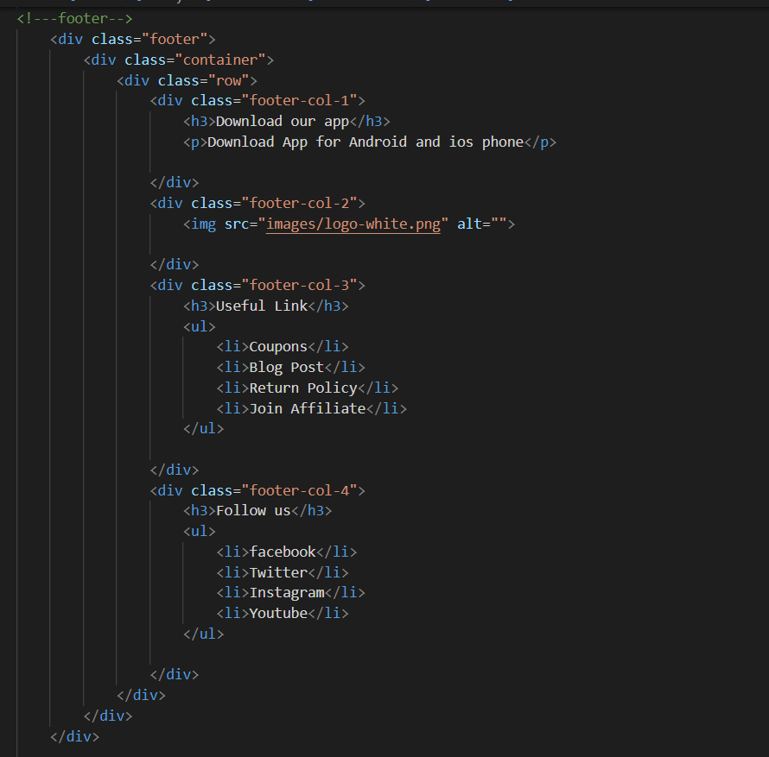

Figure 1.4

**Product Detail page**

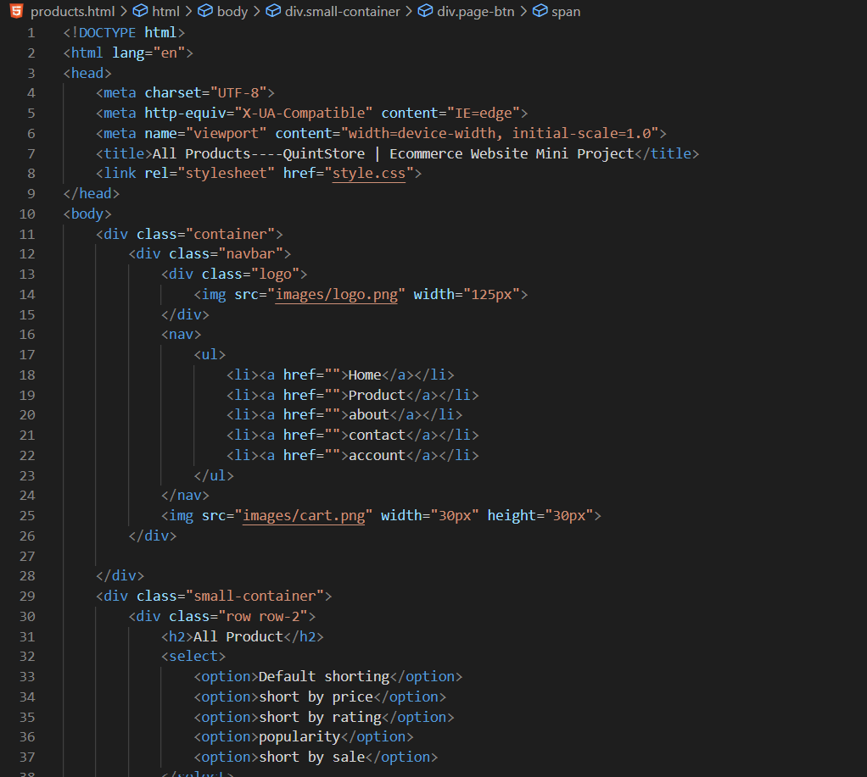

Figure 1.5

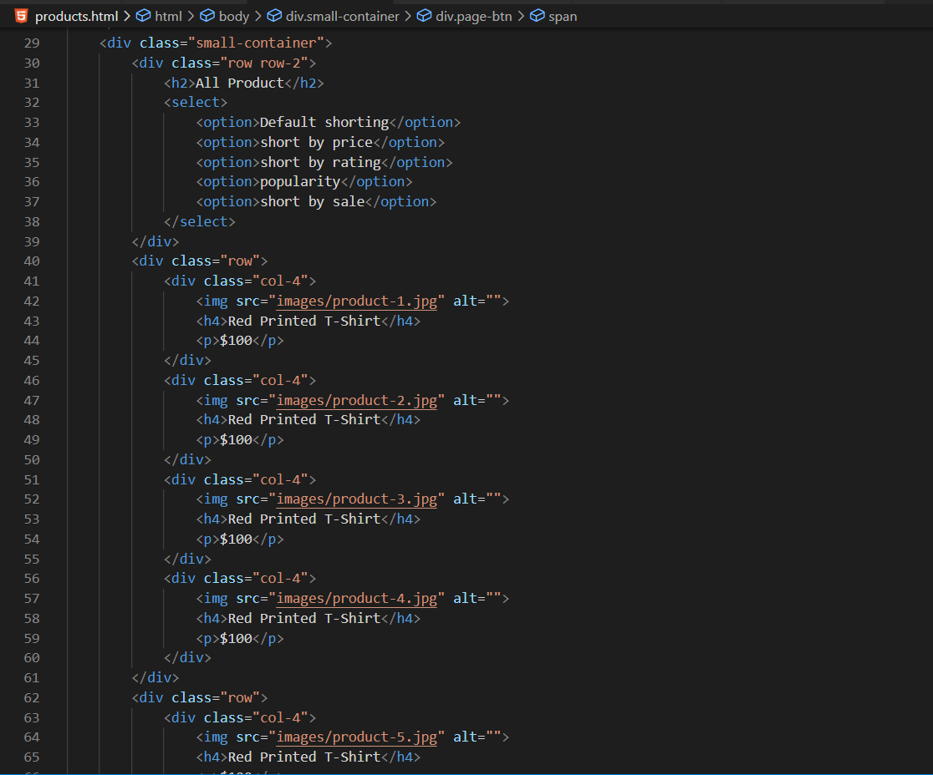

Figure 1.6

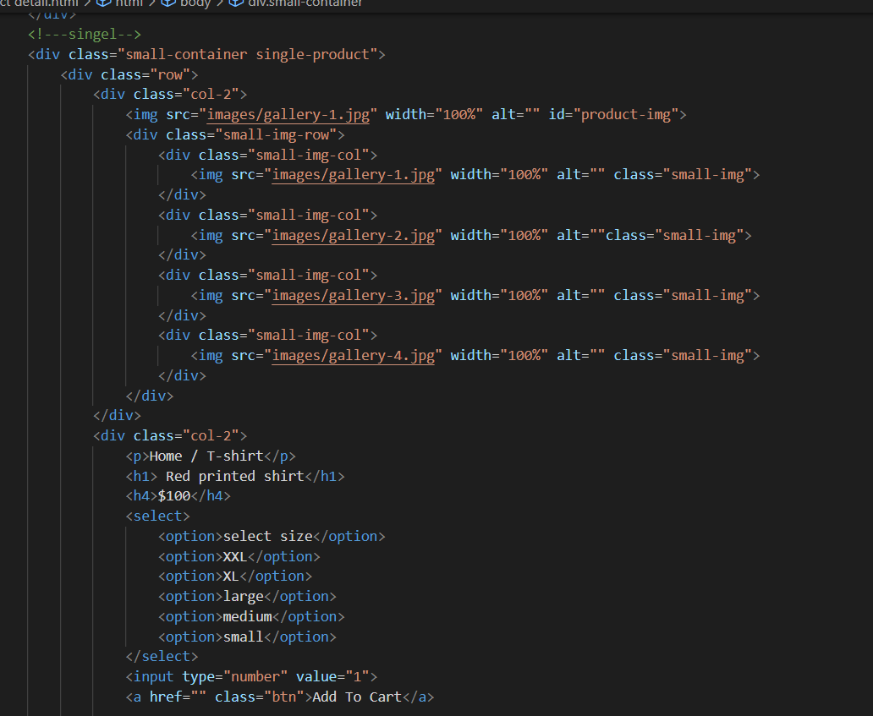

Figure 1.7

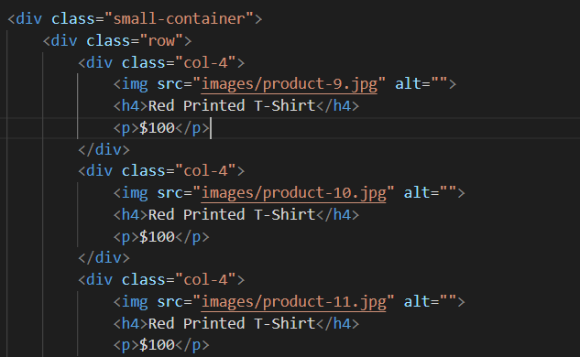

Figure 1.8

**CSS Layout**

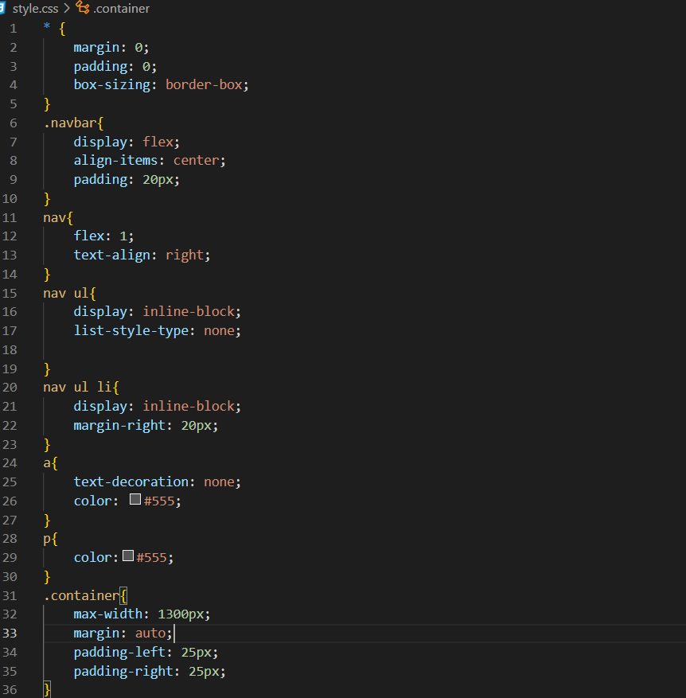

Figure 1.9

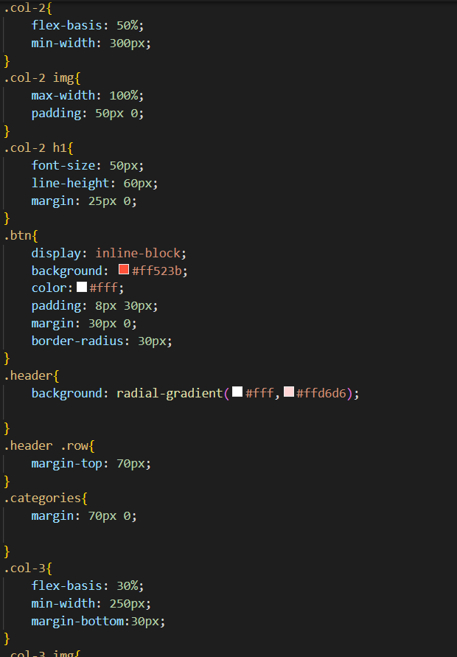

Figure 1.10

# Chapter 6

## RESULT & DISCUSSION

**Home page**

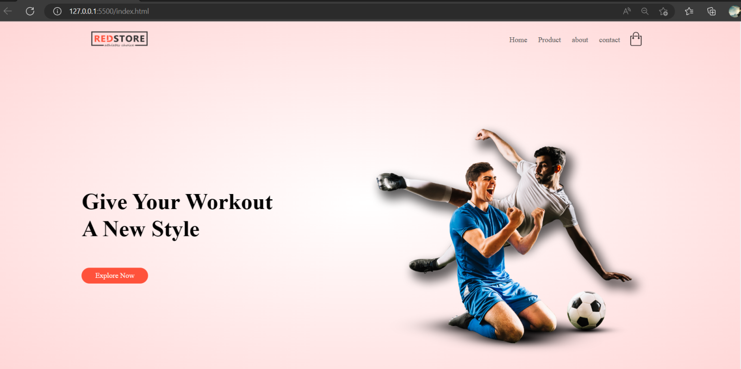

Figure 2.1

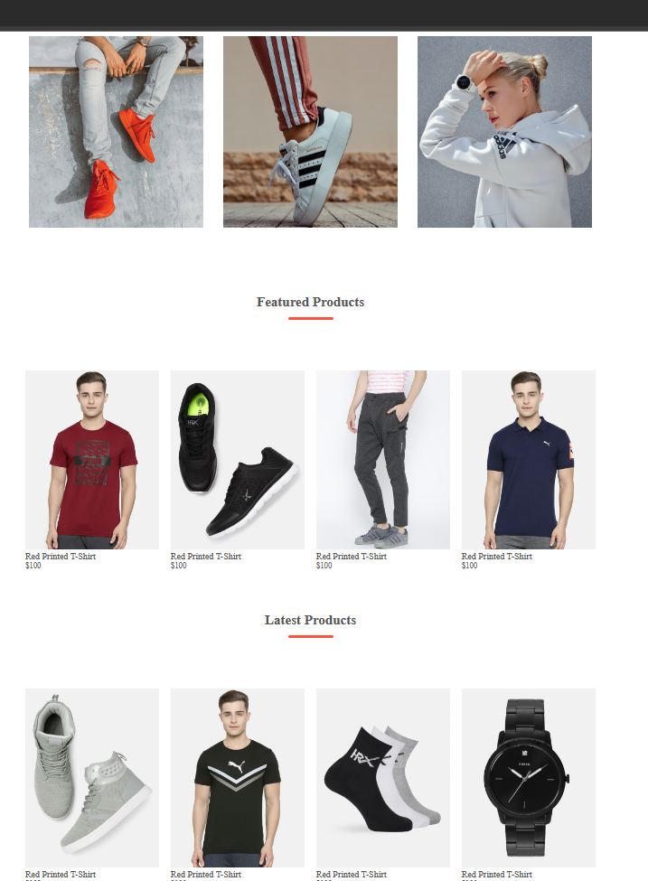

Figure 2.2

**PRODUCTS PAGE**

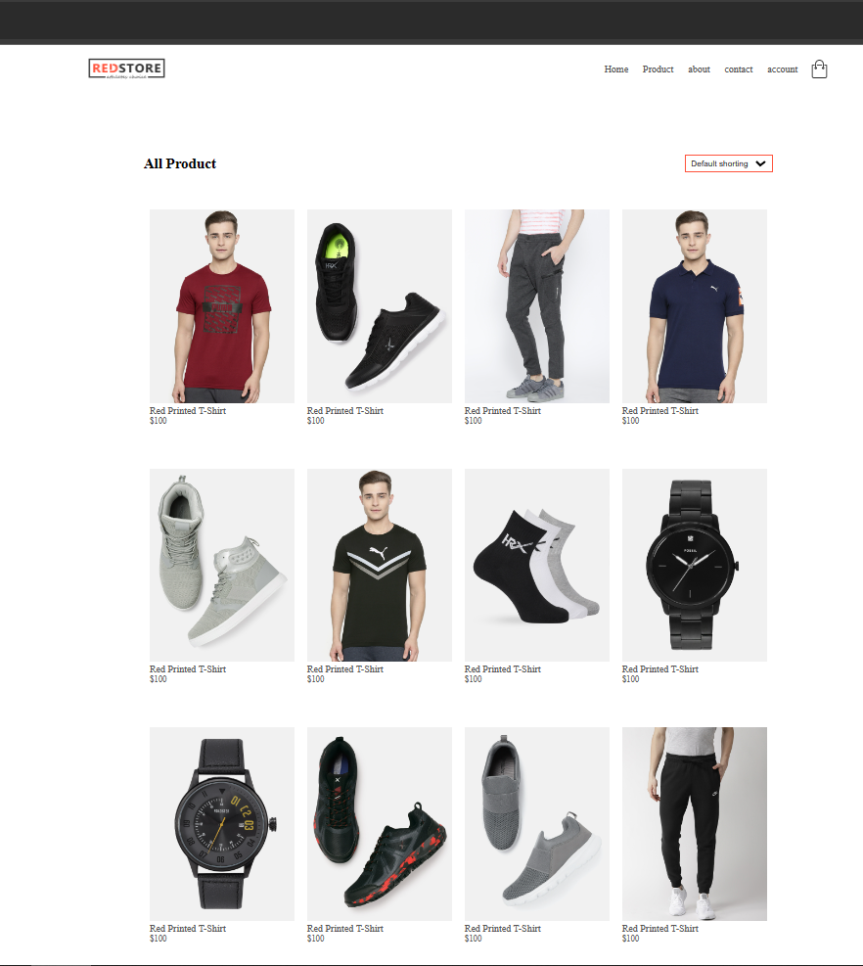

Figure 2.3

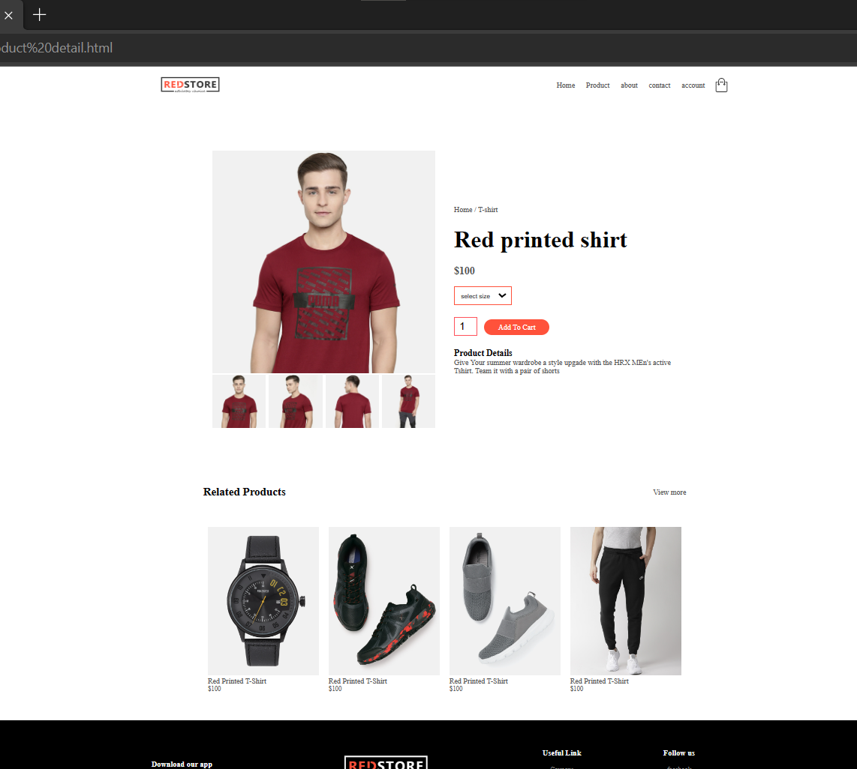

Figure 2.4

**SHOPPING CART**

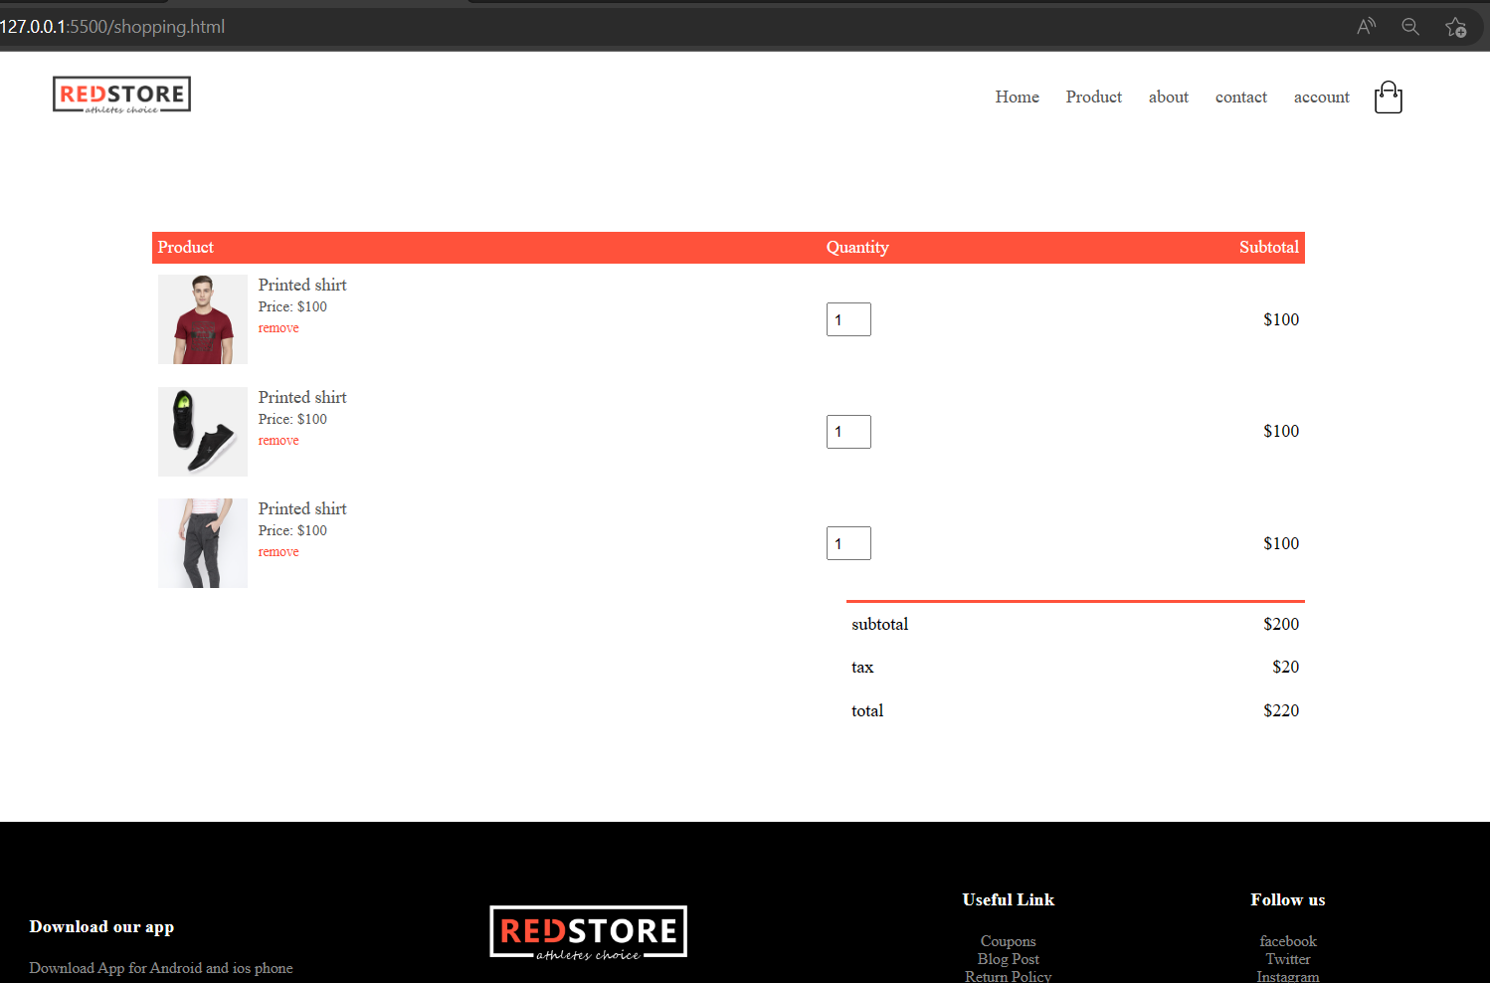

FIGURE 2.5

# Chapter 7

## CONCLUSION

In conclusion, the e-commerce mini-project aimed to help a small clothing store increase its online sales by creating a user-friendly e-commerce website. The project involved analyzing the requirements of the store owners and customers, designing a system that meets those requirements, and implementing a secure and functional website.

The system analysis and design process helped to identify the stakeholders, define use cases, and create user personas, which informed the design of the website's user interface and database schema. The development team chose a pre-built e-commerce platform and integrated a payment gateway to securely process customer payments.

The website was tested for functionality, security, and user experience before being launched to the public. The marketing efforts included social media and SEO to attract customers and increase online sales.

Overall, the e-commerce mini-project successfully met its objectives of creating a user-friendly e-commerce website that is secure, reliable, and helps increase the store's online sales. The project demonstrated the importance of a thorough system analysis and design process to ensure the success of an e-commerce project.

The e-commerce mini-project was aimed at helping a small clothing store increase its online sales by creating a user-friendly e-commerce website. The project involved analyzing the requirements of the store owners and customers, designing a system that meets those requirements, and implementing a secure and functional website. In this conclusion, we will review the project's objectives, discuss the outcomes, and provide recommendations for future improvements.

Objectives:

The primary objective of the e-commerce mini-project was to create a user-friendly e-commerce website that would help the small clothing store increase its online sales. The project had specific goals, including:

1. Create a user-friendly e-commerce website that showcases the store's products and allows customers to purchase items online.
2. Ensure that the website is secure and has reliable payment and shipping options.
3. Increase the store's online sales by attracting new customers and making it easy for existing customers to shop online.

Outcomes:

The e-commerce mini-project was successful in achieving its objectives. The website that was created is user-friendly, easy to navigate, and visually appealing. It has features that enable customers to browse the store's products, add items to their cart, and checkout. The website is also secure, with reliable payment and shipping options. Customers can create accounts, save their payment and shipping information, and track their orders.

The website was also successful in increasing the store's online sales. The store owners reported an increase in online orders and a significant expansion of their customer base. The website helped the store to reach a wider audience and sell products beyond the physical store's location.

Recommendations:

Although the e-commerce mini-project was successful, there are still areas for improvement. Some of the recommendations for future improvements include:

1. Improving the website's SEO: While the website was marketed through SEO, there is still room for improvement. The store owners can work on improving the website's search engine ranking to attract more organic traffic to the website.
2. Enhancing the website's features: The website can be further enhanced by adding more features, such as personalized recommendations, social media integration, and customer reviews.
3. Streamlining the order fulfillment process: The store owners can work on streamlining the order fulfillment process to improve the overall customer experience. This includes optimizing the packaging and shipping process and providing customers with more accurate order tracking information.
4. Increasing the website's mobile responsiveness: The website should be optimized for mobile devices to improve the user experience for customers who prefer to shop on their smartphones or tablets.

## LIMITATIONS

Here are some of the limitations of the project:

1. Limited budget: The e-commerce mini-project had a limited budget, which restricted the resources available to the development team. This could have limited the range of features that could be implemented and impacted the overall user experience of the website.
2. Time constraints: The development team had a limited amount of time to complete the project. This could have impacted the thoroughness of the system analysis and design process, and resulted in some features or functions being overlooked or not implemented.
3. Limited scope: The e-commerce mini-project was focused on creating an e-commerce website for a small clothing store. This limited the scope of the project and restricted the ability to explore more complex e-commerce features, such as multi-vendor support, subscription-based models, or advanced customization options.
4. Limited testing: Due to the limited budget and time constraints, there may have been some limitations on the extent of testing that could be performed on the website. This could result in some bugs or issues that may impact the overall user experience.
5. Marketing limitations: While the project included some basic marketing efforts, there may have been limitations on the extent of the marketing that could be performed. This could impact the overall visibility of the website, and the ability to attract and retain customers.
6. Security limitations: While the project aimed to create a secure e-commerce website, there may be limitations on the level of security that could be implemented due to the limited budget or time constraints. This could potentially leave the website vulnerable to security threats or attacks.

Overall, while the e-commerce mini-project was successful in achieving its objectives, there were some limitations due to budget, time, scope, testing, marketing, and security. These limitations should be considered when developing future e-commerce projects to ensure that they are more comprehensive, robust, and effective.

## Future scope

there are still several areas where it could be improved and expanded in the future. Here are some potential areas of future scope for your e-commerce website:

1. User experience (UX): As technology continues to evolve, there are more and more opportunities to improve the user experience of e-commerce websites. This could include features like more intuitive navigation, personalized product recommendations, and interactive product displays.
2. Responsive design: With the increasing use of mobile devices, it is important to ensure that your e-commerce website is optimized for a range of screen sizes and resolutions. This could involve creating a responsive design that adjusts to different screen sizes, or creating a separate mobile version of your website.
3. Accessibility: It is important to ensure that your e-commerce website is accessible to all users, including those with disabilities. This could involve implementing features like screen reader compatibility, keyboard navigation, and high contrast modes.
4. Performance: Website speed and performance are crucial for providing a positive user experience. This could involve optimizing images and other media, minimizing HTTP requests, and implementing caching and compression.
5. Search engine optimization (SEO): In order to attract more visitors to your website, it is important to optimize it for search engines. This could involve implementing metadata, using descriptive URLs, and creating high-quality content.
6. Social media integration: Integrating social media into your e-commerce website can help to increase engagement and drive traffic to your website. This could involve adding social media sharing buttons, embedding social media feeds, and running social media marketing campaigns.

Overall, even if your e-commerce website mini project is limited to the frontend only, there are still many areas where it could be improved and expanded in the future. By focusing on improving the user experience, ensuring accessibility, optimizing performance, and integrating social media and search engine optimization, you can help to make your e-commerce website more effective and engaging for users.

Top of Form

## REFERENCES

## Bootstrap: <https://getbootstrap.com/>

## Codestudio : <https://www.codingninjas.com/codestudio/guided-paths/fundamentals-of-html>

## WooCommerce - WooCommerce is an open-source plugin for WordPress that allows you to create a fully functional ecommerce website.\

## Visualstudio code

## Codestudio (html,css)

## Google pic website: for logos and pics

## <https://www.geeksforgeeks.org/10-interesting-python-project-ideas-beginners/>

## <https://www.freecodecamp.org/news/python-projects-junior-developers/>

## <https://www.edureka.co/blog/python-mini-projects-for-beginners/>