

Experiment No.4

Title: Calculation of correlation coefficient

Batch : A1 Roll No: 16014225005 Experiment No: 04

GITHUB LINK : https://github.com/jainamb-sketc/16014225005_FDS

Aim: To write a program to compute correlation coefficient and plot the scatter plot

Resources needed: Python 3.x environment (Jupyter Notebook / Google Colab etc.) or R language environment

Theory:
Correlation coefficient:
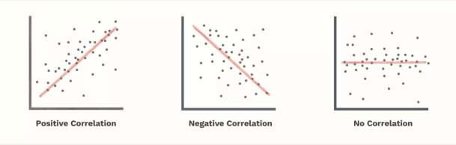
The correlation coefficient is a statistical measure of the strength of a linear relationship between two variables. Its values can range from -1 to 1. A correlation coefficient of -1 describes a perfect negative, or inverse, correlation, with values in one series rising as those in the other decline, and vice versa. A coefficient of 1 shows a perfect positive correlation, or a direct relationship. A correlation coefficient of 0 means there is no linear relationship. These types are shown in figure below.

The sample correlation coefficient can be represented with a formula:
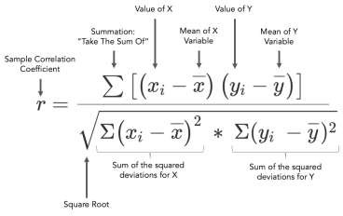
Correlation coefficients are used in science and finance to assess the degree of association between two variables, factors, or data sets. For example, as high oil prices are favourable for crude producers, one might assume that the correlation between oil prices and forward returns

on oil stocks is strongly positive. Calculating the correlation coefficient for these variables based on market data reveals a moderate and inconsistent correlation over lengthy periods.

Procedure:
- Step 1: Start the Program
- Step 2: Import math package
- Step 3: Define correlation coefficient function.
- Step 4: Calculate correlation coefficient using formula for three types as positive, negative and no correlation. (without using in-built function)
- Step 5: Print the result
- Step 6: Plot the scatter plot.
- Step 7: Stop the process

Results: (Program printout with output as per the format)

GITHUB LINK : https://github.com/jainamb-sketc/16014225005_FDS

import math

import csv

import os

os.system("") # enables ANSI colours in Windows terminals (VS Code)

# ---------- colour helpers ----------

RESET, BOLD = "\033[0m", "\033[1m"

RED, GREEN, YELLOW = "\033[91m", "\033[92m", "\033[93m"

BLUE, MAGENTA, CYAN, WHITE = "\033[94m", "\033[95m", "\033[96m", "\033[97m"

def c(text, *styles):

return "".join(styles) + str(text) + RESET

FILE_NAME = "london_weather_data_1979_to_2023.csv"

def load_columns(file_name, col_x, col_y):

"""Read two columns from the CSV, skipping rows with missing values."""

x_vals, y_vals = [], []

with open(file_name, newline="") as f:

for row in csv.DictReader(f):

if row[col_x] == "" or row[col_y] == "":

continue

x_vals.append(float(row[col_x]))

y_vals.append(float(row[col_y]))

return x_vals, y_vals

# ---------- correlation coefficient (no in-built function) ----------

# n*Σxy - (Σx)(Σy)

# r = ---------------------------------------------

# sqrt[ n*Σx² - (Σx)² ] * sqrt[ n*Σy² - (Σy)² ]

def correlation_coefficient(x, y):

n = len(x)

sum_x, sum_y = sum(x), sum(y)

sum_xy = sum(a * b for a, b in zip(x, y))

sum_x2 = sum(a * a for a in x)

sum_y2 = sum(b * b for b in y)

num = n * sum_xy - sum_x * sum_y

den = math.sqrt(n * sum_x2 - sum_x ** 2) * math.sqrt(n * sum_y2 - sum_y ** 2)

return num / den

def describe(r):

a = abs(r)

if a < 0.2:

return "No (or negligible) linear correlation"

strength = "Strong" if a >= 0.7 else "Moderate" if a >= 0.4 else "Weak"

return f"{strength} {'positive' if r > 0 else 'negative'} correlation"

# ---------- scatter plot drawn in the terminal ----------

def terminal_scatter(x, y, colour, width=60, height=18):

min_x, max_x = min(x), max(x)

min_y, max_y = min(y), max(y)

grid = [[0] * width for _ in range(height)]

for a, b in zip(x, y):

col = int((a - min_x) / (max_x - min_x) * (width - 1))

row = int((b - min_y) / (max_y - min_y) * (height - 1))

grid[height - 1 - row][col] += 1

peak = max(max(r) for r in grid)

shades = " .:oO@" # sparse -> dense

for i, row in enumerate(grid):

label = f"{max_y:>8.0f} " if i == 0 else f"{min_y:>8.0f} " if i == height - 1 else " " * 9

line = ""

for cell in row:

if cell == 0:

line += " "

else:

level = 1 + int((cell / peak) ** 0.5 * (len(shades) - 2))

line += shades[level]

print(c(label, WHITE) + c("|", WHITE) + c(line, colour))

print(" " * 9 + c("+" + "-" * width, WHITE))

print(" " * 10 + c(f"{min_x:<.0f}", WHITE) + " " * (width - 8) + c(f"{max_x:>.0f}", WHITE))

cases = [

("POSITIVE CORRELATION", "TG", "TX",

"Mean temperature TG (0.1 °C)", "Max temperature TX (0.1 °C)", GREEN),

("NEGATIVE CORRELATION", "SS", "CC",

"Sunshine duration SS (0.1 hours)", "Cloud cover CC (oktas)", RED),

("NO CORRELATION", "TG", "PP",

"Mean temperature TG (0.1 °C)", "Sea level pressure PP (0.1 hPa)", BLUE),

]

print()

print(c("=" * 70, CYAN, BOLD))

print(c(" EXPERIMENT 4 : CORRELATION COEFFICIENT - LONDON WEATHER DATA", CYAN, BOLD))

print(c("=" * 70, CYAN, BOLD))

summary = []

for title, cx, cy, lx, ly, colour in cases:

x, y = load_columns(FILE_NAME, cx, cy)

r = correlation_coefficient(x, y)

summary.append((title, cx, cy, r))

print()

print(c(f"{title} ({cx} vs {cy})", colour, BOLD))

print(c("-" * 70, colour))

print(f" {c('Data points :', YELLOW)} {len(x)}")

print(f" {c('Correlation r :', YELLOW)} {c(f'{r:.4f}', colour, BOLD)}")

print(f" {c('Meaning :', YELLOW)} {c(describe(r), colour)}")

print()

print(c(f" Scatter plot (Y: {ly})", MAGENTA))

terminal_scatter(x, y, colour)

print(c(f" X: {lx}", MAGENTA))

print()

print(c("=" * 70, CYAN, BOLD))

print(c(" SUMMARY", CYAN, BOLD))

print(c("=" * 70, CYAN, BOLD))

for (title, cx, cy, r), (_, _, _, _, _, colour) in zip(summary, cases):

print(f" {c(f'{title:<22}', colour, BOLD)} {cx} vs {cy:<3} r = {c(f'{r:+.4f}', colour, BOLD)}")

print()

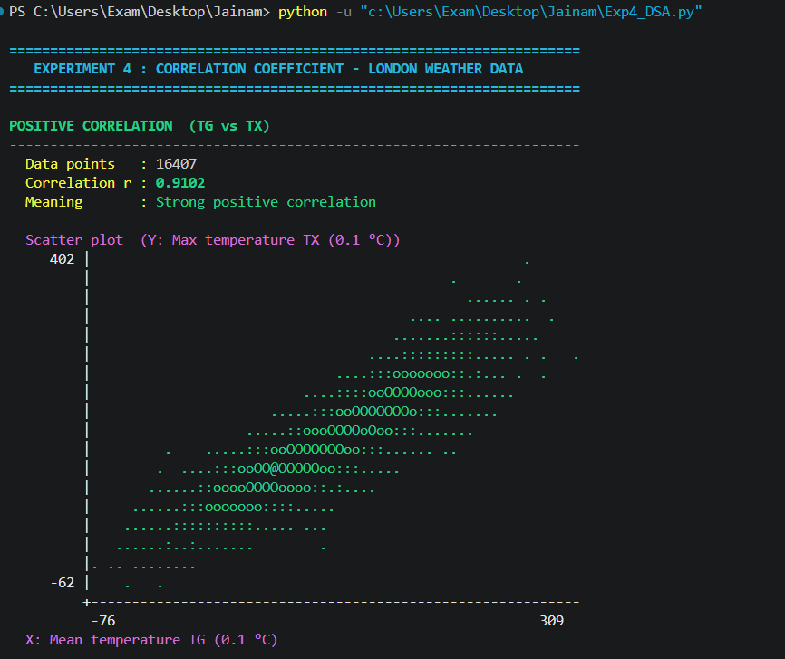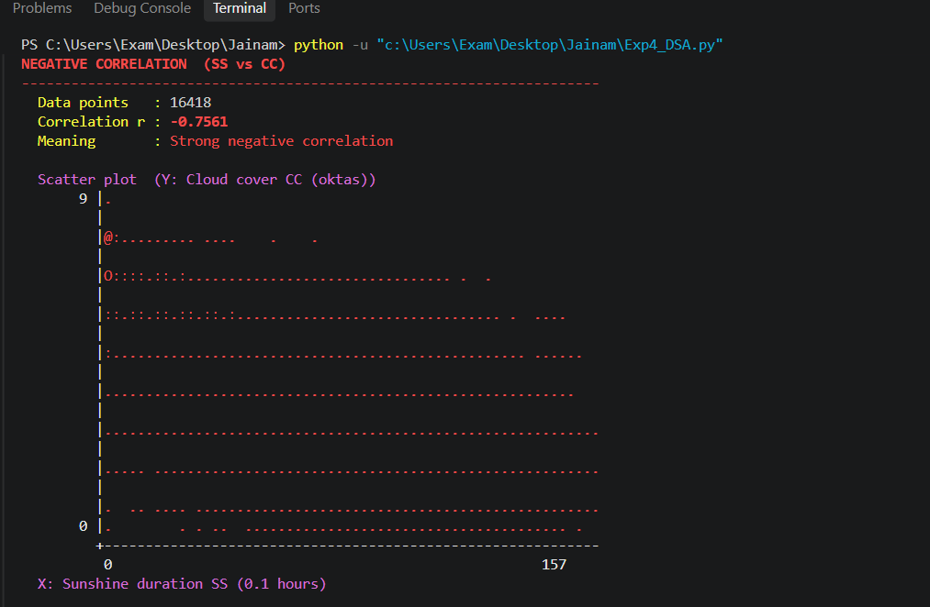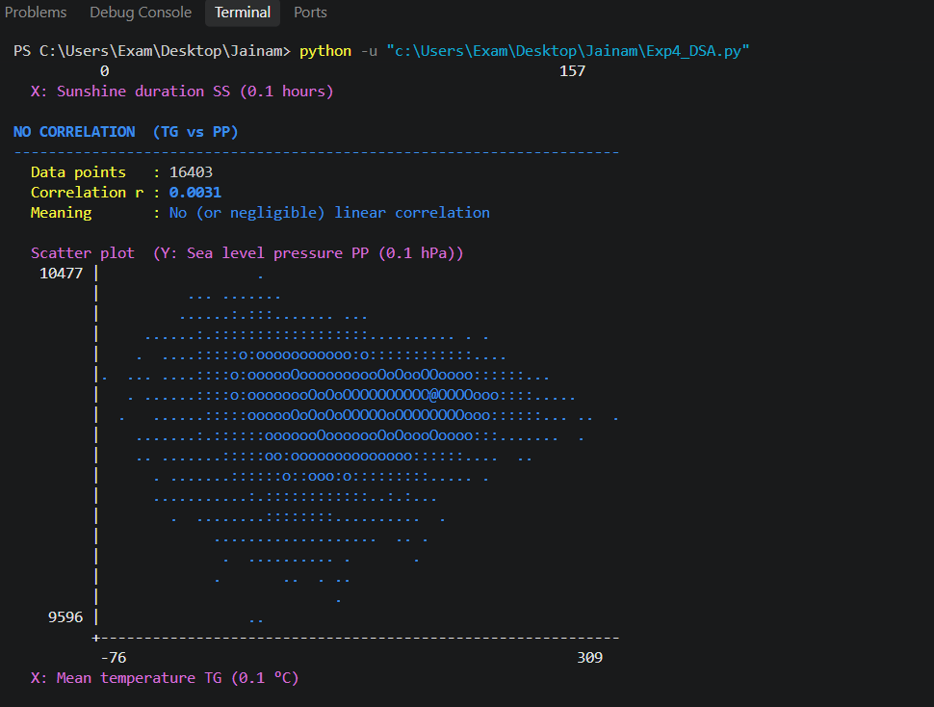



Questions:
  - What do the values of the correlation coefficient mean?
Ans : The correlation coefficient (r) ranges from -1 to +1 and shows the strength and direction of the linear relationship between two variables.
- r = +1: perfect positive correlation (both variables increase together).
- r = -1: perfect negative correlation (one increases as the other decreases).
- r = 0: no linear relationship.
- Closer to ±1: stronger relationship; closer to 0: weaker relationship.
In your dataset, TG vs TX (r = 0.91) is strongly positive, SS vs CC (r = -0.76) is strongly negative, and TG vs PP (r = 0.003) shows no correlation.

  - What are some limitations of correlation coefficient to consider?
Ans: The main limitations of the correlation coefficient are:
- Only linear relationships: a strong curved relationship can still give r close to 0.
- Sensitive to outliers: a few extreme values can raise or lower r a lot.
- Correlation is not causation: a high r does not mean one variable causes the other.
- Affected by the data range: a narrow range of values can hide a real relationship.
- Can mislead with mixed groups: combining different subgroups can create or hide a correlation.

________________________________________________________________________

Course Outcomes: (refer exp list)

Comprehend descriptive and proximity measures of data.

Conclusion:

Grade: AA / AB / BB / BC / CC / CD /DD
Signature of faculty in-charge with date

_______________________________________________________________________
References:
Books/ Journals/ Websites:
- S.C. Gupta, V. K. Kapoor, Fundamentals of Mathematical Statistics, Sultan Chand and Sons, 2020.
- P. N. Tan, M. Steinbach, Vipin Kumar, Introduction to Data Mining, Pearson Education, 2016.
- Han, Kamber, Data Mining Concepts and Techniques, Morgan Kaufmann, 3rd Edition, 2012

