

Experiment No. 5
Title: Prediction of missing data using regression modeling

Batch : A1 Roll No : 16014225005 Experiment No : 05

GITHUB LINK : https://github.com/jainamb-sketc/16014225005_FDS

Aim: To predict missing data values using regression modeling.

Resources needed: Python, any data source (Excel/CSV)

Theory:
Missing data (or missing values) is defined as the data value that is not stored for a variable in the observation of interest. The problem of missing data is relatively common in data set and can have a significant effect on the conclusions that can be drawn from the data. There are various techniques proposed for handling missing values like deletion of records/attributes, filling with a random value or using some measures of central tendency, imputation using regression etc. Regression imputation is guessing missing variables using regression if we know there is a correlation between the missing value and other variables. Scatterplots can be used to identify correlation between variables.
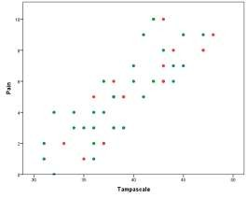

Figure 1: A scatter plot showing correlation between attributes pain and Tampa scale.

Once correlation is identified either linear regression or multiple regression can be used for imputation. Linear regression involves finding the “best” line as shown in fig. 1 to fit two
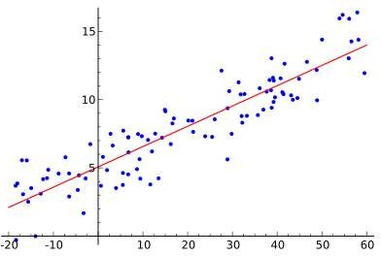
attributes (or variables) so that one attribute can be used to predict the other.
Figure 2: Example of simple linear regression, which has one independent variable

Multiple linear regression is an extension of linear regression, where more than two attributes are involved, and the data are fit to a multidimensional surface.

Prediction is predicting continuous or ordered values for a given input i.e. Numeric prediction, for example, predicting salary of employee with 10 years of experience.

Simple Linear Regression:

Straight line regression analysis involves a responsible variable y and a single predictor variable x. by modeling y as a linear function of x as given in equation 1,

y=w0 + w1*x (1)

where w0 and w1 are Regression co-efficient.

w₀ = Y-intercept
w₁ = Slope of the line
Calculate w0 and w1 by method of least squares, which estimates best fitting straight line. Let D be a training set,
[ D ] = { (x1,y1),(x2,y2),(x3,y3),… ,( x_{n}, y_{n})}

Regression co-efficient,

𝑤₁ =
∑|𝐷| (𝑥𝑖−𝑥̅) (𝑦𝑖−𝑦̅)
∑|𝐷| (𝑥𝑖−𝑥̅) 2
𝑖=1
𝑖=1
………………………………………………………………..(2)

𝑤₀ = 𝑦̅ − 𝑤₁𝑥̅…………………………………………………..…………………….(3) Where 𝑥̅ is the mean value of x1, x2, x3,….x_{n}.
And 𝑦̅ is the mean value of y1, y2, y3, y4,…y_{n}.

Multiple Linear Regression:
Multiple linear regression is used to explain the relationship between one continuous dependent variable and two or more independent variables. The independent variables can be continuous or categorical.
𝑦_{𝑖}= 𝑏₀+ 𝑏₁𝑥_{𝑖1} +𝑏₂𝑥_{𝑖2}+…+ 𝑏_{𝑛}𝑥_{𝑖𝑛} +ε Where , for i=1 to n obervetions:
𝑦_{𝑖} = dependent variable
𝑥_{𝑖1} , 𝑥_{𝑖2} , … ..= predictor variables
𝑏₁, 𝑏_{2,3…….} = Regression coeffients ε = Model’s error term

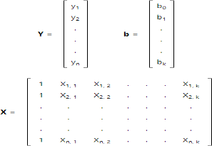

To handle the complications of multiple regression, we will use matrix algebra. The least squares normal equations can be expressed as: Y=Xb Multiply both sides with XT
XTY = XTXb or XTXb = XTY
Here, matrix XT is the transpose of matrix X. To solve for regression coefficients, simply pre-multiply by the inverse of XTX:
( XTX)-1 XTXb = ( XTX)-1 XTY since ( XTX)-1 XTX = I, the identity matrix, we get
slope b as,
b = (XTX)-1 XTY

Procedure / Approach /Algorithm / Activity Diagram:

- Identify attributes suitable for applying Linear regression. Construct a linear regression model for your dataset and predict the missing values in your data set. Evaluate the accuracy of prediction. (usage of built in package for prediction is not expected)
- Identify attributes suitable for applying Multiple Linear regression. Construct a linear regression model for your dataset and predict the missing values in your data set. Evaluate the accuracy of prediction. (usage of built in package for prediction is not expected)
- Compare All Regression Model and state the Difference in terms of Methodology and output.

Results: (Program printout with output as per the format)

GITHUB LINK : https://github.com/jainamb-sketc/16014225005_FDS

import csv
import math
import random
import os
import numpy as np

os.system("") # enables colours in VS Code / Windows terminal
GREEN, RED, YELLOW, CYAN, RESET = "\033[92m", "\033[91m", "\033[93m", "\033[96m", "\033[0m"

FILE_NAME = "london_weather_data_1979_to_2023.csv"

# ---------------------------------------------------------
# Step 1: Read the dataset
# ---------------------------------------------------------
rows = []
with open(FILE_NAME) as f:
for r in csv.DictReader(f):
rows.append(r)

print(CYAN + "=== EXPERIMENT 5 : REGRESSION IMPUTATION ===" + RESET)
print("Total rows :", len(rows))

# rows where TG is known (used to build model) and rows where TG is missing
known = [r for r in rows if r["TG"] != ""]
missing = [r for r in rows if r["TG"] == ""]
print("Rows with TG known :", len(known))
print(YELLOW + "Rows with TG missing : " + str(len(missing)) + RESET)

# ---------------------------------------------------------
# Step 2: Split known rows into training (80%) and testing (20%)
# (testing part is used only to check the accuracy)
# ---------------------------------------------------------
random.seed(1)
random.shuffle(known)
split = int(0.8 * len(known))
train = known[:split]
test = known[split:]

def get(data, col):
return [float(r[col]) for r in data]

# ---------------------------------------------------------
# Step 3: Simple Linear Regression y = w0 + w1*x
# w1 = sum((x - xmean)*(y - ymean)) / sum((x - xmean)^2)
# w0 = ymean - w1*xmean
# ---------------------------------------------------------
def simple_regression(x, y):
x_mean = sum(x) / len(x)
y_mean = sum(y) / len(y)
num = sum((a - x_mean) * (b - y_mean) for a, b in zip(x, y))
den = sum((a - x_mean) ** 2 for a in x)
w1 = num / den
w0 = y_mean - w1 * x_mean
return w0, w1

# ---------------------------------------------------------
# Step 4: Multiple Linear Regression b = (X^T X)^-1 X^T Y
# ---------------------------------------------------------
def multiple_regression(X, y):
X = np.column_stack([np.ones(len(X)), X]) # add column of 1s for b0
b = np.linalg.inv(X.T @ X) @ X.T @ np.array(y)
return b

# ---------------------------------------------------------
# Step 5: Accuracy measures
# ---------------------------------------------------------
def accuracy(actual, predicted):
n = len(actual)
errors = [a - p for a, p in zip(actual, predicted)]
mae = sum(abs(e) for e in errors) / n
rmse = math.sqrt(sum(e * e for e in errors) / n)
a_mean = sum(actual) / n
ss_res = sum(e * e for e in errors)
ss_tot = sum((a - a_mean) ** 2 for a in actual)
r2 = 1 - ss_res / ss_tot
return mae, rmse, r2

y_train = get(train, "TG")
y_test = get(test, "TG")

# ---------------- Simple Linear Regression ----------------
w0, w1 = simple_regression(get(train, "TN"), y_train)
slr_pred_test = [w0 + w1 * x for x in get(test, "TN")]
slr_mae, slr_rmse, slr_r2 = accuracy(y_test, slr_pred_test)

print(CYAN + "\n--- 1. SIMPLE LINEAR REGRESSION (TG from TN) ---" + RESET)
print(f"Equation : TG = {w0:.3f} + {w1:.3f} * TN")
print(f"MAE = {slr_mae:.3f} RMSE = {slr_rmse:.3f} R2 = {slr_r2:.4f}")

# ---------------- Multiple Linear Regression ----------------
X_train = [[float(r["TN"]), float(r["TX"])] for r in train]
X_test = [[float(r["TN"]), float(r["TX"])] for r in test]
b = multiple_regression(X_train, y_train)
mlr_pred_test = [b[0] + b[1] * x[0] + b[2] * x[1] for x in X_test]
mlr_mae, mlr_rmse, mlr_r2 = accuracy(y_test, mlr_pred_test)

print(CYAN + "\n--- 2. MULTIPLE LINEAR REGRESSION (TG from TN and TX) ---" + RESET)
print(f"Equation : TG = {b[0]:.3f} + {b[1]:.3f} * TN + {b[2]:.3f} * TX")
print(f"MAE = {mlr_mae:.3f} RMSE = {mlr_rmse:.3f} R2 = {mlr_r2:.4f}")

# ---------------------------------------------------------
# Step 6: Compare both models
# ---------------------------------------------------------
print(CYAN + "\n--- 3. COMPARISON ---" + RESET)
print(f"{'Model':<28}{'MAE':>8}{'RMSE':>8}{'R2':>9}")
print(f"{'Simple Linear (TN)':<28}{slr_mae:>8.3f}{slr_rmse:>8.3f}{slr_r2:>9.4f}")
print(f"{'Multiple Linear (TN, TX)':<28}{mlr_mae:>8.3f}{mlr_rmse:>8.3f}{mlr_r2:>9.4f}")
better = "Multiple Linear Regression" if mlr_rmse < slr_rmse else "Simple Linear Regression"
print(GREEN + "Better model (lower error): " + better + RESET)

# ---------------------------------------------------------
# Step 7: Predict the actual missing TG values (using the better model,
# trained again on ALL known rows)
# ---------------------------------------------------------
X_all = [[float(r["TN"]), float(r["TX"])] for r in known]
y_all = get(known, "TG")
b = multiple_regression(X_all, y_all)

print(CYAN + "\n--- 4. PREDICTED MISSING TG VALUES (Multiple Regression) ---" + RESET)
print(f"{'DATE':<12}{'TN':>8}{'TX':>8}{'Predicted TG':>15}")
for r in missing:
tn, tx = float(r["TN"]), float(r["TX"])
r["TG"] = round(b[0] + b[1] * tn + b[2] * tx, 1) # fill the missing value
print(f"{r['DATE']:<12}{tn:>8.0f}{tx:>8.0f}{r['TG']:>15}")

print(GREEN + f"\nAll {len(missing)} missing TG values have been filled." + RESET)
print("(TG, TN, TX are in 0.1 degC, e.g. 115 = 11.5 degC)")

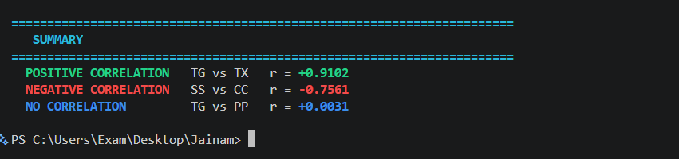

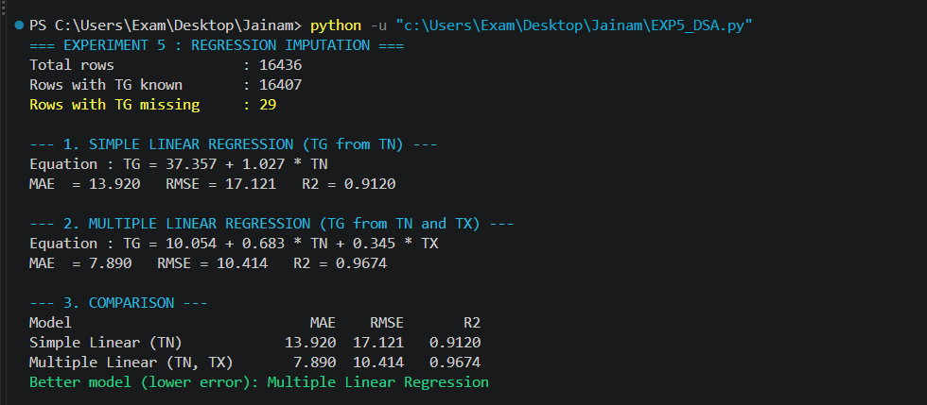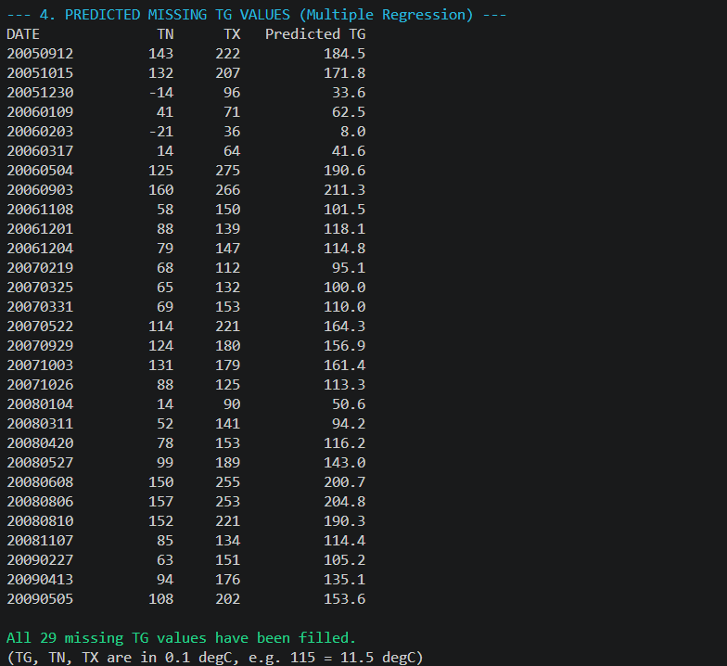

Questions:
  - How will you choose between linear regression and non-linear regression?

  - Explain the nature or characteristics of a dataset where we can apply regression imputation.

________________________________________________________________________

Course Outcomes: (refer exp list)

Conclusion:

Grade: AA / AB / BB / BC / CC / CD /DD
Signature of faculty in-charge with date

_______________________________________________________________________
References:
Books/ Journals/ Websites:
- S.C. Gupta, V. K. Kapoor, Fundamentals of Mathematical Statistics, Sultan Chand and Sons, 2020.
- P. N. Tan, M. Steinbach, Vipin Kumar, Introduction to Data Mining, Pearson Education, 2016.
- Han, Kamber, Data Mining Concepts and Techniques, Morgan Kaufmann, 3rd Edition, 2012

