Table 1: Water Disputes Tribunals

|  |  |  |  |
| --- | --- | --- | --- |
| **Tribunal** | **States Concerned** | **Date of Constitution** | **Current Status** |
| **Godavari Water Disputes Tribunal** | Maharashtra, Andhra Pradesh, Karnataka, Madhya Pradesh, Orissa | April 1969 | Report and decision given in July 1980. |
| **Krishna Water Disputes Tribunal – I** | Maharashtra, Andhra Pradesh, Karnataka, | April 1969 | Report and decision given in May 1976. |
| **Narmada Water Disputes Tribunal** | Rajasthan, Madhya Pradesh, Gujarat, Maharashtra | October 1969 | Report and decision given in December 1979. Narmada Control Authority (NCA) was constituted to implement the decision. |
| **Ravi & Beas Water Tribunal** | Punjab, Haryana, Rajasthan | April 1986 | Report and decision given in April 1987. Further Report is pending. |
| **Cauvery Water Disputes Tribunal** | Kerala, Karnataka, Tamil Nadu, Puducherry | June 1990 | Report and Decision given on 5 February 2007. Supreme Court modified the decision on 16 February 2018. The Cauvery Water Management Authority (CWMA) and Cauvery Water Regulation Committee (CWRC) were constituted to implement the modified decision. |
| **Krishna Water Disputes Tribunal -II** | Karnataka, Andhra Pradesh, Maharashtra, Telangana | April 2004 | Report and decision given on 30 December 2010. SLPs filed pending in the Court. The term of the Tribunal has been extended after the bifurcation of Andhra Pradesh. The matter is under adjudication in the Tribunal. |
| **Vansadhara Water Disputes Tribunal** | Andhra Pradesh, Odisha | February 2010 | Report and decision submitted on 13 September 2017. Further Report is pending. |
| **Mahadayi Water Disputes Tribunal** | Goa, Karnataka, Maharashtra | November 2010 | Report and decision submitted on 14 August 2018. Further Report is pending. |
| **Mahanadi Water Disputes Tribunal** | Chhattisgarh, Odisha | March 2018 | Under adjudication by the Tribunal. Report and decision are awaited. |

**Source:** Central Water Commission.[[5]](https://www.orfonline.org/research/federalism-and-interstate-river-water-governance-in-india/" \l "_edn5)

**Map 1: The River Basins of India**

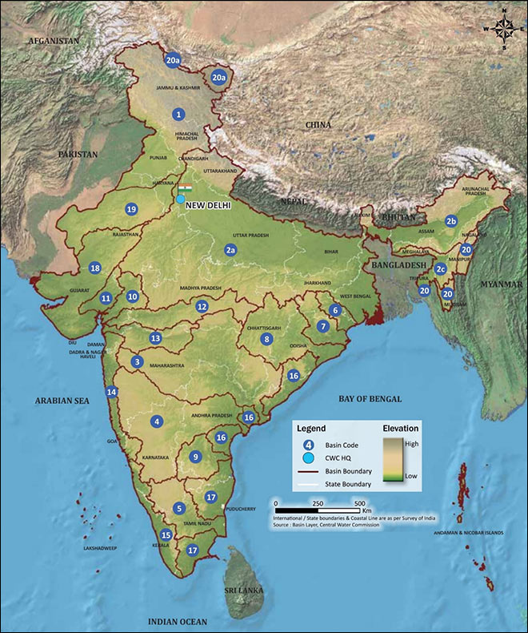Note: Coding according to the scheme used by CWC.[[6]](https://www.orfonline.org/research/federalism-and-interstate-river-water-governance-in-india/" \l "_edn6)

**Table 2.**

|  |  |  |  |  |
| --- | --- | --- | --- | --- |
| **River Basins of India (CWC Scheme)** | | | | |
|  | **Basin Code (CWC)** | **Basin Name (CWC)** | **Interstate or Intrastate** | **Total Live Storage Capacity (MCM)** (Projects with Live Storage Capacity > 10 MCM) |
|  | **1** | Indus (Up to border) | Interstate | 16,568.43 |
|  | **2 a** | Ganga | Interstate | 60,660.38 |
|  | **2 b** | Brahmaputra | Interstate | 11,680.56 |
|  | **2 c** | Barak and others | Interstate |
|  | **3** | Godavari | Interstate | 31,330.39 |
|  | **4** | Krishna | Interstate | 49,547.52 |
|  | **5** | Cauvery | Interstate | 8867.02 |
|  | **6** | Subernarekha | Interstate | 2,322.21 |
|  | **7** | Brahmani and Baitarni | Interstate | 5,523.69 |
|  | **8** | Mahanadi | Interstate | 14,207.80 |
|  | **9** | Pennar | Interstate | 4,820.11 |
|  | **10** | Mahi | Interstate | 4,984.03 |
|  | **11** | Sabarmati | Interstate | 1367.54 |
| 14 | **12** | Narmada | Interstate | 23,604.60 |
| 15 | **13** | Tapi | Interstate | 10,255.79 |
| 16 | **14** | West flowing rivers from Tapi to Tadri | Mostly Intrastate | 14,732.41 |
| 17 | **15** | West flowing rivers from Tadri to Kanyakumari | Mostly Intrastate | 11,553.70 |
| 18 | **16** | East flowing rivers between Mahanadi and Pennar | Interstate | 3,026.41 |
| 19 | **17** | East flowing rivers between Pennar and Kanyakumari | Interstate | 1,906.90 |
| 20 | **18** | West flowing rivers of Kutch and Saurashtra including Luni | Interstate | 5,524.15 |
| 21 | **19** | Area of inland drainage in Rajasthan | Intrastate | – |
| 22 | **20** | Minor rivers draining into Myanmar (Burma and Bangladesh) | Interstate | 312.00 |