Curriculum Intelligence Engine
Week 4 – Improved Model: baseline vs improved | AI University NLP Course Project 2026
Group 9 · Roll Nos: J048, J049, J050, J052, J053 · Code: github.com/jainamsethia/Curriculum-Intelligence-Engine
Week 4 Goal | Implement an improved approach for four parts of the pipeline and compare each with its baseline on the same test data: keyword search → vector retrieval, rule-based → transformer / LLM classification (Bloom’s taxonomy), rule-based → NER-style / LLM extraction (prerequisites) and basic → LLM-assisted summarisation. Improvements are kept only where the evidence supports them; where they do not help, the report says so.
Setup | - Data: the NMIMS syllabus dataset of Week 3 (2366 course versions, 655 courses). Same course-level split (458 train / 197 test); 100 of the training courses form a validation set for every choice made in this week.  - Compute: CPU only. The LLM is Phi-3 (3.8B, 4-bit) served locally by Ollama, so nothing leaves the machine. Encoders: all-MiniLM-L6-v2, bge-small-en-v1.5, nomic-embed-text and bge-base-en-v1.5; reranker: ms-marco MiniLM cross-encoder.  - Statistics: confidence intervals resample whole courses (queries of one course are correlated); paired differences use the same resampling; McNemar’s exact test for classification. Label provenance: the prerequisite test set and the Week 3 gold pairs are LLM-labelled; retrieval, Bloom and summary ground truths come from the syllabi themselves (source course, faculty K/L tag, faculty objective).
Baseline vs Improved: summary
Task | Baseline | Improved approach | Metric | Baseline | Improved | Difference [95% CI] | Verdict
1. Course search | TF-IDF cosine (Week 2) | Hybrid: BM25 + dense encoder (RRF) | MRR@10 | 0.582 | 0.617 | +0.035 [0.011, 0.057] | improved
 |  | Hybrid: BM25 + domain-adapted MiniLM (RRF) | MRR@10 | 0.582 | 0.630 | +0.048 [0.023, 0.073] | improved
 |  | Hybrid + cross-encoder rerank | MRR@10 | 0.582 | 0.607 | +0.025 [-0.003, 0.052] | no clear difference
 |  | Domain-adapted MiniLM (best unit) | MRR@10 | 0.582 | 0.610 | +0.028 [-0.005, 0.062] | no clear difference
2. Bloom level | Rule-based verb lexicon | Fine-tuned transformer (text + rule hint) | accuracy | 0.727 | 0.733 | +0.006 [-0.033, 0.045] | no clear difference
 |  | Fine-tuned transformer (text) | accuracy | 0.727 | 0.678 | −0.049 [-0.112, 0.013] | no clear difference
 |  | Phi-3 zero-shot | accuracy | 0.727 | 0.718 | −0.009 [-0.048, 0.026] | no clear difference
 |  | Phi-3 few-shot (12 examples) | accuracy | 0.727 | 0.607 | −0.120 [-0.177, -0.064] | worse
3. Prerequisite extraction | Rule-based splitter | spaCy noun chunks (NER-style) | F1 | 0.784 | 0.606 | −0.178 [-0.237, -0.113] | worse
 |  | Phi-3 few-shot (LLM-assisted) | F1 | 0.784 | 0.852 | +0.068 [0.007, 0.130] | improved
4. Course summary | Extractive: first two outcomes | Phi-3 (unit titles + outcomes) | ROUGE-L | 0.217 | 0.257 | +0.040 [0.022, 0.057] | improved
 |  | Phi-3 (full unit text + outcomes) | ROUGE-L | 0.217 | 0.267 | +0.050 [0.035, 0.065] | improved
Verdict: “improved” only if the 95% interval of the paired difference excludes zero; “worse” if it lies below zero; otherwise “no clear difference”.
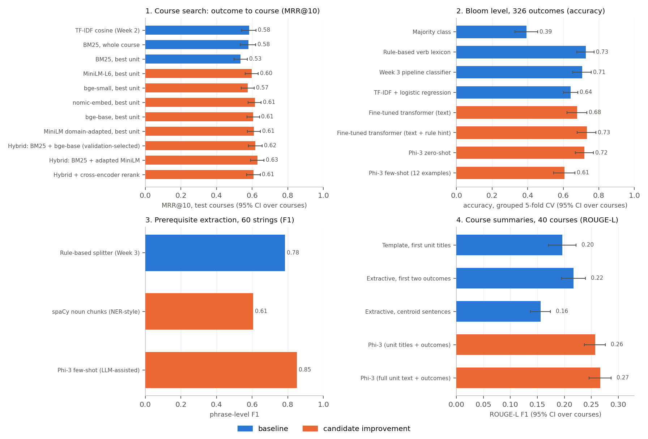
Baselines (blue) and candidate improvements (orange). Bars show 95% intervals that resample whole courses; the 60-string prerequisite test has none in the figure (see the table).
1. Course search: keyword → vector retrieval
Question: which course teaches this learning outcome? Each query is one outcome statement (869 test queries from 197 unseen courses); the collection holds 640 courses represented only by their unit descriptions, so outcomes, objectives, title and code cannot leak. A course counts as found if it, or a near-duplicate of it (TF-IDF ≥ 0.85, 607 clusters), is returned. Choices among encoders and aggregators were made on 100 validation courses (471 queries), never on the test courses.
System | MRR@10 [95% CI] | Recall@1 | Recall@5 | Recall@10 | MRR gain over TF-IDF [95% CI]
Hybrid: BM25, whole course + MiniLM domain-adapted (ours) / best unit (RRF) | 0.630 [0.591, 0.667] | 0.493 | 0.802 | 0.888 | +0.048 [0.023, 0.073]
Hybrid: BM25, whole course + bge-base-en-v1.5 / course vector (RRF) | 0.617 [0.578, 0.657] | 0.482 | 0.796 | 0.875 | +0.035 [0.011, 0.057]
nomic-embed-text / best unit | 0.615 [0.577, 0.651] | 0.484 | 0.801 | 0.863 | +0.033 [0.001, 0.066]
MiniLM domain-adapted (ours) / best unit | 0.610 [0.573, 0.646] | 0.466 | 0.808 | 0.896 | +0.028 [-0.005, 0.062]
Hybrid + cross-encoder rerank (top 10) | 0.607 [0.569, 0.645] | 0.465 | 0.802 | 0.878 | +0.025 [-0.003, 0.052]
bge-base-en-v1.5 / best unit | 0.606 [0.570, 0.641] | 0.459 | 0.802 | 0.886 | +0.024 [-0.007, 0.054]
MiniLM-L6 (Week 3 encoder) / best unit | 0.598 [0.561, 0.634] | 0.455 | 0.796 | 0.890 | +0.016 [-0.016, 0.048]
MiniLM domain-adapted (ours) / course vector | 0.596 [0.557, 0.633] | 0.457 | 0.785 | 0.883 | +0.014 [-0.021, 0.047]
MiniLM-L6 (Week 3 encoder) / course vector | 0.583 [0.545, 0.619] | 0.441 | 0.783 | 0.883 | +0.001 [-0.035, 0.034]
TF-IDF cosine (Week 2 baseline) | 0.582 [0.540, 0.622] | 0.473 | 0.736 | 0.817 | baseline
BM25, whole course | 0.578 [0.534, 0.619] | 0.467 | 0.731 | 0.812 | −0.004 [-0.026, 0.017]
bge-small-en-v1.5 / best unit | 0.575 [0.538, 0.611] | 0.426 | 0.786 | 0.858 | −0.007 [-0.038, 0.024]
nomic-embed-text / course vector | 0.575 [0.532, 0.613] | 0.443 | 0.755 | 0.843 | −0.007 [-0.042, 0.026]
bge-base-en-v1.5 / course vector | 0.574 [0.534, 0.614] | 0.435 | 0.762 | 0.861 | −0.008 [-0.040, 0.024]
bge-small-en-v1.5 / course vector | 0.557 [0.520, 0.596] | 0.417 | 0.754 | 0.841 | −0.025 [-0.062, 0.010]
BM25, best unit | 0.534 [0.497, 0.573] | 0.407 | 0.719 | 0.799 | −0.048 [-0.075, -0.020]
Selected on validation: keyword = BM25, whole course; dense = bge-base-en-v1.5 / course vector. Intervals resample whole courses, because the outcomes of one course are correlated. Domain adaptation (contrastive fine-tuning on 1692 outcome→unit pairs of 347 training courses): validation MRR@10 by epoch 0 (base encoder): 0.6214, 1: 0.625, 2: 0.6502, 3: 0.644, 4: 0.6461, 5: 0.6491.
2. Bloom’s taxonomy: rule-based → transformer
Ground truth is the faculty’s own K/L tag printed in the syllabus (326 single-level outcomes from 66 courses). Every outcome is predicted by models that never saw its course (5-fold cross-validation grouped by course), which gives 326 test outcomes instead of the 98 of Week 3. The transformer is all-MiniLM-L6-v2 fine-tuned end to end (1 seed); “rule hint” adds the verb-lexicon level to its input. Phi-3 is prompted with the level definitions, with and without 12 examples from the training folds.
System | Accuracy [95% CI] | Within ±1 level | Macro-F1 | Right where lexicon wrong / wrong where lexicon right | McNemar p
Majority class | 0.393 [0.329, 0.457] | 0.80 | 0.09 | 30 / 139 | <0.001
Rule-based verb lexicon (Week 3) | 0.727 [0.676, 0.774] | 0.86 | 0.68 | baseline
Week 3 pipeline classifier | 0.706 [0.654, 0.757] | 0.87 | 0.63 | 13 / 20 | 0.296
TF-IDF + logistic regression | 0.641 [0.600, 0.682] | 0.85 | 0.53 | 27 / 55 | 0.003
Fine-tuned transformer (text) | 0.678 [0.622, 0.733] | 0.90 | 0.37 | 35 / 51 | 0.105
Fine-tuned transformer (text + rule hint) | 0.733 [0.679, 0.783] | 0.88 | 0.66 | 14 / 12 | 0.845
Phi-3 zero-shot | 0.718 [0.667, 0.769] | 0.88 | 0.62 | 20 / 23 | 0.761
Phi-3 few-shot (12 examples) | 0.607 [0.547, 0.666] | 0.82 | 0.55 | 18 / 57 | <0.001
3. Prerequisite extraction: rule-based → NER-style model → LLM
The input is the free-text “Pre-requisite” field; the output is the list of prerequisite subjects. 60 strings were sampled across structures and labelled with the subjects a reviewer would list (single LLM annotator; 14 have an empty answer: “Nil”, or objectives text that the parser captured by mistake). A predicted phrase matches when its content words overlap a gold phrase (Jaccard ≥ 0.5). Systems: the Week 3 regex splitter, spaCy noun chunks (a classic NER-style span model), and few-shot Phi-3 returning JSON.
System | Precision | Recall | F1 [gain over rules, 95% CI] | False alarms on empty-answer strings | Unparseable outputs | s / string
Rule-based splitter (Week 3) | 0.68 | 0.93 | 0.78 | 64% | 0 | <0.05
spaCy noun chunks (NER-style) | 0.46 | 0.90 | 0.61 [−0.178, [-0.237, -0.113]] | 79% | 0 | 0.139
Phi-3 few-shot (LLM-assisted) | 0.77 | 0.96 | 0.85 [+0.068, [0.007, 0.130]] | 64% | 0 | 4.137
F1 by string type: Rule-based splitter: single 1.00, comma 0.90, and/or 0.76, code 0.83, sentence 0.63, nil 0.00 | spaCy noun chunks: single 0.94, comma 0.82, and/or 0.68, code 0.74, sentence 0.37, nil 0.00 | Phi-3 few-shot: single 1.00, comma 0.91, and/or 0.83, code 1.00, sentence 0.69, nil 0.00
4. Summarisation: basic → LLM-assisted
Task: write the course-objective paragraph of a course from its name, unit topics and learning outcomes. The reference is the faculty-written “Course Objective” of 40 unseen courses; it is never shown to any system. Baselines are extractive (a template over the first unit titles, the first two outcomes, and the sentences closest to the course centroid embedding). The improved systems are Phi-3 (3.8B, local, Ollama), given either the unit titles or the full unit text. “Unsupported terms” is the share of a summary’s content words that appear nowhere in the input (a hallucination proxy).
System | ROUGE-1 | ROUGE-2 | ROUGE-L [95% CI] | Embedding cosine to reference | Words | Unsupported terms | s / course
Template: first unit titles | 0.251 | 0.064 | 0.196 [0.171, 0.222] | 0.599 | 24 | 14% | <0.05
Extractive: first two outcomes | 0.307 | 0.076 | 0.217 [0.195, 0.239] | 0.571 | 24 | 0% | <0.05
Extractive: centroid sentences | 0.219 | 0.036 | 0.156 [0.137, 0.174] | 0.501 | 48 | 0% | 0.56
Phi-3 (unit titles + outcomes) | 0.372 | 0.099 | 0.257 [0.237, 0.276] | 0.680 | 42 | 33% | 10.5
Phi-3 (full unit text + outcomes) | 0.390 | 0.106 | 0.267 [0.246, 0.287] | 0.696 | 44 | 31% | 22.39
Example (Earthquake Engineering). Reference: “This course focusses on the basics of structural dynamics. It also focusses on the evaluation of dynamic properties of structures and their response subjected to dynamic loads and earthquake loads as per the requirements of Indian standard codal provisions” LLM: “The course aims to equip students with the skills to analyze and design structures for seismic resistance, focusing on understanding SDOF and MDOF systems, characterizing ground motion, and applying IS code method for seismic analysis.”
Pipeline v2: what changed
- Course search: Pipeline.search(query, mode) (hybrid, dense or keyword). The default is the system selected on validation: BM25 over whole courses fused with bge-base course vectors by reciprocal rank fusion. --mode course-vector keeps the Week 3 method for comparison.
- Comparison summary (optional): compare --summary asks the local Phi-3 for a three-sentence committee summary and checks it against the report. If a percentage differs, or more than 20% of its content words are not in the report, the template summary is returned instead.
- Not wired in: LLM prerequisite extraction (about 4 s per string and needs Ollama) and the fine-tuned Bloom models, which did not beat the verb lexicon. Experiments are in src/w4_*.py and shared code in src/improved.py.
Course search, same queries, three methods (top 3 courses)
Query | Keyword (BM25) | Hybrid (v2 default) | Week 3 course vector
transformers and large language models | Generative AI; Speech and Natural La...; Cognitive Science & A... | Generative AI; Speech and Natural La...; Natural Language Proc... | Generative AI; Speech and Natural La...; Formal Language and A...
blockchain and smart contracts | Blockchain Technology; Introduction to Block...; Fundamentals of Block... | Blockchain Technology; Introduction to Block...; Fundamentals of Block... | Blockchain Technology; Introduction to Block...; Fundamentals of Block...
cloud computing and DevOps | DevOps; Cloud, Microservices ...; Cloud Computing and IoT | DevOps; Cloud, Microservices ...; Cloud Technology | Cloud, Microservices ...; DevOps; Cloud Technology
protecting a network from attacks | Network Security; Blockchain Technology; Information Systems S... | Network Security; Information Systems S...; Cybersecurity Fundame... | Network Security; Network design; Cyber Security
For “transformers and large language models” the Week 3 method returned Formal Language and Automata Theory; the hybrid returns NLP courses. LLM comparison summaries: 3 of 3 examples failed the faithfulness guard (unsupported-term rate 0.207, 0.31, 0.231) and fell back to the template. Example of a rejected text (Machine Learning 2026-27 vs Deep Learning 2026-27): “Courses A and B have no unit overlap, sharing only a 11% overlap probability based on reviewer comments. Course A includes unique topics such as Linear Model Selection and Regularization, while Course B offers specialized conte...”
Findings and Limitations
- Search: hybrid retrieval is the clearest improvement. MRR@10 rises from 0.582 (TF-IDF) to 0.617 with the validation-selected BM25 + bge-base hybrid (+0.035 [0.011, 0.057]) and to 0.630 when the encoder is domain-adapted; Recall@10 rises from 0.82 to 0.88. Single encoders are not reliably better than TF-IDF at rank 1, BM25 alone is no better than TF-IDF, and the off-the-shelf cross-encoder reranker did not help (0.607 against 0.617).
- Bloom’s taxonomy: no improved model clearly beats the verb lexicon (0.727). The transformer with the lexicon hint ties it (0.733), and Phi-3 zero-shot ties it (0.718) without any labelled data, which matters for institutions whose tags differ. Few-shot prompting made Phi-3 worse (0.607). A vote between the lexicon, the transformer and Phi-3 gained +0.015 [-0.006, 0.039] (exploratory, not significant); an oracle choosing the right model per outcome would reach 0.81, so the errors are only partly complementary.
- Prerequisites: the LLM helps, the NER-style model does not. Phi-3 few-shot raises F1 from 0.78 to 0.85 (+0.068 [0.007, 0.130]), mostly on strings with course codes, names containing “and” or “&”, and full sentences; spaCy noun chunks are worse (0.61). Both systems raise false alarms on 64% of the 14 strings that name no prerequisite, because the Week 3 parser captured objectives text in that field: a parser fix is needed, not a better extractor. The LLM costs 4.14 s per string.
- Summaries: the LLM scores higher, but needs review. Against the faculty objective, Phi-3 beats the best extractive baseline on ROUGE-L (+0.040 [0.022, 0.057] with unit titles, +0.050 [0.035, 0.065] with full unit text) and on embedding similarity (0.57 to 0.70), at 11–22 s per course. But 31%–33% of its content words appear nowhere in the input (generic phrases such as “comprehensive understanding”, but also unseen topics), and faculty objectives themselves use such wording, which ROUGE rewards.
- Limits: the retrieval ground truth counts only the source course, so true relevance is understated for every system; the prerequisite set (60 strings) is small and LLM-labelled; Bloom’s results come from 66 courses; one 3.8B model on CPU; everything is specific to the NMIMS template. Intervals that resample courses are wide for small course counts.
Next Steps (Week 5)
- Expose POST /compare-curricula and POST /map-outcomes as an API with a small UI, using the hybrid search and the optional guarded summary.
- Fix the parser so objectives text is not captured as prerequisites; then wire in LLM prerequisite extraction and re-measure.
- Build a harder, human-annotated partial-overlap set and try a larger LLM (or a GPU) for summaries and the faithfulness check.

