Curriculum Intelligence Engine
Week 3 – Core NLP Model (Pipeline v1) | AI University NLP Course Project 2026
Group 9 · Roll Nos: J048, J049, J050, J052, J053 · Code: github.com/jainamsethia/Curriculum-Intelligence-Engine
Week 3 Goal | Implement the primary NLP component as Version 1 of the pipeline. Given two course syllabi it returns a structured comparison (JSON): overlap score with a confidence, common and unique topics, a redundancy flag, a prerequisite check, and the Bloom’s-taxonomy level of every learning outcome. It runs from the command line on dataset courses or on PDF/DOCX/TXT syllabi (python src/pipeline.py compare --a … --b …).
Dataset (NMIMS) | - Source: our college’s B.Tech syllabus archive (zip, 9,359 PDFs, 16 GB; years 1–4, all branches). About 6,900 files are past exam papers (by file name), and 94% of all PDFs are scanned images. No OCR is set up, so all exam papers and most pre-2020 syllabi cannot be read yet.  - Used: 531 readable (text-layer) PDFs, mainly semester syllabus booklets (academic years 2020-21 to 2026-27), holding 3,928 course blocks. After removing 1,511 exact duplicates (one syllabus re-used by several programmes) this leaves 2,366 course versions of 655 distinct courses (472 with two or more versions), 14,747 units and 8,650 learning outcomes, 546 of which carry the faculty’s own Bloom tag (K1–K6 / L1–L6).  - Week 2’s MIT OpenCourseWare set is kept only as a continuity check. Raw PDFs are not published; the repository holds the parsed dataset.
Information Extraction | - A rule-based parser for the NMIMS syllabus template turns each course block into: name, code, programme, semester, academic year, prerequisites, objectives, outcomes (with K/L tags), numbered units with hours, and books. Page headers and footers are detected per booklet (repeated numbered lines) and removed.  - Quality was audited three times by independent LLM auditors who compared the raw PDF text with the parsed record, field by field, on a fresh random sample each time. Fixes were general, not per record. Results are in Table 1.
Pipeline v1 | - Embeddings: sentence-transformers all-MiniLM-L6-v2. A course is the mean of its chunk embeddings (objectives, each outcome, each unit), which avoids truncating a long syllabus to the encoder’s 256-token window.  - Overlap and topics: every unit of A is matched to its closest unit of B and vice versa. A match counts when cosine ≥ 0.72 (the 99th percentile of the best match between two different courses of the same department, so the false-match rate is about 1%). The overlap score is the F-measure of matched units. Matched pairs are the common topics; unmatched units are the unique topics.  - Confidence: logistic regression on four signals (TF-IDF cosine, document cosine, unit overlap, soft coverage), fitted on the 113 gold pairs. It gives the probability that a curriculum reviewer would call the pair overlapping; ≥ 0.8 raises the redundancy warning.  - Prerequisites: the prerequisite text is split into phrases and each phrase is matched to a catalogue course (name and content embeddings, similarity ≥ 0.75). Unmatched phrases that the other course does not teach are reported as missing; matched prerequisites scheduled in the same or a later semester of the same programme raise a sequencing warning.  - Bloom’s taxonomy: the action verb of each outcome is looked up (hand-written Bloom verb list and a verb → level map learned from faculty tags, in the order that cross-validates best on training courses); outcomes without a known verb go to a logistic regression on the sentence embedding.  - Topic map: k-means on unit embeddings with class-based TF-IDF names, to see which topics grow or shrink over the academic years.
Evaluation Setup | Courses are split by name (458 train / 197 test), so two versions of a course never straddle the split. TF-IDF, the unit threshold and the Bloom classifier are fitted on train courses only; test outcomes whose text appears in training are removed. For the similarity tasks the baseline is Week 2’s TF-IDF cosine. Label provenance: gold overlap labels and the prerequisite audit come from LLM panels (not humans); Bloom ground truth is the faculty’s printed K/L tag.
Results
Table 1. Extraction audit (fully correct / cosmetic only / wrong; first parser on 48 records, final parser on 45 fresh records)
Field | First parser (n=48) | Final parser (n=45)
Course name | 46 / 1 / 1 | 45 / 0 / 0
Course code | 0 / 4 / 44 | 45 / 0 / 0
Semester | 45 / 1 / 2 | 44 / 0 / 1
Prerequisites | 46 / 1 / 1 | 44 / 1 / 0
Objectives | 45 / 2 / 1 | 41 / 4 / 0
Learning outcomes | 41 / 0 / 7 | 43 / 1 / 1
Units (topics) | 9 / 9 / 30 | 26 / 14 / 5
Text / reference books | 24 / 5 / 19 | 40 / 4 / 1
The first audit found systematic bugs (a table-header fragment glued to every course code, footers inside unit text, marks tables absorbed into the book list); all were fixed generally. What is left for units is mostly cosmetic titles and 5 records with merged units. Hours of multi-row units keep only the first duration.
Table 2. Same-course retrieval (222 test queries; title, code and prerequisites hidden; the other versions of the same course must be ranked first)
Method | MRR | Recall@1 | Recall@5 | MAP | Recall@1, heavily revised (n=25)
TF-IDF cosine (Week 2 baseline) | 0.927 | 0.896 | 0.964 | 0.883 | 0.48
Embedding, truncated concatenation | 0.920 | 0.878 | 0.973 | 0.868 | 0.48
Embedding, mean of chunks | 0.929 | 0.892 | 0.973 | 0.887 | 0.40
Unit alignment, soft coverage | 0.914 | 0.883 | 0.955 | 0.871 | 0.40
Unit alignment, overlap fraction | 0.901 | 0.865 | 0.950 | 0.851 | 0.36
Embeddings and TF-IDF are tied. Re-used and lightly edited syllabi share most of their words, so plain word overlap is already strong.
Table 3. Unit alignment between two versions of a course (733 units with the same title; matching uses the unit description only, title removed)
Method | Top-1, all units | Top-1, units whose text was revised (n=199) | MRR, revised units
TF-IDF | 0.986 | 0.950 | 0.973
Embedding | 0.995 | 0.980 | 0.987
On revised units the embeddings were right where TF-IDF was wrong in 6 units and wrong where TF-IDF was right in 0 (exact McNemar p = 0.031). This is the one place where the embeddings clearly help, and it is what powers the common/unique topic lists.
Table 4. Overlap on the gold pairs (113 distinct-course pairs: 68 none, 2 partial, 43 substantial)
Method | Spearman | ROC-AUC | Avg. precision | Precision@0.5 | Recall@0.5
TF-IDF cosine (Week 2 baseline) | 0.85 | 1.000 | 1.000 | – | –
Embedding doc cosine (mean of chunks) | 0.85 | 1.000 | 1.000 | – | –
Unit alignment, soft coverage | 0.85 | 1.000 | 1.000 | – | –
Unit alignment, overlap fraction | 0.96 | 1.000 | 1.000 | – | –
Calibrated, embedding features only (5-fold CV) | 0.85 | 1.000 | 1.000 | 1.000 | 1.000
Calibrated, TF-IDF + embedding features (5-fold CV) | 0.85 | 1.000 | 1.000 | 1.000 | 1.000
Every method separates the classes perfectly, so this set cannot rank them: it mostly contains renamed or re-used courses against unrelated ones, and only 2 pairs are partial overlaps. The three LLM annotators agreed on 98% of pairs (weighted kappa 0.981, 0.991, 0.991), which shows consistency, not independence. On Week 2’s 41 MIT gold pairs TF-IDF also stays ahead (Spearman 0.64 vs 0.60).
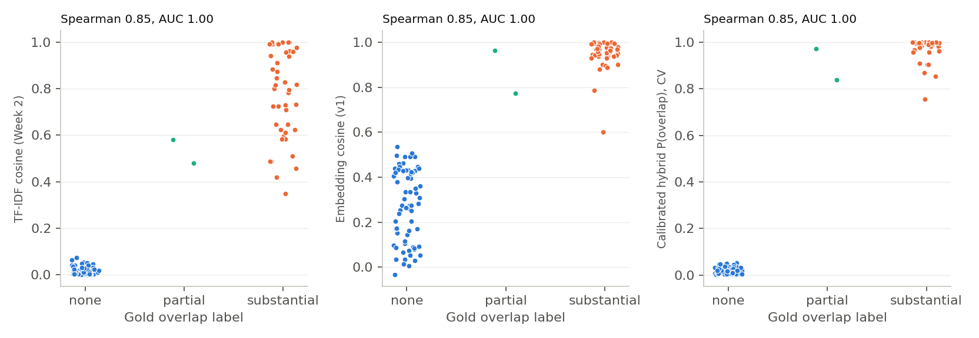
Scores of the gold pairs by label. Embedding cosine gives unrelated courses a high floor (up to 0.53); TF-IDF keeps them near 0.0, a wider gap to the overlapping courses.
Table 5. Bloom’s taxonomy of outcomes (98 held-out outcomes with a single faculty tag; accuracy with 95% bootstrap interval)
Method | Accuracy [95% CI] | Within ±1 level | Macro-F1
Majority class | 0.41 [0.32–0.50] | 0.79 | 0.10
Hand-written verb lexicon | 0.70 [0.61–0.80] | 0.83 | 0.68
Learned verb map only (train majority level per verb) | 0.62 [0.52–0.72] | 0.88 | 0.54
TF-IDF + logistic regression | 0.63 [0.54–0.72] | 0.87 | 0.50
Embedding + logistic regression | 0.51 [0.41–0.61] | 0.79 | 0.42
Pipeline v1 (verb look-ups, embedding fallback) | 0.69 [0.60–0.79] | 0.81 | 0.64
The pipeline’s look-up order was chosen by cross-validation on training courses (the two look-ups tied: 119 vs 118 correct), so on test data it behaves like the verb list plus an embedding fallback for the 5 outcomes without a known verb. The learned models did not beat the hand-written verb list; with 98 test outcomes the differences are within noise.
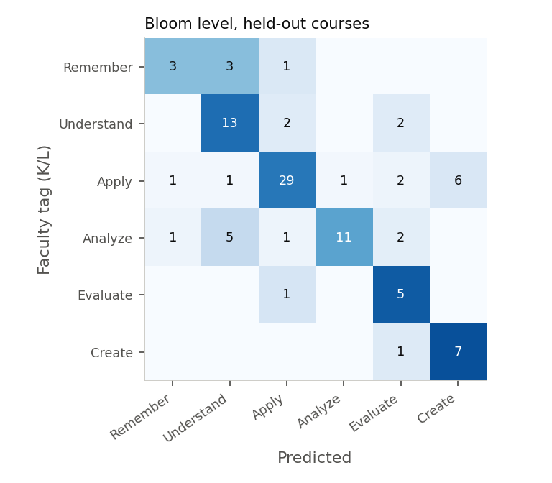
Confusion matrix (rows: faculty tag; columns: pipeline). Of 30 errors, 11 are one level off, 10 two levels and 9 three. The largest confusion is Apply predicted as Create (6 outcomes), mostly “develop”, “construct” and “design”, verbs the faculty tag K3–K4 about as often as K6.
Table 6. Prerequisite matching (audit of 88 matches by two LLM graders; “correct or acceptable”)
Similarity of the match | Matches audited | Correct or acceptable
0-0.6 | 14 | 14%
0.6-0.75 | 20 | 65%
0.75-0.9 | 34 | 79%
0.9-1 | 20 | 100%
≥ 0.75 (used by the pipeline) | 54 | 87%
The threshold was chosen from this audit, so 87% is optimistic. Errors are near-name confusions (“Engineering Mathematics – I” matched to “– III”, “Electrical Machines” to “Theory of Machines”). Over all courses: 3,683 prerequisite phrases from 1,727 courses; 2,742 matched to a catalogue course; 77 of 877 schedule-checkable matches were flagged as sequencing warnings (not verified).
Example Output
Pipeline v1 on two versions of Probability and Statistics (2021-22, B Tech Computer Science and Engineering (Cybersecurity) vs 2025-26, B Tech /MBA Tech (Except Data Science)). The full JSON, with two more comparisons, outcome mapping and search, is in results/example_reports_v1.json.
{
"course_a": "Probability and Statistics (2021-22, B Tech Computer Science and Eng...)",
"course_b": "Probability and Statistics (2025-26, B Tech /MBA Tech (Except Data S...)",
"overlap": {"percent":"100%","confidence":0.999,"redundancy_warning":true},
"similarity": {"tfidf_cosine":0.978,"doc_cosine":0.993,"unit_overlap":1,"soft_coverage":0.986},
"common_topics": [
"Basic Probability <-> Basic Probability (1)",
"Basic Statistics <-> Basic Statistics (1)",
"Bivariate Distributions <-> Bivariate Distributions (0.999)"],
"unique_to_a": [], "unique_to_b": [],
"prerequisites_b": [
{"phrase":"algebra","resolved_course":null,"similarity":0.591},
{"phrase":"calculus","resolved_course":"Calculus","similarity":1}],
"outcome_bloom_b": [
{"outcome":"Understand the basic concepts of probabilit...","level":"Understand","confidence":0.5,"faculty_tag":[2]},
{"outcome":"Solve problems involving random variables, ...","level":"Apply","confidence":0.5,"faculty_tag":[3]}]
}
Topic Trends (computing programmes)
6,776 units of computing programmes were clustered into 40 topics; the chart compares the share of units in 2021-22/2022-23 with 2025-26/2026-27. Growing: neural, deep, neural networks; learning, trees, machine; search, agents, evolutionary; clustering, mining, data mining; text, language, word; cloud, cloud computing, virtualization. Shrinking: regular, languages, automata; communication, diversity, culture; demand, curve, supply; blockchain, policy, india; planning, project, cost. K-means clusters shift a little between runs and the archive is not a controlled sample, so read individual clusters as indicative; the themes that appeared in every run were growth in deep learning and neural networks, cloud and security, and decline in management, finance/economics and project-planning material.
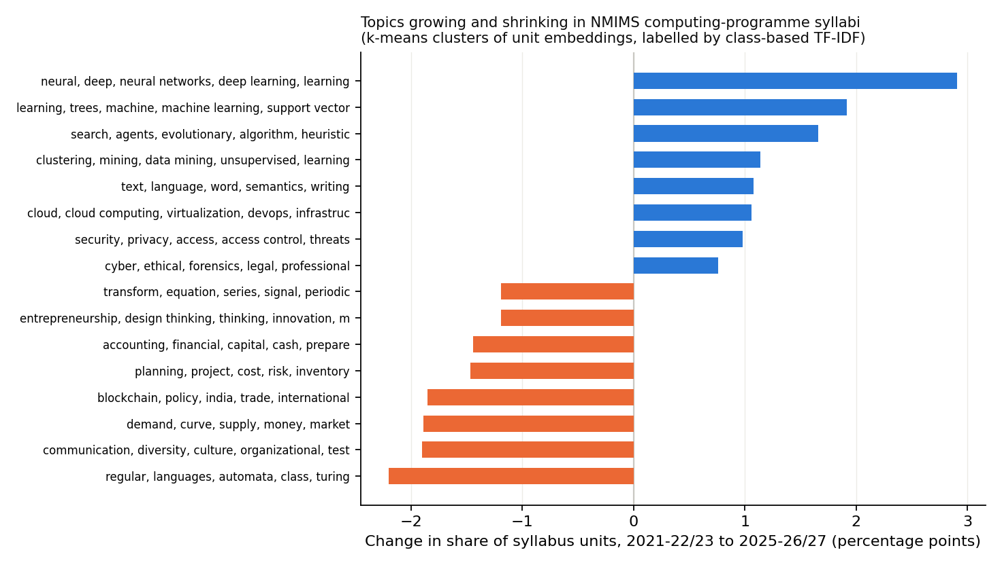
Change in share of syllabus units between the early and late periods.
Findings and Limitations
- Embeddings did not beat the TF-IDF baseline at ranking or detecting overlapping courses (Tables 2 and 4, and the MIT check). NMIMS syllabi are templated and share vocabulary, so TF-IDF is strong. Embeddings help at the unit level (Table 3), which is what makes the report explainable: which topics are common and which are unique.
- The gold set is too easy and is labelled by LLMs; partial overlap is essentially untested. Human annotation of harder pairs is needed before claiming more.
- Bloom’s mapping rests mainly on the action verb; 98 test outcomes give wide intervals. Only 6% of outcomes carry a faculty tag.
- The parser is specific to the NMIMS template; other formats fall back to paragraphs (no prerequisites or outcomes). Scanned PDFs are not read.
- The overlap percentage is the share of matched units at a fixed threshold, not a human-scale rating; the confidence value is the calibrated probability of overlap.
Next Steps (Week 4)
- Expose POST /compare-curricula and POST /map-outcomes as an API with a small UI.
- Build a harder, human-annotated set with partial overlaps; compare NMIMS with MIT OCW courses, where vocabulary differs and embeddings should matter more.
- Add OCR for scanned syllabi (pre-2020, remaining programmes) and an LLM-assisted pass for prerequisite and outcome mapping.

