Curriculum Intelligence Engine — Week 2: Dataset & Baseline (redo)
Group 9 · Roll Nos: J048, J049, J050, J052, J053 · AI University NLP Course Project 2026 · redone 9 Oct 2026

CODE
Repository : https://github.com/jainamsethia/Curriculum-Intelligence-Engine
Tag : week-2-redo
Commit : c3a1e1b2358da725cfa81f4b28838a2c1c3172a4
Run : python -m curriculum_engine.run data && python -m curriculum_engine.run week2 (NMIMS_ZIP=<path to "B TECH.zip">)
Tests : python -m pytest -q
Folders :
.gitignore
README.md
curriculum_engine/ the NLP engine (parser, data, overlap, redundancy, prerequisites, diff, Bloom, evaluation)
labels/ LLM-annotated reference labels (ids + labels per pass + consensus)
legacy/ old Week 3-4 scripts and reports (history only)
legacy_mit/ old MIT OCW scripts (not used)
reports/ report templates (numbers are placeholders)
requirements.txt
results/ metrics JSON + figures per week
submissions/ per-week submission folders
tests/ unit tests (pytest)
tools/ report builder, report checker, submission packer

Feedback addressed
Instructor comment | What we changed | Evidence
"Please use the course catalog from your own college … not for MIT" | The whole dataset is now NMIMS B.Tech semester syllabus booklets; MIT data is archived and unused. | curriculum_engine/parse.py, results/dataset/
(Week 4) "missing pre-requisites" | Parser bug fixed: an empty prerequisite field swallowed the course objectives in 19 records. Programme structure built so prerequisites can be checked against earlier semesters. | tests/test_data.py, curriculum_engine/data.py
(Week 4) "Where is the code?" | CODE block above, tagged commit, code zip, one command per step. | curriculum_engine/run.py

Progress vs previous week
Item | Week 1 (proposal) | Week 2 (this report)
Parsed NMIMS course versions | planned | 2,366 in 645 course families, 13 programmes
Train / validation / test families | planned | 387 / 129 / 129
Reference-labelled course pairs | protocol only | 200 pairs, two LLM labellers + a third on disagreements
Capabilities with a measured baseline | none | overlap, redundancy, prerequisites, curriculum diff, Bloom

1. Dataset: NMIMS semester syllabus booklets
- Collection. Our college's B.Tech archive (all years and branches). 2,413 non-exam PDFs are considered (past exam papers are not syllabi and are skipped). Coverage limitation: 531 of 2,413 PDFs have a text layer; 1,882 are scanned images and need OCR, which is future work.
- Cleaning. Repeated page headers and footers are detected per booklet and removed; 1,511 exact duplicate course blocks (the same syllabus printed in several programme booklets) are merged, keeping every source booklet; 46 blocks before 2020-21 or without a year are dropped. Grading, attendance and assessment tables are cut by the parser and are not modelled; no student data and no faculty names are present.
- Schema (one record per course version). Name, code, programme, semester, academic year, L/P/T hours, credits, prerequisite text, objectives, outcomes with the faculty's K/L Bloom tag, numbered units (title, text, hours), books, source booklets. Result: 2,366 course versions; 8,650 outcomes (546 with a faculty tag); 14,747 units.
- Versions and families. All versions of one course (same code or same normalised name) form a family: 645 families, 472 with two or more versions. Comparing versions is a separate version-change task, never mixed with cross-course overlap.
- Programme structure. Each version is placed in its programmes (from the booklet folders) and semester; 233 versions are common first-year or all-programme courses and count for every programme. Prerequisite checks skip programmes with too little parsed data.
Programme | Versions | With prerequisite | With outcomes | Units / course
MECHANICAL | 422 | 61% | 100% | 5.400
DS | 394 | 56% | 99% | 6.700
IT | 283 | 84% | 99% | 6.300
AI | 258 | 64% | 100% | 5.600
CSE-CYBER | 254 | 66% | 99% | 5.600
CSBS | 248 | 81% | 100% | 6.900
MECHATRONICS | 244 | 72% | 100% | 5.700
CIVIL | 234 | 57% | 100% | 6.000
COMP | 213 | 79% | 100% | 6.300
CSE-DS | 202 | 67% | 100% | 7.600
EXTC | 169 | 86% | 100% | 5.600

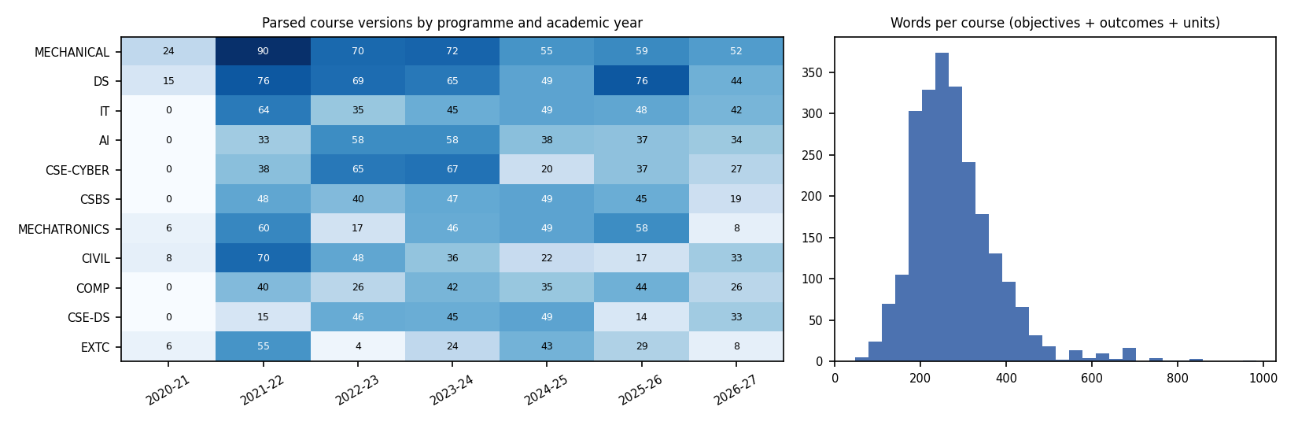
Left: parsed course versions per programme and academic year (gaps are mostly scanned booklets). Right: words per course.
Median course length 263 words; 72% of versions name at least one prerequisite.

2. Split and LLM-annotated reference labels
- Split by family (seed 42, hash 4763325fd5): 387 / 129 / 129 families = 1,423 / 487 / 456 versions for train / validation / test. TF-IDF and the Bloom fallback are fitted on train; every threshold is chosen on validation; the test split is used once.
- LLM-annotated reference labels. 200 cross-course pairs (both courses in the same split; versions of one course excluded), stratified by programme relation and by score band of both TF-IDF and embeddings, plus near-name, disagreement and random pairs. Labels: 0 = no meaningful overlap, 1 = partial (at least one unit-level topic shared), 2 = substantial / redundant. Pass 1: a Claude model in a fresh context; pass 2: Phi-3 running locally for 106 pairs and a second Claude prompt (wording B) for the other 94; no labeller saw any model score. Pass 3 settled disagreements; items without a 2-of-3 majority are excluded.
- LLM-vs-LLM agreement, reported separately: Claude vs Phi-3 on 106 pairs 74% (weighted kappa 0.561); Claude vs Claude (wording B) on 94 pairs 99% (weighted kappa 0.969). 28 items were settled by pass 3, 1 excluded as uncertain. Usable labels — validation: 61 / 14 / 5, test: 87 / 30 / 2 (labels 0 / 1 / 2). No human annotators were used; results are indicative. For 94 of 200 pairs the second labeller was a Claude prompt rather than Phi-3, so agreement on those items is not independent. Detector flags (Week 3 onwards) were labelled by two Claude passes with different wording plus a pass 3, with no Phi-3, so agreement on flags is not independent. labels/human_spot_check.csv lets each member check ten pairs later.
- Label-free tests (no annotation needed): faculty Bloom tags; near-duplicate units injected into an unrelated course of the same programme; removal or renaming of a prerequisite course; known year-over-year course changes, also with renamed courses.

3. Baselines on the test split
Capability | Method | Metric (test split) | Result
1 Overlap | TF-IDF cosine | Spearman [95% CI] | 0.708 [0.62, 0.78]
 |  | ROC-AUC any overlap [95% CI] | 0.959 [0.93, 0.98]
 |  | F1 at validation threshold | 0.774
2 Redundancy | course-level TF-IDF cosine within a programme | injected near-duplicates found in top 20 | 0.600
3 Prerequisites | regex split + exact course-name match | removal recall [95% CI] | 1.000 [1.00, 1.00]
 |  | false alarms, intact programme | 0.470 [0.34, 0.59]
 |  | false alarms after renaming the course | 1.000 [1.00, 1.00]
4 Curriculum diff | exact course-name set difference | precision / recall of changes | 0.990 / 1.000
 |  | precision / recall with renamed courses | 0.793 / 1.000
5 Bloom level | hand-written verb lexicon (majority level when no verb matches) | accuracy [95% CI] | 0.776 [0.72, 0.83]
 |  | within one level / macro-F1 | 0.871 / 0.756

- Overlap. On the reference labels, TF-IDF has Spearman 0.708 and ROC-AUC 0.959 for "any overlap"; at the threshold chosen on validation (0.126) precision is 0.800 and recall 0.750. Versions of one course (reported separately, 359 pairs) have median TF-IDF 1.000, against 0.595 for substantially overlapping different courses.
- Redundancy. Course pairs in a programme above the validation threshold (0.451): 5 flags among test courses. When one lightly edited unit of an unrelated course is copied into another course of the same programme, the course-level score ranks that pair in the top 20 in 60% of 60 cases: one shared unit barely moves a whole-course score.
- Missing prerequisites. 228 prerequisite phrases of 141 test course-programme pairs were checked; 136 were flagged (126 because no course has exactly that name). On 83 test cases the baseline finds every removed prerequisite course (recall 1.000) but also flags 47% of intact programmes and 100% after the prerequisite course is renamed: exact names are too brittle.
- Curriculum diff. Across 53 programme year-pairs, name matching gives precision 0.990 and recall 1.000 for added and removed courses, but precision falls to 0.793 when courses are renamed. Many "changes" are booklets missing in one year (scanned), not real revisions.
- Bloom. The verb lexicon matches the faculty tag for 78% of 85 test outcomes (majority class: 31%).

4. Observations and next steps
- Lexical baselines are strong where syllabi re-use text, and weak exactly where the committee needs help: a single shared unit inside different courses, renamed courses, and prerequisites written in free text.
- Week 3 adds unit-level embeddings (MaxSim) for overlap and redundancy, embedding-based prerequisite resolution with a topic check over earlier semesters, content matching for the diff, and topic labels, evaluated on this same split and these same metrics.
- Limitations: labels come from LLMs; scanned booklets leave gaps in the programme structure; the test split has 85 faculty-tagged outcomes, so Bloom intervals are wide.

AI assistance
Code and report text were written with AI assistance (Claude). Reference labels are LLM-annotated (Claude, Phi-3). Every number is generated from results/*.json by tools/build_report.py and verified by tools/check_reports.py.

