Curriculum Intelligence Engine
Week 2 – Dataset & Baseline | AI University NLP Course Project 2026
Group 9 · Roll Nos: J048, J049, J050, J052, J053
Week 2 Goal | Turn the Week 1 plan into a usable dataset and a working baseline with a first evaluation: data collection, cleaning, preprocessing, annotation, train/test split and baseline model. Everything below is reproducible with three scripts (collect.py → preprocess.py → baseline.py). Deliverables: code (src/), raw and cleaned dataset with annotations (data/), metrics, predictions and figures (results/), and this report.
Data Collection | - Source: MIT OpenCourseWare (licence CC BY-NC-SA 4.0). Course metadata, catalog description and OCW topic tags come from the public MIT Learn search API; the Syllabus, Calendar and Lecture-Notes pages come from ocw.mit.edu.  - Selection: 17 queries in the overlapping areas named in the proposal (machine learning, deep learning, AI, NLP, statistics, probability, inference, data science, algorithms, linear algebra, optimization, computer vision, econometrics, signal processing, reinforcement learning, neural networks, data mining); top 8 hits each; kept only courses tagged Computer Science, Mathematics, Probability & Statistics, AI or Econometrics; at most 2 semesters per course number.  - Result: 87 courses from 15 departments (Electrical Engineering and Computer Science 34, Mathematics 18, Economics 7, Sloan School of Management 7, …). 82 have at least one syllabus/calendar/lecture-notes page (78 a syllabus); 5 newer courses only have the catalog description. 9 courses appear in two semesters, which gives natural “known overlap” pairs.  - Only course-level public documents are used; no student data. A loader for our own NMIMS/Teams handbooks (data/raw/local/, .txt/.docx/.pdf) is in place and uses the same schema.
Cleaning | - HTML split into heading-delimited sections. Content sections are kept (description, overview, topics/outline, objectives, prerequisites); logistics sections are dropped by keyword rules (meeting times, grading, exams, problem sets, policies, textbooks, staff, software).  - Lecture topics taken from the TOPICS column of calendar/lecture-notes tables; quiz/exam/holiday rows, “Lecture n:” prefixes and “(PDF)” markers removed.  - Unicode NFKC normalisation; URLs, e-mails and image credits removed; HTML stripped from API descriptions; whitespace collapsed.  - Quality filter (< 50 words) and exact-duplicate check: 0 of 87 dropped. Mean length 399.3 words (range 74–1225).
Preprocessing | - One record per course in a common schema: id, course number, title, department, level, offering, description, prerequisites text + referenced course numbers, learning outcomes, syllabus text, lecture topics, OCW topics, labels, split.  - Rule-based information extraction: prerequisites found for 63/87 courses (57 with course-number references such as 18.06 or 6.041), lecture topics for 59, explicit outcome statements for 18.  - Model text = title + description + prerequisites + kept syllabus text + lecture topics, then spaCy (en_core_web_sm) tokenisation and lemmatisation, lower-casing, removal of stop-words, punctuation and numbers. Vocabulary after preprocessing: 3,503 lemmas.
Annotation | - Silver pair labels: OCW topic tags are assigned by OCW staff, so we use them as annotation. Top-level categories (Mathematics, Engineering, …) are removed and the overlap score of a pair is the IDF-weighted Jaccard of the remaining tags. The same course in two semesters = 1.0. Label = overlap if score ≥ 0.30, a cut-off picked by reading sample pairs from each score band.  - Topic labels: the 12 OCW tags carried by ≥ 8 courses (e.g. Probability and Statistics, Artificial Intelligence, Algorithms and Data Structures, Econometrics).  - Gold set: 41 test pairs, stratified by silver score, labelled 0 = none, 1 = partial (several shared lectures), 2 = substantial/redundant, judged from descriptions and lecture topics without looking at any model score. Labelled by a single LLM annotator with a one-line rationale stored per pair (22 × 0, 15 × 1, 4 × 2). Note: the proposal planned a human-annotated set; this set is LLM-annotated, so no inter-annotator agreement is reported.
Train/Test Split | Course-level 70/30 split grouped by course number (GroupShuffleSplit, seed 42), so two offerings of the same course never sit on both sides: 60 train / 27 test courses. Pairs: 1,770 train (98 overlapping) and 351 test (17 overlapping); 1,620 train–test pairs are not used. IDF weights, the decision threshold and the classifier’s C are fit on train only.
Baseline Models | - Overlap scoring: TF-IDF (unigrams + bigrams, sublinear tf, min_df 2, max_df 0.8; 2,179 features) + cosine similarity. Threshold chosen to maximise F1 on train pairs (0.20). Trivial comparison: Jaccard overlap of lemma sets.  - Topic classification (multi-label): TF-IDF + one-vs-rest logistic regression, balanced class weights, C = 1 chosen by grouped 3-fold CV on train. Trivial comparison: always predict the 2 most frequent labels.  - Rule-based extraction: a 46-topic curriculum lexicon (regex) gives common and unique topics; a prerequisite-gap rule flags topics one course’s prerequisites assume but the other course does not teach. Output is the JSON comparison report that the future POST /compare-curricula endpoint will return.
Initial Evaluation (test split)
Course-overlap scoring, 351 test pairs, 17 silver-positive (chance average precision = 0.048):
Method | Spearman ρ | ROC-AUC | Avg. precision | Precision | Recall | F1 | Accuracy
Word-overlap Jaccard | 0.396 | 0.823 | 0.323 | 0.286 | 0.235 | 0.258 | 0.934
TF-IDF + cosine (baseline) | 0.446 | 0.826 | 0.351 | 0.233 | 0.412 | 0.298 | 0.906

Against the gold labels, 41 pairs, 19 overlapping (label ≥ 1); P/R/F1 at the thresholds fixed on train / by the silver cut-off:
Method | Spearman ρ | ROC-AUC | Avg. precision | Precision | Recall | F1
Word-overlap Jaccard | 0.542 | 0.768 | 0.784 | – | – | –
Silver labels (OCW tags) | 0.611 | 0.821 | 0.826 | 0.769 | 0.526 | 0.625
TF-IDF + cosine (baseline) | 0.636 | 0.830 | 0.828 | 1.000 | 0.316 | 0.480

Topic classification, 27 test courses, 12 labels (macro-F1 over labels present in test):
Method | Micro-F1 | Macro-F1 | Samples-F1 | Hamming loss ↓
Always predict 2 most frequent labels | 0.496 | 0.133 | 0.499 | 0.194
TF-IDF + logistic regression (baseline) | 0.561 | 0.302 | 0.604 | 0.145

Rule-based extraction coverage: on average 6.16 lexicon topics per course; ≥ 3 topics found for 76/87 courses; prerequisites for 63/87; outcome statements for 18/87.
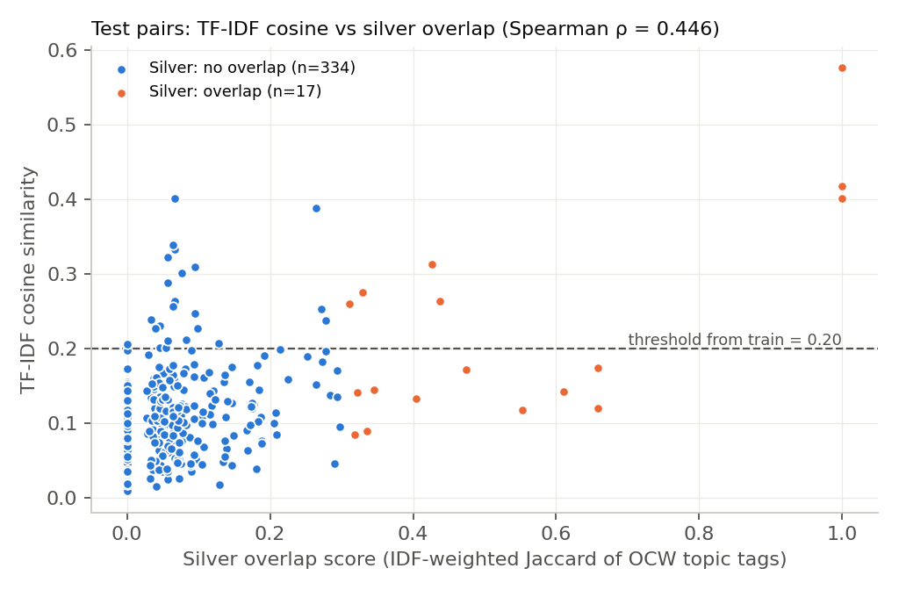 | 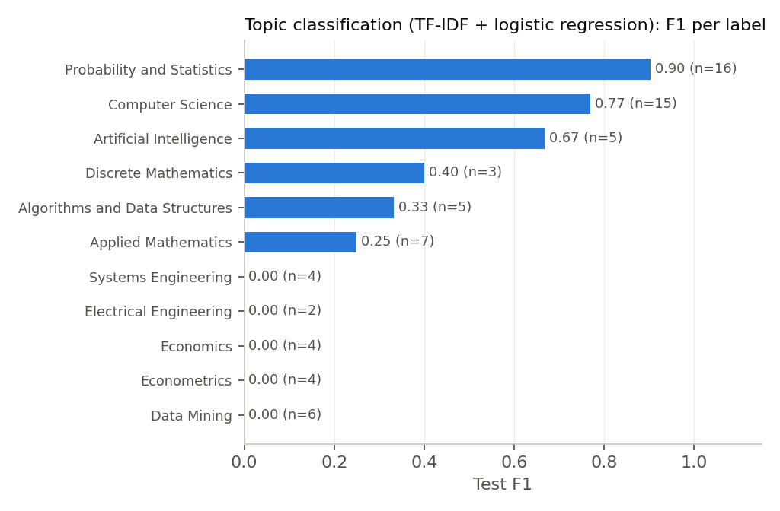
Left: TF-IDF cosine vs silver overlap score for every test pair (orange = silver overlap). Right: per-label test F1 of the topic classifier (n = test support).
Example Output (baseline comparison report)
{
"course_a": "18.650 (formerly 18.443) Statistics for Applications (fall_2006)",
"course_b": "18.650 (formerly 18.443) Statistics for Applications (spring_2015)",
"overlap_score": 0.576,
"overlap_percent": "58%",
"redundancy_warning": true,
"common_topics": ["Probability","Statistical Inference","Hypothesis Testing","Bayesian Methods","Regression"],
"unique_to_a": ["Classification","Algorithms & Complexity","Programming Tools (Python/R/Julia/MATLAB)"],
"unique_to_b": ["Calculus & Differential Equations"],
"missing_prerequisites": [{"course":"Statistics for Applications","assumes":"Calculus & Differential Equations","not_taught_in":"Statistics for Applications"}]
}
Observations
- TF-IDF beats plain word overlap on every ranking metric (ρ 0.446 vs 0.396, AP 0.351 vs 0.323). An ROC-AUC of 0.826 means overlapping pairs are usually ranked above non-overlapping ones, but precision at the threshold is low (0.233).
- The low precision against silver labels is mostly label noise. On the gold pairs TF-IDF tracks the gold labels better than the silver labels do (ρ 0.636 vs 0.611), every pair it flags is a real overlap (precision 1.000), and the silver labels themselves reach only 0.769 precision. Examples: 1.017 Computing and Data Analysis vs 6.436J Fundamentals of Probability overlap but get silver score 0.10, while 6.006 Introduction to Algorithms vs 6.438 Algorithms for Inference share OCW tags (silver 0.40) but not content.
- The threshold learned from silver labels (0.20) is too strict: TF-IDF finds only 6 of 19 gold overlaps (recall 0.316). The gold set is small, stratified and labelled by one LLM annotator, so these numbers are indicative.
- Short documents are the main failure case. 6.036 Introduction to Machine Learning has no syllabus page on OCW (description only), so its pair with 15.773 Hands-On Deep Learning, the proposal’s own example, scores only 9%.
- The classifier works for frequent labels (Probability and Statistics F1 0.903, Computer Science 0.769, Artificial Intelligence 0.667) and fails on labels with few or vague training examples (Data Mining, Econometrics, Economics, Systems Engineering: F1 0).
- The lexicon is literal. It misses paraphrases and over-flags: for example, it reports a “Calculus” prerequisite gap between two offerings of the same statistics course. Explicit learning-outcome statements are rare on OCW (18/87), so Bloom’s mapping will need the LLM pass or our own NMIMS course files, which list course outcomes.
Next Steps (Week 3)
- Re-tune the overlap threshold on the gold labels instead of the silver ones, and extend the gold set to pairs that involve the new model’s errors.
- Add our own NMIMS/Teams course handbooks to data/raw/local.
- Improved model: sentence-transformer embeddings at section and lecture-topic level, and BERTopic topics replacing the hand-written lexicon, compared with this baseline on the same split and metrics.
- LLM-assisted prerequisite and outcome extraction, then the POST /compare-curricula and /map-outcomes API.

