Pre terraform provisioning:

create s3 in specified region

create keyfile and save pem file

Post terraform provisioning:

1. Ansible Server Configuration

Create keys.pem on ansible server /home/ubuntu/keys.pem with permission 0600

1. Pipeline repo configuration

Update ansible server private ip in jenkinsfile

Update docker servers private ips in inventory file

1. Jenkins configuration

Login on Jenkins-server and find jenkinsinitial password by command sudo cat /var/lib/jenkins/secrets/initialAdminPassword

7a5cd68597af4b8f8407c0630727d153

1. Jenkins portal configuration

Login on Jenkins console by url <Jenkins-public-ip>:8080 and use initial password

Install suggested plugins

update maven home as /usr/share/maven: go to manage Jenkins>> global tool configuration >> Add maven >>

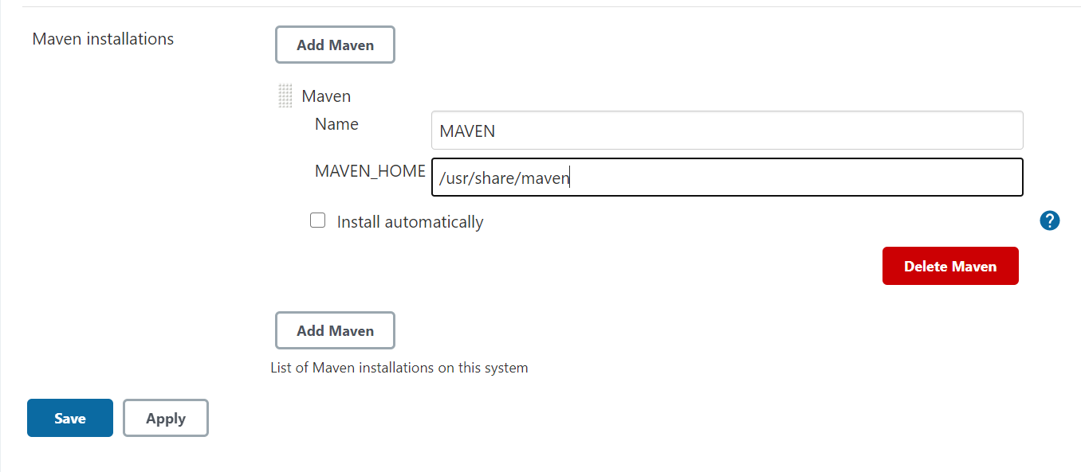

create docker hub credential as dockerhub-pwd (secret user password):

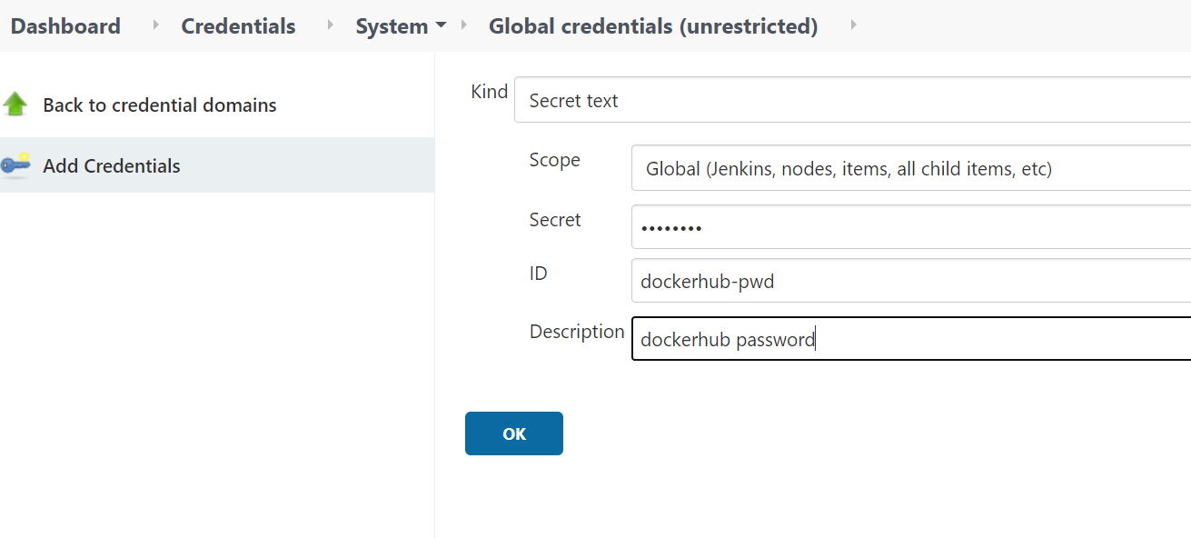

create ansible key credential as ansible-pem (ssh username with private key):

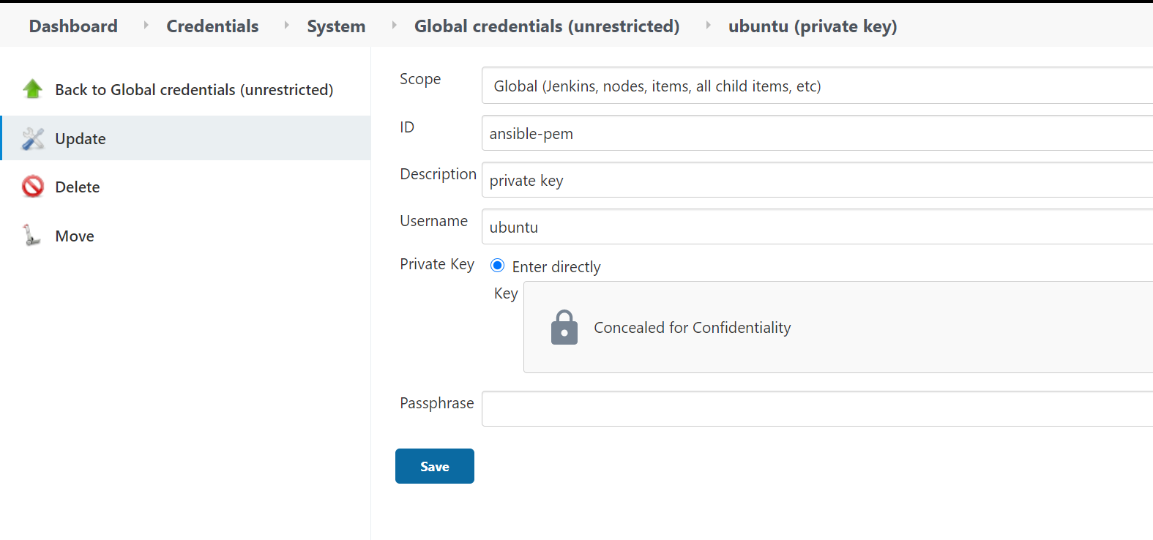

Install required plugins:

Go to dashboard >> manage Jenkins >> manage Jenkins >> available >> search docker

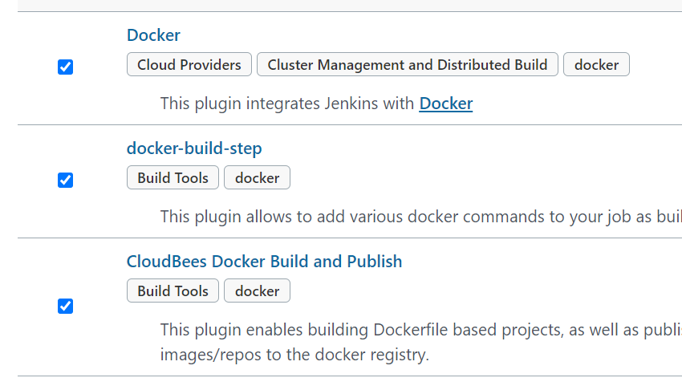 install without restart

Go to dashboard >> manage Jenkins >> manage Jenkins >> available >> search ssh

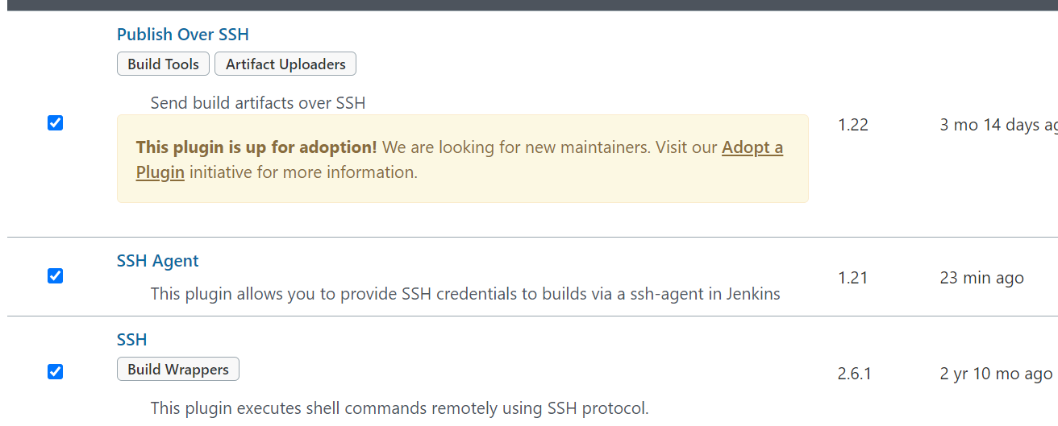

Create pipeline:

Go to new item >> pipeline >> ok

Definition: pipeline script from scm:

<https://github.com/jainankur2/hello-world-1.git>

Note: in this repo main ci-cd pipeline is written in jenkinsfile2

url: http://loylogic-prod.jainankur2.info/