Staging: It act as a layer between source and target database.

There are 4 types of staging: -

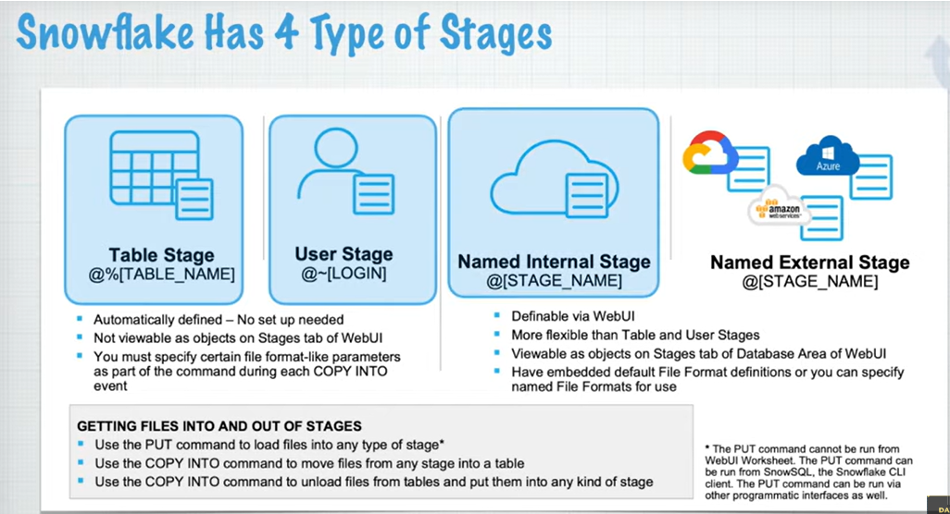

list @~ -- **for user stage**

list @%Student -- **for table stage**

List @stagename – **for named and external stage**

put file://C:/Users/jai.jain.ACS/Downloads/File.csv @~; // **user stage**

put file://C:/Users/jai.jain.ACS/Downloads/File.csv @%student; // **table stage**

put file://C:/Users/jai.jain.ACS/Downloads/File.csv @my_csv_stage; // **named stage**

We cannot put file in external stage

**How to remove files from any stage**

remove @~/File.csv;

**How to show all stages**

show stages // it will show all named and external stages