**ACROPOLIS INSTITUTE OF TECHNOLOGY AND RESEARCH**

Department of Information Technology

**Synopsis**

On

Task Tracking Tool Project

1. **INTRODUCTION**

1.1 **Overview**

"TaskMitra-Friend of tasks" is a task tracking tool that helps teams manage and track their projects. TaskMitra implement features like creating projects, assigning tasks to team members, setting deadlines, and tracking progress, to organize and manage events.

1.2 **Abstract**

Now a days it is noticed that many people are not able to remember their tasks so the advantage of this website is remind their tasks to user and give the track report about their project/task.This website gives the capability to distribute the work among the user for the particular project purpose of good, efficient and effective work.It provides best team Productivity, decreases expenses and increases profits, facilitates team communication. It is easy to work with this website.

1.3 **Purpose**

* Helps to organize, assign, and prioritize tasks, all from a single platform.
* Helps to monitor User progress and User can mark milestones to keep your project on schedule.
* Allows users to set goals, keep track of deliverables, and manage deadlines.
* Offers comprehensive, customizable schedules to facilitate uninterrupted workflows.
* User can assign team's members and goals. Eliminates the need to remember all tasks and keeps one on track with timely reminders.

1. **LITERATURE SURVEY**

2.1 **Existing Problems and Solutions**

Their were several Solutions Proposed such as Todoist,Task o pad, Bitrix24, TaskQue, Social Tables, Octonius for Problems such as Task allotment in absence ot the leader. Admin tend to forgot follow up with the customers. Overhead on equal task distribution. Loss of recurring tasks or Unwanted delay in task submissions.But all this websites are either not user friendly or do not have advanced features. Their is no platform which is user friendly and has all the features in a single website.

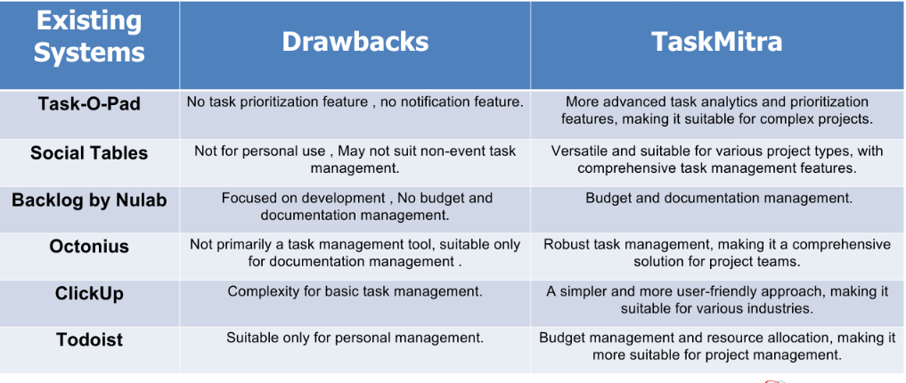

2.2 **Proposed Solution**

* Sending reminders messages.
* Setting up Priority.
* Providing a Calander view.
* Progress update.
* Improves Team Productivity.
* Admin and User views.
* Providing different task template
* Email support

1. **THEORETICAL ANALYSIS**

3.1 **Block Diagrams**

* **Admin Module**

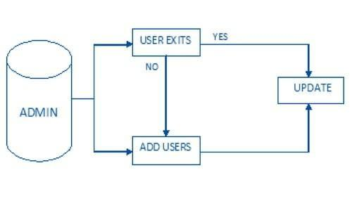

* **User Module**

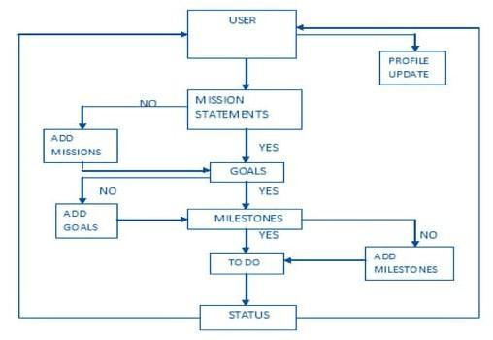

3.2 **Designing requirements**

* **Hardware**

The specification of the system is as follows:

**SYSTEM**

Intel/Pentium/ 500 MHz Processor

**RAM**

256MB

**STORAGE**

500MB Hard Disk/SSD

* **Software**

The specification of the software is as follows:

**FRAMEWORK**

MySQL, Bootstrap,Django(python)

**LANGUAGE**

HTML5,CSS, Javascript, Python-3

**DOCUMENTATION**

MS-Word, MS-PowerPoint

**OPERATING SYSTEM**

Microsoft Windows XP Onwards

1. **APPLICATIONS**

The website can be used by:

* Task And Project Managers
* Team Leaders And Supervisors
* Remote And Distributed Teams
* HR And Recruitment Teams
* Educators And Students
* Event Planners
* Personal users

**REFERENCES**

* "Task Management Tool Proposal"

Author/Team: John Doe and Team XYZ,

Date: March 1, 20XX ,Description: The initial proposal outlining the purpose and objectives of the task management tool project.

* "Task Manager System Architecture and Design"

Author/Team: Alan Johnson and Development Team Bravo

Date: May 10, 20XX, Description: Overview of the tool's architectural design and component details

* "Technology Stack for Task Management Tool"

Author/Team: Development Team Bravo

Date: May 30, 20XX ,Description: A list of technologies and tools used in the project, including programming languages and frameworks.

* "Task Management Tool Database Schema"

Author/Team: Database Team Charlie

Date: June 20, 20XX, Description: Documentation of the database structure and data model.

* "Task Management Tool Project Management Plan"

Author/Team: John Doe and Project Team Alpha

Date: March 15, 20XX, Description: Details of the project management methodology, timeline, and workflow.

**Submitted to: Submitted By:**

Prof. Pawan Gupta Astha Jain (0827IT211020)