
A

SEMINAR

REPORT

ON

“
Quantum Kernel-

Quantum Machine Learning”
”

Submitted

To

DEPARTMENT OF COMPUTER SCIENCE

As A Partial Fulfillment

For The Degree Of

MASTER

OF COMPUTER APPLICATION

(
M
.
C
.
A
.
)

ACADEMIC YEAR 2025-26

SUBMITED

BY:

Student Name
:
-

JAIN CHIRAG SHRICHAND

GUIDED BY:

Prof
.
:
-

Mrs. Jayshree Patel
.

.

VEER NARMAD SOUTH GUJARAT UNIVERSITY

SURAT

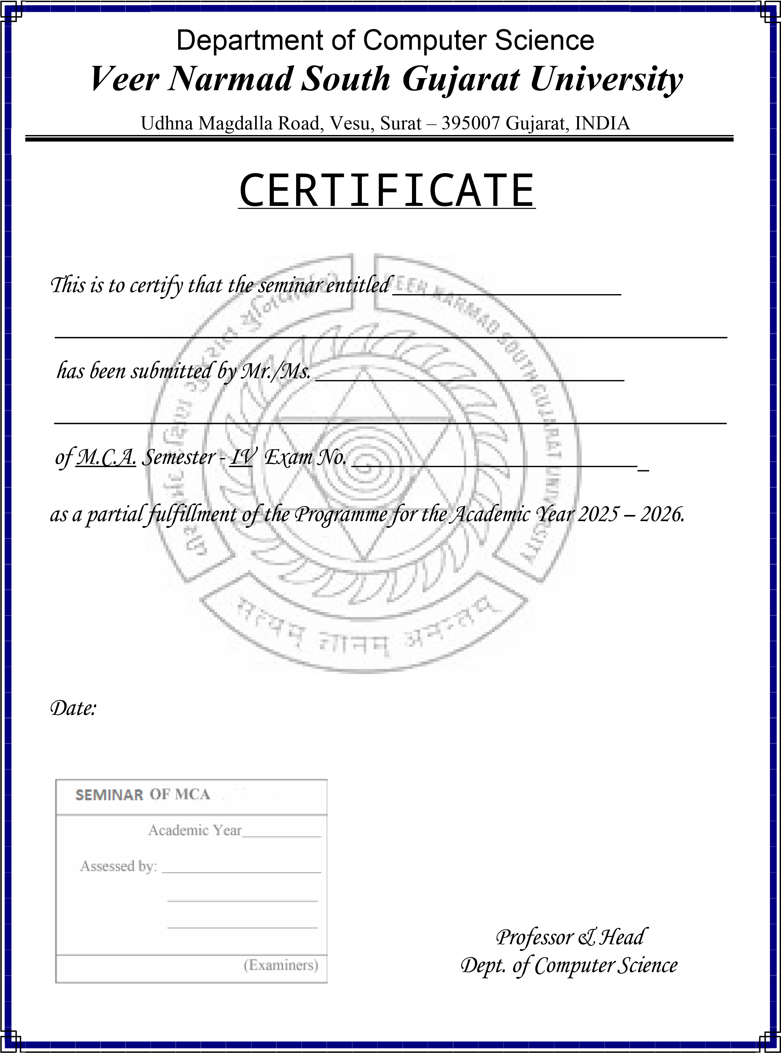
24
Jain Chirag Shrichand
Quantum Machine Learning
Quantum Kernel-

Acknowledgement

I would like to express my sincere gratitude to Prof. Mr. JayShree Patel, Department of Computer Science, Veer Narmad South Gujarat University (VNSGU), for his constant guidance, support, and motivation throughout the development of the seminar titled:
“Quantum Kernel-Quantum Machine Learning”.

His valuable insights, timely suggestions, and deep understanding of the subject have been instrumental in shaping the direction and success of this project. I am truly thankful for the opportunity to work under his mentorship.

I would also like to thank all the supporting staff members of the Department of Computer Science, VNSGU for their cooperation and encouragement throughout the course of this project. Their technical support and readiness to help have contributed significantly to the smooth execution of the project.

Lastly, I extend my heartfelt appreciation to my peers, friends, and family for their moral support and continuous encouragement.

THANKING ALL…….
Jain Chirag Shrichand

Index
No. | Topic | Page No.
1. | Introduction | 01
2. | Definition of Quantum Machine Learning | 02
3. | Components of Quantum Machine Learning | 03
4. | Architecture of Quantum Machine Learning | 06
5. | Quantum Kernel | 08
6. | Components of Quantum Kernel | 10
7. | How Quantum Kernel Works | 12
8. | Advantages of Quantum Kernel | 14
9 | Technology use in Quantum Machine Learning | 17
10 | Applications of Quantum Machine Learning | 19
11 | Advantages and Disadvantages of Quantum Machine Learning | 22
12. | Future of Quantum Kernel and QML | 24
13. | Conclusion | 25
14. | References | 26

- Introduction
Quantum Machine Learning is the integration of quantum computing with machine learning to create faster and more powerful learning algorithms.
Quantum Machine Learning (QML) is an emerging interdisciplinary field that combines Quantum Computing and Machine Learning.
It explores how quantum computers can be used to improve the speed, efficiency, and capability of machine learning algorithms.
Quantum Machine Learning (QML) is the integration of quantum computing with machine learning to create more powerful and efficient learning systems.
- Machine Learning (ML): Learns patterns from data using algorithms
- Quantum Computing (QC): Uses quantum mechanics to perform computations faster
QML combines both to solve learning problems more efficiently than classical systems
Classical machine learning faces challenges:
- Slow processing for large-scale data
- Difficulty handling high-dimensional features
- Computational limits in optimization problems
Quantum computing addresses these issues by:
- Performing computations in parallel (via superposition)
- Representing complex relationships using quantum states
- Solving some problems with exponential speed advantage
A Quantum Kernel is a technique used in Quantum Machine Learning (QML) to measure the similarity between data points using a quantum computer or quantum simulator.
In classical machine learning, algorithms such as Support Vector Machines (SVMs) use kernel functions to calculate how similar two data points are. Quantum Kernels perform the same task but use quantum states and quantum circuits instead of classical mathematical formulas.
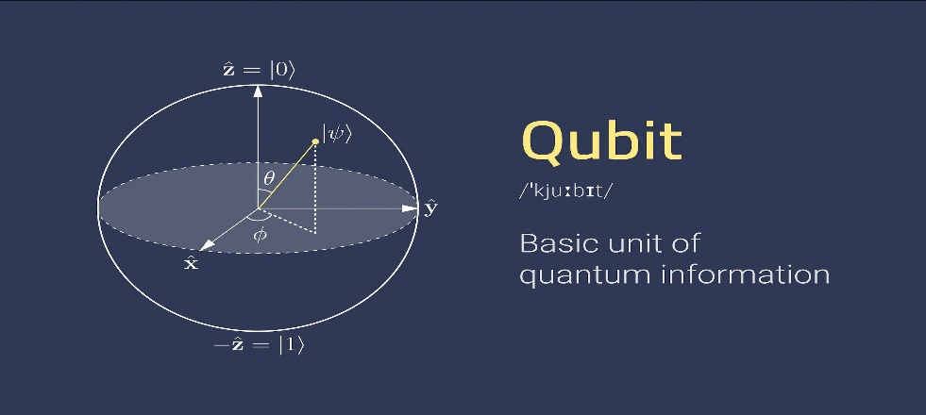
Quantum Machine Learning is a field that combines Quantum Computing and Machine Learning (ML) to build smarter, faster algorithms for data analysis, pattern recognition, and predictionQuantum Machine Learning = Machine Learning algorithms that run on quantum computers or use quantum principles. This gives quantum computers the potential to process huge amounts of data much faster.

- Definition of Machine Learning:
Quantum Machine Learning is the integration of quantum computing with machine learning to create faster and more powerful learning algorithms. Quantum Machine Learning (QML) is an emerging interdisciplinary field that combines Quantum Computing and Machine Learning. It explores how quantum computers can be used to improve the speed, efficiency, and capability of machine learning algorithms.
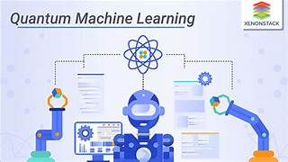
Quantum Machine Learning is the integration of quantum computing with machine learning to improve:
- Speed
- Efficiency
- Learning capability
of machine learning algorithms.
Classical machine learning faces several limitations:
- High computational cost
- Slow processing for large datasets
- Difficulty in solving complex optimization problems
Quantum computing helps to overcome these limitations by:
- Performing parallel computations
- Handling high-dimensional data efficiently
- Solving complex problems faster
Quantum Machine Learning is a field that combines Quantum Computing and Machine Learning (ML) to build smarter, faster algorithms for data analysis, pattern recognition, and prediction
Quantum Machine Learning = Machine Learning algorithms that run on quantum computers or use quantum principles.
Quantum Machine Learning runs (fully or partially) on quantum computers using qubits, which can be:
- 0 and 1 , Both 0 and 1 at the same time (called superposition)
- This gives quantum computers the potential to process huge amounts of data much faster.

- Components of Quantum Machine Learning
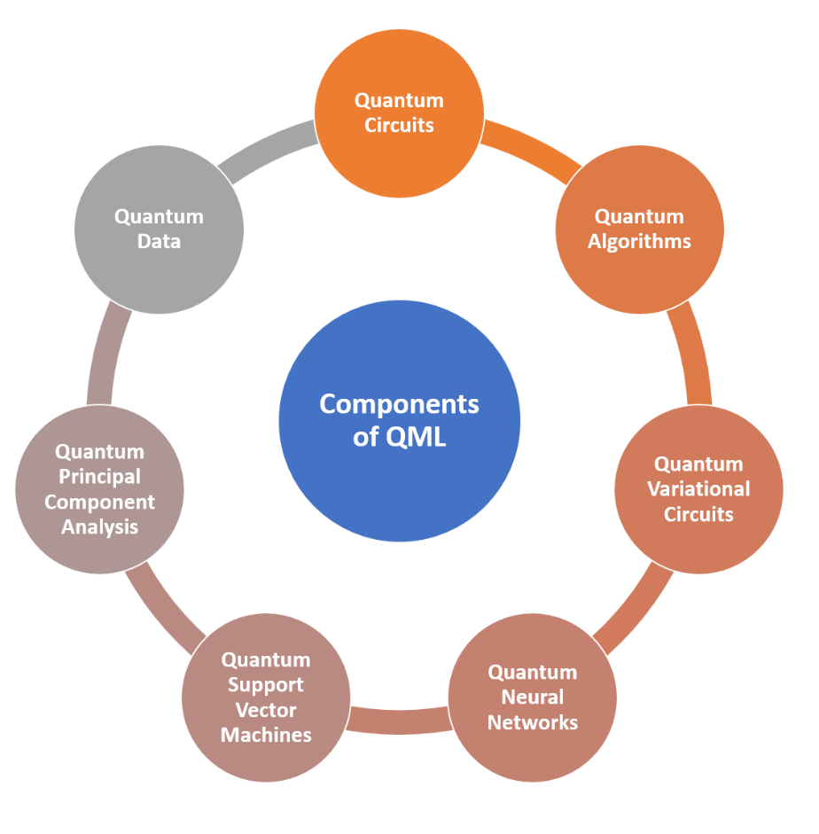
- Quantum Data Encoding (Feature Mapping)
Quantum Data Encoding is the process of converting classical data into quantum states so that it can be processed by a quantum computer. This step is essential in quantum machine learning applications. Feature mapping transforms input features into a higher-dimensional quantum space. It allows quantum algorithms to identify complex patterns in data. Different encoding methods include basis encoding, amplitude encoding, and angle encoding.
Quantum computers work with quantum states, not classical data.
Therefore, classical data must be converted into quantum form → called feature mapping.
Key Idea:
Transform input data into a quantum state using a feature map circuit.
Types of Encoding:
- Amplitude Encoding → stores data in amplitudes of qubits
- Angle Encoding → encodes data into rotation angles
- Basis Encoding → maps binary data directly
Importance:
- Determines how effectively quantum algorithms can learn patterns
- Directly affects model performance
- Qubits & Quantum States
A qubit is the basic unit of information in quantum computing, similar to a bit in classical computing. Unlike classical bits, qubits can exist in multiple states simultaneously through superposition. Quantum states describe the condition of a qubit or a group of qubits. These states can also become entangled, creating strong correlations between qubits. Quantum states are represented mathematically using vectors in a Hilbert space.
- Qubits are the basic unit of quantum information
- Unlike classical bits (0 or 1), qubits can exist in:
Superposition → both 0 and 1 simultaneously
Quantum State Representation:
$$∣ψ⟩=α∣0⟩+β∣1⟩$$
- α and β are probability amplitudes
- |α|² + |β|² = 1
- Quantum Circuits
Quantum circuits are computational models that perform operations on qubits using quantum gates. They are similar to logic circuits in classical computing but exploit quantum properties. Gates such as Hadamard, Pauli-X, and CNOT manipulate quantum states. A sequence of gates forms a quantum algorithm. Quantum circuits are executed on quantum hardware or simulators to solve computational problems.
- Quantum Algorithms
Quantum algorithms are specialized procedures designed to run on quantum computers. They utilize quantum phenomena such as superposition and entanglement to achieve computational advantages. Examples include Shor's Algorithm for factorization and Grover's Algorithm for searching. These algorithms can solve certain problems faster than classical methods. Quantum algorithms are a key focus of modern quantum research.
- Quantum Support Vector Machines (QSVM)
Quantum Support Vector Machines are quantum-enhanced versions of classical Support Vector Machines. They use quantum feature spaces to improve classification performance. QSVMs can handle complex datasets more efficiently in certain cases. Quantum kernels are used to measure similarities between data points. This approach is particularly useful in quantum machine learning applications.
🔹 6. Quantum Principal Component Analysis (QPCA)
Quantum Principal Components Analysis is a quantum version of the classical PCA technique used for dimensionality reduction. It identifies the most significant features within large datasets. QPCA can potentially process high-dimensional data faster than classical methods. The algorithm leverages quantum states and density matrices for analysis. It is useful in data compression and pattern recognition tasks.
- Variational Quantum Circuits (VQC)
Variational Quantum Circuits are parameterized quantum circuits used in hybrid quantum-classical computing. Their parameters are adjusted during training to optimize performance. VQCs are widely used in quantum machine learning and optimization problems. They combine quantum computations with classical optimization techniques.
- Quantum-Classical Optimizer
A Quantum-Classical Optimizer is a hybrid system where quantum circuits and classical computers work together. The quantum processor evaluates a function, while the classical optimizer updates parameters. This iterative process continues until an optimal solution is found. Such optimizers are commonly used in variational quantum algorithms
- Hybrid approach combining:
  - Quantum circuits
  - Classical optimization algorithms

8. Variational Quantum Circuits (VQC)
Variational Quantum Circuits are parameterized quantum circuits used in hybrid quantum-classical computing. Their parameters are adjusted during training to optimize performance. VQCs are widely used in quantum machine learning and optimization problems.
9. Quantum Teleportation
- Technique to transfer quantum information between qubits
Key Concept:
- Uses entanglement to transmit state
10. Quantum Sensing and Metrology
- Uses quantum effects for high-precision measurements
11. Quantum Hardware / Simulator
Quantum Hardware:
- Real quantum computers
- Built using qubits (superconducting, trapped ions, etc.)
Quantum Simulators:
- Classical systems that simulate quantum behavior

4. Architecture of Quantum Machine Learning

1. Classical Data (Input)
- QML starts with classical data, just like traditional machine learning.
Types of Input Data:
- Images (e.g., handwritten digits, medical scans) ,Numerical data (e.g., financial records, sensor values) ,Text data (e.g., documents, reviews)
Key Point:
Quantum computers cannot directly process classical data, so it must first be prepared and converted.
2. Preprocessing
Before sending data to a quantum system, it must be cleaned and transformed.
Common Preprocessing Steps:
a) Scaling
- Adjusts data values to a specific range (e.g., 0 to 1)
- Important because quantum gates often expect normalized inputs
b) Feature Selection
- Selects the most important features from the dataset
- Reduces complexity and improves efficiency
c) Normalization
- Ensures data follows a standard format
- Required for valid quantum state representation
3. Quantum Data Encoding (Feature Mapping)
- Converts classical data into quantum states (qubits)
How it Works:
- Data values are encoded into:
  - Rotation angles
  - Amplitudes
  - Basis states
4. Quantum Circuit (Processing Layer)
- The encoded data is processed using a quantum circuit
Components:
- Qubits (carry information)
- Quantum gates (perform operations)
- Entanglement (connects qubits)
Function:
- Transforms quantum states to extract patterns
5. Measurement
- After processing, quantum states are measured
What Happens:
- Quantum state collapses into classical values (0 or 1)
- Probabilities of outcomes are calculated
6. Classical Optimization
- The output is used to update model parameters (θ)
Process:
- Compare predicted output with actual output
- Calculate loss/error
- Update parameters using optimization algorithms
Role:
- Improves model performance step by step
7. Feedback Loop (Training Cycle)
- The entire process is repeated multiple times
Steps in Loop:
- Input data
- Encode into quantum state
- Process via circuit
- Measure output
- Update parameters
This loop continues until:
- Error is minimized
- Accuracy is improved
Importance:
- Core of learning process in QML
- Enables the model to adapt and improve

5. Quantum Kernel:-
A Quantum Kernel is a technique used in Quantum Machine Learning (QML) to measure the similarity between data points using a quantum computer or quantum simulator.
In classical machine learning, algorithms such as Support Vector Machines (SVMs) use kernel functions to calculate how similar two data points are. Quantum Kernels perform the same task but use quantum states and quantum circuits instead of classical mathematical formulas.
The main idea is that quantum computers can represent information in a very high-dimensional quantum space, potentially capturing complex patterns that classical kernels may struggle to identify.
Types of Quantum Kernel
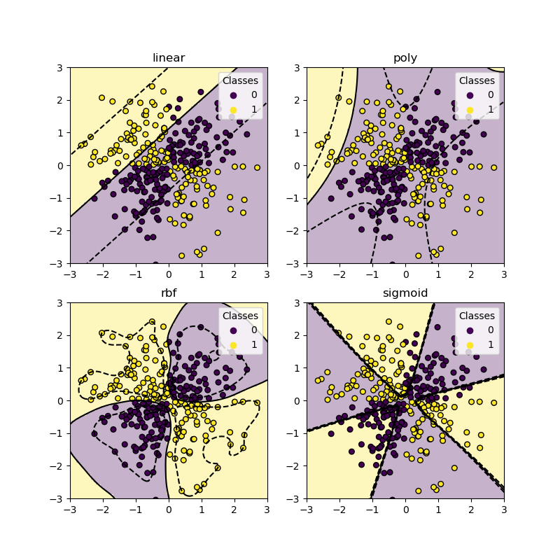
What is a Kernel
A Quantum Kernel is a technique used in Quantum Machine Learning (QML) to measure the similarity between data points using a quantum computer or quantum simulator.
In classical machine learning, algorithms such as Support Vector Machines (SVMs) use kernel functions to calculate how similar two data points are. Quantum Kernels perform the same task but use quantum states and quantum circuits instead of classical mathematical formulas.
The main idea is that quantum computers can represent information in a very high-dimensional quantum space, potentially capturing complex patterns that classical kernels may struggle to identify.
a kernel measures similarity between two data points.
Example:-
A = [2, 3]
B = [2.1, 3.2]
Why Use Quantum Kernels?
The main idea is:
Some patterns are difficult to detect in classical feature space.
Quantum circuits can map data into a higher-dimensional quantum feature space where separation may become easier.
Iris Dataset
↓
StandardScaler
↓
ZZ Feature Map
↓
Quantum States
↓
Fidelity Quantum Kernel
↓
SVM Classifier
↓
Prediction

6. Components of Quantum Kernel
1. Input Data (Feature Vectors)
The first component of the RBF kernel is the input data.
Each data sample is represented as a feature vector:
$$x_{i}=(x_{i1},x_{i2},...,x_{in}) \\ x_{j}=(x_{j1},x_{j2},...,x_{jn})$$
where:
- $x_{i}$= first data point
- $x_{j}$= second data point
- $n$= number of features
Example
Suppose we have:
$$x_{i}=(2,3) \\ x_{j}=(4,5)$$
These vectors are used to calculate similarity.
2. Euclidean Distance
The RBF kernel measures similarity based on the distance between two data points.
The squared Euclidean distance is calculated as:
$$∣∣x_{i}-x_{j}∣∣^{2}$$
For two-dimensional data:
$$∣∣x_{i}-x_{j}∣∣^{2}=(x_{i1}-x_{j1})^{2}+(x_{i2}-x_{j2})^{2}$$
A smaller distance indicates greater similarity between the points.
3. Gamma (γ) Parameter
Gamma ($γ$) is an important hyperparameter that controls how far the influence of a training example reaches.
The relationship with standard deviation ($σ$) is:
$$γ=\frac{1}{2σ^{2}}$$
Effect of Gamma
High Gamma
- Considers only nearby points.
Low Gamma
- Considers distant points as similar.
- Produces a smoother decision boundary.
- May lead to underfitting.
Importance
Choosing the correct gamma value is crucial for achieving good model performance.
4. Exponential Function
The core operation of the RBF kernel is the exponential function.
The complete RBF kernel formula is:
$$K(x_{i},x_{j})=e^{-γ∣∣x_{i}-x_{j}∣∣^{2}}$$
where:
- $K(x_{i},x_{j})$= similarity between two points
- $e$= Euler's number (≈ 2.718)
- $γ$= gamma parameter
- $∣∣x_{i}-x_{j}∣∣^{2}$= squared Euclidean distance
Thus, the RBF kernel converts distance into similarity.
5. Implicit Feature Mapping
A key advantage of the RBF kernel is that it performs an implicit mapping of data into a very high-dimensional feature space.
Instead of explicitly computing new features, the kernel computes similarity directly.
This is known as the Kernel Trick.
Benefits
- Handles non-linear data efficiently.
- Avoids expensive computations.
- Improves classification performance.
6. Kernel Matrix (Gram Matrix)
After computing kernel values between all pairs of training samples, a Kernel Matrix is generated.
Purpose
- Stores pairwise similarities.
- Used by SVM during training.

7. How Quantum Kernel Works

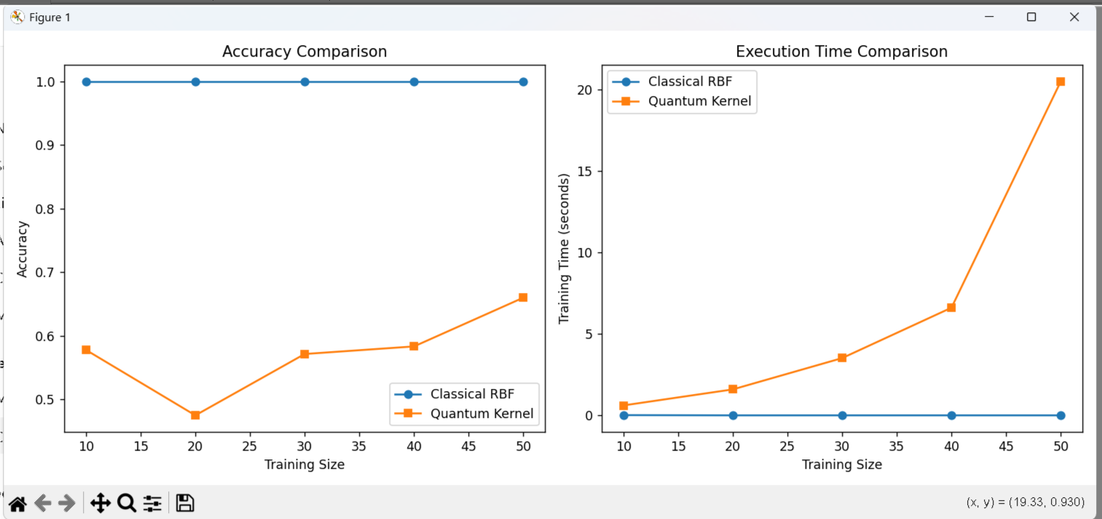
Comparison of Classical RBF and Quantum Kernel SVMs in terms of accuracy and training time across varying training set sizes
Explanation:-
The accuracy plot shows that the Classical RBF kernel achieves a perfect accuracy of 1.0 across all training sizes, remaining completely stable regardless of how much data is used. In contrast, the Quantum Kernel performs noticeably worse, with accuracy fluctuating between approximately 0.47 and 0.66. It dips to its lowest point at a training size of 20 before gradually improving as more data is added, but it never comes close to matching the classical model's performance. This suggests that the quantum kernel struggles to find a good decision boundary for this dataset, possibly due to the nature of the feature map used or the relative simplicity of the data, which the classical RBF kernel is already able to separate perfectly.
The execution time plot reveals an even starker contrast. The Classical RBF kernel trains almost instantaneously, with training time staying near zero seconds even as the dataset size increases to 50 samples. The Quantum Kernel, however, shows a clear exponential growth in training time — starting at roughly 0.5 seconds for 10 samples and rising sharply to over 20 seconds at 50 samples. This steep increase is likely due to the computational overhead of simulating quantum circuits and computing quantum kernel matrices, which scales much less favorably than classical kernel computations on conventional hardware.
Overall, the results indicate that for this particular dataset and problem size, the classical RBF kernel clearly outperforms the quantum kernel in both accuracy and computational efficiency, highlighting that quantum kernel methods may only offer an advantage on problems specifically suited to quantum feature spaces, rather than on simple, low-dimensional classical datasets like this one.

7. Advantages of Quantum Kernel
1.Exponential Feature Space
Classically computing inner products in a 2ⁿ-dimensional space becomes intractable past just a few dozen qubits. But a quantum computer can prepare and measure these high-dimensional states directly, in polynomial time. This lets quantum kernels represent feature maps that have no efficient classical analogue at all
2.No Barren Plateaus
Variational quantum circuits are trained using gradient descent, and their loss landscapes suffer from "barren plateaus" — gradients that vanish exponentially as qubit count grows. Quantum kernels largely sidestep this problem because once the kernel matrix is computed, training becomes a classical convex SVM optimization. This guarantees a unique global optimum, guaranteed convergence, and decades of well-established theory behind it.
3.NISQ-Friendly
The quantum computer's only job here is to estimate fidelity between states — a comparatively shallow, well-understood circuit task. There's no need for deep variational circuits, error-corrected long computations, or iterative quantum-classical parameter updates. This is why kernel methods are considered one of the more near-term-feasible approaches on today's noisy intermediate-scale quantum (NISQ) hardware. It's a practically implementable approach even with limited resources.
4. Classical Generalization Theory
Regardless of how the similarity measure is computed, the final model is still just a standard SVM. This means all of classical statistical learning theory — VC dimension bounds, margin-based generalization bounds, regularization theory — applies directly. There's no need to develop a brand-new theoretical framework just because the kernel came from a quantum circuit. This is a major practical advantage since decades of established ML theory are readily available to draw on.
5. Geometric Difference
Huang et al. (2021) introduced a calculable metric called the "geometric difference," which compares a quantum kernel against the best possible classical kernel on the same dataset. If this geometric difference turns out to be small, it means a classical kernel can match the quantum kernel's performance. This lets researchers know in advance whether a given dataset is even a candidate for quantum advantage. It's a useful diagnostic check before investing in expensive training.
6. Quantum Data Fit
When data already originates from a quantum process — like molecular electronic structure or quantum many-body states — a quantum kernel can naturally represent its relevant correlations (entanglement, superposition effects). Forcing such data through a classical feature map instead tends to be unnatural and inefficient. This is considered the most physically motivated use case for quantum kernels. Practical applications here are being explored in fields like quantum chemistry and materials science.

8. Technology use in Quantum Machine Learning
- Quantum Computing Hardware
  - Physical devices that perform quantum computations using qubits.
Types of Hardware:
  - Superconducting qubits
  - Trapped ions
  - Photonic systems
Key Features:
  - Superposition and entanglement
  - High computational power Examples:
  - IBM Quantum systems
  - Google Quantum processors
  - Rigetti Computing hardware
Role:
  - Executes quantum circuits used in QML models
- Quantum Gates & Circuits
  - Fundamental building blocks of quantum computation
Quantum Gates:
  - Perform operations on qubits Examples: Hadamard, Pauli-X, CNOT
Quantum Circuits:
  - Sequence of gates applied to qubits
Function:
  - Transform quantum states to process data
Role in QML:
  - Works like layers in a machine learning model
- Quantum Algorithms for ML
  - Algorithms designed to solve machine learning problems using quantum systems
Examples:
  - Quantum Support Vector Machine (QSVM)
  - Quantum PCA
  - Variational algorithms
Benefits:
  - Faster computation
  - Efficient handling of complex data
- Hybrid Quantum–Classical Computing
  - Combines quantum and classical systems
Working:
  - Quantum part → processes data
  - Classical part → optimizes parameters
Importance:
  - Practical approach for current quantum devices
Example:
  - Variational Quantum Algorithms
- Quantum Programming Frameworks
  - Software tools to build and run quantum programs
Popular Frameworks:
  - Qiskit • Cirq PennyLane Features:
  - Circuit design
  - Simulation
  - Integration with ML
- Classical Machine Learning Libraries
  - Used alongside quantum systems for preprocessing and optimization
Examples:
  - Scikit-learn
  - TensorFlow
  - PyTorch
Role:
  - Data preparation
  - Model evaluation
  - Parameter optimization
- Data Encoding Techniques
  - Methods to convert classical data into quantum states
Types:
  - Amplitude Encoding
  - Angle Encoding
  - Basis Encoding
Importance:
  - Critical for performance of QML models
  - Determines how effectively data is processed
- Quantum Simulators
  - Classical systems that simulate quantum circuits
Examples:
  - Qiskit Aer Simulator
  - Cirq Simulator
Advantages:
No need for real quantum hardware
  - Useful for testing and development
- Quantum Cloud Platforms
  - Provide remote access to quantum computers via the internet
Examples:
  - IBM Quantum Experience
  - Amazon Braket
  - Microsoft Azure Quantum
- Error Mitigation & Noise Handling
  - Quantum systems are highly sensitive to noise
Challenges:
  - Decoherence
  - Gate errors
  - Measurement errors

9.Applications of Quantum Machine Learning

1. Optimization Problems
Optimization problems un situations ko represent karte hain jahan bahut saare possible solutions mein se sabse best solution choose karna hota hai. Traditional machine learning algorithms jab bahut large datasets ya complex constraints ke saath kaam karte hain, tab computation time kaafi badh jata hai. Quantum Machine Learning quantum states aur quantum algorithms ka use karke search space ko efficiently explore kar sakta hai. QML models multiple possible solutions ko quantum superposition ke through represent karte hain, jisse optimization process faster aur more effective ho sakta hai. Iska use logistics, scheduling, resource management aur route planning jaise domains mein kiya ja raha hai jahan decision variables ki sankhya bahut adhik hoti hai.

2. Drug Discovery and Molecular Modeling
Drug discovery mein researchers ko molecules ke structure, properties aur interactions ko samajhna padta hai. Classical machine learning techniques molecular data ka analysis karti hain, lekin complex molecular interactions ko accurately simulate karna difficult hota hai. Quantum Machine Learning molecular systems ke quantum behavior ko better represent kar sakta hai kyunki molecules khud quantum mechanics ke principles ko follow karte hain. QML algorithms molecular structures ke patterns ko identify kar sakte hain aur chemical compounds ke interactions ka prediction kar sakte hain. Isse researchers ko disease treatment ke liye naye compounds identify karne aur molecular behavior ko samajhne mein madad milti hai.

3. Financial Modeling and Risk Analysis
Financial institutions daily millions of transactions aur market records generate karti hain. In data sets mein hidden relationships aur patterns ko identify karna kaafi challenging hota hai. Quantum Machine Learning large-scale financial data ko process karke market behavior, asset performance aur investment risks ka analysis kar sakta hai. QML algorithms multiple market conditions ko simultaneously evaluate kar sakte hain aur complex financial relationships ko model kar sakte hain. Iske madhyam se organizations future market trends aur financial uncertainties ko better understand kar sakti hain. Financial modeling mein QML ka role data-driven decision-making ko enhance karne mein dekha ja raha hai.

4. Image and Pattern Recognition
Image recognition systems digital images ke andar objects, shapes, faces aur patterns ko identify karte hain. Traditional machine learning methods ko high-dimensional image data process karne ke liye significant computational resources ki zarurat hoti hai. Quantum Machine Learning image features ko quantum states ke roop mein encode kar sakta hai aur complex visual patterns ko analyze kar sakta hai. QML models image classification aur feature extraction tasks mein useful hote hain kyunki ye large amounts of visual information ko efficiently process karne ki capability rakhte hain. Medical imaging, facial recognition aur remote sensing jaise areas mein QML-based image recognition techniques par research ki ja rahi hai.

5. Natural Language Processing (NLP)
Natural Language Processing computer systems ko human language ko samajhne, interpret karne aur generate karne ki capability deta hai. Human language mein ambiguity, context aur semantic relationships ko process karna ek complex task hota hai. Quantum Machine Learning text data ko quantum representations mein convert karke language patterns aur contextual relationships ka analysis kar sakta hai. QML models words aur sentences ke beech ke complex relationships ko capture karne ka prayas karte hain. Is approach ka use language understanding, text classification, machine translation aur conversational AI systems mein explore kiya ja raha hai. Quantum-enhanced NLP systems future mein more sophisticated language processing solutions provide kar sakte hain.

6. Cybersecurity
Cybersecurity ka objective digital systems, networks aur information ko unauthorized access aur cyber attacks se protect karna hota hai. Modern cyber environments mein enormous amounts of network data generate hota hai jiska continuous monitoring karna difficult ho sakta hai. Quantum Machine Learning network traffic aur user behavior patterns ka analysis karke unusual activities ko identify kar sakta hai. QML techniques anomalies aur hidden attack patterns ko detect karne ke liye advanced pattern recognition methods ka use karti hain. Cybersecurity researchers QML models ko intrusion detection, malware analysis aur threat intelligence systems mein integrate karne ke possibilities par kaam kar rahe hain.

7. Artificial Intelligence Acceleration
Artificial Intelligence systems ko train karne ke liye large datasets aur extensive computational power ki zarurat hoti hai. Training process mein model parameters ko continuously optimize kiya jata hai jisse computation cost badh sakti hai. Quantum Machine Learning AI algorithms ko quantum computing capabilities ke saath combine karta hai taaki learning process ko enhance kiya ja sake. Quantum-enhanced learning models large-scale data representations ko efficiently process karne ka potential rakhte hain. Researchers QML ka use neural networks, classification models aur predictive systems ki performance improve karne ke liye explore kar rahe hain. Is field ka primary focus machine learning workflows ko more powerful aur scalable banana hai.

8. Climate and Weather Modeling
Climate systems aur weather patterns mein atmosphere, oceans, temperature aur environmental factors ke complex interactions shamil hote hain. In interactions ko accurately model karna ek highly computational task hai. Quantum Machine Learning environmental datasets mein hidden relationships aur long-term trends ko identify karne mein madad kar sakta hai. QML algorithms climate variables ke beech ke dependencies ko analyze kar sakte hain aur predictive models ko improve kar sakte hain. Researchers weather forecasting aur climate change analysis ke liye quantum-enhanced machine learning approaches par study kar rahe hain. Is field mein QML ka objective large-scale environmental data ko efficiently analyze karna hai.

9. Traffic Optimization
Urban transportation systems mein daily millions of vehicles road networks ka use karte hain. Traffic flow, congestion aur route planning ko manage karna increasingly complex hota ja raha hai. Quantum Machine Learning traffic data, vehicle movement patterns aur road network information ko analyze karke transportation systems ke behavior ko model kar sakta hai. QML algorithms multiple traffic scenarios ko evaluate kar sakte hain aur real-time traffic conditions ke basis par intelligent decisions support kar sakte hain. Smart cities aur intelligent transportation systems mein QML-based approaches ko future traffic management solutions ke roop mein investigate kiya ja raha hai.

10. Advantages of Quantum Machine Learning
1. Exponential Speed-up for Certain Problems
- Quantum algorithms can solve some problems much faster than classical algorithms.
- Use of superposition → process many possibilities simultaneously
- Use of entanglement → faster correlation between variable
- Search and optimization tasks
- Significant reduction in computation time for specific problems
🔹 2. Efficient Handling of High-Dimensional Data
- QML can represent and process very large feature spaces efficiently
- Quantum states naturally exist in high-dimensional Hilbert space
- Handles complex datasets better than classical models
- Improves performance in data-heavy applications
🔹 3. Improved Optimization Capabilities
- Optimization is central to machine learning
- Quantum algorithms can explore multiple solutions simultaneously
- Faster convergence to optimal solutions
Applications:
- Training models
- Resource allocation
- Financial optimization
🔹 4. Faster Pattern Recognition
- QML can identify patterns in data more efficiently
- Uses quantum parallelism
- Captures complex relationships using entanglement
- Improved classification and prediction accuracy
🔹 5. Enhanced Feature Space Mapping
- QML maps data into complex quantum feature spaces
- Better separation of data points
- Captures non-linear relationships
- Improved performance of algorithms like classification models
🔹 6. Potential Energy Efficiency
- Quantum computers may use less energy for certain computation
- Perform multiple calculations in parallel
- Reduce need for repeated computations
- More sustainable computing for large-scale problems
Note:
- Current hardware still consumes significant energy
🔹 7. Solving Classically Intractable Problems
- Some problems are too complex for classical computers
- Can handle problems with:
  - Huge datasets
  - Complex interactions
- Molecular simulation
- Large-scale optimization
- Opens new possibilities in science and engineering
🔹 8. Advancement in AI Research
- QML pushes the boundaries of Artificial Intelligence
- New learning models
- Faster training methods
- Improved decision-making systems
- Accelerates development of next-generation AI
🔹 9. Ethical and Security Implications
- QML introduces new ethical and security challenges
- Bias in models
- Data misuse
- Lack of transparency
- Breaking traditional encryption
- New types of cyber threats
- Requires strong governance and regulations
🔹 10. Resource Requirements
- QML requires advanced resources
- Specialized quantum hardware
- High computational infrastructure
- Skilled professionals
- High cost and limited accessibility
🔹 11. Educational and Workforce Development
- Growing need for skilled professionals in QML
- Quantum computing
- Machine learning
- Mathematics and physics
- Creation of new job roles
- Need for updated education systems

- Disadvantages of Quantum Machine Learning
1. Immature Quantum Hardware
- Current quantum computers are still in the early development stage.
- Limited number of qubits
- High noise levels
- Short coherence time
- Limits the complexity of QML models
- Reduces reliability of results
2. Extremely High Cost
- Building and maintaining quantum systems is very expensive
- Requires ultra-low temperature environments
- Specialized equipment and infrastructure
- High research and development costs
3. Lack of Skilled Professionals
- QML requires expertise in multiple fields:
  - Quantum physics
  - Machine learning
  - Mathematics
- Very few trained professionals available
4. Limited Practical Applications
- Most QML solutions are still experimental
- Many algorithms are theoretical
- Limited real-world deployment
5. Data Input & Output Bottleneck
- Converting data between classical and quantum systems is difficult
- Encoding classical data into qubits is complex
- Measurement converts quantum data back to limited classical output
6. Error Sensitivity
- Quantum systems are highly sensitive to external disturbances
- Noise
- Decoherence
- Gate errors
7. Limited Scalability
- Scaling quantum systems is challenging
- Difficult to increase number of qubits
- Maintaining stability becomes harder
8. Shortage of Skilled Experts
- There is a global shortage of experts in QML
- Field is new and interdisciplinary
9. Limited Real-World Applications
- Many QML applications are still in testing phase
- Few commercial implementations
- Mostly research-based use
10. Difficult Algorithm Design
- Designing quantum algorithms is complex
- Requires deep understanding of quantum mechanics
- Difficult to translate classical ML algorithms into quantum form
11. Dependency on Classical Systems
- QML relies heavily on classical computers
- Preprocessing is classical
- Optimization is classical
- Control systems are classical
12. Lack of Standardization
- No universal standards for QML development
- Different frameworks and tools
- No common protocols

12.Future of Quantum Kernel and QML
1. Hybrid Quantum-Classical Architectures
Future systems will likely blend classical pre-processing and post-processing with quantum kernel evaluation, optimizing the division of labor between classical and quantum hardware to minimize circuit cost while maximizing the quantum advantage on the hardest subproblems.
2. Problem-Inspired Quantum Feature Maps
Rather than generic feature maps, research is moving toward domain-specific encodings — derived from the structure of chemistry, optimization, or physics problems — that are more likely to provide a genuine computational advantage over classical kernels.
3. Error Mitigation and Fault Tolerance
As error correction matures, deeper and more expressive quantum kernels will become feasible, reducing the noise-driven degradation that currently limits performance on real hardware.
4. Scalable and Trainable QML Models
New theoretical work aims to design circuits that avoid barren plateaus and exponential concentration, enabling QML models to scale to practically useful problem sizes as qubit counts grow.
5. Quantum Advantage and Benchmarking
A major research focus going forward is rigorously identifying problem classes where quantum kernels provably outperform the best-known classical kernels, alongside developing standardized benchmarks to fairly compare quantum and classical machine learning models.
6. Real-World Applications
- Drug discovery and molecular simulation
- Financial modeling and risk analysis
- Materials science and pattern recognition in complex datasets
7. Industry and Hardware Outlook
As quantum hardware providers scale qubit counts and improve coherence times, cloud-accessible quantum processors are expected to make quantum kernel experimentation more widely available, accelerating collaboration between academia and industry on practical QML pipelines.

13. Conclusion

Quantum kernel methods extend the classical kernel trick by using quantum circuits to map data into high-dimensional Hilbert spaces, aiming to capture patterns classical methods may struggle with.
However, current research shows this advantage is not universal — it depends heavily on dataset structure, and most real-world data shows little to no quantum benefit yet.
A major practical hurdle is exponential kernel concentration, where kernel values become indistinguishable as qubit count grows, hurting trainability. Combined with NISQ-era noise and limited qubit counts, this means quantum kernels today work best in hybrid quantum-classical pipelines rather than standalone quantum systems.
Quantum kernel methods and QML are still in an early, experimental stage, but the trajectory points toward tightly integrated hybrid systems, smarter problem-specific designs, and improved hardware reliability. As fault-tolerant quantum computers emerge, these methods are expected to transition from theoretical promise to practical tools for solving classically intractable problems

14. References
Websites:
https://qiskit.org/documentation
https://quantum.ibm.com/learn
https://quantumai.google
https://www.tensorflow.org/quantum
https://pennylane.ai
https://azure.microsoft.com/products/quantum
https://www.dwavesys.com
https://www.xanadu.ai

Books: -
Nielsen, M. A., & Chuang, I. L. Quantum Computation and Quantum Information. Cambridge University Press.
Schuld, M., & Petruccione, F.. Machine Learning with Quantum Computers. Springer.
Wittek, P.. Quantum Machine Learning: What Quantum Computing Means to Data Mining. Academic Press.
Raj, S. Machine Learning with TensorFlow: Implement Machine Learning and Deep Learning Models with Python. Packt Publishing.
Machine Learning with TensorFlow: Implement Machine Learning and Deep Learning Models with Python" by Sumit Raj
Python Natural Language Processing: Advanced machine learning and deep learning techniques for Natural Language Processing" by Jalaj Thanaki

