IIIDEM Moodle — Site Flow Diagrams
Visual flowcharts for visitor, student, and teacher journeys (theme_iiidem2).

1. Site overview — visitor through role dashboards to certificate
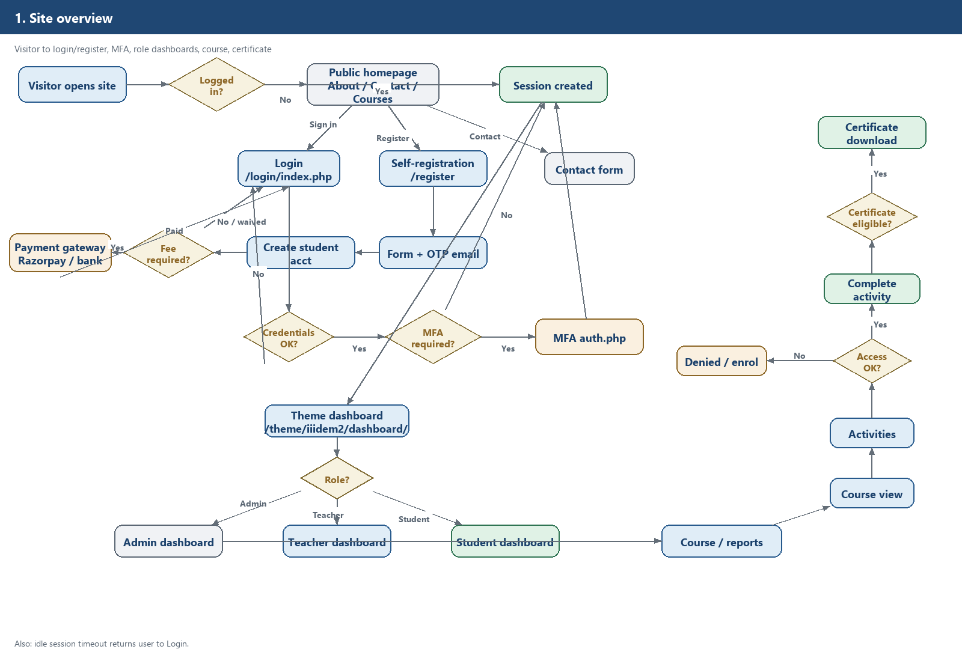

2. Student path (detailed) — register, OTP, pay, enrol, course, certificate
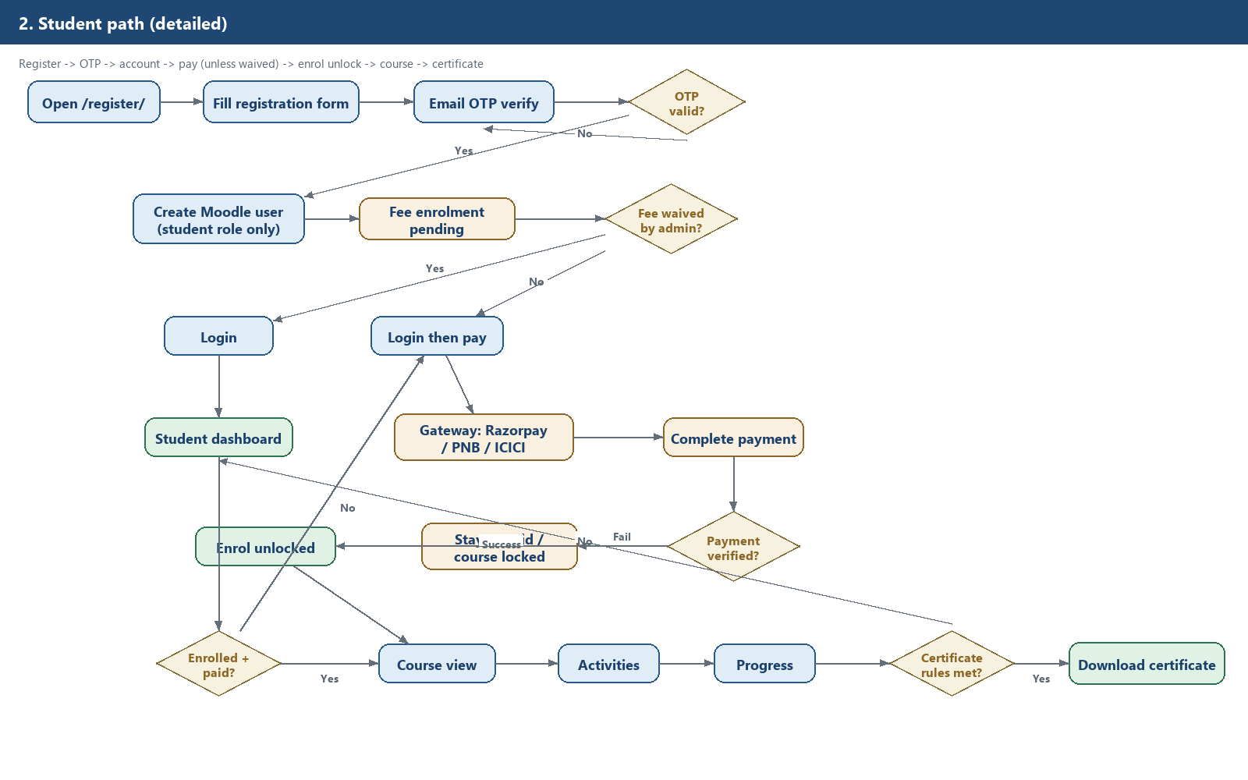

3. Student path (one-liner)
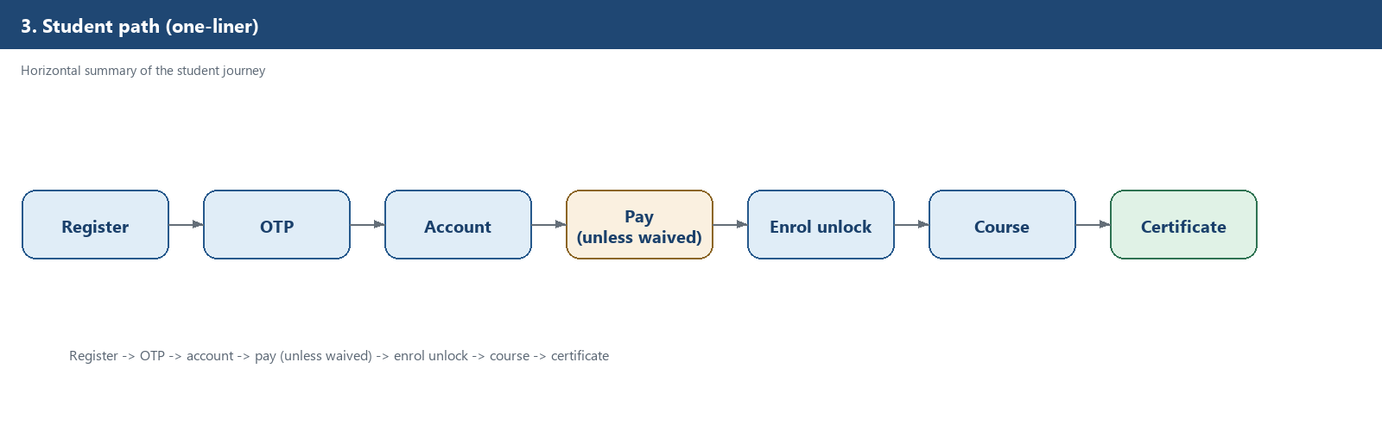

4. Teacher path (detailed) — live class, Webex, attendance sync, reports
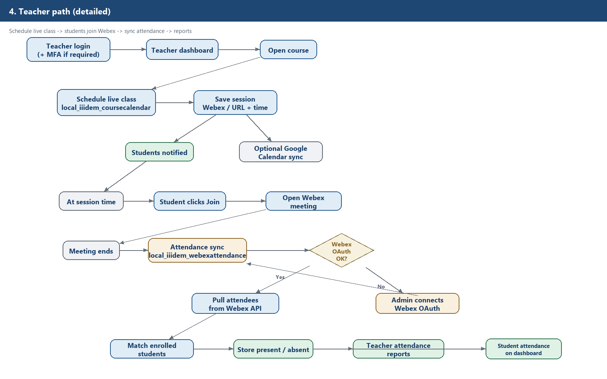

5. Teacher path (one-liner)
