# Details of Team Members:

* Hardik Jain – 21103185
* Keshav Khandelwal – 21103182
* Abhay Pratap Singh Tomar – 21103180
* Siddhant Kumar - 21103195

B7 CSE

Cafe management and billing system

Data Structure Project

December 2, 2021

Jaypee Institute of Information Technology

NOIDA

Acknowledgement

We take this occasion to thank God, almighty for blessing us with his grace and taking our endeavour to a successful culmination. We would like to extend our sincere and heartfelt thanks to our esteemed guide, Prof. Sherry Garg, for providing us with the right guidance and advice, that came to help us greatly in making of our project. I would like to thank the other faculty members also, at this occasion. Last but not the least, I would like to thank my friends and family for the support and encouragement they have given me during the course of our work.

Cafe Management and Billing System

# Problem Statement:

What is the need for a software managing our Café?

Why isn’t the current, offline system sufficient to deal with modern day problems?

Does the system actually reduce the load and make the system more effective?

What are the other things we can use this management system for?

# Abstract of Project:

In large cafe, it could be tedious to keep record of the quantities of all items they have.

The function of this program is to help a cafe to manage the items in their inventory. They can save quantity of each item in their store. Update the stock as soon as the sell a product or they order items for the store.

Other main function of the program is to help customers give orders from their desk. Those orders are received by the cook and they prepare them and then the prepared orders are passed to the serving window where the customers can collect their order.

# Topics of SDF-II used:

* File Handling
* Basic print, scan functions and mathematical operators
* Functions
* Loops: For loop, while loop, nested loops
* If else, nested if else
* String Methods
* Switch Case
* Pointers

## Data Structures used:

* Array
* Structures
* Vectors
* Linked List
* Queue
* Linear Search

# Design of the project:

The program consists of total four different applications which are as follows:

1. User: This file is for customers where customer could do the following operations:

* View Menu
* Place New Order
* Check Status for their Previous Orders

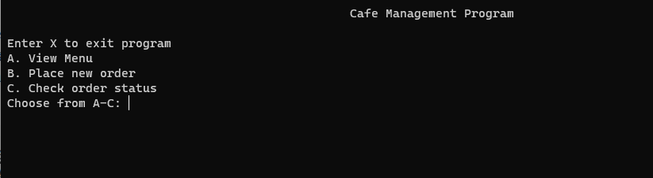

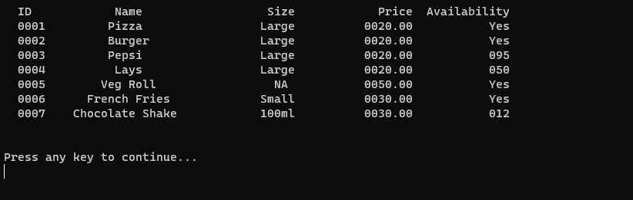

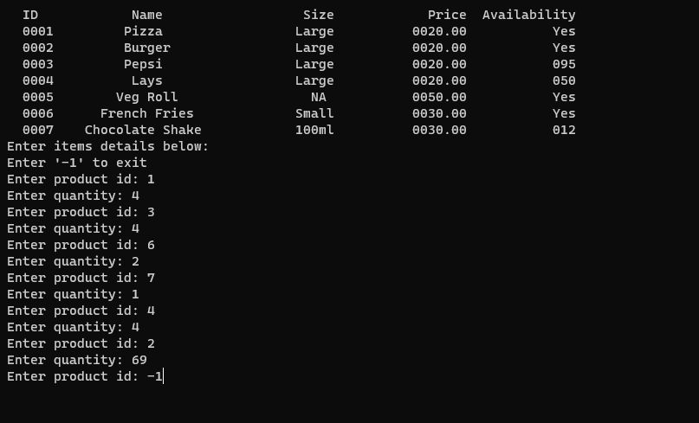

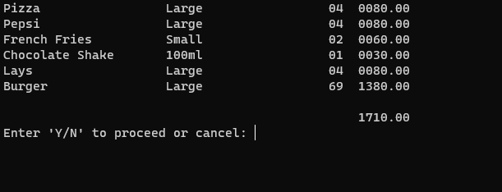

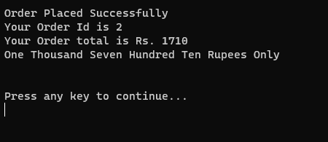

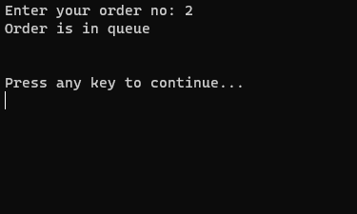

1. Cook: This file is for the preparing staff where they can see existing orders and details of the order at the top of the order queue. For each order he is shown two options:
   * Order is Prepared
   * Cannot prepare order

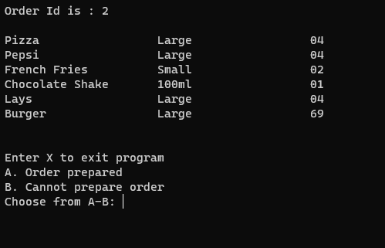

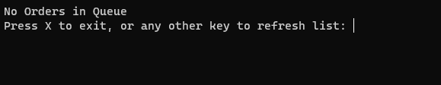

1. Counter: This file is for the delivery window where a list of all the prepared orders is listed and they can either deliver an order from the list, refresh the list.

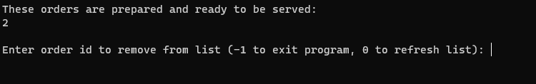

1. Manager: This file is for the manager of the café.
   * View Menu
   * Update Quantities
   * Change Availability Status
   * Add new menu item
   * View orders for a day

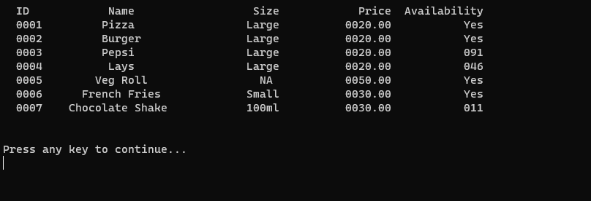

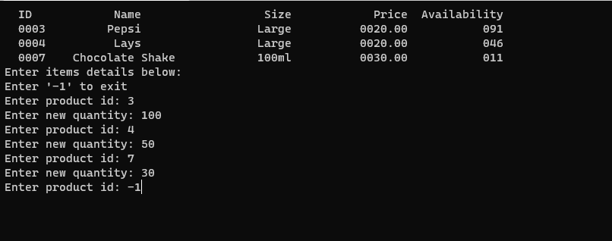

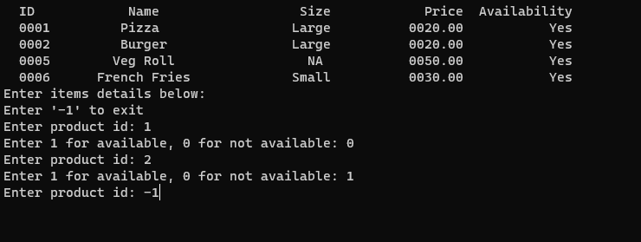

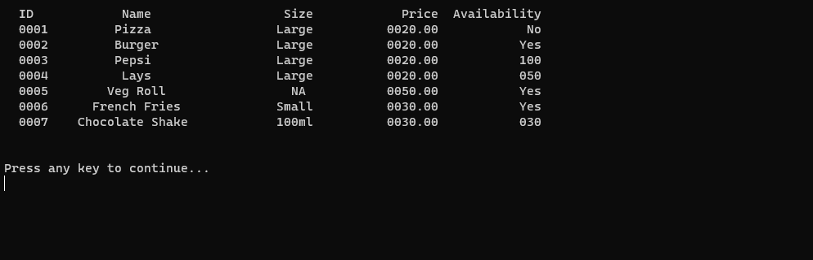

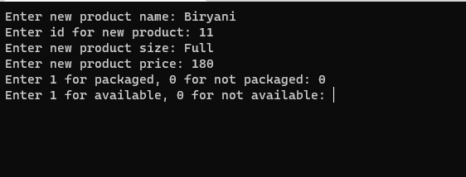

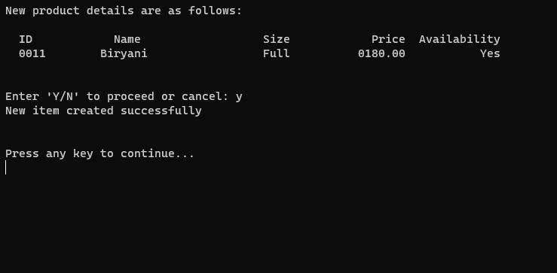

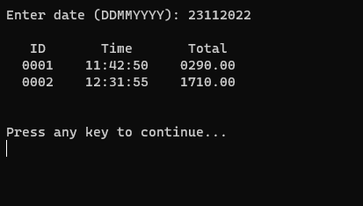

# References

* https://www.tutorialspoint.com/cprogramming/c_constants.htm
* https://www.geeksforgeeks.org/sprintf-in-c/
* https://www.techonthenet.com/c_language/standard_library_functions/stdlib_h/atof.php
* https://www.tutorialspoint.com/what-are-pointers-to-structures-in-c-language/;
* https://www.epochconverter.com/
* https://zetcode.com/articles/cdatetime/
* https://stackoverflow.com/questions/1442116/how-to-get-the-date-and-time-values-in-a-c-program
* https://www.geeksforgeeks.org/time-h-header-file-in-c-with-examples/
* https://www.geeksforgeeks.org/ctime-function-in-c-c/
* https://www.geeksforgeeks.org/time-function-in-c/
* https://www.geeksforgeeks.org/basics-file-handling-c/
* https://stackoverflow.com/questions/15472299/split-string-into-tokens-and-save-them-in-an-array
* https://stackoverflow.com/questions/19424030/why-gets-function-skips-when-preceded-by-scanfd/
* https://www.geeksforgeeks.org/strcmp-in-c-cpp/
* https://www.geeksforgeeks.org/goto-statement-in-c-cpp/
* https://stackoverflow.com/questions/12740268/how-can-i-restart-while-loop-after-certain-condition-if-satisfied-in-c
* https://www.educative.io/blog/concatenate-string-c
* https://stackoverflow.com/a/32349605
* https://stackoverflow.com/a/153895
* <https://www.epochconverter.com/programming/c>
* <https://iq.opengenus.org/create-and-delete-folder-in-cpp/#:~:text=For%20this%20open%20a%20command,the%20folder%20has%20been%20created>