----------------------------------------Node.js---------------------------------------------

Introduction:-

- Node.js is open source, cross-platform, JavaScript runtime environment.

- Node applications can be developed using either JavaScript or typescript.

- Node.js was released by Ryan Dahl on 27th May 2009, at Netscape.

- The applications (servers) developed by Node.js are called 'Single Threaded Event Loop'

--------------------------------------------------------------------------------------------

- Node.js contain infinite event loop.

- This loop can handle two types of requests

- Non - blocking I/O requests.

- Blocking I/O requests.

- Multiple clients requesting to server.

- these requests kept in Event queue.

- these requests sent to event loop.

- if the requests are non-blocking I/O requests, response will be sent immediately to clients.

- if the requests are blocking I/O requests, those are sent to thread pool.

- thread pool will pass requests to databases or file systems (third parties).

- the response given by third parties will be in thread pool.

- the response from thread pool will be in event loop.

- event loop will give this response back to clients.

--------------------------------------------------------------------------------------------

-- HTTP

- This is the native module.

- This module is available along with 'Node Engine'.

--------------------------------------------------------------------------------------------

-- URL

- This is native module.

- This module is used to read get parameters in http servers.

--------------------------------------------------------------------------------------------

-- query-string

- This is native module.

- This module is used to read the post parameters in http servers.

--------------------------------------------------------------------------------------------

-- fs

- This is native module.

- fs stands for 'File System'.

- This module is used to interact with flat files.

- Eg :- txt, xml, json, etc

--------------------------------------------------------------------------------------------

-- Express

- This is third party module.

- This module is used to develop 'ReST APIs' (web services)

- ReST API :- Representational State Transfer Application Programming Interface.

--------------------------------------------------------------------------------------------

-- MySQL

- This is third party module.

- This module is used to interact with MySQL database.

--------------------------------------------------------------------------------------------

-- mongodb

- This is third party module.

- This module is used to interact with mongodb without schema.

- Note :- rules and regulations of db are called as schema.

--------------------------------------------------------------------------------------------

-- Mongoose

- This is third party module.

- This module is used to interact with mongodb with schema.

--------------------------------------------------------------------------------------------

-- mssql

- This is third party module.

- This module is used to interact SQL server.

--------------------------------------------------------------------------------------------

-- multer

- This is third party module.

- This module is used to upload images to server.

--------------------------------------------------------------------------------------------

-- Socket.io

- This is third party module.

- This module is used to develop chat applications.

--------------------------------------------------------------------------------------------

-- jwt-simple

- This is third party module.

- This module is used to generate tokens for authentication purpose.

- This system is technically called as token based authentication system.

--------------------------------------------------------------------------------------------

-- body-parser

- This is third party module.

- This module is used to set MIME type.

--------------------------------------------------------------------------------------------

-- cluster

- This is third party module.

- This module is used to implement child process in http server.

- Implementing child process is called as load balancing.

--------------------------------------------------------------------------------------------

-- express-cluster

- This third party module.

- This module is used to implement load balancing in ReST APIs.

--------------------------------------------------------------------------------------------

-- Cookie-parser

- This is third party module.

- This module is used to work with cookies.

--------------------------------------------------------------------------------------------

- We can download all third party modules by using either 'npm' or 'yarn' tool.

- 'npm' stands for Node packaging manager.

- 'yarn' is latest tool used to download node modules in faster manner as compared to 'npm'.

- 'yarn' tool given by facebook

- All node modules are downloaded to 'node_modules' directory in current path.

--------------------------------------------------------------------------------------------

https://shorturl.at/bw12r 12 Dec 2024

G21 BEE

KickStart with Node.js https://shorturl.at/6DjNO

Creating HTTP server

Passing Custom HTML response

=======================================================

Implementing HTTP Server

=======================================================

- ‘http’ is the predefined module used to create http servers.

- http is the native module, so no need to download it.

- ‘require()’ is used to import.

- Eg let http = require(‘http’)

- ‘createServer()’ is the predefined function in http module.

- This function is used to create the server.

- The argument to createServer() is arrow function.

- To this arrow function there are two arguments, ‘req’ and ‘res’.

- request and response objects provided by node engine respectively.

- req object is used to store client data.

- res object is used to send response to client.

- 'writeHead(-,-)' is the predefined function in res object.

- This function is used to set the MIME type.

- First argument to this function is the status code (200 - ok).

- Second argument is the JSON object.

- JSON key is ‘content-type’ and the value is ‘text/html’.

- ‘write(-)’ is the predefined function in res object.

- This function is used to append response to res object.

- ‘end()’ is the predefined function in res object.

- This function is used to lock the response.

Task:- Getting Custom HTML response from http server

let resText = `Welcome to HTTP server`

let myRes = `

<!DOCTYPE html>

<Html>

<head>

<style>

body

{

background-color: black;

}

h1{

color: black;

text-shadow: 0px 0px 2px red;

}

</style>

</head>

<body>

<h1>${resText}</h1>

</body>

</Html>

`

//import http module

let http = require('http')

let server = http.createServer((req, res) => {

//set MIME type

res.writeHead(200, { 'content-type': 'text/html' })

res.write(myRes)

res.end()

})

//assign port no

server.listen(8080)

console.log('Server listening port no 8080')

-------------------------------------------------------------------------------------------------------------

https://shorturl.at/bw12r 13 Dec 2024

G21 BEE

KickStart with Node.js https://shorturl.at/6DjNO

=======================================================

HTTP get parameters

=======================================================

- 'url' is the predefined module in node.

- url module is used to read get parameters in http server.

***server.js***

//import http module

let http = require('http')

//import url module

let url = require('url')

let server = http.createServer((req, res) => {

let obj = url.parse(req.url, true).query

let uname = obj.uname

let upwd = obj.upwd

//set MIME type

res.writeHead(200, { 'content-type': 'text/html' })

if (uname === 'admin' && upwd === 'admin')

res.write("<h1> Login Success </h1>")

else

res.write("<h1> Login Failed </h1>")

res.end()

})

//assign port no

server.listen(8080)

console.log('Server listening port no 8080')

//url :- http://localhost:8080/?uname=admin&upwd=admin

***index.html***

<!DOCTYPE html>

<html>

<head>

<link rel="stylesheet" href="style.css">

</head>

<body>

<form action="http://localhost:8080" method="get" class="box">

<h1>Login</h1>

<input type="text" placeholder="Username" name="uname">

<input type="password" placeholder="Password" name="upwd">

<input type="submit" value="Login">

</form>

</body>

</html>

***style.css***

h1 {

color: white;

text-transform: uppercase;

font-weight: normal;

}

body {

background: radial-gradient(white, black);

font-family: sans-serif;

}

.box {

background-color: black;

width: 300px;

margin: 50px auto;

padding: 40px;

border-radius: 20px;

text-align: center;

}

input {

margin: 20px auto;

text-align: center;

padding: 14px 10px;

width: 200px;

border-radius: 24px;

background: none;

}

input[type="text"],

input[type="password"] {

border: 2px solid skyblue;

color: lightyellow;

}

input[type="submit"]

{

border: 2px solid burlywood;

color: white;

cursor: pointer;

}

=================================================

HTTP post parameters

=================================================

- 'querystring' is the predefined module in nodejs.

- querystring module is used to read post parameters in http server

***server.js***

//import http module

let http = require('http')

//import querystring module

let qs = require('querystring')

let server = http.createServer((req, res) => {

//set MIME type

res.writeHead(200, { 'content-type': 'text/html' })

let body = ''

//listen to post parameters

req.on('data', (result) => {

body = body + result

})

//end callback to node engine

req.on('end', () => {

let obj = qs.parse(body)

let uname = obj.uname

let upwd = obj.upwd

if (uname === 'admin' && upwd === 'admin')

res.write("<h1 style = 'color:green'> Login Success </h1>")

else

res.write("<h1 style = 'color:red'> Login Failed </h1>")

res.end()

})

})

//assign port no

server.listen(8080)

console.log('Server listening port no 8080')

//url :- http://localhost:8080/?uname=admin&upwd=admin

***index.html***

<!DOCTYPE html>

<html>

<head>

<link rel="stylesheet" href="style.css">

</head>

<body>

<form action="http://localhost:8080" method="post" class="box">

<h1>Login</h1>

<input type="text" placeholder="Username" name="uname">

<input type="password" placeholder="Password" name="upwd">

<input type="submit" value="Login">

</form>

</body>

</html>

***style.css***

h1 {

color: white;

text-transform: uppercase;

font-weight: normal;

}

body {

background: radial-gradient(white, black);

font-family: sans-serif;

}

.box {

background-color: black;

width: 300px;

margin: 50px auto;

padding: 40px;

border-radius: 20px;

text-align: center;

}

input {

margin: 20px auto;

text-align: center;

padding: 14px 10px;

width: 200px;

border-radius: 24px;

background: none;

}

input[type="text"],

input[type="password"] {

border: 2px solid skyblue;

color: lightyellow;

}

input[type="submit"]

{

border: 2px solid burlywood;

color: white;

cursor: pointer;

}

**Similar Technologies Like Node.js**

•  Django (Python)

•  Ruby on Rails (Ruby)

•  Spring Boot (Java)

•  Flask (Python)

•  ASP.NET Core (C#)

**Django (Python)**

•  High-level, batteries-included web framework.

•  Built-in tools for security, database management, and authentication.

•  Scalable and secure, with automatic protections against common vulnerabilities.

•  Ideal for rapid development of complex applications.

•  Great for web apps like CMS, social networks, and e-commerce.

•  Users :- Instagram, Pinterest, Mozilla, Disqus, Washington Post

**Ruby on Rails (Ruby)**

•  Convention-over-configuration framework for fast development.

•  Follows the MVC architecture (Model-View-Controller).

•  Built-in ORM (ActiveRecord) for easy database management.

•  Ideal for prototyping and startups.

•  Strong ecosystem with many reusable libraries (gems).

•  Users :- Basecamp, GitHub, Shopify, Airbnb, Twitch

**Spring Boot (Java)**

•  Simplifies Java web development with minimal configuration.

•  Ideal for microservices and RESTful APIs.

•  Includes embedded servers (e.g., Tomcat, Jetty).

•  Part of the larger Spring ecosystem (security, cloud, etc.).

•  High performance and scalability for enterprise applications.

•  Users :- Netflix, Uber, Alibaba, eBay, Accenture

**Flask (Python)**

•  Lightweight and minimalistic web framework.

•  Flexible and extensible, ideal for small to medium-sized apps.

•  Commonly used for microservices and RESTful APIs.

•  Jinja2 templating for dynamic content rendering.

•  Easy to integrate with third-party extensions.

•  Users :- Airbnb, Netflix, Uber, Reddit, LinkedIn

**ASP.NET (C#)**

•  Cross-platform, high-performance web framework.

•  Suitable for building scalable, cloud-based applications.

•  Modular architecture with built-in security features.

•  Great for microservices, especially with Azure integration.

•  High speed and low overhead for large apps.

•  Users :- Stack Overflow, Microsoft, Trello, Siemens, IntellIJ IDEA

**Quick Overview**

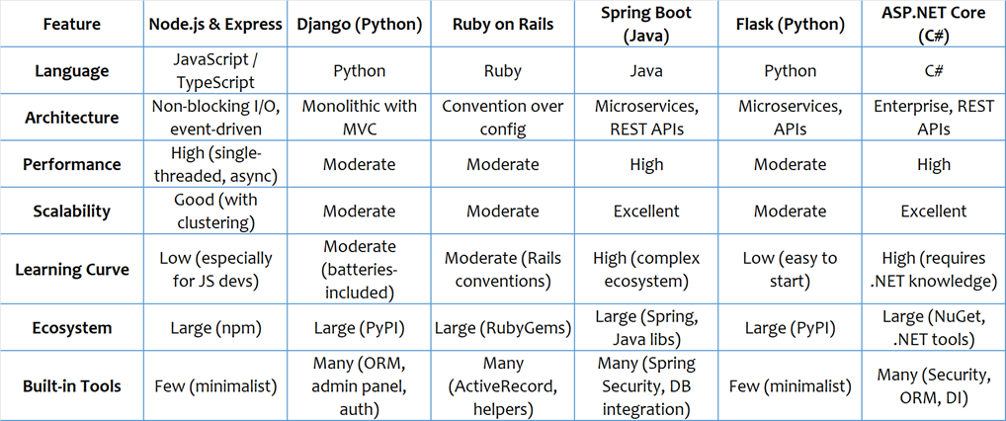

**advantages and disadvantages of Node.js with above technologies**

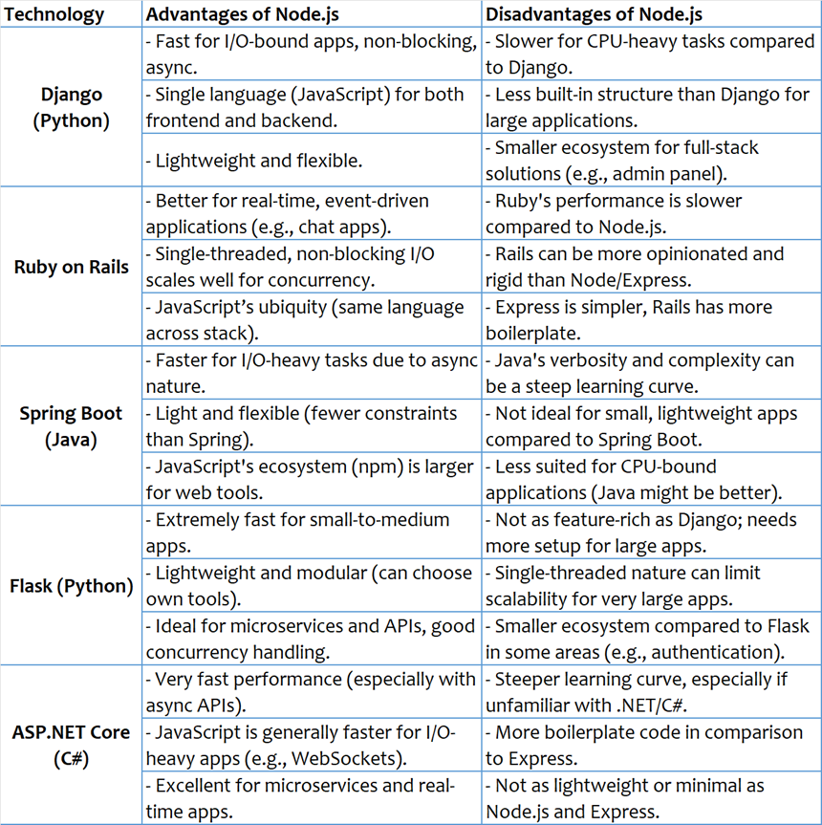

**Application of Node.JS**

•  Real-time chats

•  Complex single-page applications

•  Real-time collaboration tools

•  Streaming apps

•  JSON APIs

handling exceptions(errors)

 - There are various ways in node.js to handle the exceptions

- Synchronous errors: Use try-catch blocks to handle exceptions.

- Asynchronous errors: Handle errors in callbacks by checking the first argument (err).

- Global errors: Use process.on('uncaughtException') to handle uncaught exceptions globally.

- Custom errors: You can create custom error objects using Error and manipulate their properties.

Creating endpoints

 - method is the predefined key from req object.

 - this key gives type of method in request.

 - url is the predefined key from req object.

 - this key gives url of the request.

 - setHeader is the predefined function from res object

 - this function is used to set headers.

 - statusCode is the predefined key from res object.

 - we can set status code using this key.

 - handleError is the user defined function.

 - we are handling exceptions(errors) from this function.

 - possible errors are

- 'Route not found'

- 'Invalid method'

- etc

 - if any error occurred statusCode will be 4xx.

//Import the 'http' module

const http = require('http')

//handle the errors

function handleError(res, errorCode, message) {

    res.statusCode = errorCode

    res.write(message)

    res.end()

}

// Create HTTP server

const server = http.createServer((req, res) => {

    // Set the response header indicating the content type is JSON

    res.setHeader('Content-Type', 'application/json')

    res.statusCode = 200

    console.log('url',req.url)

    console.log('Method',req.method)

    //GET method

    if (req.method == 'GET') {

        if (req.url == '/')

            res.write('Default get request')

        else if (req.url == '/login')

            res.write('Login get request')

        else

            handleError(res, 404, 'Route not found')

    }

    //POST method

    else if (req.method == 'POST') {

        if (req.url == '/')

            res.write('Default post request')

        else if (req.url == '/login')

            res.write('Login post request')

        else

            handleError(res, 404, 'Route not found')

    }

    else

        handleError(res, 404, 'Invalid Method')

    res.end()

})

// Start the server on port 8080

const PORT = 8080

server.listen(PORT, () => {

    console.log(`Server is running at http://localhost:${PORT}`)

})

//Test in Postman

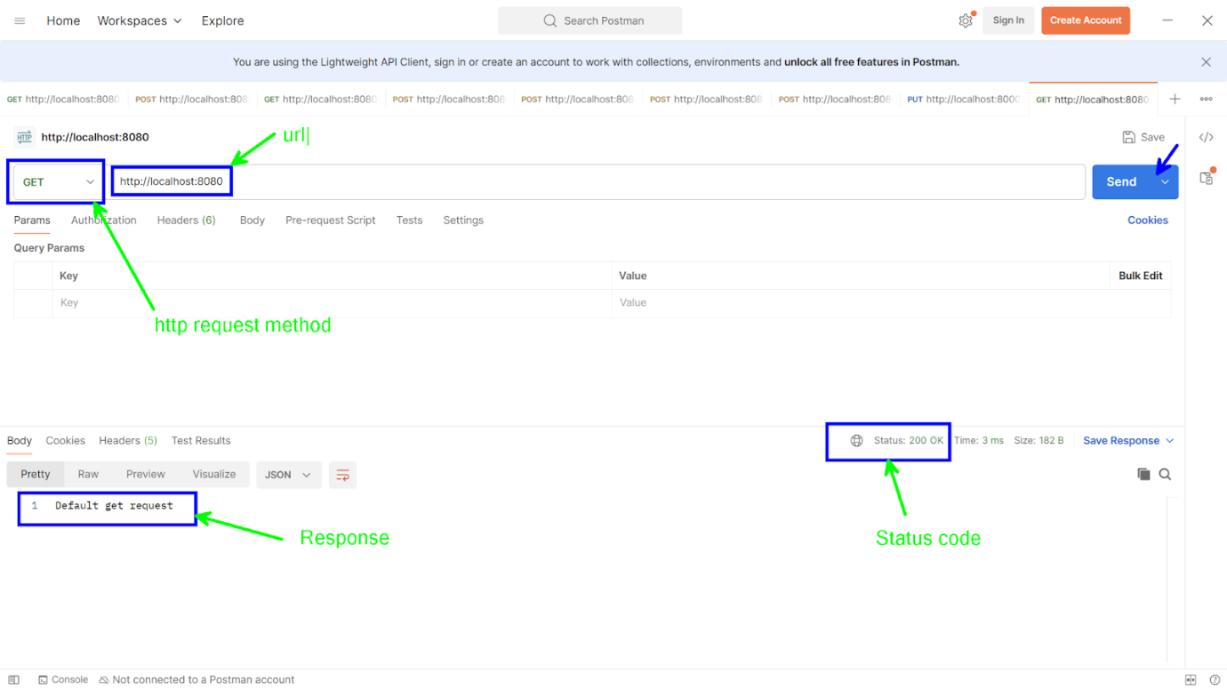

Task:-

Create nodeserver

Display home page

on home page provide two links/buttons

login and dashboard

dashboard -> error route not found

on login navigate to login endpoint -> login get request

on login page accept username and password

as per authentication display respective messages

apply proper styling

//Import the 'http' and 'querystring' modules

const http = require('http')

const qs = require('querystring')

// handle the errors

function handleError(res, errorCode, message) {

    res.statusCode = errorCode

    res.write(message)

    res.end()

}

// Create HTTP server

const server = http.createServer((req, res) => {

    // Set the response header

    res.setHeader('Content-Type', 'text/html')

    res.statusCode = 200

    // Log the incoming request to see headers

    console.log(`Request method: ${req.method} | URL: ${req.url}`)

    //GET method

    if (req.method == 'GET') {

        if (req.url == '/') {

            res.write(homePage)

        }

        else if (req.url == '/login') {

            res.write(loginPage)

        }

        else {

            handleError(res, 404, 'Route not found')

        }

    }

    // POST method

    else if (req.method == 'POST') {

        if (req.url == '/') {

            res.write('Default post request')

        }

        else if (req.url == '/login') {

            let body = ''

            // Listen to post parameters

            req.on('data', (data) => {

                body += data

            })

            // end callback to node engine

            req.on('end', () => {

                // Log the body to see what data is being received

                console.log('Received Body:', body)

                // Parse the form data

                let obj = qs.parse(body)

                console.log('Parsed Object:', obj) // Check if we are parsing correctly

                // Extract username and password

                let uname = obj.uname

                let upwd = obj.upwd

                // Basic validation

                if (uname === 'admin' && upwd === 'admin') {

                    res.write("<h1 style='color:green'> Login Success </h1>")

                } else {

                    res.write("<h1 style='color:red'> Login Failed </h1>")

                }

                res.end()

            })

        } else {

            handleError(res, 404, 'Route not found')

        }

    }

    else {

        handleError(res, 404, 'Invalid Method')

    }

})

// Start the server on port 8080

const PORT = 8081

server.listen(PORT, () => {

    console.log(`Server is running at http://localhost:${PORT}`)

})

// Home Page HTML

let homePage = `<!DOCTYPE html>

<html lang="en">

<head>

    <meta charset="UTF-8">

    <meta name="viewport" content="width=device-width, initial-scale=1.0">

    <link href="https://cdn.jsdelivr.net/npm/bootstrap@5.3.0-alpha1/dist/css/bootstrap.min.css" rel="stylesheet">

    <title>Home Page</title>

</head>

<body class="bg-light">

    <nav class="navbar navbar-expand-lg navbar-light bg-primary">

        <div class="container-fluid">

            <a class="navbar-brand text-white" href="#">Home</a>

            <button class="navbar-toggler" type="button" data-bs-toggle="collapse" data-bs-target="#navbarNav" aria-controls="navbarNav" aria-expanded="false" aria-label="Toggle navigation">

                <span class="navbar-toggler-icon"></span>

            </button>

            <div class="collapse navbar-collapse" id="navbarNav">

                <ul class="navbar-nav ms-auto">

                    <li class="nav-item">

                        <a class="nav-link text-white" href="/login">Login</a>

                    </li>

                    <li class="nav-item">

                        <a class="nav-link text-white" href="/dashboard">Dashboard</a>

                    </li>

                </ul>

            </div>

        </div>

    </nav>

    <div class="container text-center my-5">

        <h1 class="display-4 text-primary mb-4">Welcome to Home</h1>

        <p class="lead">Please choose an action below:</p>

        <div>

            <a href="/login" class="btn btn-primary btn-lg mx-3">Login</a>

            <a href="/dashboard" class="btn btn-secondary btn-lg mx-3">Dashboard</a>

        </div>

    </div>

    <script src="https://cdn.jsdelivr.net/npm/@popperjs/core@2.11.6/dist/umd/popper.min.js"></script>

    <script src="https://cdn.jsdelivr.net/npm/bootstrap@5.3.0-alpha1/dist/js/bootstrap.min.js"></script>

</body>

</html>`

// Login Page HTML (same as before)

let loginPage = `

<!DOCTYPE html>

<html>

<head>

    <style>

        h1 {

            color: white;

            text-transform: uppercase;

            font-weight: normal;

        }

        body {

            background: radial-gradient(white, black);

            font-family: sans-serif;

        }

        .box {

            background-color: black;

            width: 300px;

            margin: 50px auto;

            padding: 40px;

            border-radius: 20px;

            text-align: center;

        }

        input {

            margin: 20px auto;

            text-align: center;

            padding: 14px 10px;

            width: 200px;

            border-radius: 24px;

            background: none;

        }

        input[type="text"],

        input[type="password"] {

            border: 2px solid skyblue;

            color: lightyellow;

        }

        input[type="submit"] {

            border: 2px solid burlywood;

            color: white;

            cursor: pointer;

        }

    </style>

</head>

<body>

    <form action="/login" method="post" class="box">

        <h1>Login Page</h1>

        <input type="text" placeholder="Username" name="uname" required>

        <input type="password" placeholder="Password" name="upwd" required>

        <input type="submit" value="Login">

    </form>

</body>

</html>`

**G21 BEE**

**Task :- Custom Navigation  Using static files**

Handling Static files

 - path is the predefined module in node.js.

 - this module is used for working with file and directory paths.

 - this module is having predefined functions like,

join()

resolve()

basename()

are used to handle and manipulate file paths.

 - __dirname gives current path of server.js

<>

public

- index.html

server.js

***index.html***

<!DOCTYPE html>

<html>

    <head></head>

    <body>

        <h1 style="color: blue;">Welcome to static files</h1>

    </body>

</html>

***server.js***

// Import required modules

const http = require('http')

const fs = require('fs')

const path = require('path')

// Create an HTTP server

const server = http.createServer((req, res) => {

    const filePath = path.join(__dirname, 'public','index.html')

    console.log('Path:- ', __dirname)                    //?

    console.log('Base name', path.basename(__dirname))   //?

    console.log('Resolve:- ', path.resolve(filePath))    //?

    fs.readFile(filePath, (err, data) => {

        if (err)

            console.log(err)

        else

            res.write(data)

        res.end()

    })

})

// Specify the port and start the server

const PORT = 8080;

server.listen(PORT, () => {

    console.log(`Server is running on http://localhost:${PORT}`)

})

Complete task given in last session using static files.

**G21 BEE**

**Routing in express**

**Routing methods**

**Route paths**

**Route parameters**

**Route Handlers**

=================================================

Routing in express

=================================================

 - module is the predefined object in node.

 - exports is the predefined key in module object.

 - exports key is used to export (JSON object or function)

**1. Routing Methods:**

* **Routing methods** define the HTTP method (GET, POST, PUT, DELETE) for a route in Express.

**2. Route Paths:**

* **Route paths** are the URL patterns used to define a route in Express. They can be static (e.g., /login) or dynamic, using parameters (e.g., /user/:id).

**3. Route Parameters:**

* **Route parameters** are dynamic placeholders in a route path, prefixed by a colon (:), which capture values from the URL. They are accessed via req.params (e.g., req.params.id).

**4. Route Handlers:**

* **Route handlers** are callback functions that are executed when a request matches a route. They handle the request and send a response using res.send() or res.json().

<>

           login

                        - login.js

           logout

                        - logout.js

           - server.js

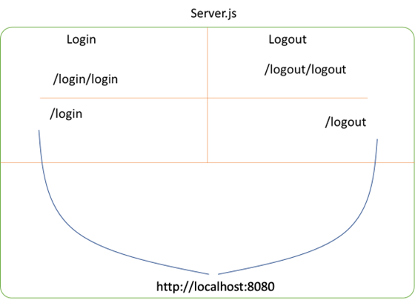

***login.js***

//import express module

let express = require('express')

//create router instance

let router = express.Router()

//create get request

router.get("/",(req, res)=>{

    res.send({ 'message': 'Welcome to Login module' })

})

//create one more get request

router.get("/login/:uname/:upwd", (req, res) => {

    //here we are reading url parameters using params

    let uname = req.params.uname

    let upwd = req.params.upwd

    if (uname == 'admin' && upwd == 'admin')

        res.json({ 'login': 'success' })

    else

        res.json({ 'login': 'failed' })

})

//export router instance

module.exports = router

***logout.js***

//import express module

let express = require('express')

//create router instance

let router = express.Router()

//create get request

router.get("/", (req, res) => {

    res.json({ 'message': 'Welcome to logout module' })

})

//create one more get request

//URL :- http://localhost:8080/logout/logout/?uname=admin&upwd=admin

router.get("/logout", (req, res) => {

    //here we are reading get parameters using query

    let uname = req.query.uname

    let upwd = req.query.upwd

    if (uname == 'admin' && upwd == 'admin')

        res.send({ 'logout': 'Success' })

    else

        res.send({ 'logout': 'Failed' })

})

//export router

module.exports = router

***server.js***

//import modules

let express = require('express')

let login = require('./login/login')

let logout = require('./logout/logout')

//create rest object

let app = express()

//use modules

app.use("/login",login)

app.use("/logout",logout)

//create port

let port = 8080

//assign port no

app.listen(port, () => {

    console.log(`Server running on port no :- ${port}`)

})

/*

http://localhost:8080/login

http://localhost:8080/login/login/admin/admin

http://localhost:8080/logout

http://localhost:8080/logout/logout?uname=admin&upwd=admin

*/