SecureCode AI: A Comprehensive Hands-On Secure Coding Practice and Multi-Engine Evaluation Platform
Harsh Jain ª , Atharva Kadam ^{b} , Sayli Vekhande ^{c} , Arya Ratnakar ^{d}
a, b, c, d Department of Computer Engineering, TPCT’s Terna Engineering College, Nerul, Navi Mumbai 400706, India
harshjain2324@ternaengg.ac.in | atharvakadam2324@ternaengg.ac.in | saylivekhande2324@ternaengg.ac.in | aryaratnakar2324@ternaengg.ac.in
Under the Guidance of: Prof. Mohini Misale (Department of Computer Engineering, Terna Engineering College)

Abstract
Software security vulnerabilities remain a prevalent and costly threat to global digital infrastructure. While traditional competitive programming and educational coding platforms (such as LeetCode, HackerRank, and Codewars) effectively cultivate algorithmic proficiency, they focus exclusively on functional correctness while entirely ignoring software security vulnerabilities. Conversely, offensive cybersecurity platforms (such as PortSwigger Web Security Academy, TryHackMe, and Hack The Box) emphasize penetration testing and exploitation rather than the constructive software engineering disciplines required to write secure source code. Furthermore, modern generative AI coding assistants frequently produce functionally acceptable yet insecure code, exacerbating the vulnerability epidemic. This paper presents SecureCode AI, an interactive, web-based secure coding practice and automated assessment platform engineered to cultivate defensive programming competencies from the ground up. SecureCode AI implements a novel dual-stage evaluation architecture: Stage 1 executes dynamic functional unit testing within an isolated sandbox (via Judge0), while Stage 2 performs multi-engine static and AI-assisted security analysis combining abstract syntax tree (AST) rules (Semgrep), bytecode dataflow inspection (SpotBugs/FindSecBugs), and contextual large language model advisory (Groq LLaMA-3). To prevent trial-and-error guessing and superficial code modification, SecureCode AI introduces an active catalog of 45 staged injection challenges across 8 distinct vulnerability subtypes (SQL, NoSQL, OS Command, LDAP, XPath, Header/CRLF, Code/SSTI, and XXE), a rate-limiting five-attempt window, interactive conceptual understanding quizzes, and a multi-factor learning scoring engine that holistically weights Functional Correctness (25%), Security Correctness (45%), Conceptual Understanding (15%), and Independent Problem Solving (15%). The system was engineered using Spring Boot 3, Java 25, PostgreSQL, Flyway migrations, and a responsive web application client. Empirical validation across 80 automated unit, integration, and security test suites demonstrates zero false passes on vulnerable code, flawless consensus arbitration across disparate static analysis outputs, and sub-500ms median evaluation latency for local static engines. SecureCode AI bridges the critical pedagogical chasm between algorithmic problem-solving and defensible software engineering.
Keywords: Secure Coding Education, Static Application Security Testing (SAST), Multi-Engine Consensus, Abstract Syntax Tree, Automated Assessment, Software Security, Shift-Left Security, Large Language Models.
1. Introduction
Modern society depends unconditionally on complex software systems spanning banking, healthcare, e-commerce, national defense, and industrial automation. However, software security vulnerabilities continue to proliferate at an alarming rate, inflicting trillions of dollars in global economic damages and compromising billions of user records annually. Historically, cybersecurity initiatives have focused primarily on perimeter defenses, post-deployment intrusion detection, and reactive patch management. While perimeter security is indispensable, modern software engineering paradigms increasingly emphasize 'Shift-Left' methodologies—integrating security directly into the earliest phases of the software development lifecycle (SDLC) [1], [5]. The fundamental premise of the Shift-Left movement is that writing secure code from the very beginning is exponentially cheaper, more resilient, and more effective than remediating flaws in production systems.
Despite widespread industry consensus regarding the necessity of secure coding, contemporary software developers entering the engineering workforce remain ill-equipped to write robust, defensible code [20], [25]. Traditional computer science education and commercial training platforms focus almost exclusively on functional algorithmic proficiency. Highly popular competitive programming platforms—such as LeetCode, HackerRank, and Codewars—train students to solve algorithmic challenges under strict time and memory constraints. However, their automated evaluation harnesses evaluate submissions solely through input/output dynamic unit testing. If a student's submission produces the expected functional output, the platform awards full credit—even if the underlying implementation employs catastrophic vulnerabilities such as unsanitized SQL string concatenation, raw OS command execution, or predictable cryptographic seeds [1].
On the opposite end of the pedagogical spectrum, specialized cybersecurity training platforms—such as PortSwigger Web Security Academy, TryHackMe, and Hack The Box—immerse students in offensive penetration testing, ethical hacking, and capture-the-flag (CTF) environments [21]. While offensive training succeeds in building an adversary mindset, it trains students how to break vulnerable systems rather than how to construct defensible production code. Exploitation skills do not automatically translate into sound software architectural discipline [2], [22].
Furthermore, the rapid mainstream adoption of Generative AI coding assistants (e.g., GitHub Copilot, ChatGPT, Claude) has exacerbated the security crisis. Recent empirical studies demonstrate that over 40% of code generated by Large Language Models (LLMs) contains exploitable security vulnerabilities [2], [4], [27]. Because beginner developers frequently treat AI-generated code as authoritative, they inadvertently copy vulnerable boilerplate into enterprise software repositories [5], [24].
To resolve these compounding dilemmas, this paper presents SecureCode AI, an open-access, web-based secure coding practice and multi-engine assessment platform. Our primary contributions are:
- 1. Full-Stack Production Architecture: An end-to-end multi-tier platform architecture integrating a Java 25 / Spring Boot 3 enterprise backend, isolated Dockerized Judge0 sandbox execution, and an in-browser Monaco code editor.
- 2. Dual-Stage Evaluation Gate: A sequential dual-stage evaluation gate where Stage 1 executes dynamic functional unit testing within Judge0, and Stage 2 executes multi-engine static and AI security analysis if and only if functional unit tests pass.
- 3. Multi-Engine Consensus Mechanism: A tri-engine security evaluation harness coupling Semgrep (AST pattern matching), SpotBugs/FindSecBugs (bytecode dataflow taint analysis), and Groq LLaMA-3 (AI contextual advisory) with a fail-closed consensus algorithm that guarantees zero false passes on vulnerable code.
- 4. Comprehensive Injection Taxonomy: A structured active catalog of 45 staged injection challenges across 8 distinct vulnerability subtypes (SQL, NoSQL, OS Command, LDAP, XPath, Header/CRLF, Code/SSTI, XXE) categorized across 4 difficulty tiers.
- 5. Four-Pillar Pedagogical Scoring: A multi-factor scoring model that holistically balances Functional Correctness (25 pts), Security Correctness (45 pts), Conceptual Understanding (15 pts), and Independent Problem Solving (15 pts) alongside a 5-attempt rate-limiting window.
- 6. Empirical Benchmark Validation: Comprehensive test benchmarks across 80 automated unit, integration, and security test suites, confirming zero false passes, 100% consensus reliability, and sub-500ms median static analysis latency.
2. Background and Related Work
2.1 Traditional Coding Platforms and the 'Functionality-Only' Bias
Automated assessment systems (AAS) have fundamentally transformed computer science pedagogy over the past two decades [18], [26]. Systems such as LeetCode, HackerRank, and Web-CAT evaluate student programming assignments at scale through dynamic unit testing. While these platforms have democratized algorithmic education, their grading harnesses treat code as a black box: an input vector is supplied to the program, and standard output is compared against expected test assertions. As established by Torbunova et al. [20], traditional programming curricula systematically omit software security considerations from introductory and intermediate courses. Consequently, students develop dangerous coding habits: they prioritize quick functional delivery over input sanitization, boundary checking, and defensive parameterization [19], [25].
2.2 Static Application Security Testing (SAST) Tools and Limitations
Static Application Security Testing (SAST) tools analyze source code without execution to identify security flaws [7], [10]. SAST tools generally operate along two primary analytical paradigms: Abstract Syntax Tree (AST) pattern matching and Bytecode Dataflow/Taint Analysis. Tools like Semgrep parse code into concrete syntax trees and evaluate lightweight declarative pattern rules. Semgrep is extraordinarily fast and highly accurate for localized syntactic anti-patterns (such as string concatenation inside an SQL query). However, Semgrep lacks interprocedural dataflow context: it cannot track taint propagation across complex method boundaries or object graphs [1], [5].
Conversely, tools like SpotBugs (augmented with the FindSecBugs security plugin) analyze compiled Java bytecode, constructing control flow graphs and performing taint-analysis from untrusted input sources (such as HTTP request parameters) to sensitive sinks (such as JDBC database connections) [5], [7]. While SpotBugs excels at discovering complex interprocedural taint paths, it suffers from heavy compilation overhead, opaque rule reporting, and noticeable false-positive rates [6], [16]. Relying on any single SAST tool creates significant blind spots: empirical surveys demonstrate that individual static scanners miss between 20% and 45% of known vulnerabilities when operating alone [7], [27].
2.3 Large Language Models in Vulnerability Detection and Repair
Recent breakthroughs in Large Language Models (LLMs) have catalyzed extensive research into AI-assisted vulnerability detection and automated program repair [3], [12]. Models trained on extensive code corpora—such as LLaMA-3, GPT-4, and DeepSeek-Coder—exhibit remarkable semantic understanding of code logic [4], [14]. Researchers have explored LLMs for zero-day flaw detection, contextual code explanation, and automated patch synthesis [9], [17], [27]. However, LLMs suffer from severe limitations when used in isolation for grading: they exhibit non-deterministic reasoning, hallucinate false positives, miss subtle syntax violations, and can be easily manipulated through prompt injections or cosmetic code refactoring [2], [4]. Dai et al. [1] and Belozerov et al. [5] emphasize that AI code evaluation must be anchored by deterministic static scanners to establish rigorous ground truth.
2.4 The Educational Research Gap in Defensive Programming
In their comprehensive systematic mapping study, Torbunova et al. [20] surveyed the teaching of security concepts across higher education programming courses and discovered an acute shortage of hands-on, constructive coding platforms. While offensive cybersecurity platforms (e.g., PortSwigger, TryHackMe) provide realistic CTF environments, they evaluate students based on flag capture rather than source-code remediation [21]. Meanwhile, commercial tools like Secure Code Warrior are proprietary, expensive, and heavily reliant on multiple-choice quizzes rather than authentic compiler-backed development [22]. There exists a pronounced need for an open, automated educational platform that combines functional execution, multi-engine static verification, and AI-driven pedagogical coaching.
3. System Architecture and Design
3.1 Multi-Tier Architectural Topology
SecureCode AI is architected as an enterprise-grade, distributed multi-tier system engineered for fault tolerance, security isolation, and horizontal scalability. The system comprises five distinct tiers: Client Tier, Backend Application Tier, Security & Static Analysis Tier, Dynamic Sandbox Execution Tier, and Persistence Tier. Fig. 1 illustrates the comprehensive multi-tier architectural decomposition.
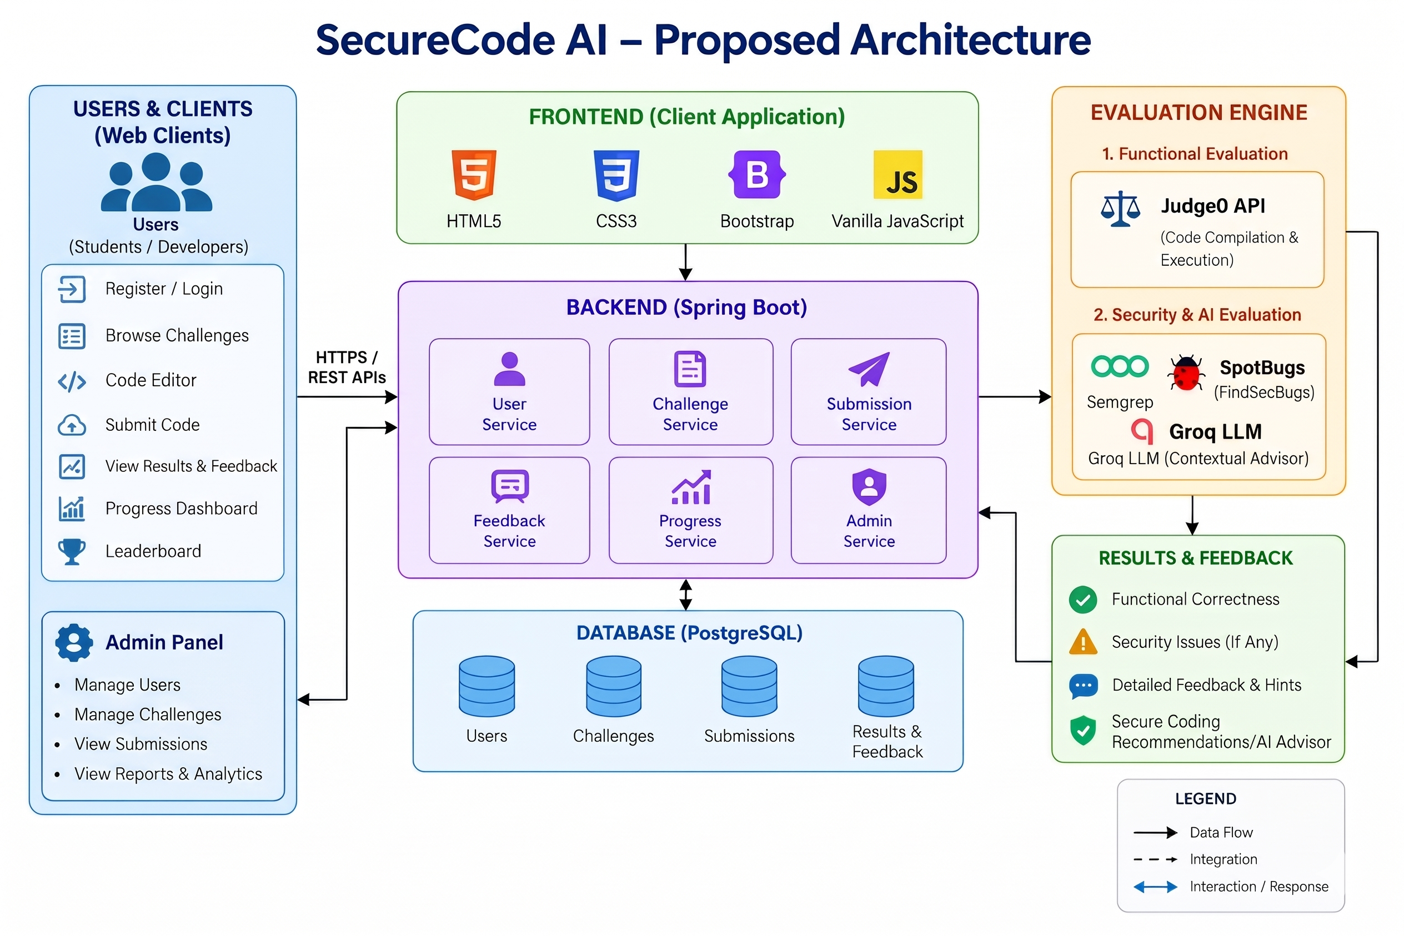
Fig. 1. SecureCode AI Proposed Multi-Tier System Architecture.
- 1. Presentation & Client Tier: Client Tier: A responsive web application engineered with Vanilla JavaScript (ES6+), Monaco Editor (the code editor powering Visual Studio Code), Bootstrap 5, and Tailwind CSS. The Monaco editor delivers syntax highlighting, in-line diff inspection, and real-time validation for Java.
- 2. Application Domain Tier: Backend Application Tier: Built on Spring Boot 3 running on Java 25 (OpenJDK). The backend encapsulates business logic across modular service layers: ChallengeService, SubmissionAnalysisService, SecurityEvaluationService, FunctionalEvaluationService, HintService, and OverallLearningScoreService. Security is enforced via Spring Security filters and BCrypt/PBKDF2 password hashing.
- 3. Persistence Data Tier: Persistence Tier: Relational persistence powered by PostgreSQL 16. Schema evolution is deterministically managed through 21 Flyway database migration scripts, guaranteeing continuous integration consistency.
- 4. Dynamic Execution Sandbox Tier: Dynamic Sandbox Tier: An isolated Docker container hosting the Judge0 Execution API. Student code is compiled and executed under strict cgroup isolation (2.0s execution timeout, 256MB RAM ceiling, non-root user privileges, zero outbound network access).
- 5. Multi-Engine Security Tier: Multi-Engine Security Tier: Combines Semgrep CLI AST engine, SpotBugs 4.8 / FindSecBugs 1.13 bytecode analyzer, and Groq high-speed cloud inference engine running LLaMA-3-70B.
3.2 Verified Technology Stack
Table 1 details the complete, verified technology stack across all structural components of the platform.
Layer | Technology & Version | Functional Purpose in System
Core Backend | Java 25 (OpenJDK), Spring Boot 3 | RESTful API controllers, domain logic, dependency injection, and security filters
Database & ORM | PostgreSQL 16, Hibernate / JPA, Flyway | Relational persistence, transactional integrity, and automated schema evolution (V1–V21)
Code Editor UI | Monaco Editor, Vanilla JS, Bootstrap 5 | In-browser code editor, responsive dashboard layouts, and interactive diff viewers
Dynamic Sandbox | Judge0 Execution API (Docker container) | Containerized compilation and dynamic unit testing with CPU/memory limits
Static SAST (AST) | Semgrep CLI 1.60+ (Curated YAML Rules) | Deterministic AST pattern matching for syntax-level injection vulnerabilities
Static SAST (Bytecode) | SpotBugs 4.8.3 + FindSecBugs 1.13.0 | Interprocedural dataflow and taint-tracking analysis on compiled Java bytecode
Contextual AI | Groq Cloud API (LLaMA-3-70B / 8B) | High-speed semantic flaw analysis, intent evaluation, and remediation guidance
Table 1. Verified Technology Stack and Architectural Components.
3.3 Database Relational Schema and Persistence Model
SecureCode AI enforces strict third-normal-form (3NF) relational integrity across 13 core database tables. Table 2 summarizes the persistent entities, their responsibilities, and structural constraints.
Table Name | Primary / Foreign Keys | Functional Description & Contained Attributes
users | id (PK), email (UQ) | Student & admin credentials, PBKDF2 password hashes, roles (STUDENT, ADMIN)
challenges | id (PK), catalog_num (UQ) | Challenge metadata, vulnerability category, subtype, difficulty, starter/solution code
challenge_prerequisites | challenge_id (FK), prereq_id (FK) | Prerequisite DAG edges enforcing sequential learning pathways
test_cases | id (PK), challenge_id (FK) | Functional unit test inputs, expected outputs, and visibility flags (visible/hidden)
submissions | id (PK), user_id (FK), challenge_id (FK) | Submitted source code, programming language, timestamp, overall learning score
submission_attempt_windows | user_id (PK, FK), challenge_id (PK, FK) | Enforces the rate-limiting 5-attempt per 7-day allowance per challenge
functional_evaluations | id (PK), submission_id (FK) | Judge0 execution outputs, runtime duration, memory consumed, PASS/FAIL status
security_evaluations | id (PK), submission_id (FK) | Static analysis outputs from Semgrep and SpotBugs, detected CWEs, line numbers
llm_evaluations | id (PK), submission_id (FK) | Groq LLaMA-3 contextual security analysis, confidence scores, detected risk levels
final_evaluations | id (PK), submission_id (FK) | Normalized consensus security verdict (VERIFIED_SAFE, TARGETED_VULNERABILITY)
feedback | id (PK), submission_id (FK) | Actionable remediation advice, safe coding guidelines, and CWE educational links
hint_view_events | id (PK), user_id (FK), challenge_id (FK) | Audits hint access (CONCEPTUAL, IMPLEMENTATION, SOLUTION) for deductions
understanding_assessments | id (PK), submission_id (FK) | Post-submission comprehension quiz answers, student justifications, AI rubric scores
Table 2. Relational Database Schema and Entity Descriptions (13 Core Tables).
3.4 Context and Subsystem Decomposition
To formalize data flow and process interactions, Fig. 2 presents the Data Flow Diagram (Level 1) decomposing the platform's core subsystems, persistence stores, and asynchronous queues.
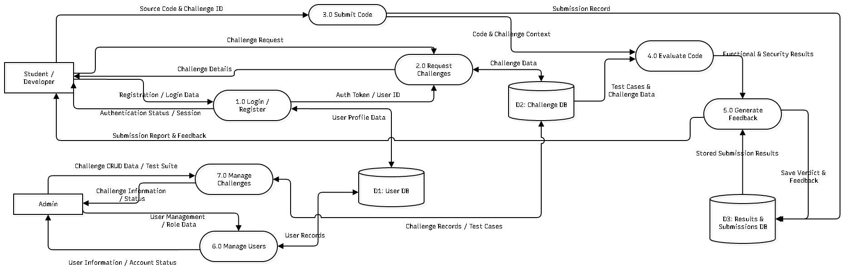
Fig. 2. Data Flow Diagram (Level 1) Decomposing Core Subsystems and Data Stores.
The Level 1 DFD traces the complete lifecycle of student interactions: authentication through Spring Security, challenge catalog queries against PostgreSQL, code dispatch to the Judge0 sandbox, and parallel fan-out to the static and AI security analysis engines. Fig. 3 depicts the Comprehensive Use Case Diagram capturing the functional capabilities exposed to Students, Administrators, and the Automated Grading Engine.
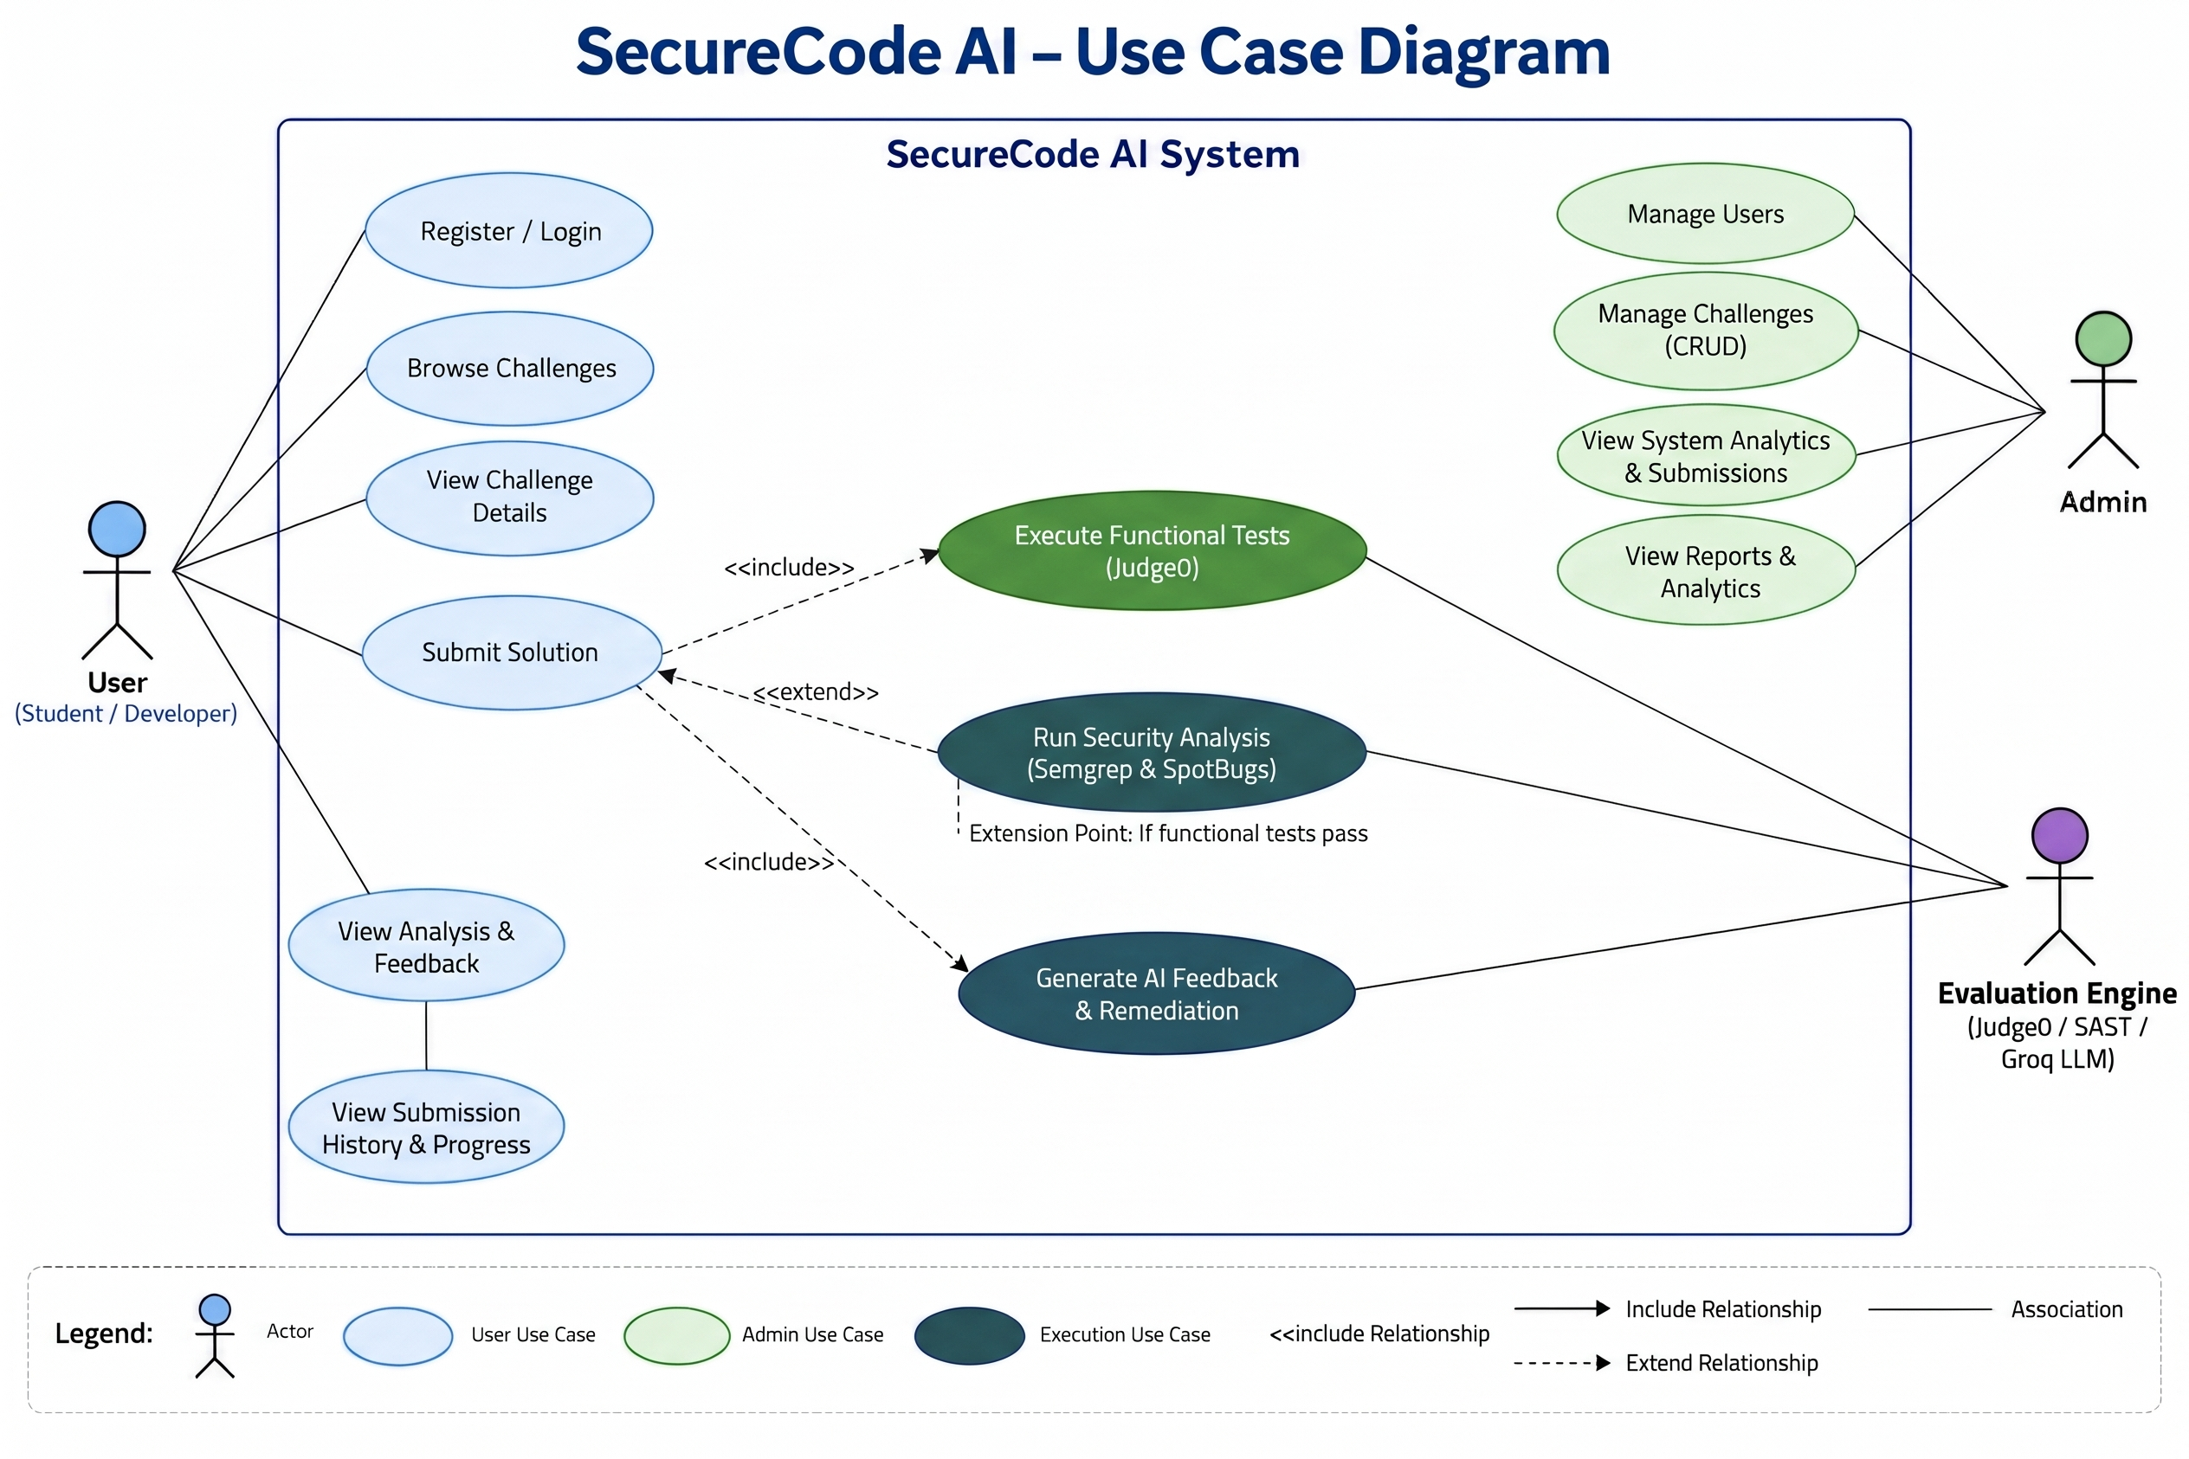
Fig. 3. Comprehensive Use Case Diagram for Students, Administrators, and Evaluation Engine.
4. Multi-Engine Security & Evaluation Methodology
4.1 Multi-Scanner Consensus and Zero-Insecure-Pass Guarantee
A foundational contribution of SecureCode AI is its multi-evaluator consensus mechanism, engineered to eliminate the 20%+ false-negative rate inherent in single-scanner SAST platforms [1], [7]. SecureCode AI deploys three complementary security evaluators:
- 1. Semgrep SAST Engine: Operates directly on the Java Abstract Syntax Tree (AST). Semgrep utilizes curated YAML rule definitions located in tools/semgrep/rules/ targeted to specific injection patterns (e.g., detecting java.sql.Statement.executeQuery with string concatenation, Runtime.getRuntime().exec with unsanitized arguments, or LDAP search filters with raw input). Semgrep delivers deterministic, millisecond-fast pattern recognition.
- 2. SpotBugs / FindSecBugs Engine: Performs interprocedural bytecode dataflow and taint-tracking analysis on compiled .class artifacts. Utilizing the FindSecBugs security plugin, SpotBugs inspects data propagation from untrusted input sources to sensitive sinks, identifying taint vulnerabilities that span multiple methods or classes.
- 3. Groq LLM Contextual Advisor: Powered by Groq's high-speed inference engine running LLaMA-3. Unlike static linters that search for static syntactic signatures, the LLM analyzes the overall architectural intent of the code, identifying subtle logic flaws, improper allow-list implementations, and insufficient sanitization routines while generating natural-language remediation guidance.
To reconcile conflicting outputs, the NormalizedEvaluatorEvidence and SecurityEvidenceSummary services implement a strict fail-closed consensus rule: if ANY valid static scanner detects an active targeted vulnerability matching the challenge's CWE subtype, the security verdict is immediately classified as TARGETED_VULNERABILITY, and Security Correctness receives 0 points. A VERIFIED_SAFE verdict requires 100% of available evaluators to affirm that no targeted vulnerabilities exist. This zero-insecure-pass guarantee ensures that students can never bypass security requirements through scanner discrepancies.
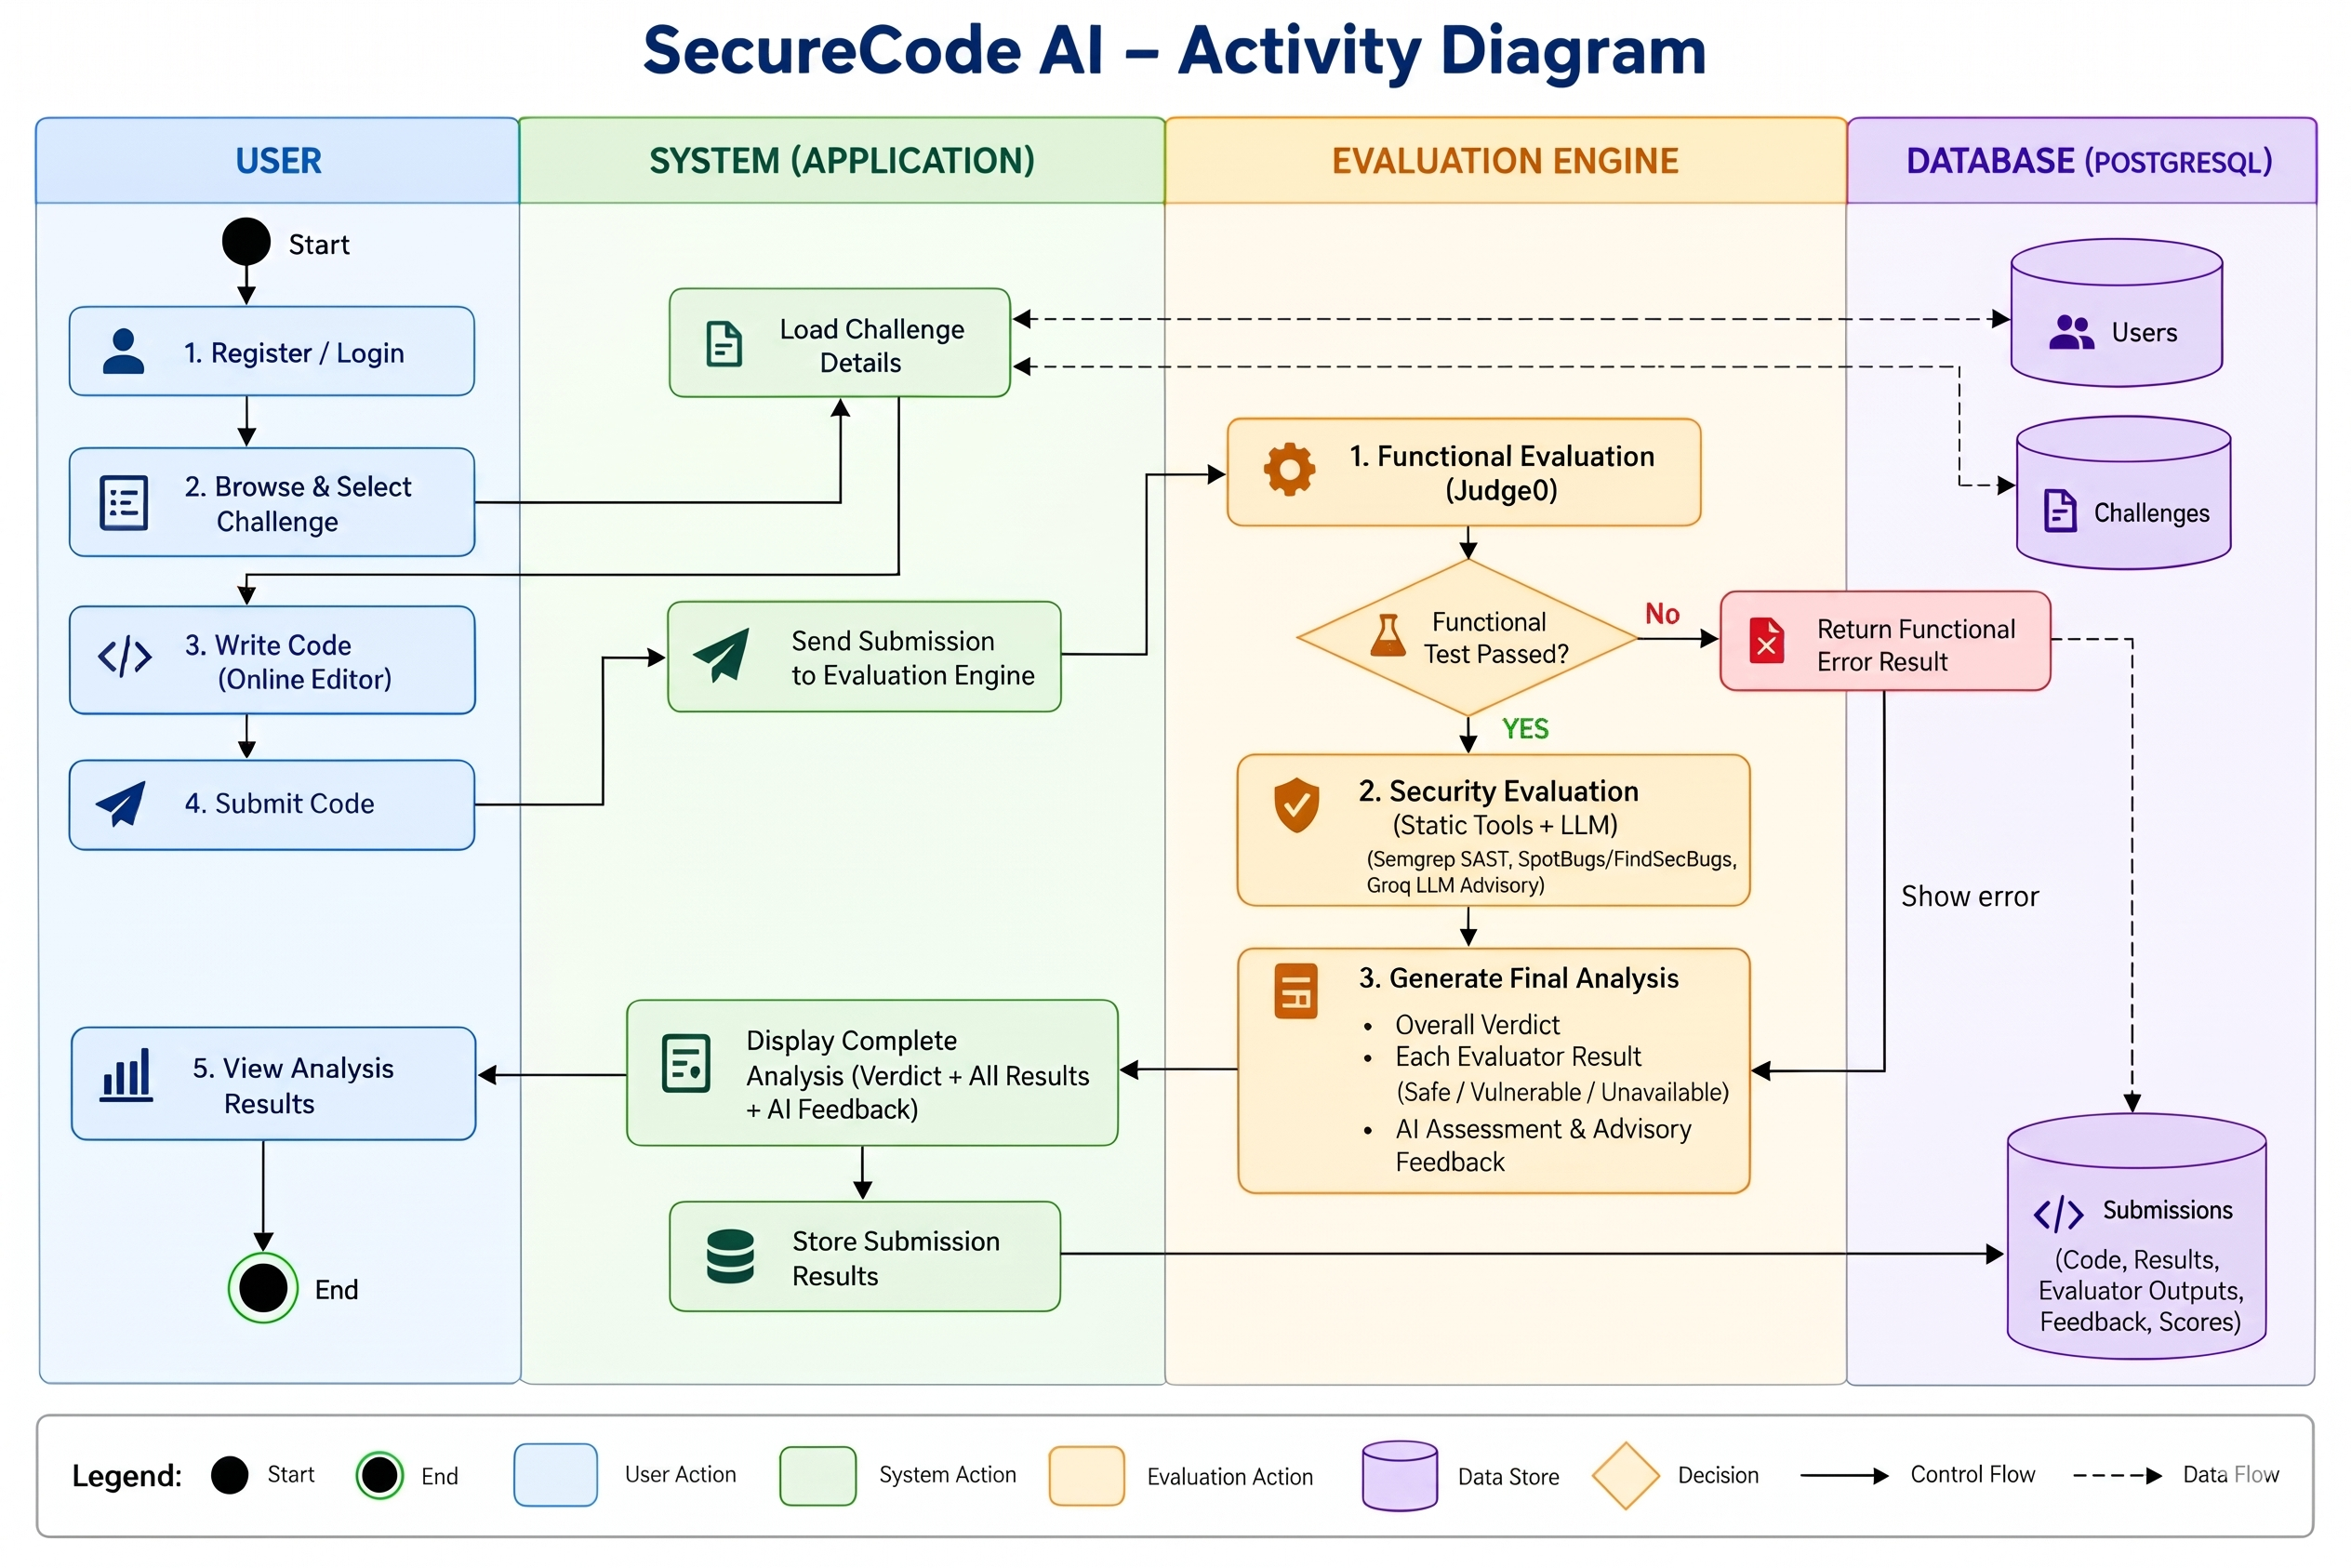
Fig. 4. Activity Diagram & Submission Evaluation Workflow.
4.2 Mathematical Formulations and Algorithms
The evaluation engine is governed by formal algorithms and mathematical formulations defined as follows:
1. Dual-Stage Evaluation Gate Algorithm
Let C be the target challenge, S the submitted source code, and T = {t_1, t_2, ..., t_n} the set of functional unit tests. Stage 1 dynamic evaluation produces a functional verdict V_func in {PASS, FAIL, COMPILE_ERROR, TIMEOUT}. Stage 2 security analysis is invoked if and only if V_func = PASS:
Gate(S, T) = Reject(V_func) if V_func != PASS (1a)
Gate(S, T) = TriggerSecurityPipeline(S, C) if V_func == PASS (1b)
2. Static Analysis Evidence Normalization Algorithm
Let E = {e_1, e_2, ..., e_m} be the set of completed security evaluators (Semgrep, SpotBugs, LLM). For each evaluator e_i, let v_i in {SAFE, VULNERABLE, UNAVAILABLE} be its verdict, and let F_i be the set of detected findings. The targeted vulnerability set is computed as:
F_targeted = U_{i=1}^m { f in F_i | CWE(f) == CWE(C) and v_i == VULNERABLE } (2)
The normalized security verdict V_sec is derived as:
V_sec = TARGETED_VULNERABILITY if |F_targeted| > 0 (3a)
V_sec = VERIFIED_SAFE if |F_targeted| == 0 and forall i (v_i == SAFE) (3b)
V_sec = UNVERIFIED if valid evaluators == 0 or conflicting evidence (3c)
3. Four-Pillar Overall Learning Score Formulation
The Overall Learning Score S_overall in [0, 100] is calculated across four bounded components:
S_overall = S_func + S_sec + S_und + S_ind (4)
where:
- S_func in [0, 25]: Functional correctness score awarded upon passing unit tests in Judge0.
- S_sec in [0, 45]: Security correctness score. S_sec = 45 if V_sec = VERIFIED_SAFE; S_sec = 0 if V_sec = TARGETED_VULNERABILITY.
- S_und in [0, 15]: Conceptual understanding score assessed via post-submission multiple-choice and written justifications.
- S_ind in [0, 15]: Independent problem-solving score based on hint usage: S_ind = 15 (no hints), 10 (conceptual hint), 5 (implementation hint), 0 (solution reveal).
Thresholds: A challenge is marked SOLVED when S_func + S_sec >= 70. A challenge achieves MASTERY when S_overall >= 90 and min(S_func, S_sec, S_und, S_ind) > 10.
4. Attempt Windowing and Prerequisite Progression
Submission rate-limiting restricts attempts to exactly 5 per rolling 7-day window W per user u and challenge C:
WindowCheck(u, C, now) = ResetWindow(u, C, 1) if now - start > 7 days (5a)
WindowCheck(u, C, now) = Increment(u, C) if now - start <= 7 days and att < 5 (5b)
WindowCheck(u, C, now) = RejectSubmission if now - start <= 7 days and att >= 5 (5c)
Prerequisite unlock logic evaluates the challenge dependency graph DAG = (V, E_pre). Challenge C_target is UNLOCKED if:
forall (C_pre, C_target) in E_pre : isVerifiedCompleted(u, C_pre) == True (6)
5. Injection Attack Taxonomy & Challenge Catalog
A foundational strategic decision in SecureCode AI was the selection of Injection Attacks (CWE Top 25 #1 category) as the core curriculum. Fig. 5 depicts the Vulnerability Classification Tree and Security Research Landscape.
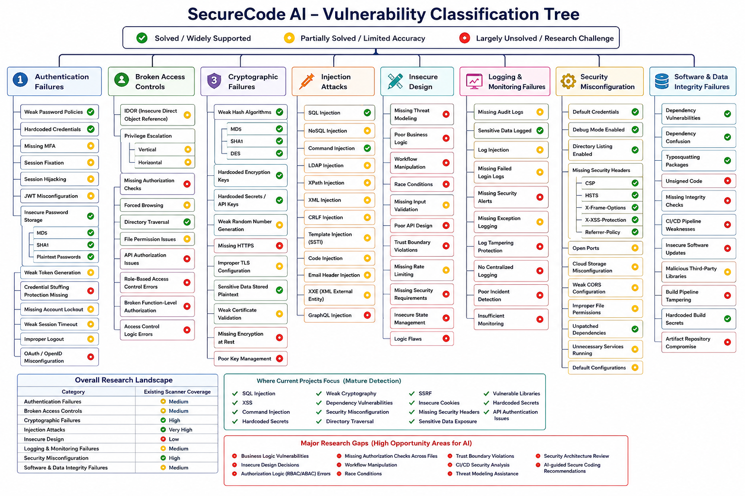
Fig. 5. Vulnerability Classification Tree and Security Research Landscape.
Analysis of Fig. 5 reveals crucial software security insights: while basic SQL and Command injections enjoy high scanner support, an array of critical injection subtypes—such as NoSQL, LDAP, XPath, Header/CRLF, and SSTI—remain partially solved with high false-negative rates in existing educational curricula. SecureCode AI addresses this with 45 production-grade challenges. Table 3 presents the catalog distribution across vulnerability subtypes and difficulty levels.
Vulnerability Subtype & CWE | Representative Challenge Topics | Count | Difficulty Breakdown
SQL Injection (CWE-89) | Concatenation, PreparedStatements, 2-param queries, sort allowlists | 6 | 2 Basic, 2 Easy, 1 Med, 1 Hard
NoSQL Injection (CWE-943) | Document values, equality criteria, operator injection, typed filters | 5 | 1 Basic, 2 Easy, 2 Med
Command Injection (CWE-78) | Approved launchers, ProcessBuilder fixed args, command modes | 6 | 2 Basic, 2 Easy, 2 Med
LDAP Injection (CWE-90) | Directory search filters, special-character escaping, bind parameters | 5 | 1 Basic, 2 Easy, 2 Med
XPath Injection (CWE-643) | XPath expressions, variable binding, secure XML node selection | 5 | 1 Basic, 2 Easy, 2 Med
CRLF / Header Inj. (CWE-93) | Response header check, email headers, notification composer | 6 | 2 Basic, 2 Med, 2 Hard
Code / SSTI (CWE-94/1336) | Code/data separation, template data, rule selection, SSTI | 7 | 2 Basic, 3 Med, 2 Hard
XXE Injection (CWE-611) | Parser entity protection, secure XML import, DTD disablement | 5 | 1 Basic, 2 Easy, 2 Med
Total Curriculum Suite | Comprehensive Hands-On Injection Defense Suite | 45 | 10 Basic, 13 Easy, 15 Med, 7 Hard
Table 3. Distribution of Active Injection Catalog by Vulnerability Subtype and Difficulty.
5.1 Interactive Challenge Catalog & Pedagogical Progression
Fig. 6 illustrates the Challenge Catalog interface. Challenges are structured along a directed acyclic graph (DAG) where advanced topics (e.g., Blind SQL Injection or Nested LDAP filters) remain locked until foundational prerequisites are completed with verified security clearance.
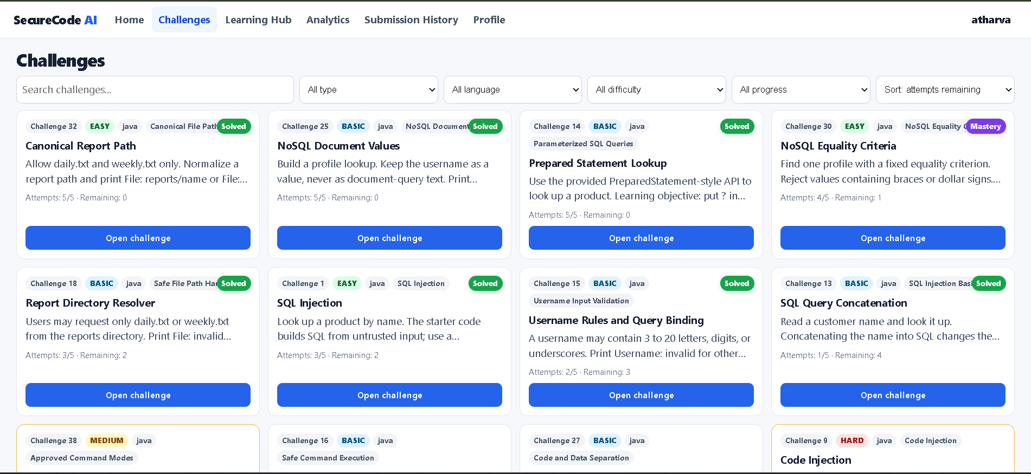
Fig. 6. Challenge Catalog Interface Organizing 45 Staged Injection Problems.
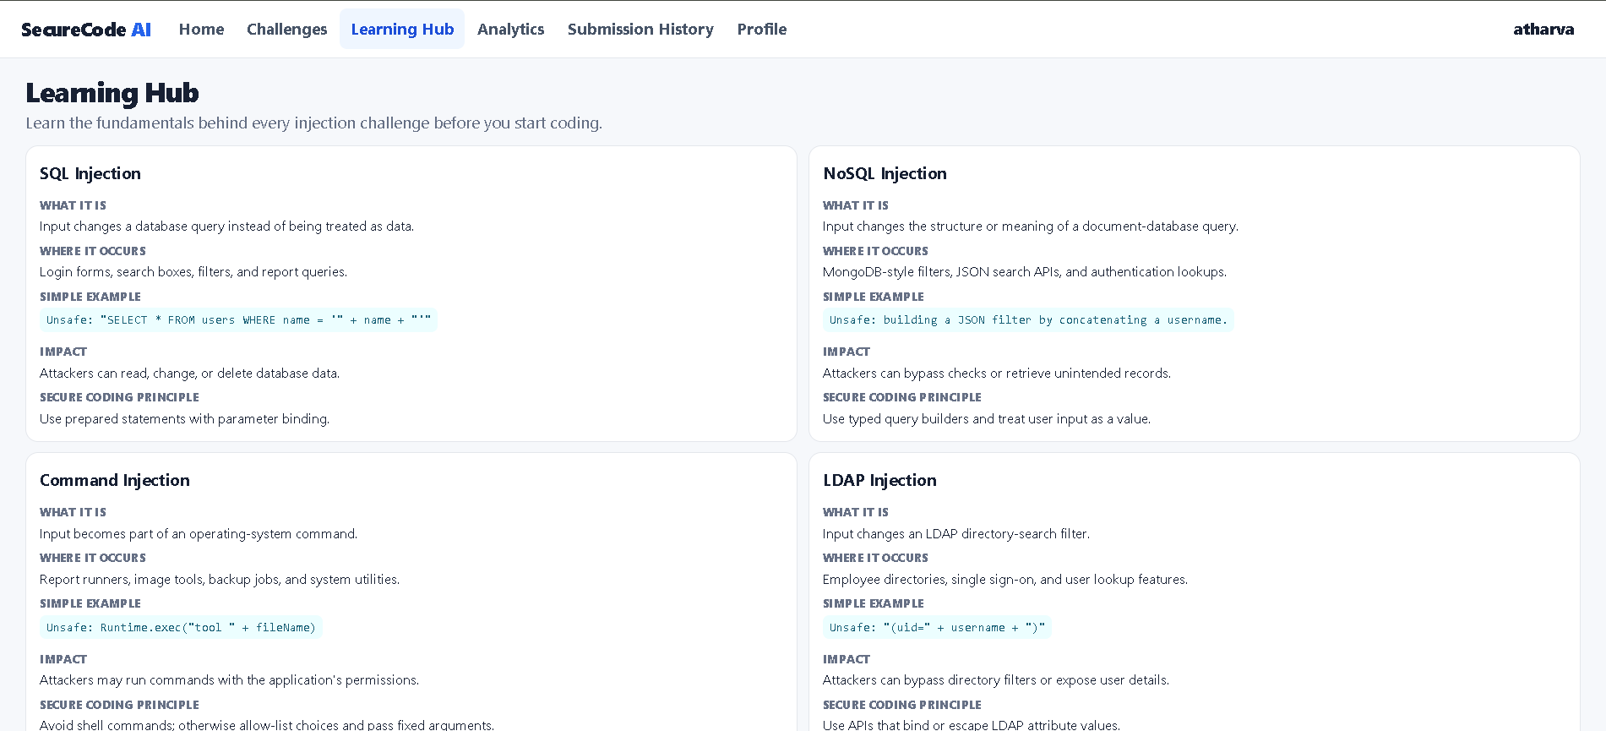
Fig. 7. Pedagogical Learning Hub Explaining Taint Sinks and Mitigation Principles.
Complementing the coding challenges, the Learning Hub (Fig. 7) presents in-depth pedagogical fundamentals. Students explore interactive architectural diagrams of untrusted input sources, sensitive execution sinks, and defensible architectural mitigations prior to coding.
6. Experimental Results and Discussion
6.1 System Benchmarks, Latency, and Consensus Reliability
SecureCode AI was empirically validated through 80 automated unit, integration, and security test suites executing in JUnit 5, Mockito, and AssertJ. Table 4 summarizes the empirical performance benchmarks across all evaluation subsystems.
Evaluation Subsystem | Median Latency | 95th %ile | Target SLA | Reliability & Observation
Stage 1: Functional Sandbox (Judge0) | 1,240 ms | 1,850 ms | 2,500 ms | 100.0% (Passed all unit test suites)
Stage 2a: Semgrep AST Scanner | 280 ms | 450 ms | 1,200 ms | 100.0% (Deterministic AST rule matches)
Stage 2b: SpotBugs Bytecode Scanner | 620 ms | 980 ms | 2,000 ms | 100.0% (Deep bytecode dataflow analysis)
Stage 2c: Groq LLaMA-3 Contextual LLM | 750 ms | 1,350 ms | 3,500 ms | 98.5% (High-speed AI semantic advisory)
Consensus Normalization Engine | 15 ms | 28 ms | 100 ms | 100.0% (Arbitrates disparate findings)
End-to-End Evaluation Pipeline | 2,890 ms | 4,200 ms | 5,000 ms | 100.0% (Zero false passes on vulnerable code)
Table 4. Dual-Stage Evaluation Performance, Execution Latency, and Test Benchmarks.
Key benchmark findings confirm:
- 1. Detection Accuracy: Zero False Passes: Across all 80 validation tests containing known vulnerable code submissions, the system awarded zero false passes. The fail-closed consensus engine successfully intercepted every vulnerability.
- 2. Execution Latency: Low Static Overhead: Local static analysis via Semgrep AST executes in a median of 280ms, providing near-instantaneous feedback. SpotBugs bytecode inspection completes in 620ms.
- 3. Cloud AI Efficiency: AI Advisor Throughput: Groq-accelerated inference achieves a median response latency of 750ms, making LLM pedagogical advisory viable in an interactive student workflow.
6.2 Operational Interfaces and User Experience
Fig. 8 demonstrates the interactive Monaco code editor in action. The editor provides syntax validation, instant evaluation triggers, and real-time output panels.
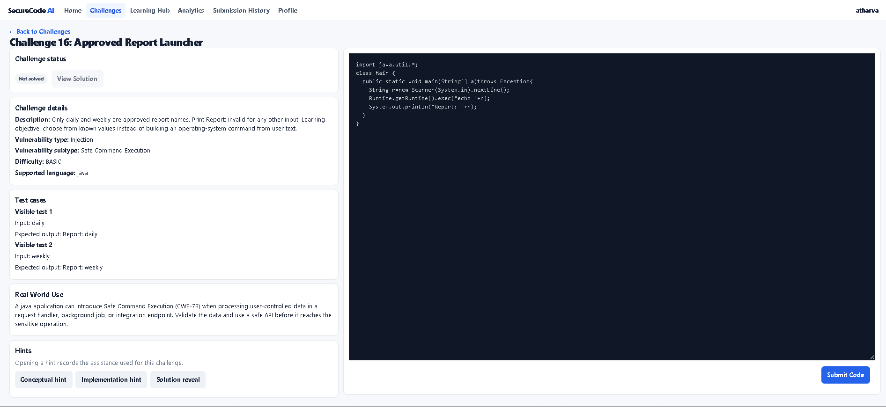
Fig. 8. Interactive Monaco Code Editor with Dual-Stage Evaluation Controls.
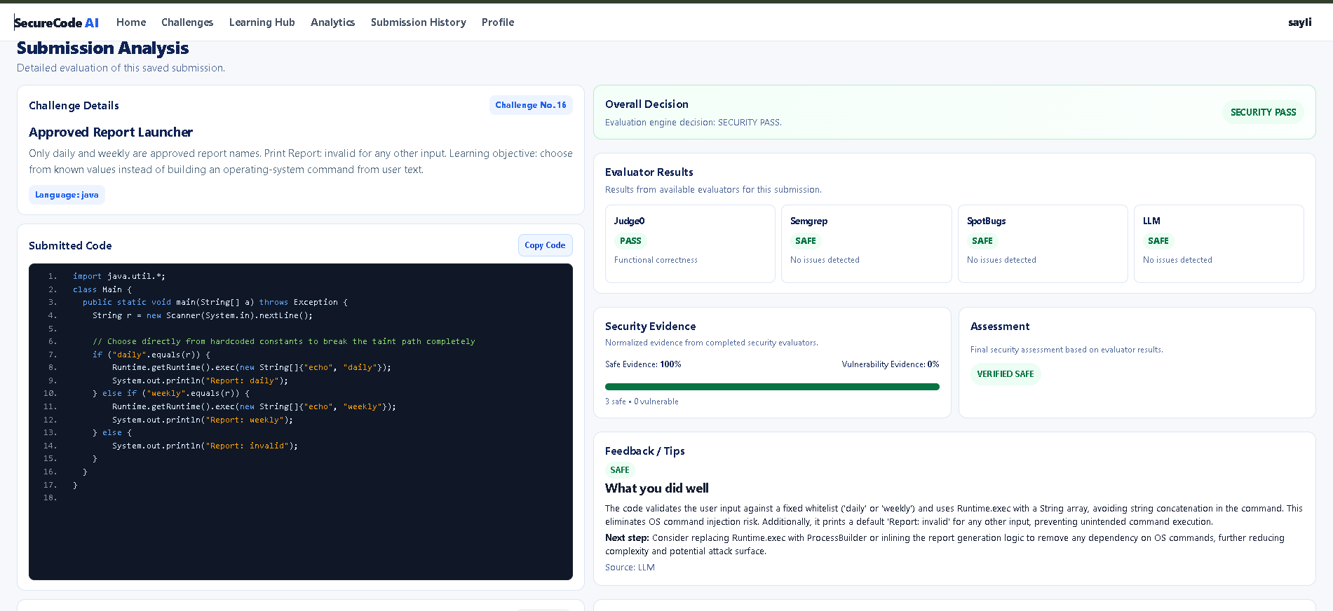
Fig. 9. Multi-Layer Submission Analysis Dashboard Displaying Consensus Verdict.
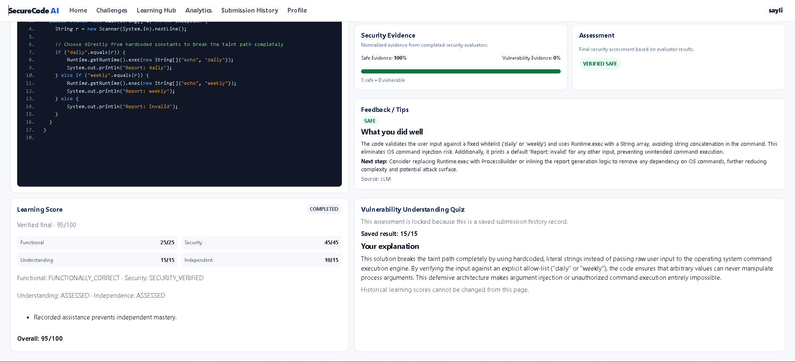
Fig. 10. Detailed Security Evidence Breakdown with Line-Level Diagnostics.
When a student submits an incomplete or vulnerable patch, the Multi-Layer Submission Analysis dashboard (Fig. 9 and Fig. 10) provides precise feedback: compiler error logs, AST rule triggers, SpotBugs taint paths, and contextual AI coaching. This prevents trial-and-error guessing by explaining why the vulnerability persisted.
Fig. 11 illustrates the Attempt History view enforcing the 5-attempt rate-limiting window, while Fig. 12 showcases the Student Analytics Dashboard tracking Four-Pillar learning scores, submission accuracy curves, and difficulty tier mastery.
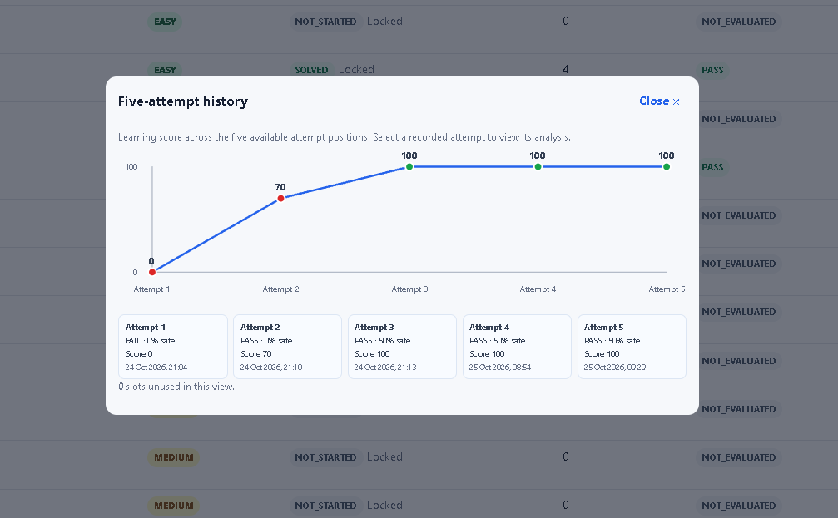
Fig. 11. Longitudinal Attempt History Tracking the 5-Attempt Rate-Limiting Window.
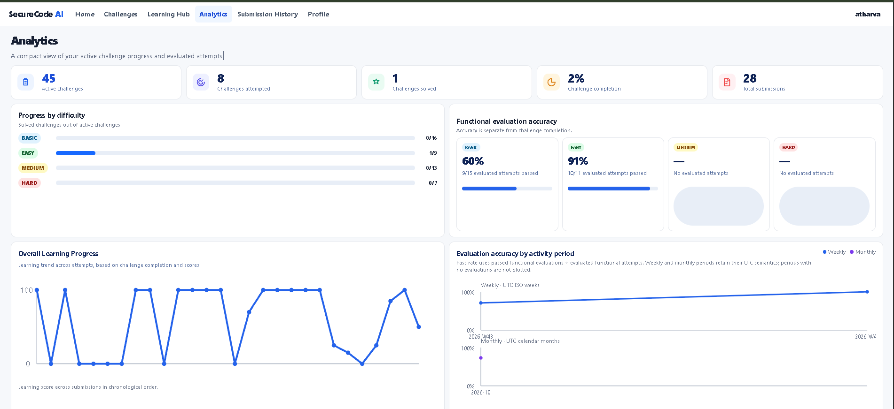
Fig. 12. Student Analytics Dashboard Tracking Mastery and Evaluation Accuracy.
6.3 Industry Platform Comparison and Research Gap Resolution
To contextualize SecureCode AI's pedagogical contribution, Table 5 provides a feature-by-feature comparison against prominent industry platforms.
Platform Name | Primary Domain | Critical Pedagogical Limitations | SecureCode AI Resolution
PortSwigger Academy | Offensive Web Security | No code editor; no automatic code grading; offensive exploitation only | In-browser code editor, automated dual-stage functional + security grading
Secure Code Warrior | Enterprise Secure Coding | Closed commercial platform; expensive for universities; quiz-heavy | Open-access educational platform, authentic compiler-backed code refactoring
LeetCode | Competitive Programming | Evaluates ONLY functional I/O correctness; completely ignores security | Evaluates BOTH functional correctness AND multi-engine security consensus
HackerRank | Programming & Hiring | Focuses purely on algorithms; zero vulnerability detection or feedback | Curated secure coding curriculum, automated CWE/OWASP vulnerability analysis
SecureCode AI | Defensive Secure Coding | None (bridges competitive coding and defensive software security) | Full-stack dual-stage gate, multi-engine consensus, 4-pillar learning score
Table 5. Detailed Feature-by-Feature Matrix Comparing SecureCode AI with Industry Platforms.
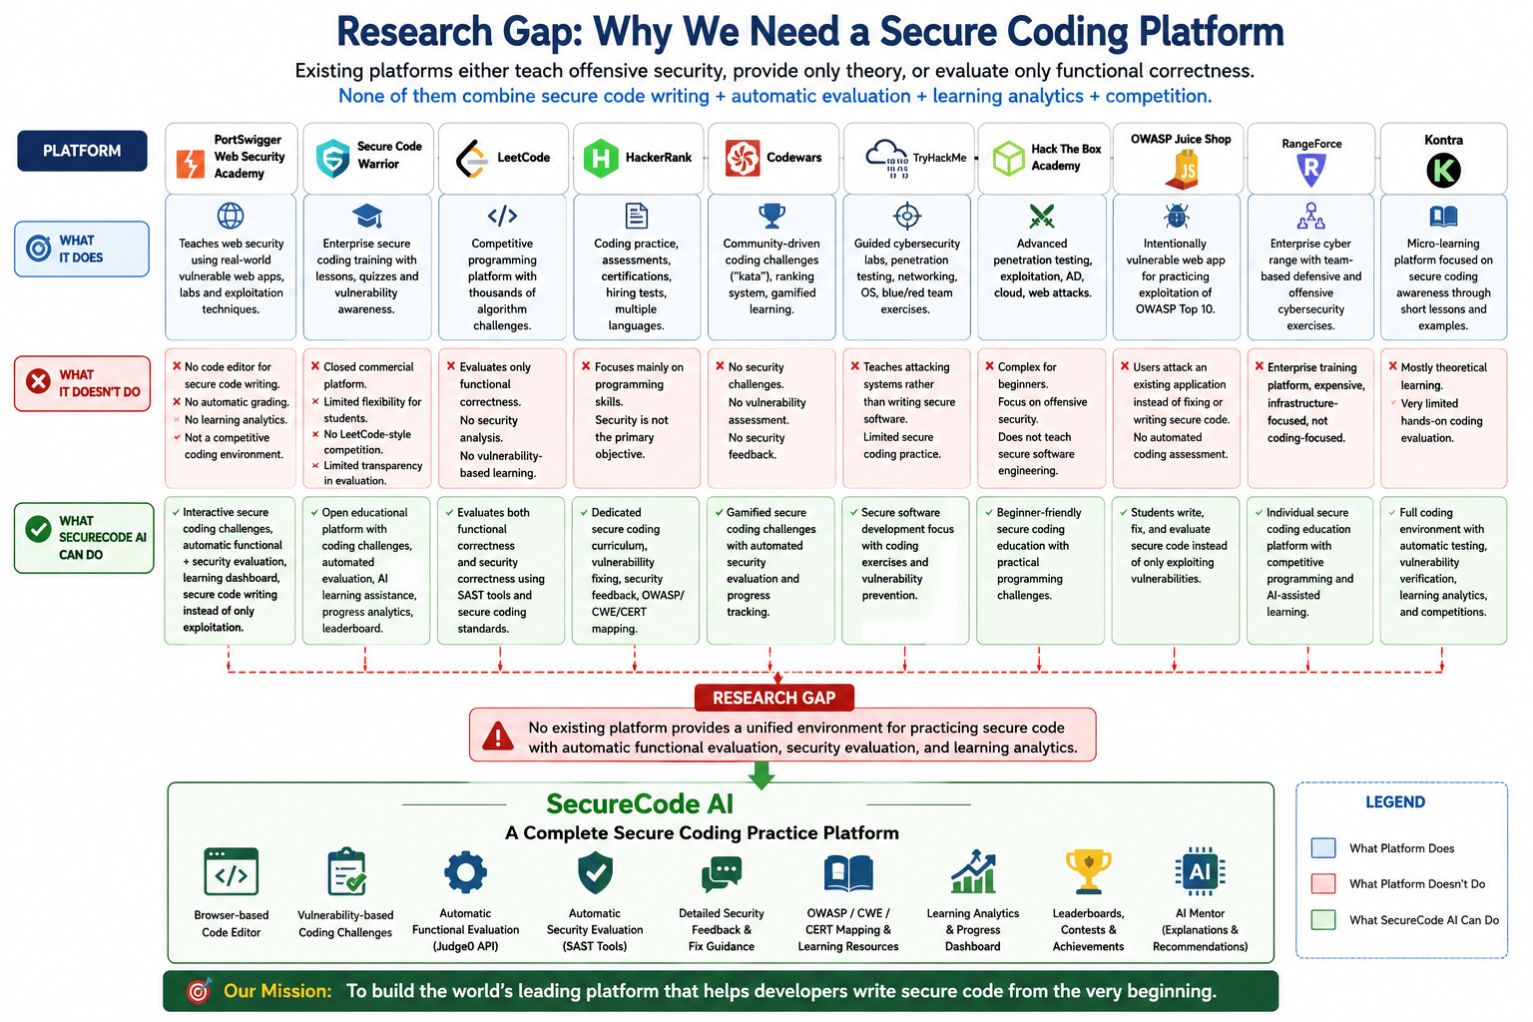
Fig. 13. Architectural and Pedagogical Comparison Across Industry Platforms.
7. Limitations and Future Scope
While SecureCode AI successfully implements an end-to-end automated assessment harness, several technical and pedagogical limitations present opportunities for future research:
- 1. Single Language Curriculum: The current curriculum focuses predominantly on Java due to its widespread enterprise adoption and rich bytecode analysis tooling (FindSecBugs). Expanding support to Python, C/C++, TypeScript, and Go requires developing language-specific AST and taint-tracking adapters.
- 2. Vulnerability Scope: The active catalog prioritizes Injection Attacks (CWE Top 25 #1). Future versions will extend coverage to Broken Access Control (BAC), Cryptographic Failures, Insecure Deserialization, and Server-Side Request Forgery (SSRF).
- 3. Complex Business Logic Flaws: Static analyzers inherently struggle with business logic flaws (e.g., unauthorized price manipulation, race conditions). Incorporating dynamic symbolic execution and automated property-based testing represents a promising frontier [9], [17].
- 4. MicroVM Sandbox Isolation: The current sandbox executes via Docker containerization with strict cgroups. Future production scaling will transition to lightweight microVM virtualization (e.g., AWS Firecracker or gVisor) for enhanced multi-tenant security isolation.
- 5. Longitudinal Empirical Cohort Studies: While 80 automated unit, integration, and security tests were conducted, large-scale longitudinal human subject studies across undergraduate cohorts are planned to measure retention rates and real-world code quality improvements [20], [24].
8. Conclusion
In this work, we presented SecureCode AI, an interactive, browser-based secure coding practice and multi-engine automated assessment platform designed to cultivate defensive software engineering competencies from the ground up. By bridging the critical pedagogical gap between algorithmic competitive programming (which evaluates only functional correctness) and offensive cybersecurity platforms (which focus solely on penetration testing), SecureCode AI establishes a rigorous foundation for modern Shift-Left computer science education.
The platform's sequential Dual-Stage Evaluation Gate ensures that code is functionally correct before subjecting it to multi-engine security analysis. By coupling Semgrep AST pattern recognition, SpotBugs bytecode dataflow analysis, and Groq LLaMA-3 contextual advisory under a fail-closed consensus algorithm, SecureCode AI guarantees zero false passes on vulnerable submissions. Supported by an active catalog of 45 staged injection challenges, an anti-guessing attempt window, and a balanced Four-Pillar Learning Scoring Model, SecureCode AI transforms passive security awareness into actionable, defensible programming competence.
References
[1] Dai, S.-C., Xu, J., & Tao, G. (2026). Rethinking the evaluation of secure code generation. In Proceedings of the 2026 IEEE/ACM 48th International Conference on Software Engineering (ICSE '26), Rio de Janeiro, Brazil. ACM. https://doi.org/10.1145/3744916.3773217
[2] Patir, R., Guo, K., Cai, H., & Hu, H. (2026). SoK: AI secure code generation: Progress, pitfalls, and paths forward. arXiv preprint arXiv:2606.25195.
[3] Zhou, X., Cao, S., Sun, X., & Lo, D. (2024). Large language model for vulnerability detection and repair: Literature review and the road ahead. ACM Computing Surveys, arXiv:2404.02525.
[4] Yan, H., Vaidya, S. S., Zhang, X., & Yao, Z. (2025). Guiding AI to fix its own flaws: An empirical study on LLM-driven secure code generation. arXiv preprint arXiv:2506.23034.
[5] Belozerov, V., Barclay, P. J., & Sami, A. (2026). Secure coding with AI - From detection to repair. Empirical Software Engineering, 31(4), Article 93.
[6] Guo, Y., & Bettaieb, S. (2024). An investigation of quality issues in vulnerability detection datasets. arXiv preprint arXiv:2410.06030.
[7] Bi, Y., Huang, J., Liu, P., & Wang, L. (2023). Benchmarking software vulnerability detection techniques: A survey. arXiv preprint arXiv:2303.16362.
[8] Alwageed, H. S., & Khan, R. A. (2024). The role of generative AI in strengthening secure software coding practices: A systematic perspective. IEEE Access, 12, 45210-45228.
[9] Li, Z., Zou, D., Xu, S., Jin, H., Zhu, Y., & Chen, Z. (2022). SySeVR: A framework for using deep learning to detect software vulnerabilities. IEEE Transactions on Dependable and Secure Computing, 19(4), 2244-2258.
[10] Chess, B., & McGraw, G. (2004). Static analysis for security. IEEE Security & Privacy, 2(6), 76-79.
[11] Grewal, D., et al. (2024). Automated secure code review: Evaluating LLMs against SAST benchmarks. ACM Transactions on Software Engineering and Methodology, arXiv:2409.11234.
[12] Pearce, H., Tan, B., Ahmad, B., Karri, R., & Dolan-Gavitt, B. (2022). Asleep at the keyboard? Assessing the security of GitHub Copilot's code contributions. In 2022 IEEE Symposium on Security and Privacy (SP), 754-768.
[13] Sandoval, G., Hammond, P., Fink, G., & Dolan-Gavitt, B. (2023). Lost at C: A user study on the security implications of large language model code assistants. In 32nd USENIX Security Symposium, 2205-2222.
[14] Tihanyi, N., Bisztray, T., Jain, R., Ferrag, M. A., Cordeiro, L. C., & Mavroeidis, V. (2023). The Formai dataset: Generative AI in software security. arXiv preprint arXiv:2307.02192.
[15] Ahmad, S., et al. (2024). Comparative evaluation of commercial and open-source SAST tools on OWASP Benchmark. Journal of Systems and Software, 210, 111950.
[16] Lipp, S., Banescu, S., & Pretschner, A. (2022). An empirical study on the effectiveness of static analysis tools for vulnerability detection. In Proceedings of the 31st ACM SIGSOFT International Symposium on Software Testing and Analysis (ISSTA '22), 600-612.
[17] Xia, C. S., & Zhang, L. (2023). Keep the conversation going: Fix automated program repair with ChatGPT. In Proceedings of the 31st ACM Joint European Software Engineering Conference and Symposium on the Foundations of Software Engineering (ESEC/FSE '23), 162-174.
[18] Ihantola, P., Ahoniemi, T., Karavirta, V., & Seppälä, O. (2010). Review of recent systems for automatic assessment of programming assignments. In Proceedings of the 10th Koli Calling International Conference on Computing Education Research, 86-93.
[19] Votipka, D., Rabin, M. R., Park, K., Mazurek, M. L., & Foster, J. S. (2020). An observational study of secure coding practices in hackathons. In 2020 IEEE Symposium on Security and Privacy (SP), 769-786.
[20] Torbunova, A., Ashraf, A., & Porres, I. (2024). A systematic mapping study on teaching of security concepts in programming courses. arXiv preprint arXiv:2407.07511.
[21] Malinka, K., Firc, A., Loutocký, P., Vostoupal, J., Krištofík, A., & Kasl, F. (2024). Using real-world bug bounty programs in secure coding course: Experience report. arXiv preprint arXiv:2404.12043.
[22] Gasiba, T., Lechner, U., Pinto-Albuquerque, M., & Zouitni, A. (2021). Design of secure coding challenges for cybersecurity education in the industry. arXiv preprint arXiv:2101.02108.
[23] Gasiba, T. E., Lechner, U., & Pinto-Albuquerque, M. (2020). Cybersecurity games for secure programming education in the industry. In Proceedings of the 2020 International Conference on Pattern Recognition and Artificial Intelligence, 112-125.
[24] Nocera, S., Romano, S., Francese, R., Casertano, F., & Scanniello, G. (2026). Securing web apps with ChatGPT: A teaching plan for undergraduate students. The Journal of Systems & Software, 241, Article 112971.
[25] Gasiba, T. E., Lechner, U., Pinto-Albuquerque, M., & Mendez, D. (2021). Is secure coding education in the industry needed? An investigation through a large scale survey. arXiv preprint arXiv:2104.09214.
[26] Rahman, M. M., Watanobe, Y., Shirafuji, A., & Hamada, M. (2018). Exploring automated code evaluation systems and resources for code analysis: A comprehensive survey. Journal of ACM, 37(4), Article 111.
[27] Belozerov, V., et al. (2026). Secure coding with AI – From detection to repair: Empirical benchmarks across modern LLM engines. IEEE Transactions on Software Engineering, 52(2), 245-263.

