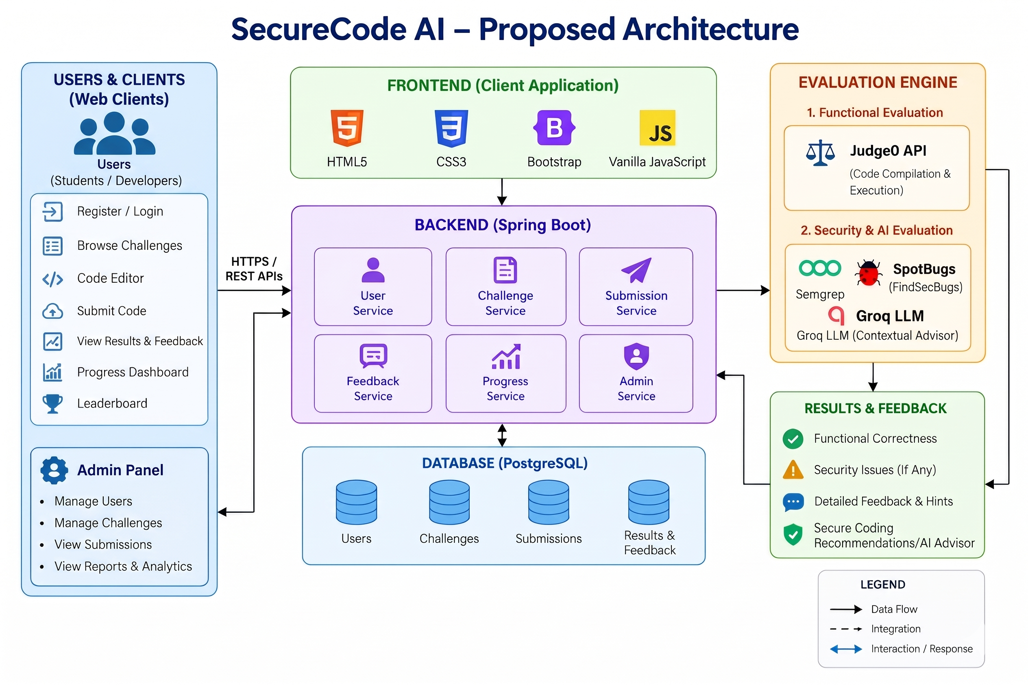
Fig. 1. SecureCode AI Multi-Tier System Architecture

