Column text 1

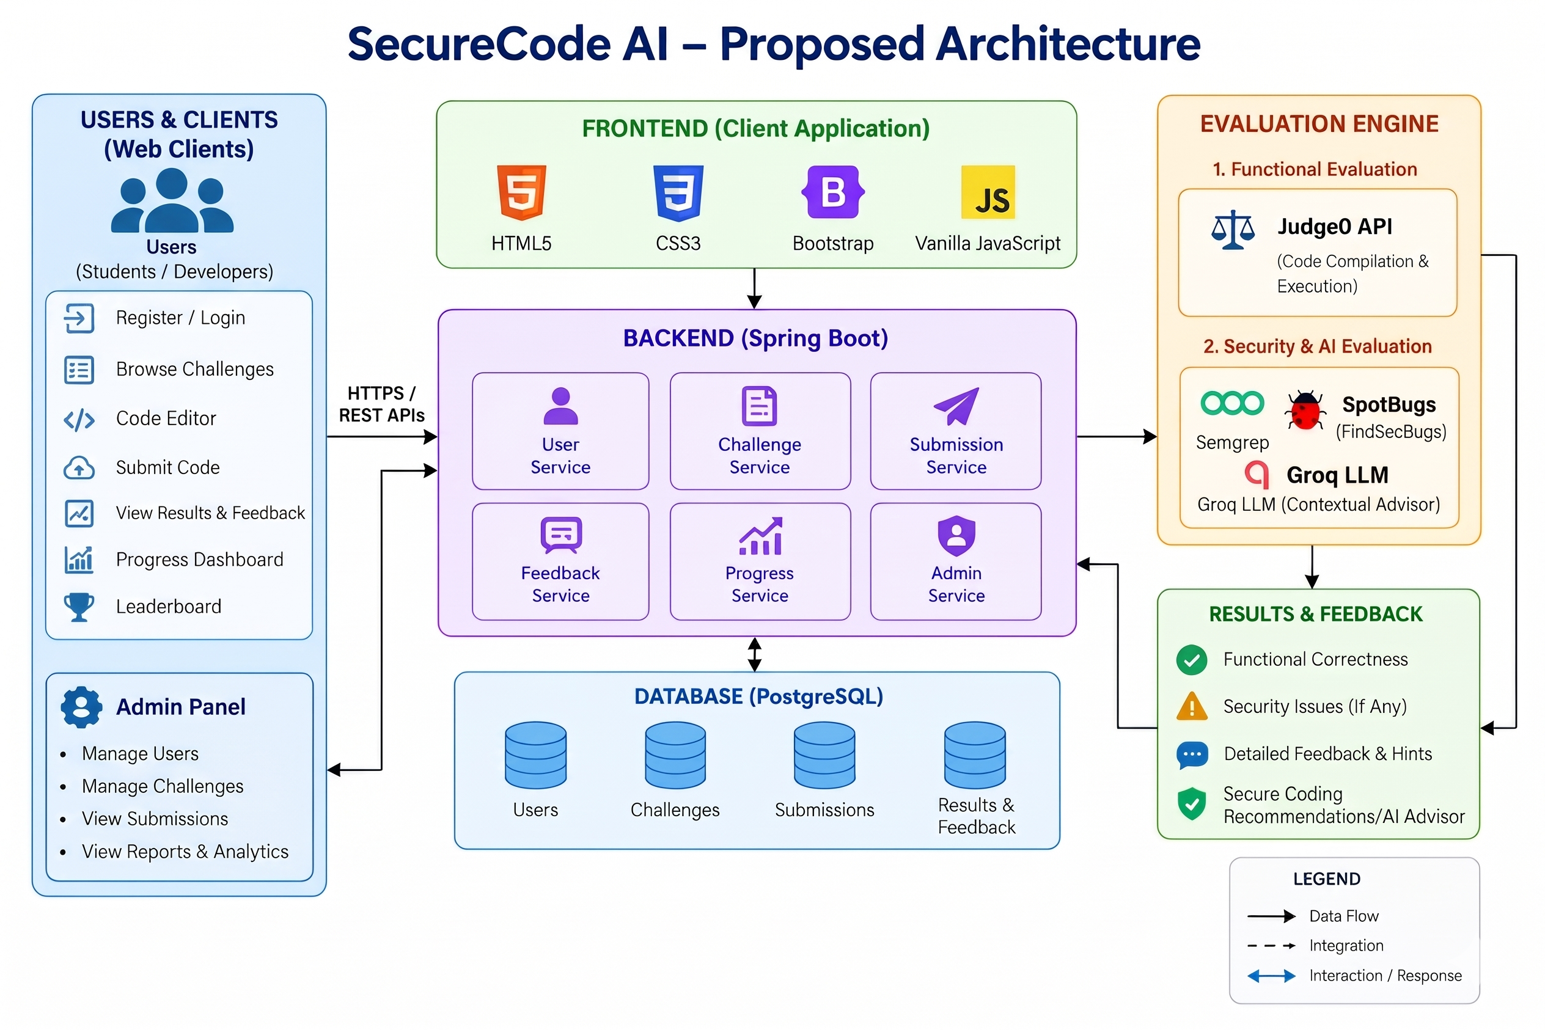
Fig. 1. Architecture Wide

Column text 2

