**Steps to install Spyder IDE.**

1. Go to <https://www.spyder-ide.org/>.
2. Click on the Download button which is available in the top right corner.

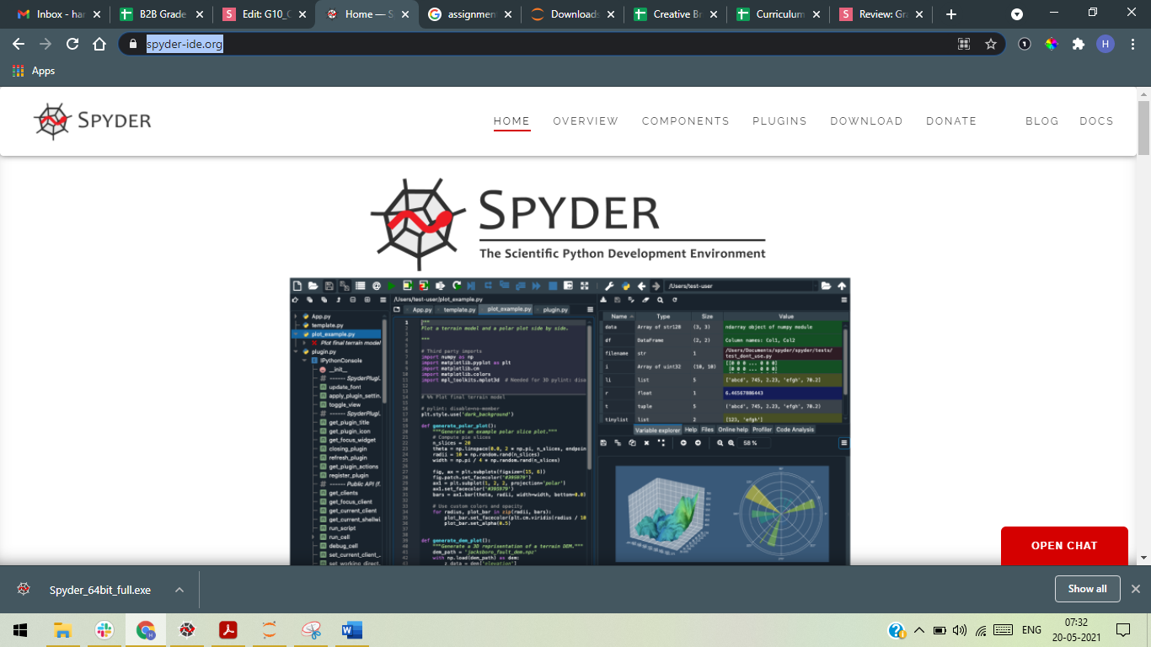

1. Scroll Down and click “Download for Windows”.

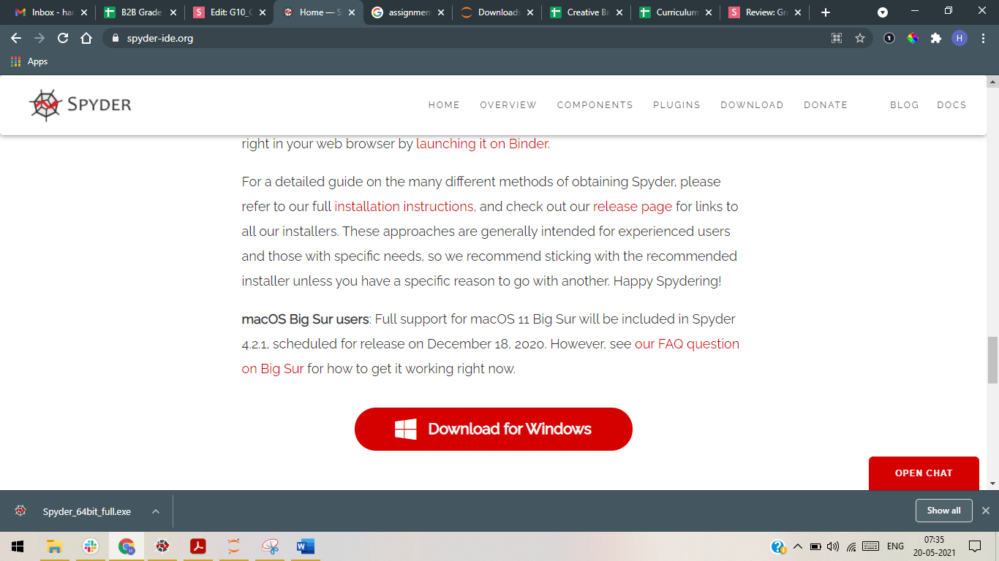

1. Setup file will download. Click on the file to run the setup.

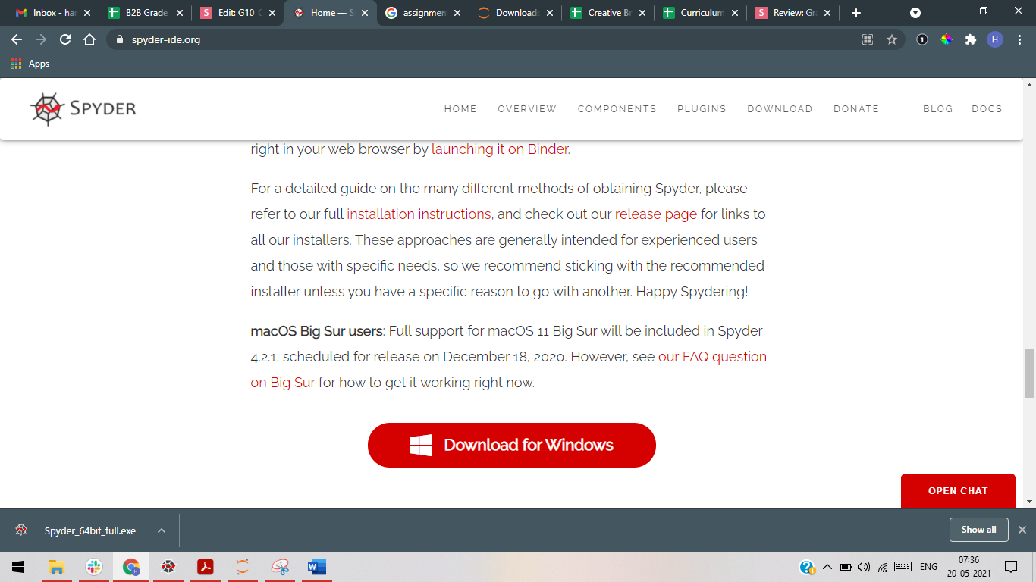

1. Click on “**Next**”.

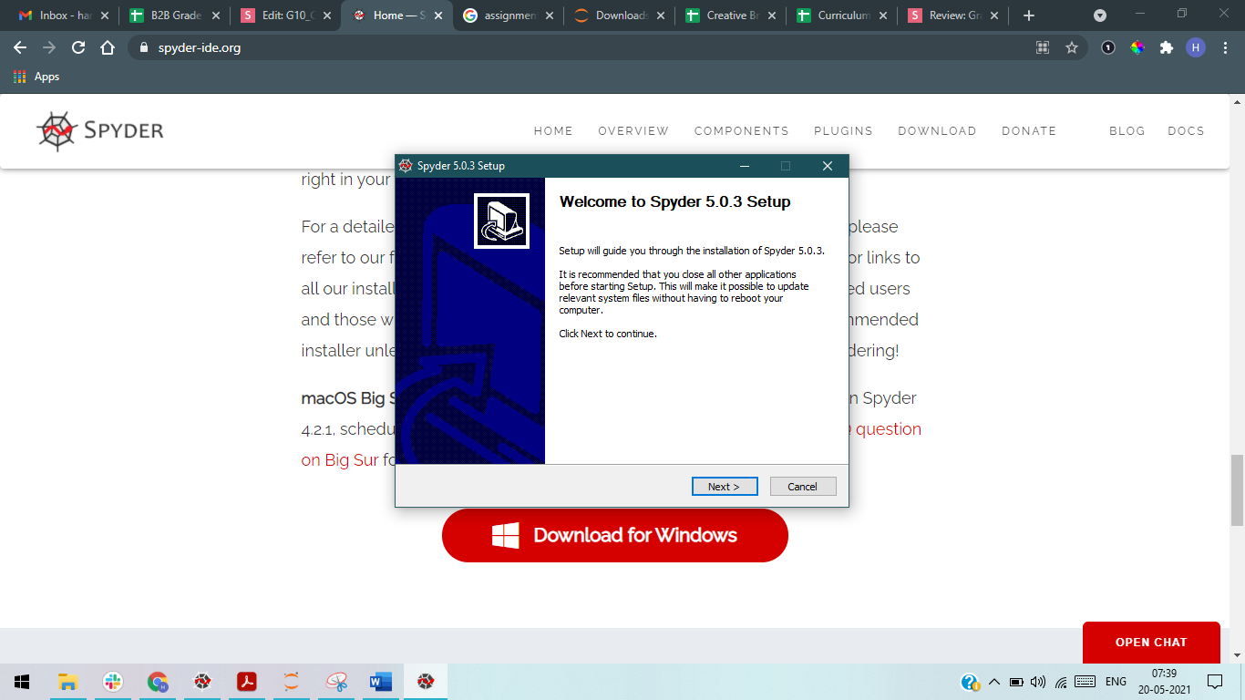

1. Click on “**I Agree**”.

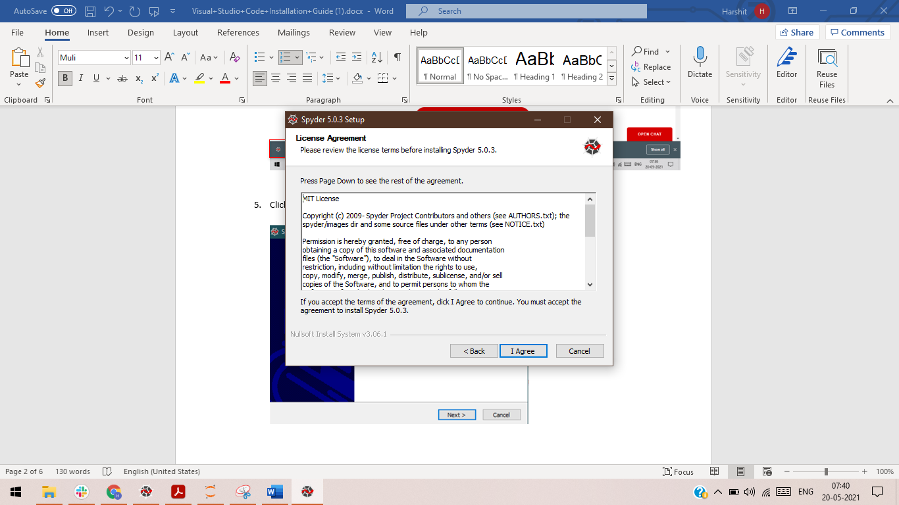

1. Click on “**Next**”.

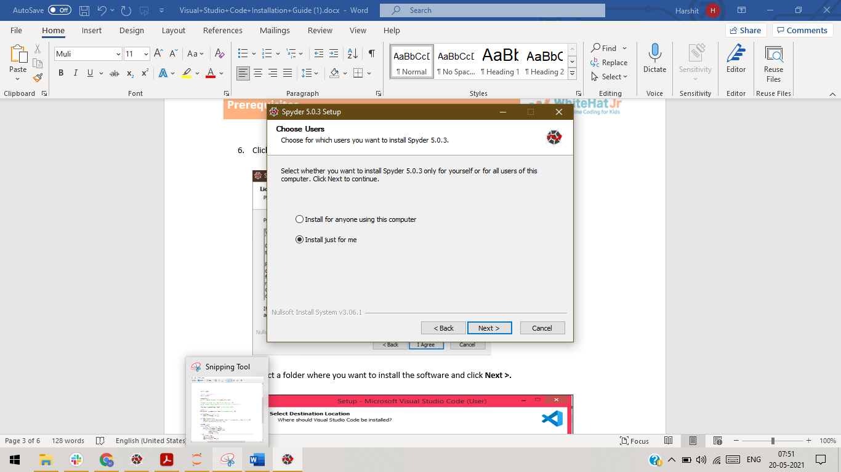

1. Select a folder where you want to install the software and click **Install.**

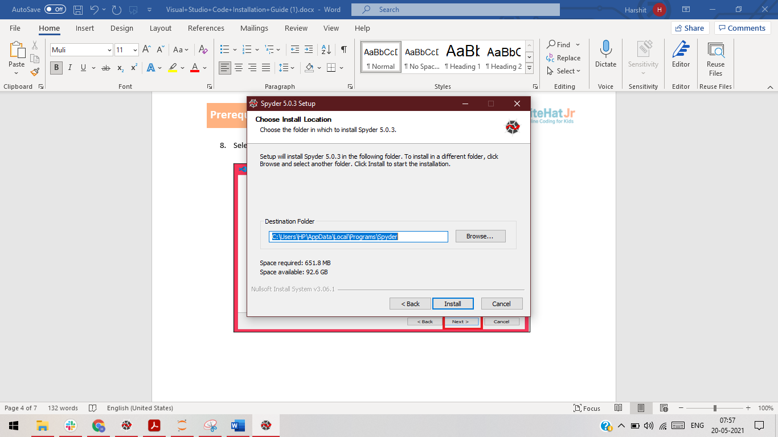

1. Select **“Launch Spyder”** and click on the **Finish** button. Congratulations!