**Name:** Hemant Jain

**Lab Progress Report Due Date:** 2/08/2021

**Current Week Since Start Date:** Week 4 (2/09/2021– 2/15/2021)

**Reporting Week:** From Feb 02, 2021 to Feb 09, 2021

**Summary about the TestOut Module-1 Learning:**

From the TestOut LabSim Security Threats, Attacks and Vulnerabilities Section, I got to learn

about Physical Security, Control Measures and Defense in depth to avoid the threat attacks.

Read what does the physical security indicates and is the protection of corporate assets from threats such as theft or damage. There are 3 factors namely: Prevention, Detection and Recovery. The important aspects of the physical security include the limiting physical get to offices and computer systems. Preventing intrusions of computer administrations caused by issues such as misfortune of control or fire. Preventing unauthorized divulgence of information. Disposing of touchy material. Protecting the insides and outside of your facility.

Learnt about the different control measures to be implemented in the physical security like Perimeter barriers, CCTV, Doors, Door Locks, Physical access logs, Physical access controls and many more.

Learnt about the various methods in implementing the multi-layered defense system: Secure passage focuses with a card get to framework, or a few other sorts of control, as well as a security camera. Use a gathering zone to avoid the open, guests, or temporary workers from entering secure zones of the building without an escort. Use the card get to or other framework to square get to lift and stairwells. This prevents someone who effectively tailgates from picking up assist access. Use an assortment of get to frameworks such as key locks, keypad locks, or biometric controls to secure offices or other delicate areas. Implement security inside workplaces and information centers utilizing locking capacity ranges and computer passwords.

Physical security can secure a arrange from abuses of gear by untrained representatives or contractors. It can ensure the organize from programmers, competitors, and fear-based oppressors who might enter the premises and attempt to alter hardware setups. Physical security can moreover secure assets from natural calamities, such as surges, fires, storms, and earthquakes.

Read about the key terms of the secure environmental systems including the terms like Infrastructure, Cold Aisle, Hot Aisle, and the EMI interference. Computer frameworks are delicate to natural conditions. Natural controls to protect computer frameworks include: Cool temperatures to secure equipment from being harmed by overheating. Humidity control to keep stickiness over 50% to maintain a strategic distance from electric shock. Moisture locators to recognize the nearness of water and give early cautions to anticipate water/flood damage from water channels and sprinklers. Fire concealment controls to anticipate harm from warm and smoke.

Continuing the read about the environmental monitoring for the environmental concerns like the EMI Interferences, Temperature, Humidity, Airflow, Power Conditions, Water or Gas. Resolved out the solutions under the Fire Protections facts ranging from the fire suppression, fire suppression methods like portable, fixed type of methodologies to fire extinguishers in the Class A, Class B, Class C, Class D, Class K to the end the fire responses and how education is the key to proper response in the event of an emergency.

**In-class Lab Homework:**

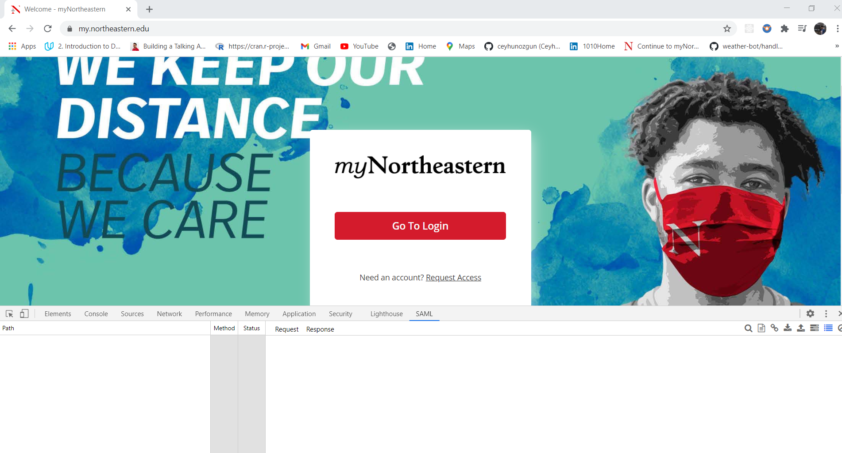

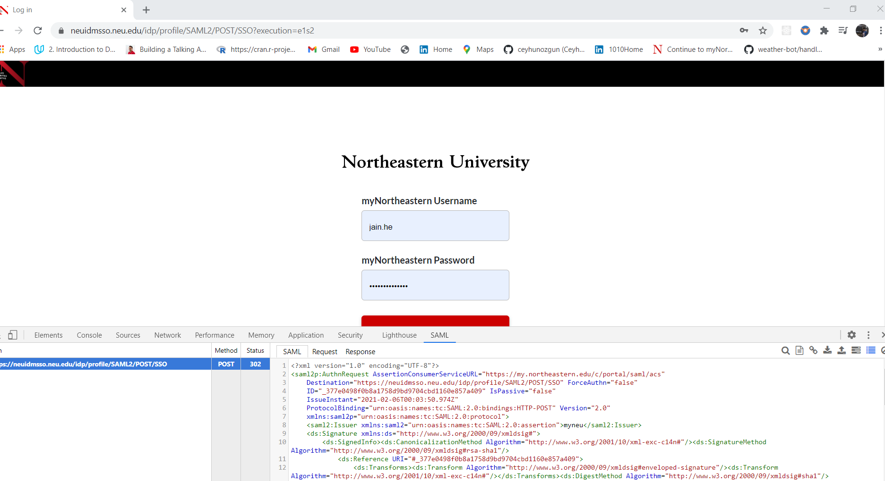

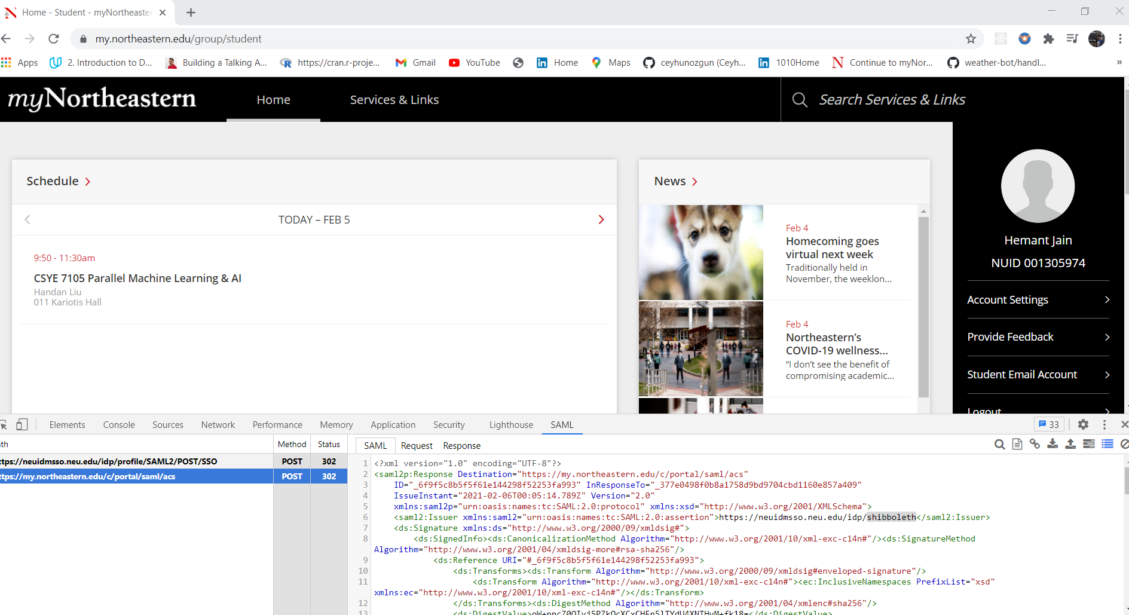

**Progress Embedded Image of Progress Report from LabSim :**

