Hello Everyone,

I am sharing my screenshots for the Tableau Visualizations I worked over this weekend analyzing some the facts and csv files shared within the Discussion and Individual Breakout Rooms.

I was unable to publish out my Tableau Visualizations and Story on the Tableau Public account due the Number of Rows in the Dataset Restrictions in creating out the Data Extract to Support the visualizations in the portal:

**Enclosing the various visualizations screenshots and visualizations dashboards in the Screen Capture**

1. **Outlier Detection ScatterPlot**

This graph shows you the outlier employees from the normal employee distributions.

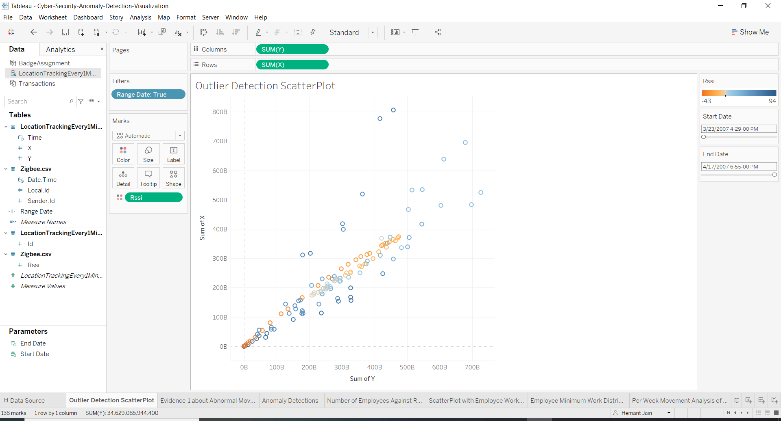

1. **Evidence-1 about the Abnormal Movements in the Organization Employees**

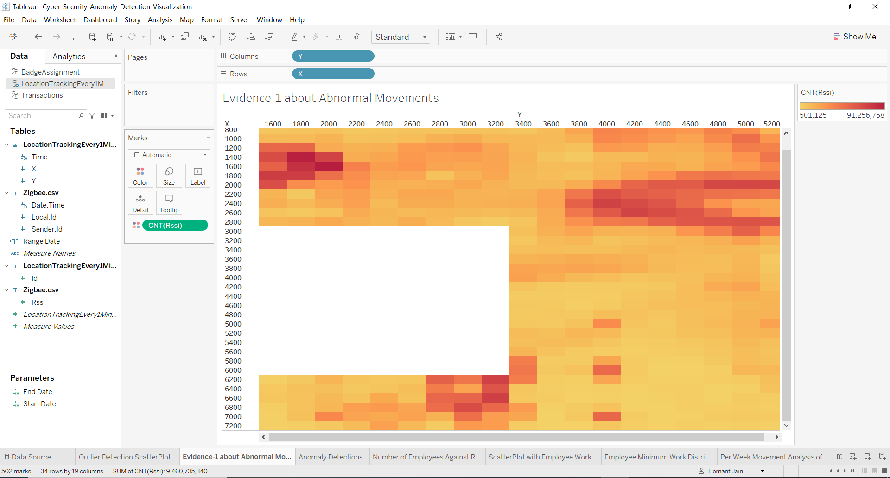

1. **Anomaly Detections using the RSSI Signal Strengths Values**

This graph visualizes the anomalies using the RSSI Strength and figures and points to the Employee 266,290,N8 and others.

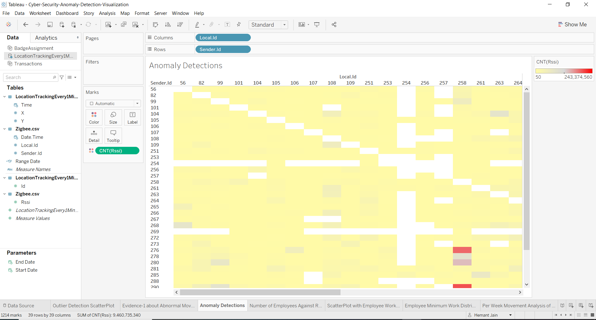

1. **Number of Employees Work Distributions Against Role**

Sampling and Distributing the Employees Against the Roles like Base Station, Configuration, Coordinators, Pricing and RSSI.

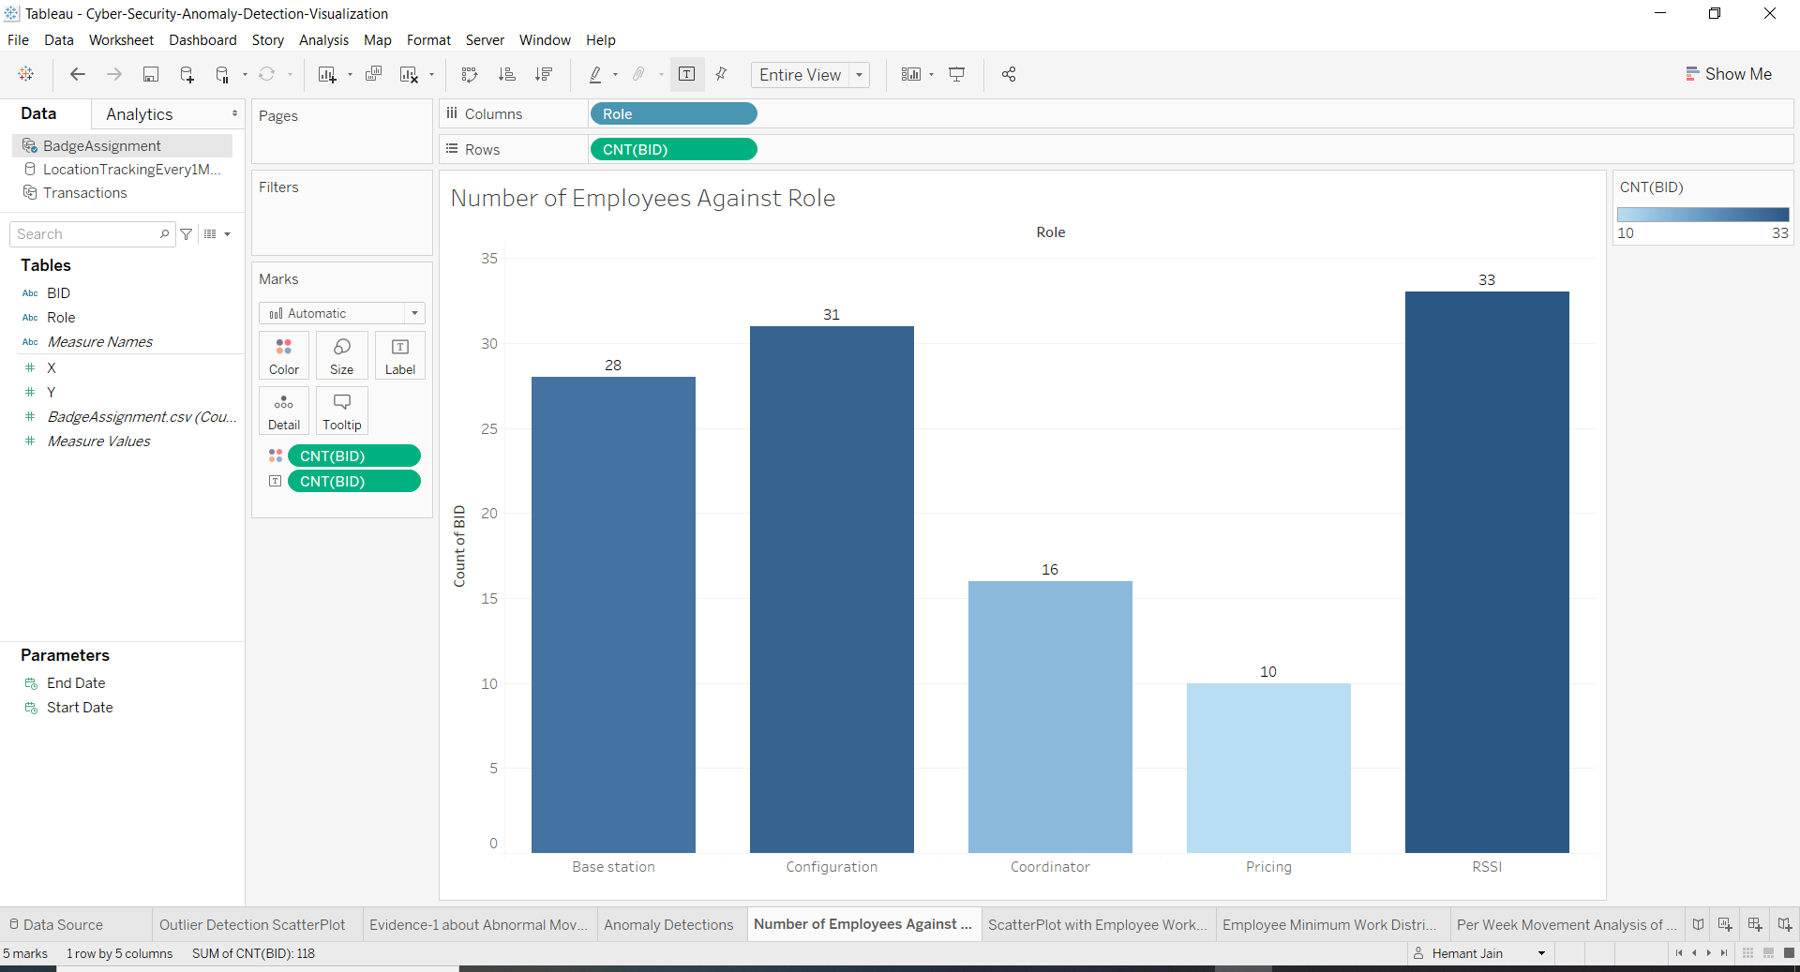

1. **ScatterPlot with Employee Work Distribution along Complexity of the Task Assignments**

Employee Work Distribution according to the Task Work Assignment Complexities and the non-uniform work distribution for some employees.

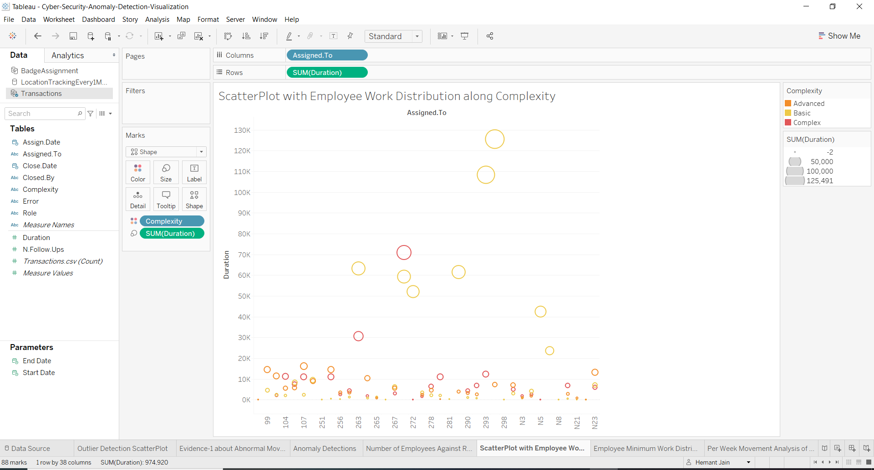

1. Employee Minimum Work Distribution Bar Chart With Less Than 300 Durations

It shows up the Employees who had less than 300 hours duration task work assignments and favoured by Managers for the Tasks like 251,N8,N21,266,298,N22.

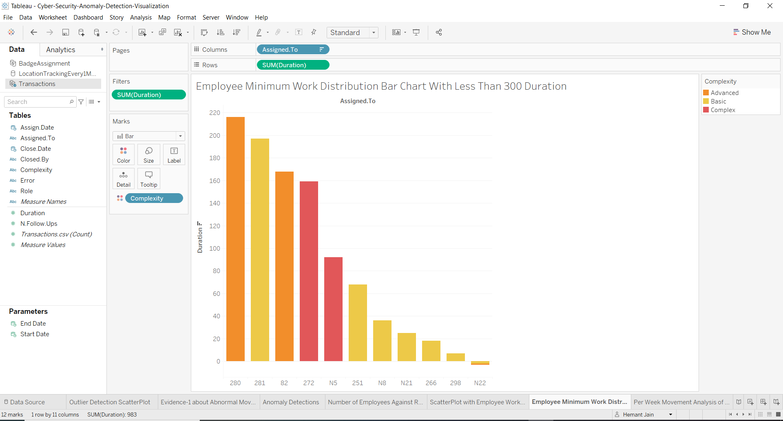

1. **Per Week Movement Analysis of Employees Movement with the Variable Start and End Date Filter to Predict in Anomaly Week Detection**

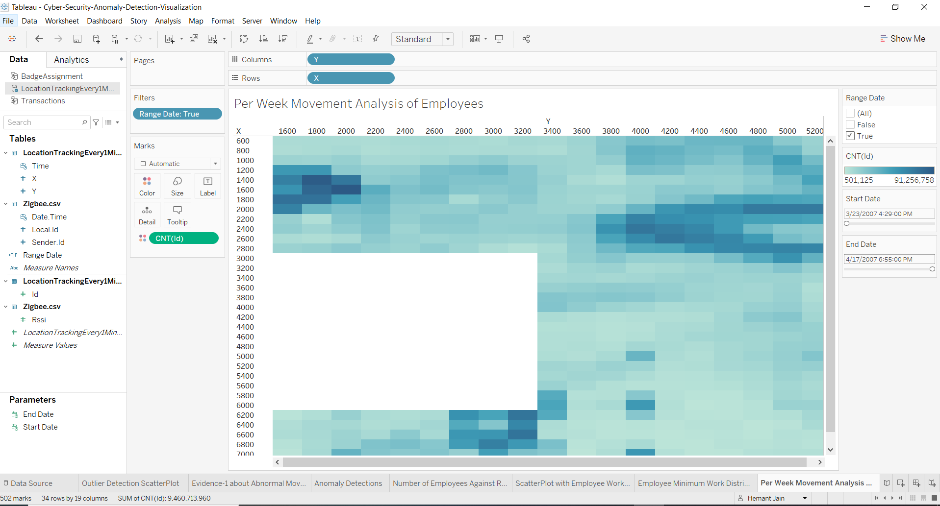

**Quick Story Summary of All the Visualization Prepared Above:**

