

Technical Safety Concept Lane Assistance

**Document Version: [Version]**

**Template Version 1.0, Released on 2017-06-21**



# Document history

**[Instructions: Fill in the date, version and description fields. You can fill out the Editor field with your name if you want to do so. Keep track of your editing as if this were a real world project.**

**For example, if this were your first draft or first submission, you might say version 1.0. If this is a second submission attempt, then you'd add a second line with a new date and version 2.0]**

|  |  |  |  |
| --- | --- | --- | --- |
| Date | Version | Editor | Description |
| 22-05-2018 | 1.0 | Hitesh C | Initial Attempt |
|  |  |  |  |
|  |  |  |  |
|  |  |  |  |
|  |  |  |  |

# 

# Table of Contents

**[Instructions: We have provided a table of contents. If the table of contents is not showing up correctly in your word processor of choice, please update it. The table of contents should show each section of the document and page numbers or links. Most word processors can do this for you. In** [**Google Docs**](https://support.google.com/docs/answer/116338?co=GENIE.Platform%3DDesktop&hl=en)**, you can use headings for each section and then go to Insert > Table of Contents.** [**Microsoft Word**](https://support.microsoft.com/en-us/help/285059/how-to-create-a-table-of-contents-by-marking-text-in-word) **has similar capabilities]**

Document history

Table of Contents

Purpose of the Technical Safety Concept

Inputs to the Technical Safety Concept

Functional Safety Requirements

Refined System Architecture from Functional Safety Concept

Functional overview of architecture elements

Technical Safety Concept

Technical Safety Requirements

Refinement of the System Architecture

Allocation of Technical Safety Requirements to Architecture Elements

Warning and Degradation Concept

# Purpose of the Technical Safety Concept

**[Instructions: Answer what is the purpose of a technical safety concept?]**

ISO 26262 places the functional safety concept in the concept phase while the technical safety concept is part of the product development phase.

This is because the technical safety concept is more concrete and gets into the details of the item's technology. The product development phase also includes designing hardware and software.

# Inputs to the Technical Safety Concept

## Functional Safety Requirements

**[Instructions: Provide the functional safety requirements derived in the functional safety concept ]**

|  |  |  |  |  |
| --- | --- | --- | --- | --- |
| **ID** | **Functional Safety Requirement** | **ASIL** | **Fault Tolerant Time Interval** | **Safe State** |
| Functional  Safety  Requirement  01-01 | The lane keeping item shall ensure that the lane departure oscillating torque amplitude is below Max_Torque_Amplitude. | C | 50 ms | Turn of the LDW functionality |
| Functional  Safety  Requirement  01-02 | 1. The lane keeping item shall ensure that the lane departure oscillating torque frequency is below Max_Torque_Frequency. | C | 50 ms | Turn of the LDW functionality |
| Functional  Safety  Requirement  02-01 | LKA Function will be time limited for a Max_Duration | B | 500 ms | Set the LKA torque to zero |

## Refined System Architecture from Functional Safety Concept

**[Instructions: Provide the refined system architecture from the functional safety concept]**

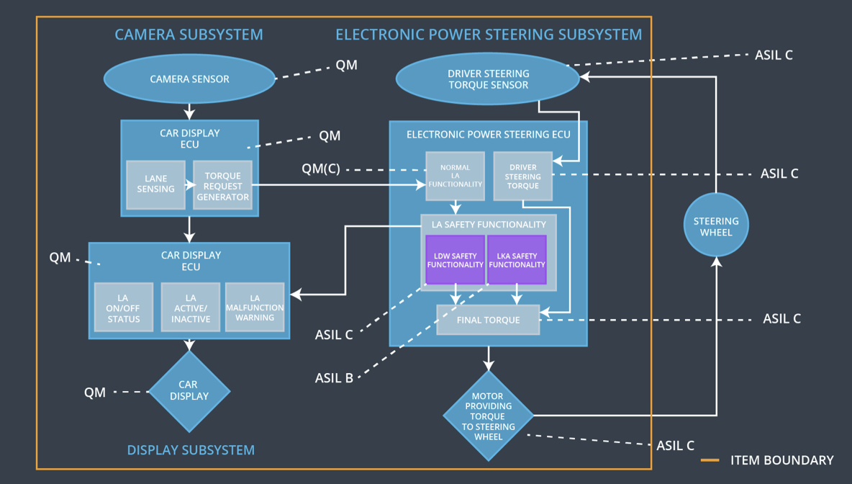

Fig 1. Lane Assistance Architecture

### 

### Functional overview of architecture elements

**[Instructions: Provide a description for each functional safety element; what is each element's purpose in the lane assistance item? ]**

|  |  |
| --- | --- |
| **Element** | **Description** |
| Camera Sensor | Capture images and provide them to the camera sensor ECU continuously |
| Camera Sensor ECU - Lane Sensing | Detect Lane Lines and calculate the position of the car with respect to the lanes |
| Camera Sensor ECU - Torque request generator | Generate Torque request to the car for the Electronic Power Steering ECU |
| Car Display | Display the status of the systems and also warnings when a system malfunctions |
| Car Display ECU - Lane Assistance On/Off Status | Displays whether the lane assistance system is turned on or off. |
| Car Display ECU - Lane Assistant Active/Inactive | Displays whether the Lane Assistance system is active or not at a particular moment |
| Car Display ECU - Lane Assistance malfunction warning | Displays any malfunction in the Lane Assistance system |
| Driver Steering Torque Sensor | It measures the torque applied to the steering wheel. |
| Electronic Power Steering (EPS) ECU - Driver Steering Torque | The input from Driver Steering Torque Sensor is processed here. |
| EPS ECU - Normal Lane Assistance Functionality | It takes input from Driver Steering Torque Sensor and camera ECU and passes it to the safety lane assistance functionality |
| EPS ECU - Lane Departure Warning Safety Functionality | Checks for any malfunction in the Lane Departure Warning function and take appropriate action. (deactivate if there is malfunction, pass the output torque to the final torque is there isn’t any malfunction) |
| EPS ECU - Lane Keeping Assistant Safety Functionality | Checks for any malfunction in the Lane Keeping Assistance function and take appropriate action. (deactivate if there is malfunction, pass the output torque to the final torque is there isn’t any malfunction) |
| EPS ECU - Final Torque | Combine the inputs from LDW and LKA and deliver the final torque request to the motor |
| Motor | The Motor is actuated by the input from Electronic Power Steering ECU. It applies the requisite torque to the steering wheel |

# Technical Safety Concept

## Technical Safety Requirements

**[Instructions: Fill in the technical safety requirements for the lane departure warning first functional safety requirement. We have provided the associated functional safety requirement in the first table below. Hint: The technical safety requirements were discussed in the lesson videos. The architecture allocation column should contain element names such as LDW Safety block, Data Transmission Integrity Check, etc. Allocating the technical safety requirements to the "EPS ECU" does not provide enough detail for a technical safety concept.]**

**Lane Departure Warning (LDW) Requirements:**

Functional Safety Requirement 01-01 with its associated system elements

(derived in the functional safety concept)

|  |  |  |  |  |
| --- | --- | --- | --- | --- |
| **ID** | **Functional Safety Requirement** | **Electronic Power Steering ECU** | **Camera ECU** | **Car Display ECU** |
| Functional  Safety  Requirement  01-01 | The lane keeping item shall ensure that the lane departure oscillating torque amplitude is below Max_Torque_Amplitude | X |  |  |

Technical Safety Requirements related to Functional Safety Requirement 01-01 are:

|  |  |  |  |  |  |
| --- | --- | --- | --- | --- | --- |
| **ID** | **Technical Safety Requirement** | **ASIL** | **Fault Tolerant Time Interval** | **Architecture Allocation** | **Safe State** |
| Technical  Safety  Requirement  01 | The LDW safety component shall ensure that the amplitude of the 'LDW_Torque_Request' sent to the 'Final electronic power steering Torque' component is below 'Max_Torque_Amplitude. | C | 50 ms | LDW Safety | LDW feature and the 'LDW_Torque_Request' shall be set to zero |
| Technical  Safety  Requirement  02 | As soon as the LDW function deactivates the LDW feature, the 'LDW Safety' software block shall send a signal to the car display ECU to turn on a warning light. | C | 50 ms | LDW Safety | LDW feature and the 'LDW_Torque_Request' shall be set to zero |
| Technical  Safety  Requirement  03 | As soon as a failure is detected by the LDW function, it shall deactivate the LDW feature and the 'LDW_Torque_Request' shall be set to zero. | C | 50 ms | LDW Safety | LDW feature and the 'LDW_Torque_Request' shall be set to zero |
| Technical  Safety  Requirement  04 | The validity and integrity of the data transmission for 'LDW_Torque_Request' signal shall be ensured. | C | 50 ms | LDW Safety | LDW feature and the 'LDW_Torque_Request' shall be set to zero |
| Technical  Safety  Requirement  05 | Memory test shall be conducted at start up of the EPS ECU to check for any faults in memory. | A | 50 ms | Data Transmission Integrety Check | LDW feature and the 'LDW_Torque_Request' shall be set to zero |

**[Instructions: Fill in the technical safety requirements for the lane departure warning second functional safety requirement. We have provided the associated functional safety requirement in the table below. Hint:. Most of the technical safety requirements will be the same. At least one technical safety requirement will have to be slightly modified because we are talking about frequency instead of amplitude. These requirements were not given in the lessons]**

Functional Safety Requirement 01-2 with its associated system elements

(derived in the functional safety concept)

|  |  |  |  |  |
| --- | --- | --- | --- | --- |
| **ID** | **Functional Safety Requirement** | **Electronic Power Steering ECU** | **Camera ECU** | **Car Display ECU** |
| Functional  Safety  Requirement  01-02 | The lane keeping item shall ensure that the lane departure oscillating torque frequency is below Max_Torque_Frequency | X |  |  |

Technical Safety Requirements related to Functional Safety Requirement 01-02 are:

|  |  |  |  |  |  |
| --- | --- | --- | --- | --- | --- |
| **ID** | **Technical Safety Requirement** | **ASIL** | **Fault Tolerant Time Interval** | **Architecture Allocation** | **Safe State** |
| Technical  Safety  Requirement  01 | The LDW safety component shall ensure that the Frequency of the 'LDW_Torque_Request' sent to the 'Final electronic power steering Torque' component is below 'Max_Torque_Frequency. | C | 50 ms | LDW Safety | LDW feature and the 'LDW_Torque_Request' shall be set to zero |
| Technical  Safety  Requirement  02 | As soon as the LDW function deactivates the LDW feature, the 'LDW Safety' software block shall send a signal to the car display ECU to turn on a warning light. | C | 50 ms | LDW Safety | LDW feature and the 'LDW_Torque_Request' shall be set to zero |
| Technical  Safety  Requirement  03 | As soon as a failure is detected by the LDW function, it shall deactivate the LDW feature and the 'LDW_Torque_Request' shall be set to zero. | C | 50 ms | LDW Safety | LDW feature and the 'LDW_Torque_Request' shall be set to zero |
| Technical  Safety  Requirement  04 | The validity and integrity of the data transmission for 'LDW_Torque_Request' signal shall be ensured. | C | 50 ms | LDW Safety | LDW feature and the 'LDW_Torque_Request' shall be set to zero |
| Technical  Safety  Requirement  05 | Memory test shall be conducted at start up of the EPS ECU to check for any faults in memory. | A | 50 ms | Data Transmission Integrety Check | LDW feature and the 'LDW_Torque_Request' shall be set to zero |

**Lane Departure Warning (LDW) Verification and Validation Acceptance Criteria:**

**[OPTIONAL: For each technical safety requirement, identify both the verification and validation acceptance criteria. “Validation” asks whether or not you chose the appropriate parameters. “Verification” involves testing to make sure the vehicle behaves as expected when the parameter value is crossed. There is not necessarily one right answer. Look at your verification and validation acceptance criteria from the functional safety concept for inspiration.]**

**Lane Keeping Assistance (LKA) Requirements:**

**[Instructions: Fill in the technical safety requirements for the lane keeping assistance functional safety requirement 02-01. We have provided the associated functional safety requirement in the table below. Hint:. You can reuse the technical safety requirements from functional safety requirement 01-01. But you need to change the language because we are now looking at a different system. The ASIL and Fault Tolerant Time Interval are different as well.]**

Functional Safety Requirement 02-1 with its associated system elements

(derived in the functional safety concept)

|  |  |  |  |  |
| --- | --- | --- | --- | --- |
| **ID** | **Functional Safety Requirement** | **Electronic Power Steering ECU** | **Camera ECU** | **Car Display ECU** |
| Functional  Safety  Requirement  02-01 | The lane keeping item shall ensure that the lane keeping assistance torque is applied for only Max_Duration | X |  |  |

Technical Safety Requirements related to Functional Safety Requirement 02-01 are:

|  |  |  |  |  |  |
| --- | --- | --- | --- | --- | --- |
| **ID** | **Technical Safety Requirement** | **ASIL** | **Fault Tolerant Time Interval** | **Allocation to Architecture** | **Safe State** |
| Technical  Safety  Requirement  01 | The LKA safety component shall ensure that the Duration of LKA Torque application is less than Max_Duration. | B | 500 ms | LKA Safety | LKA feature and the LKA_Torque_Request' shall be set to zero |
| Technical  Safety  Requirement  02 | As soon as the LKA function deactivates the LKA feature, the LKA Safety' software block shall send a signal to the car display ECU to turn on a warning light. | B | 500 ms | LKA Safety | LKA feature and the LKA_Torque_Request' shall be set to zero |
| Technical  Safety  Requirement  03 | As soon as a failure is detected by the LKA function, it shall deactivate the LKA feature and the LKA_Torque_Request' shall be set to zero. | B | 500 ms | LKA Safety | LKA feature and the LKA_Torque_Request' shall be set to zero |
| Technical  Safety  Requirement  04 | The validity and integrity of the data transmission for LKA_Torque_Request' signal shall be ensured. | B | 500 ms | LKA Safety | LKA feature and the LKA_Torque_Request' shall be set to zero |
| Technical  Safety  Requirement  05 | Memory test shall be conducted at start up of the EPS ECU to check for any faults in memory. | A | Ignition Cycle | Data Transmission Integrety Check | LKA feature and the LKA_Torque_Request' shall be set to zero |

**Lane Keeping Assistance (LKA) Verification and Validation Acceptance Criteria:**

**[OPTIONAL: For each technical safety requirement, identify both the verification and validation acceptance criteria. “Validation” asks whether or not you chose the appropriate parameters. “Verification” involves testing to make sure the vehicle behaves as expected when the parameter value is crossed. There is not necessarily one right answer. Look at your verification and validation acceptance criteria from the functional safety concept for inspiration.]**

## Refinement of the System Architecture

**[Instructions: Include the refined system architecture. Hint: The refined system architecture should include the system architecture from the end of the technical safety lesson, including all of the ASIL labels.]**

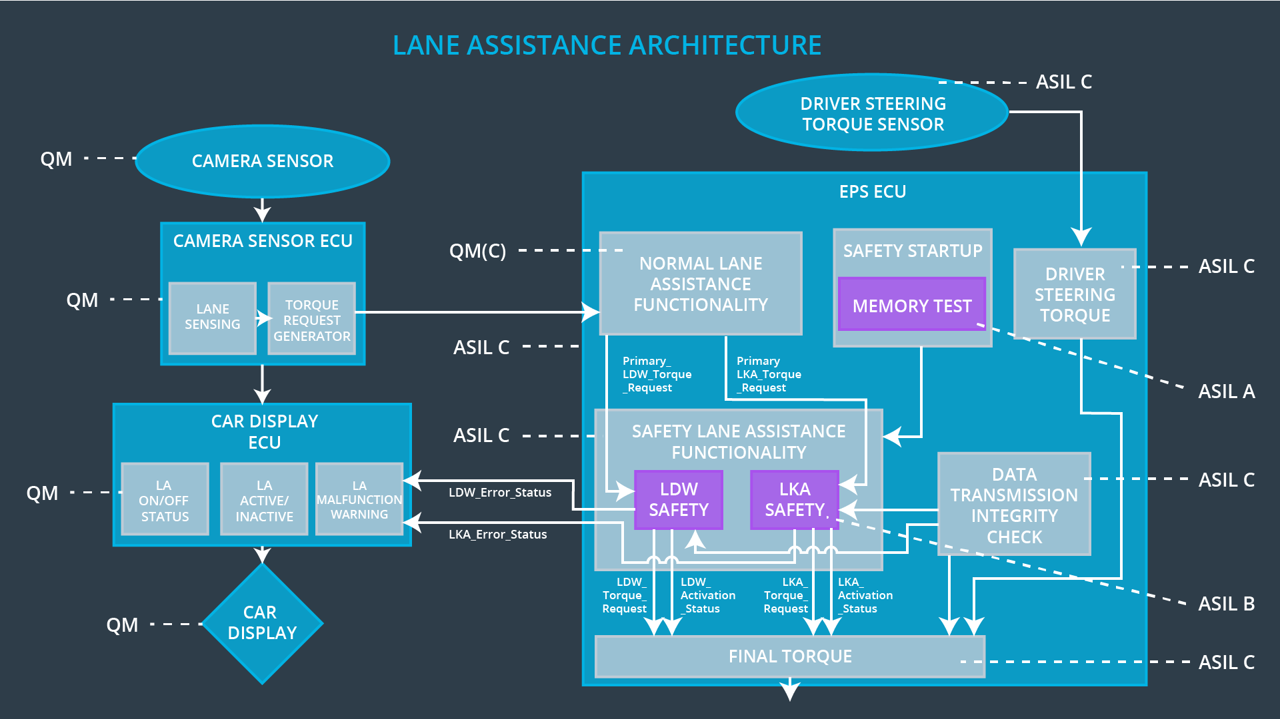

Fig 2. Refined Lane Assistance Architecture

## Allocation of Technical Safety Requirements to Architecture Elements

**[Instructions: We already included the allocation as part of the technical requirement tables. Here you can state that for this particular item, all technical safety requirements are allocated to the Electronic Power Steering ECU]**

All The Technical Safety Requirements like LDW Safety, LKA Safety and memory are assigned to the EPS ECU (Fig. 2)

## Warning and Degradation Concept

**[Instructions: We've already identified that for any system malfunction, the lane assistance functions will be turned off and the driver will receive a warning light indication. The technical safety requirements have not changed how functionality will be degraded or what the warning will be.**

**So in this case, the warning and degradation concept is the same for the technical safety requirements as for the functional safety requirements. You can copy the functional safety warning and degradation concept here.**

**Oftentimes, a technical safety analysis will lead to a more detailed warning and degradation concept. ]**

|  |  |  |  |  |
| --- | --- | --- | --- | --- |
| **ID** | **Degradation Mode** | **Trigger for Degradation Mode** | **Safe State invoked?** | **Driver Warning** |
| WDC-01 | Turn OFF the Functionality | Malfunction_01  Malfunction_02 | Yes | Warning Light on Dashboard and warnings displayed on car display |
| WDC-02 | Turn OFF the Functionality | Malfunction_03 | Yes | Warning Light on Dashboard and warnings displayed on car display |