- Remove unused getter methods like this.adContent, this.endcardInner, this.appDetails and remove respected all Dom elements like this.ctaInfoWrap = null;
- While writing methods use one space. E.g. getAdContent () ➔ Right instead of getAdContent() ➔ Wrong
- While writing if else use rule like
Right ➔
if (!this.endcard) {
// Code
} else {
//code
}
Wrong ➔
if(!this.endcard) {
// Code
} else
{
//code
}
- window8.1 support is not required for this ad unit
- Don’t leave empty blocks in SCSS
- Remove commented lines of code for production quality.
- Don’t use unnecessary nested div’s
Example : <div class="ad-content row collapse">
<div class="small-12 small-centered columns">
<div class="endcard row collapse">
//code
</div>
</div>
</div>
- Indentations should be tab width 4 and it should use spaces instead of tab.
- Check styling od ad Units on actual iOS and Android devices. Although browsers have a responsive device debugging option, it doesn't reflect the true css styling.
- when you modify code, remove methods that are not used.
- Use font size vh and vw to scale accordingly for texts.
- Default token values given in “Token requirement ” in design doc has to be updated in adUnitConfig.json
- Don’t commit local.html or don’t change local.html default values
- Write comments in one or two sentences is to briefly explain what template is about

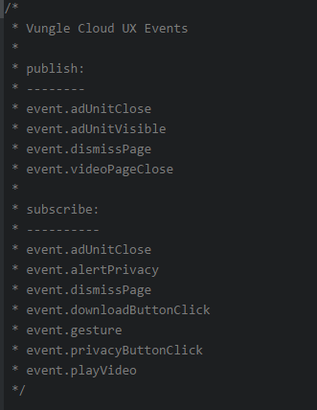

- Instead of writing min-width: 767px use min-width: $large-breakpoint
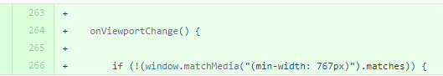
- Use mixin property if scss code is repetitive
- For video tag, we recently had some issue with webkit-playsinline attribute. We need both playsinline and webkit-playsinline attributes for HTML5 video tag moving forward.
- For , app ico and cta button roundness and hide privacy button on iOS devices use below line :
document.querySelector("#dynamic").className = [document.querySelector("#dynamic").className, cloudUX.os, cloudUX.osVersion].join(" ").trim();

- Use caniuse.com for browser support tag
- For add/removeClass, use elementAddClass/elementRemoveClass from the DOMHelper class.
- Please move all event listeners to init() or show() function, depending on the logic, and you should add specific event listener to a specific element instead of document/window.
- Use SVG images from already defined in template.hbs
- Don’t use any background color for video.
- Let's use it consistently across all files. use #000 and #fff respectively.
- Move all SVG icons in one file
- Naming convention should fullscreen-icon instead of fullScreen-icon .
- The endcardView is important event because it's related to our ad reporting.
- The easiest way of determining whether or not it's DiView vs VideoView is to take a look at init() function. See if you are subscribe/publishing any events that are related to video AND endcard and this means it should be DiView. If you're calling events related to only video and has only video element in a page controller, it should be VideoView.
- Naming convention for getter method is:
get + specific class + element/content/container
when you name a hbs class name, let's keep the sequence the same, so it should be
peek-app-info-container
- It looks like some getters are on top and some are on the bottom. This is hard to find and it's also good to alphabetically list them to increase readability. An ad unit like this has a lot of getters and helpers that it's hard to find and spot things unless we list them alphabetically and group similar methods together.
- Only id to match page name and inside the page should only matched by class to be consistent.
- you actually look into the Carousel adunit's config file to copy the token values? Carousel Image 4 & Carousel Image 5 are not required. it should be false or Token Library Confluence page has all information you need.

