Assignment 1

**Task: Create a simple Docker container for a Node.js web application.**

1. Create a Node.js web application or use an existing one.
2. Write a Dockerfile to containerize the Node.js application.
3. Build the Docker image.
4. Push it to Docker hub.
5. Run the Docker container, exposing the application on a specific port.
6. Access the web application in a web browser.
7. Application should be up and running, also create documentation for the whole process.

 Steps to create a simple docker container for a nodejs web application.

1. I have created a simple nodejs application.
2. Then create a ‘Dockerfile’ in directory.
3. Add the following to the docker file:

FROM node:latest

WORKDIR /app

COPY package.json ./

RUN npm install

COPY . .

EXPOSE 3000

CMD [ "node", "index.js" ]

1. Then build the image using the following command, I am naming it assignment1 with tag 1.0:

docker build -t jainilp12/assignment1:1.0 .

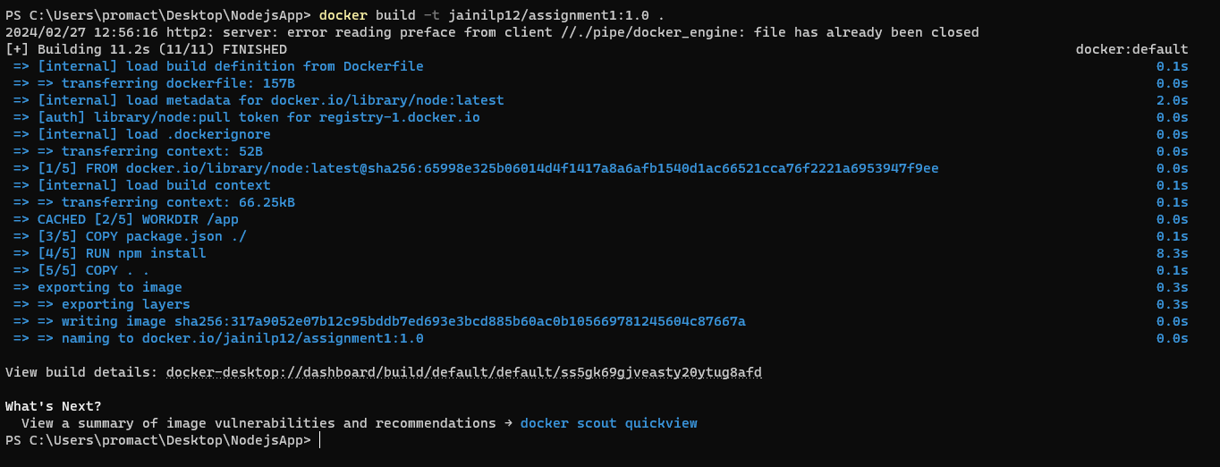

1. Now push it to the docker hub using the following command:

docker image push jainilp12/assignment1:1.0

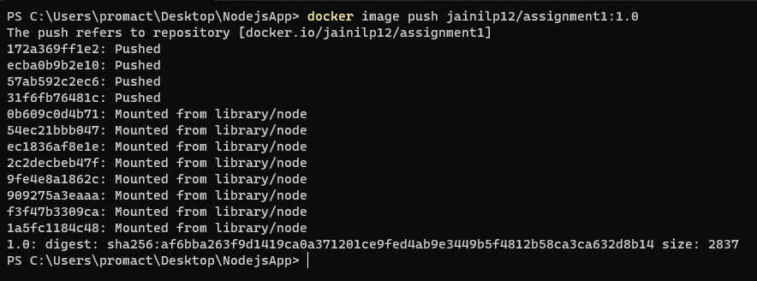

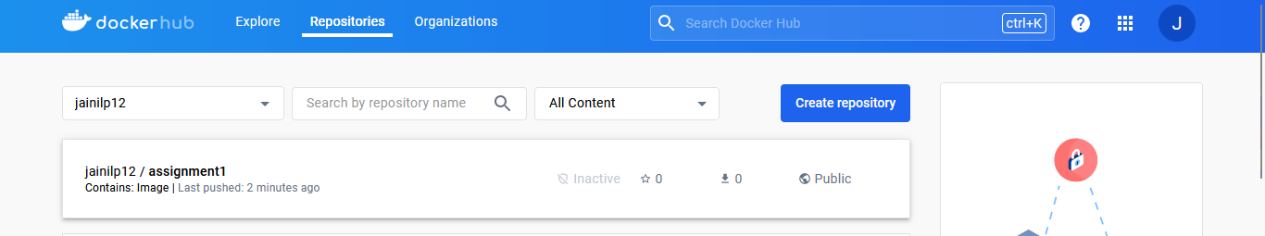

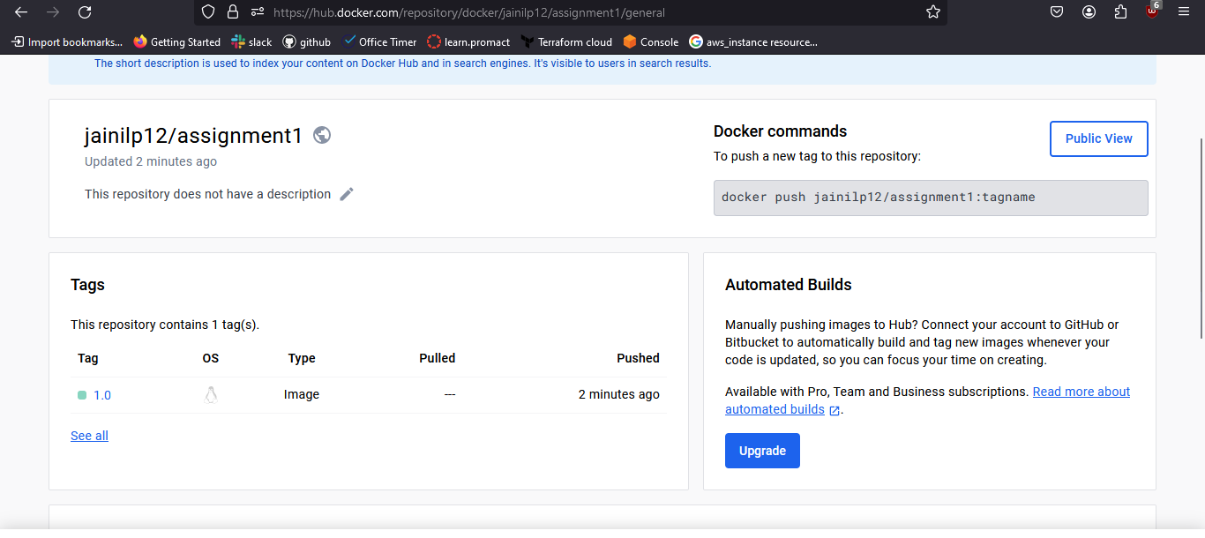

1. To run the docker image use the following command:

docker run -d -p 3000:3000 jainilp12/assignment1:1.0

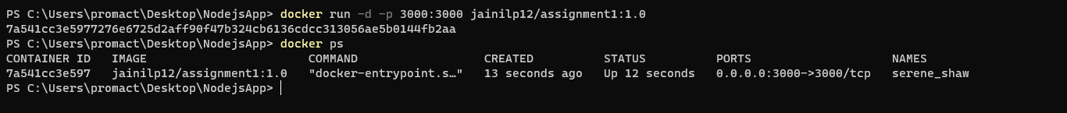

1. Exposed port is 3000 so enter localhost:3000 to access the web page.

