# **TASK 1: Create a new Amazon RDS instance with a database engine of your choice (PostgreSQL)**

1. **Configure the instance with appropriate settings, including the master username and password.**
2. **Take a manual snapshot of your RDS instance.**
3. **Do PG Dump of RDS using connection string or Connect to the DB using connection string.**

**Steps to create RDS PostgreSQL database:**

1. Search for RDS in AWS Console.

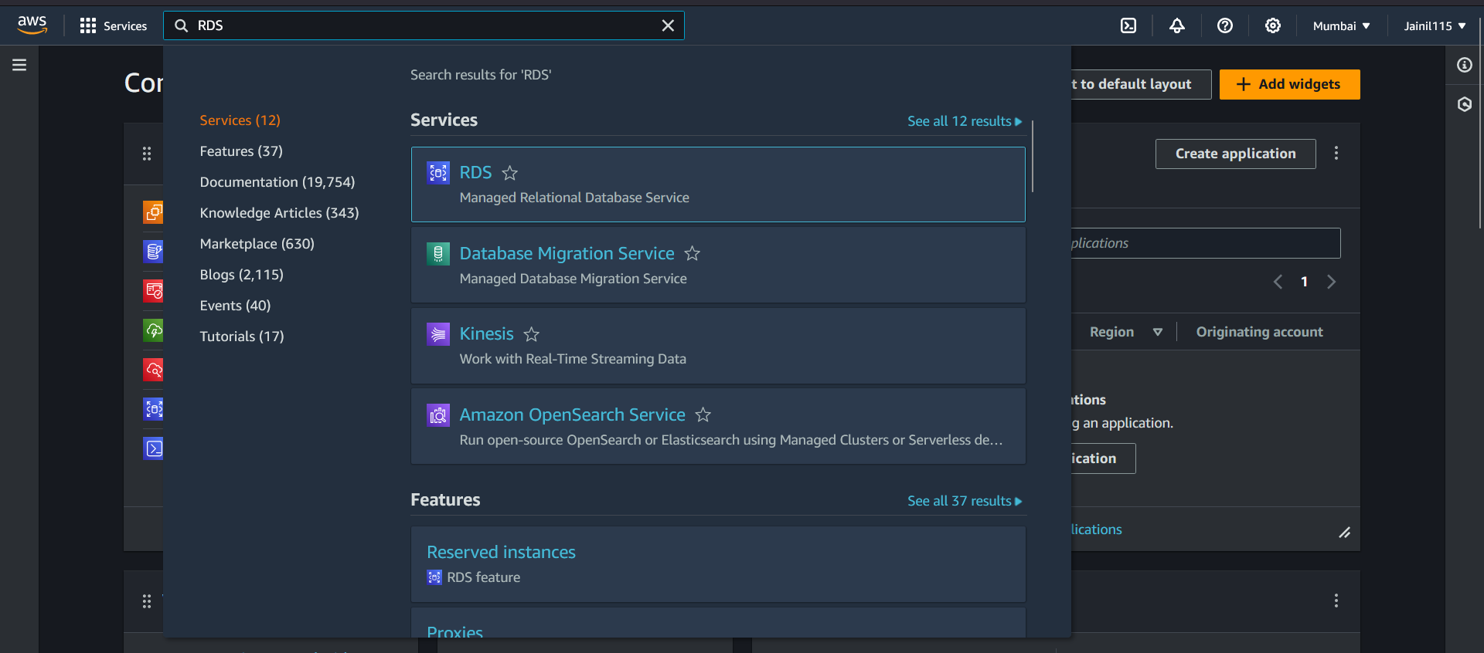

1. In RDS click on “Create Database”.

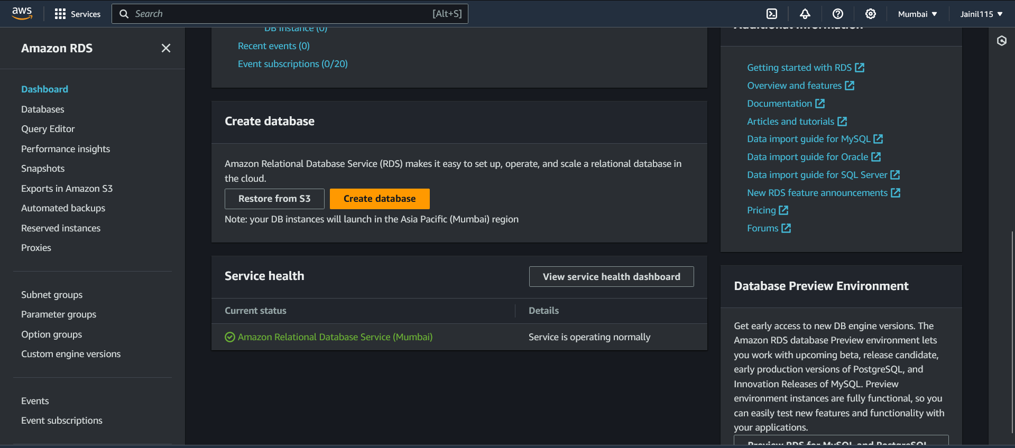

1. Now select "Standard Create" in choose database creation, Select postgresql in Engine options. Select version PostgreSQL 15.5-R2.

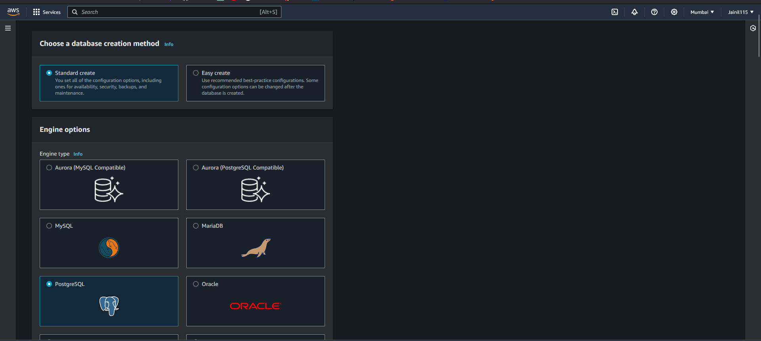

1. Now enter the following details:
   1. Name: jainilsDatabase
   2. Master Username: jainilpatel
   3. Master Password

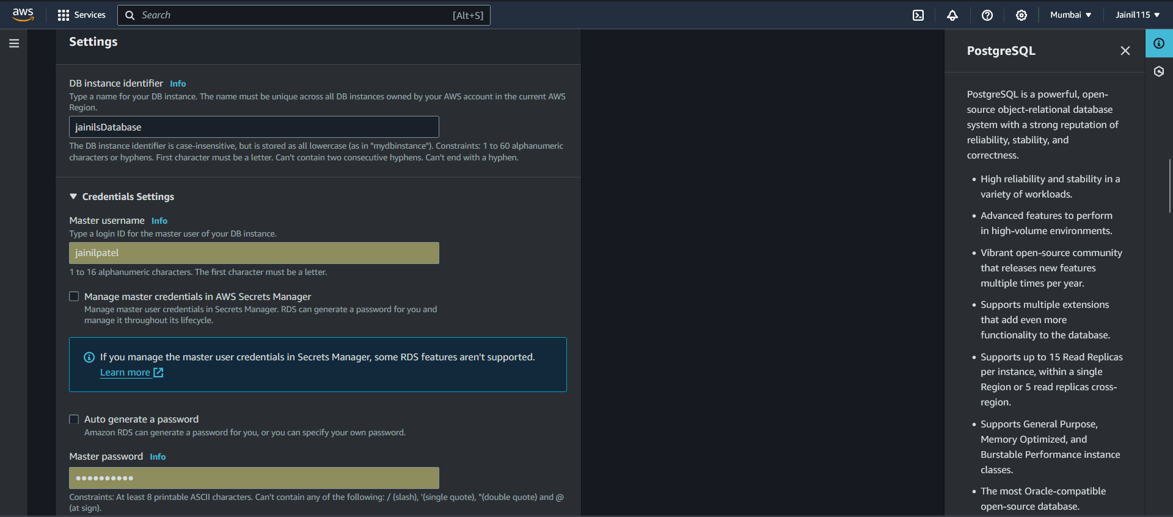

1. Select Instance configuration as db.t3.micro (covered under free tier).

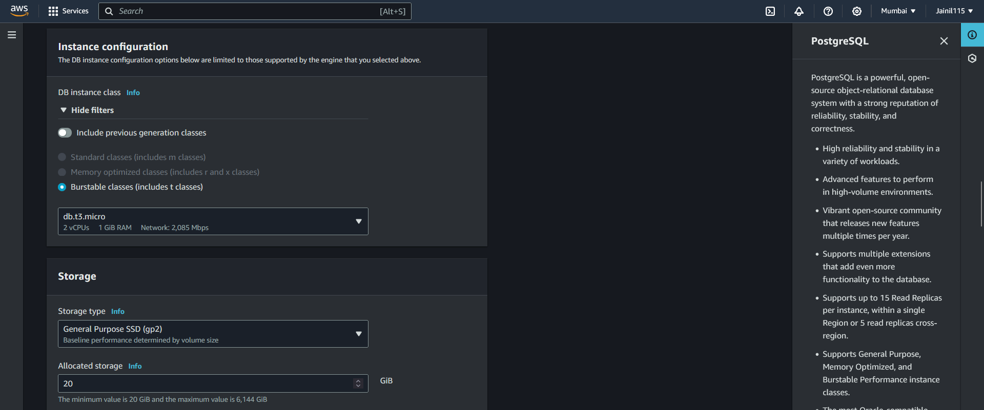

1. Then select storage type "gp2" and allocate 20gb of storage, Enabling storage autoscaling is an good option. Setting maximum storage threshold to 22 for this assignment.

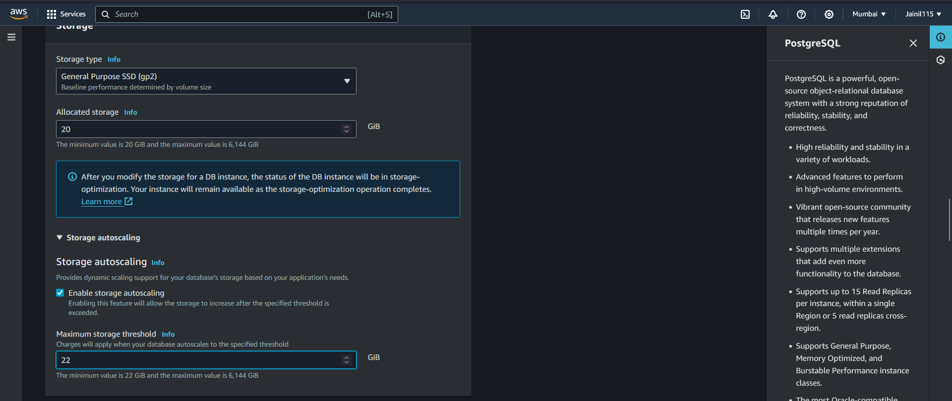

1. Under connectivity select "Don’t Connect to an EC2 compute resource", Then select Default VPC. And select default-vpc in subnet group.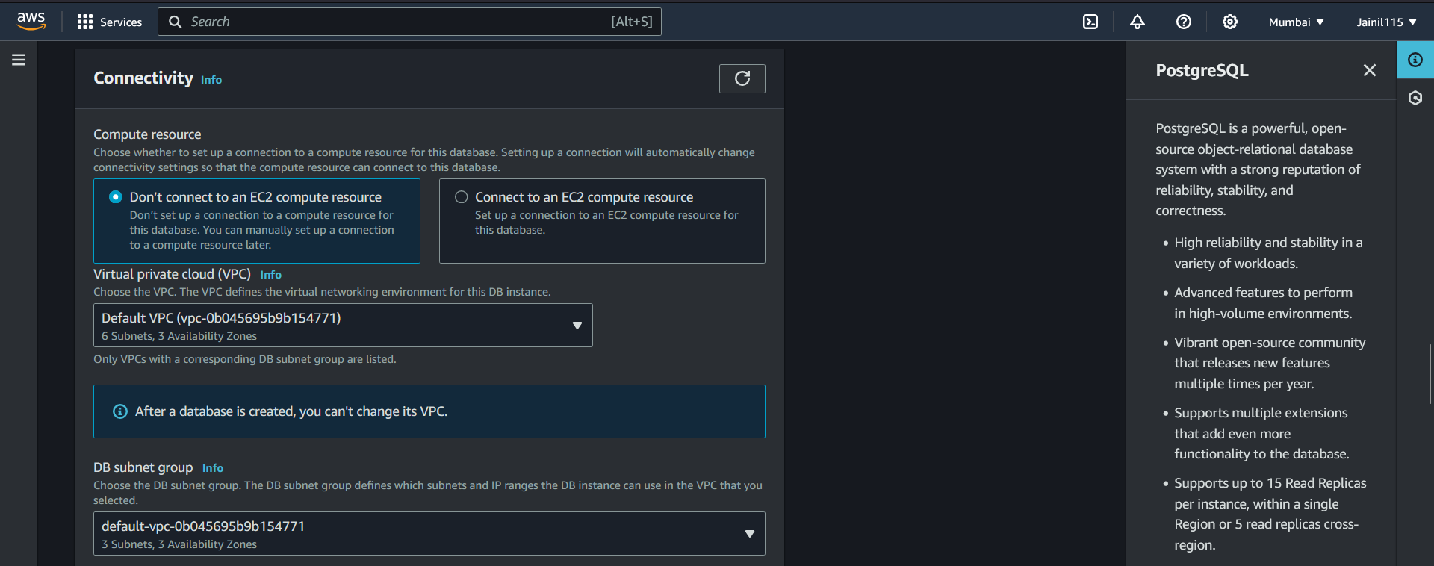
2. Choose no in public access section as we don’t want to allow RDS database to be accessed directly from the internet.

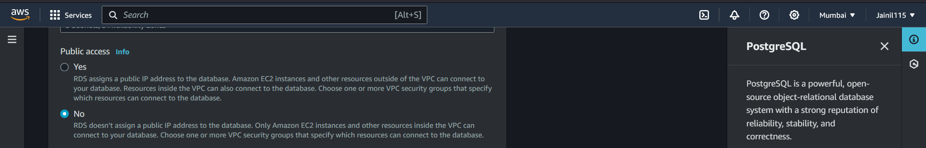

1. Create a new security group and name it RDSPsqlSG. And then add Inbound rule and select the following:
   1. Type: PostgreSQL
   2. Source: IPv4 172.31.0.0/16 (default vpc CIDR).
   3. Remove outbound rules.

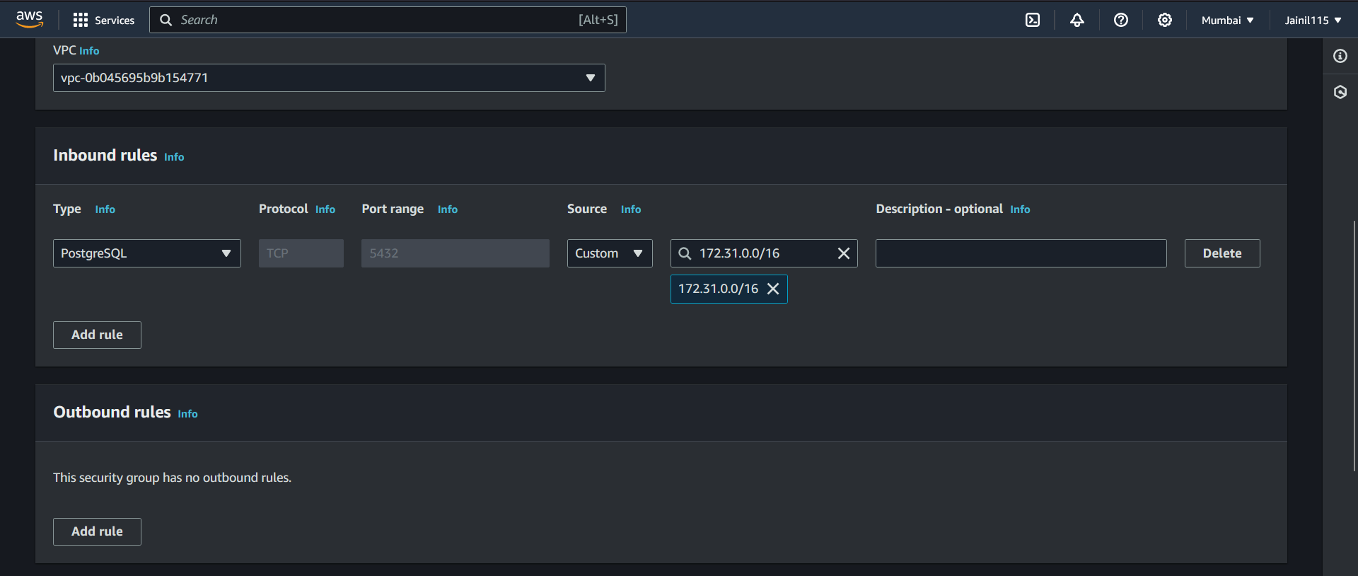

1. Now select RDSPsqlSG under existing VPC security groups.

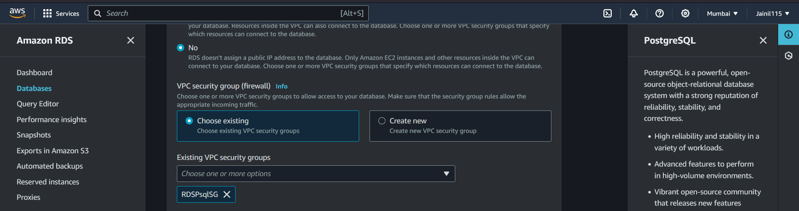

1. In database authentication select password authentication. And in Monitoring turn off additional insights.

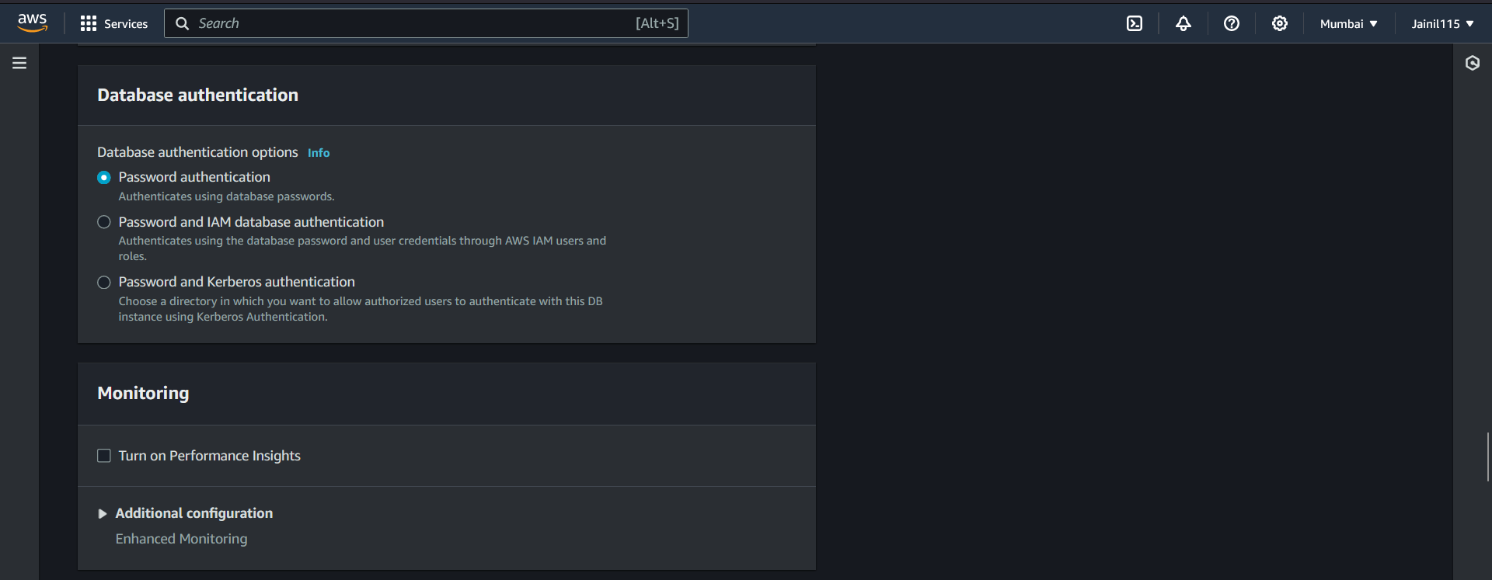

1. Leave everything else in connectivity as default.

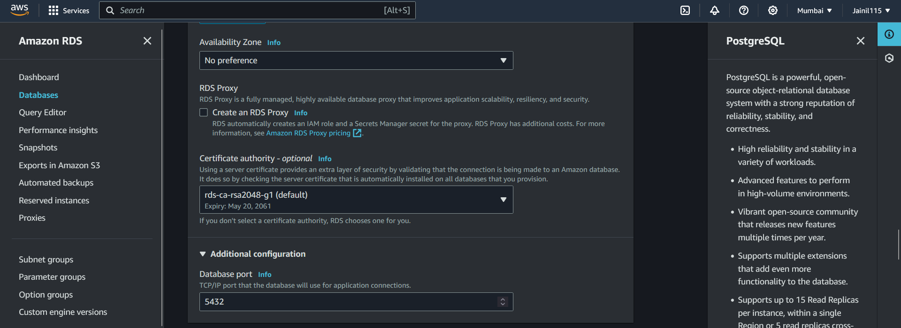

1. After that in Additional configuration enter initial database name and leave everything else under Additional configuration as default.

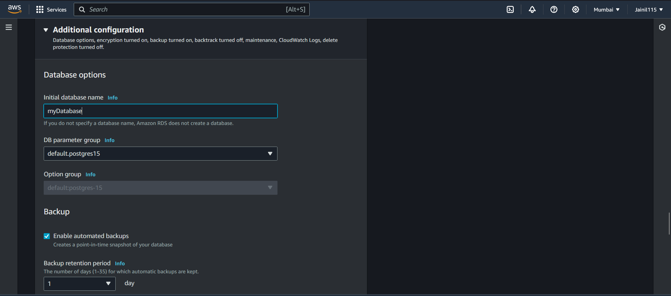

1. Finally click on create database.

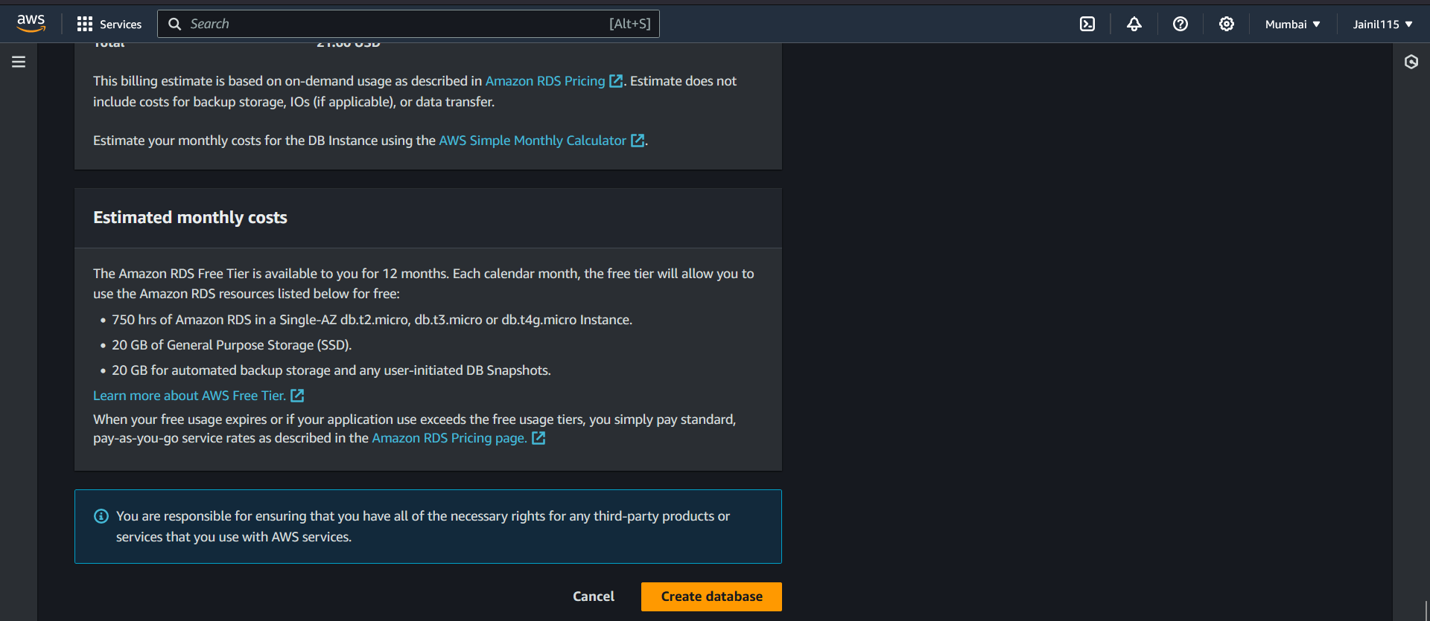

**Steps for taking manual snapshots:**

1. In RDS Databases select "jainilsDatabase" then click on Actions and select "Take snapshot".

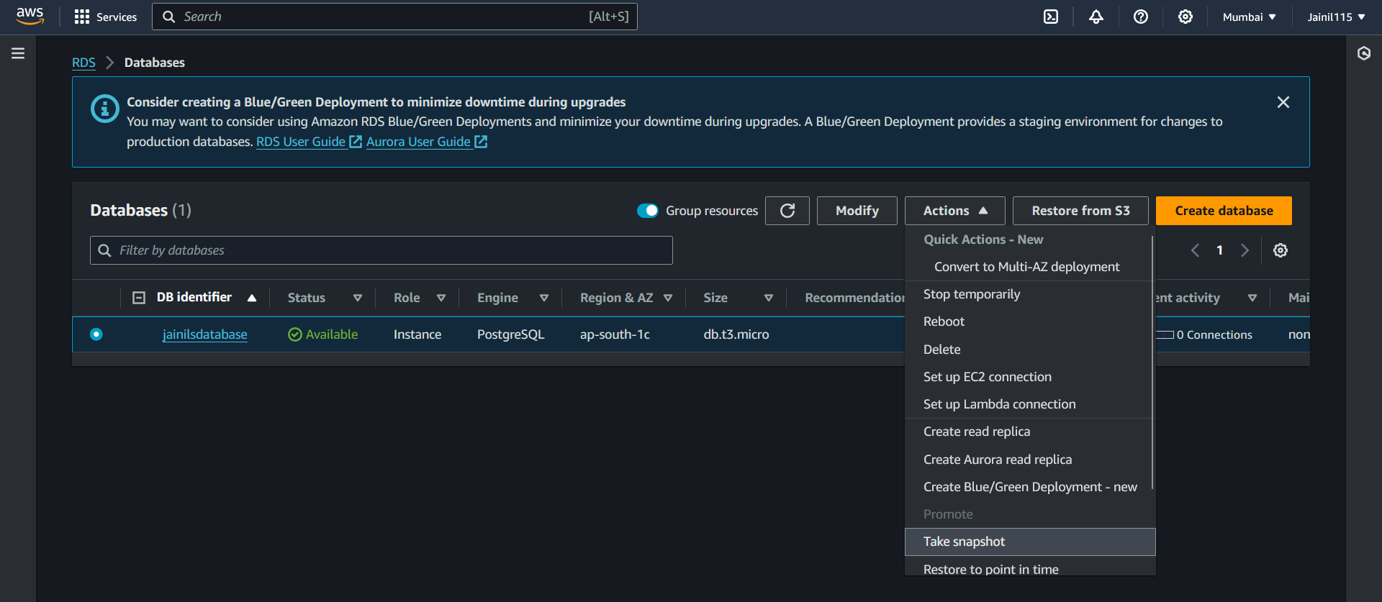

1. In Take DB Snapshot select DB Instance as Snapshot type. Enter the name of snapshot, in my case it is "jainilsdatabase-snapshot-11-23-02-03-2024", and then click on "Take snapshot".

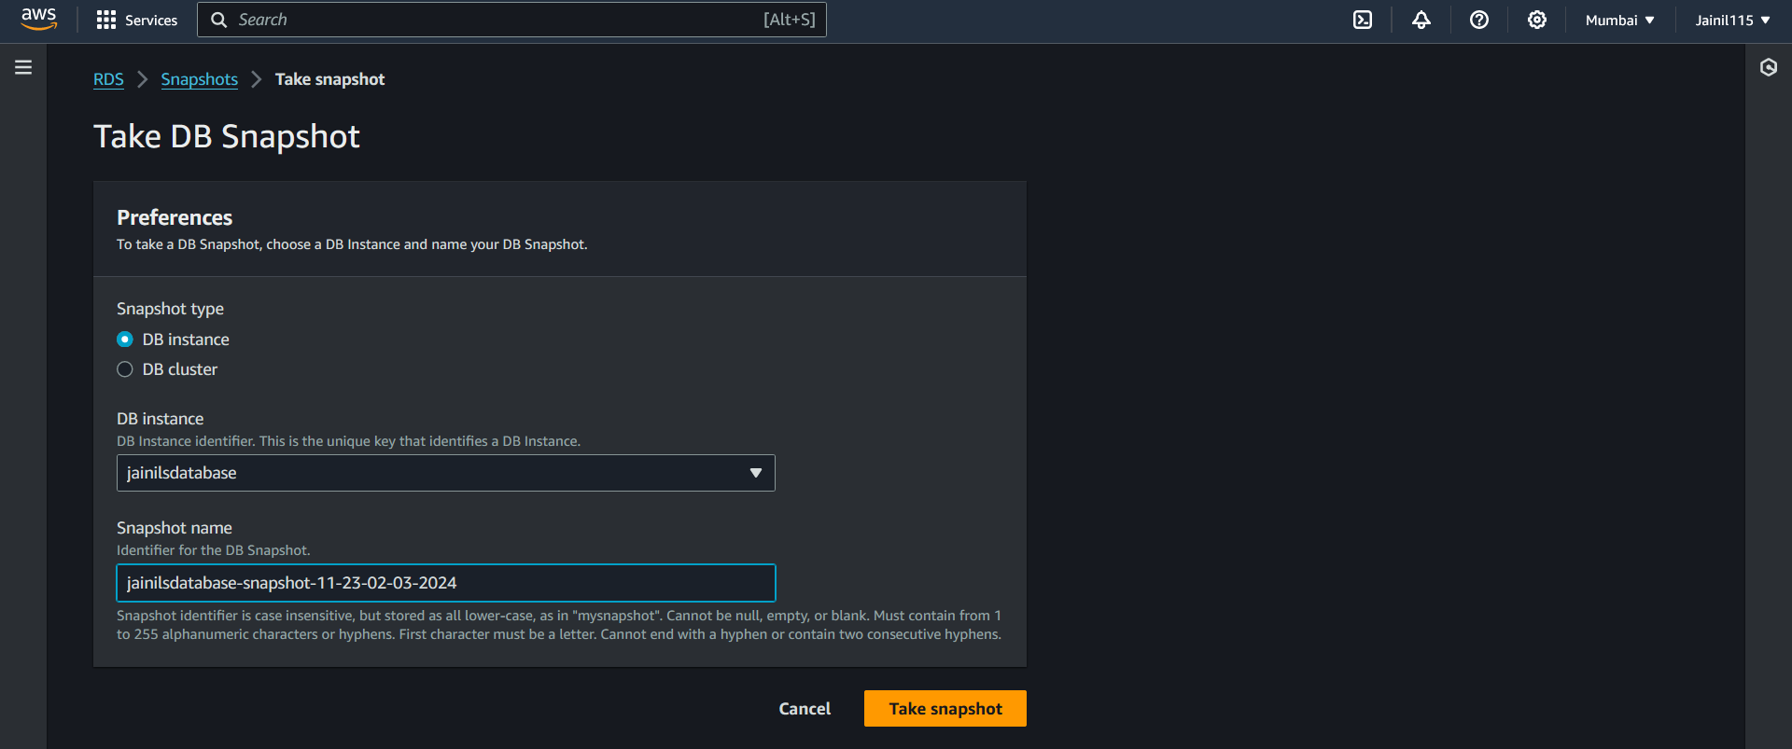

1. Now you will see your snapshot being created.

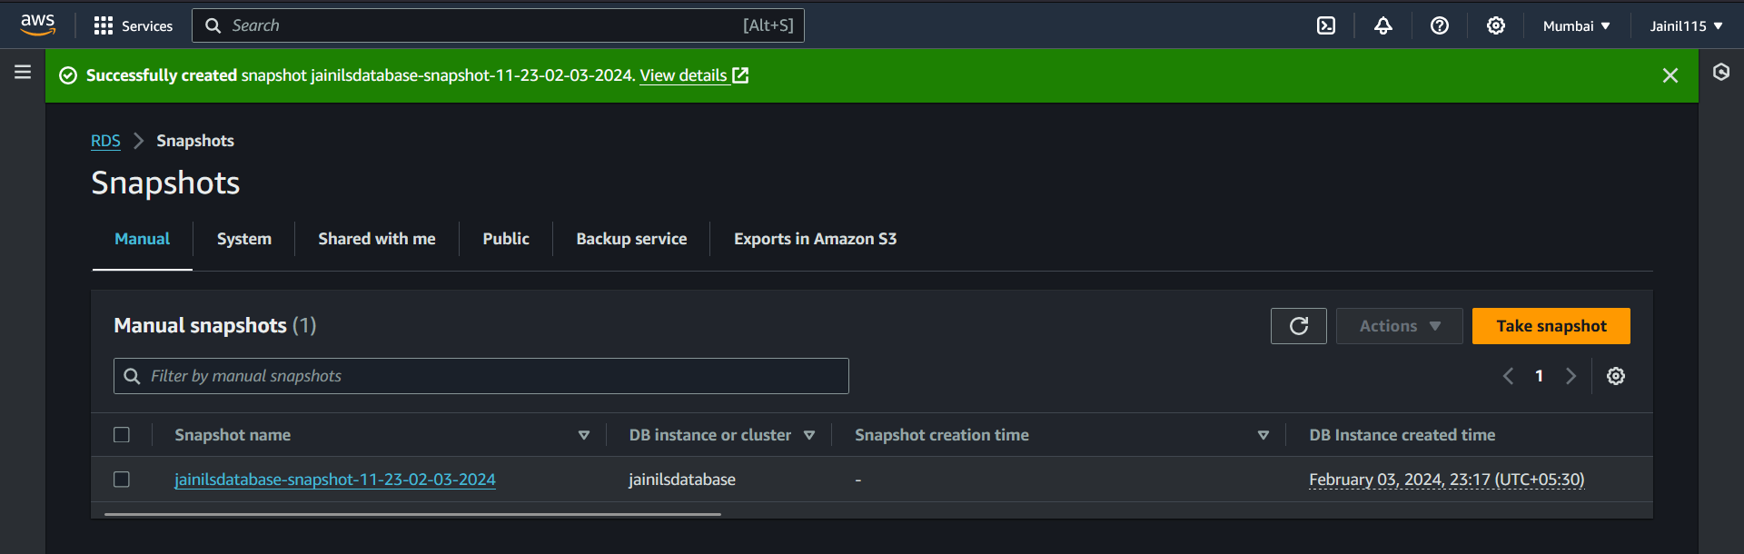

**Steps to do pg_dump using connection string:**

First we need to install postgresql15, here are the steps to install postgresql15 on Amazon Linux 2 EC2 Instance:

1. If postgres is installed then uninstall postgresql.

sudo yum remove postgresql

Create pgdg.repo in /etc/yum.repos.d/, Enter the following command.

sudo touch /etc/yum.repos.d/pgdg.repo



1. Change the permission of the file to make it writable.

sudo chmod 777 /etc/yum.repos.d/pgdg.repo



1. Edit the file and enter the following lines:

[pgdg15]

name=PostgreSQL 15 for Redhat Linux – x86_64

baseurl=<https://download.postgresql.org/pub/repos/yum/15/redhat/rhel-7.10-x86_64>

enabled=1

gpgcheck=0

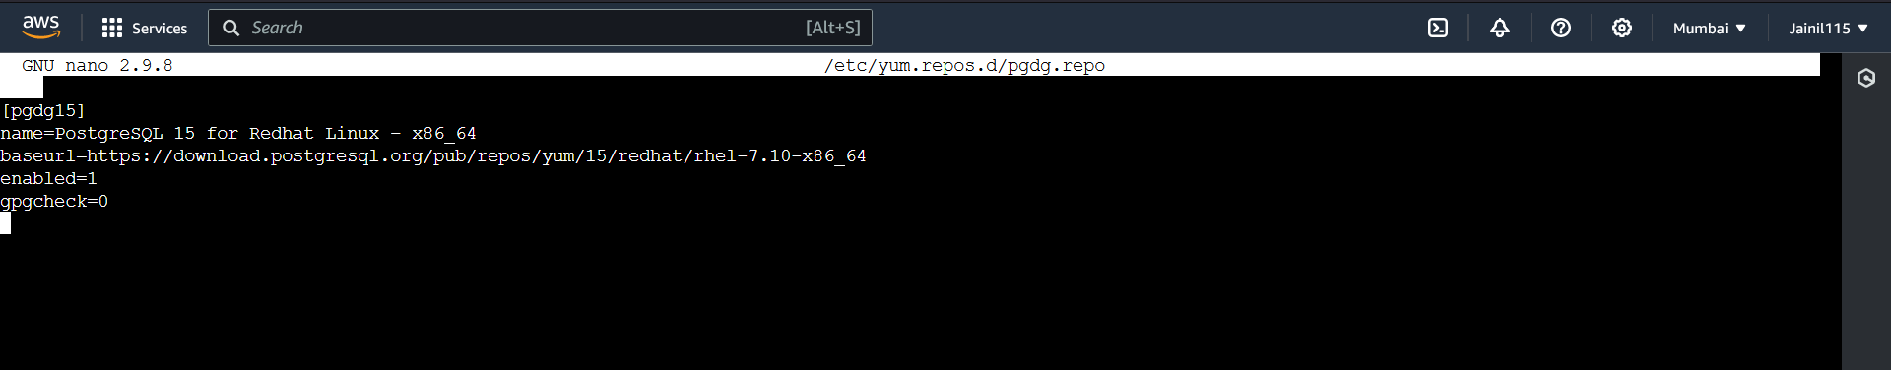

1. Enter the following command to install postgresql15:

sudo yum install postgresql15-15.3-1PGDG.rhel7

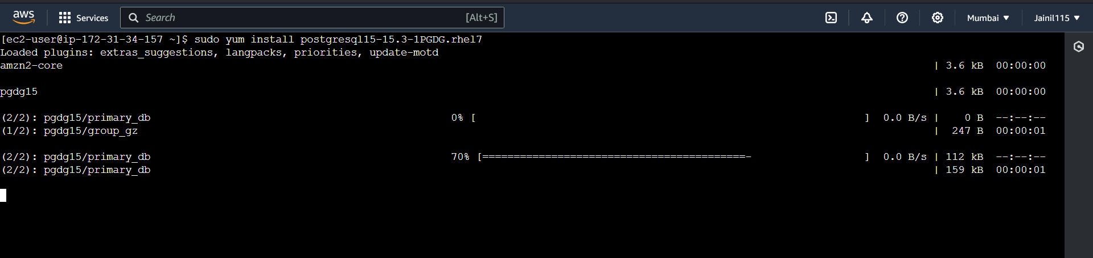



**Now connect to EC2 instacne using ssh or connecting aws console:**

**Steps to do pg_dump:**

1. Navigate to the RDS > jainilsDatabase. Now in configuration tab you will be able to see the endpoint.

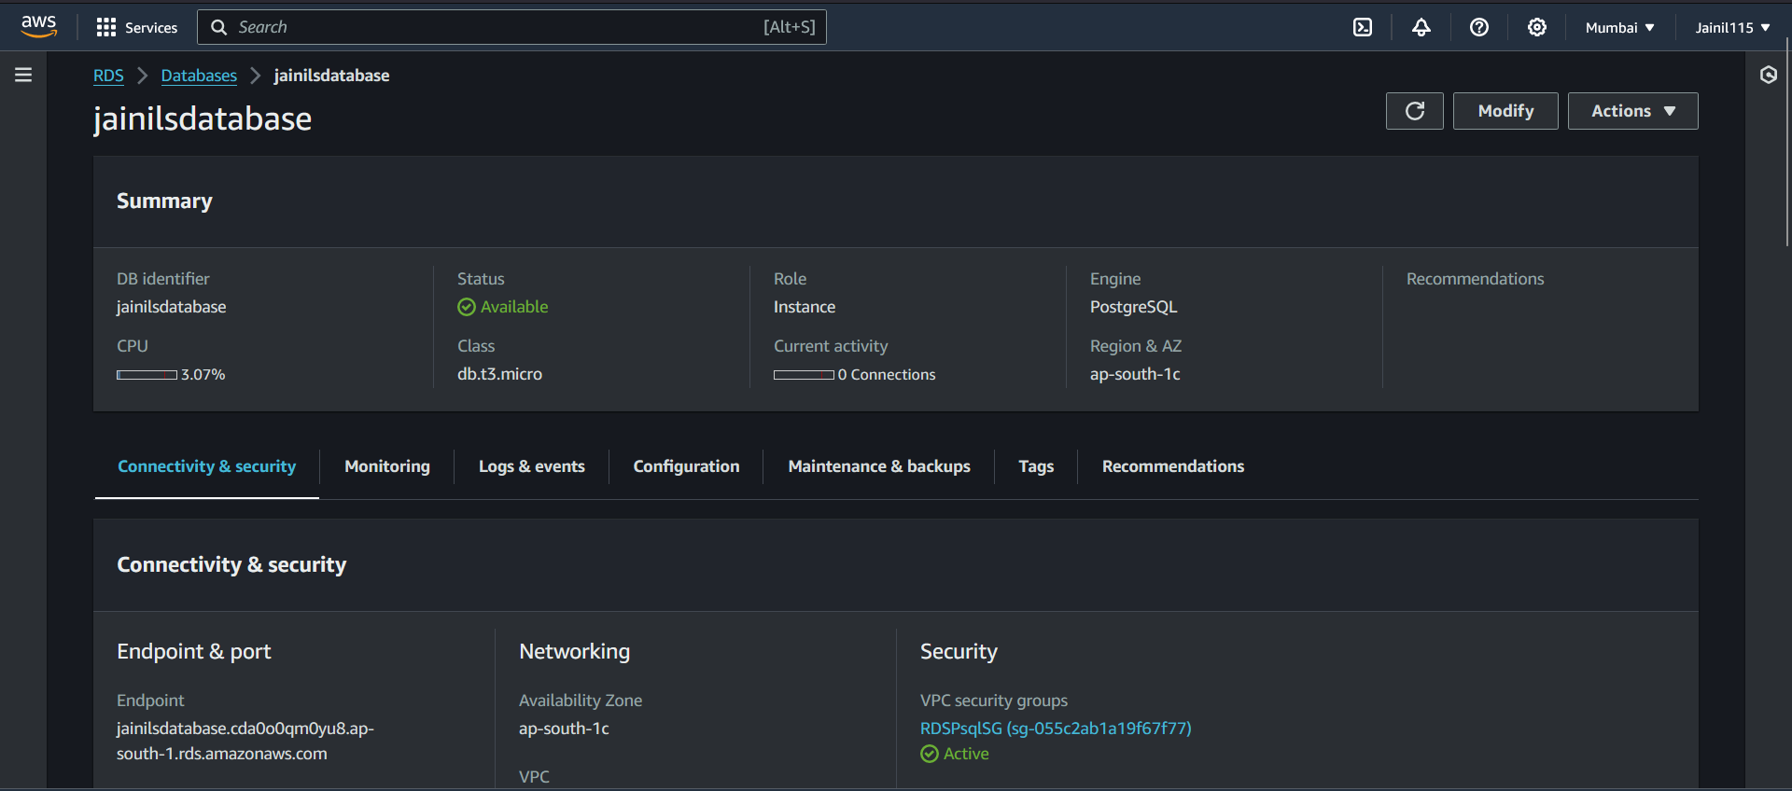

1. Now go to EC2 Instance an connect to an instance that is inside default VPC.

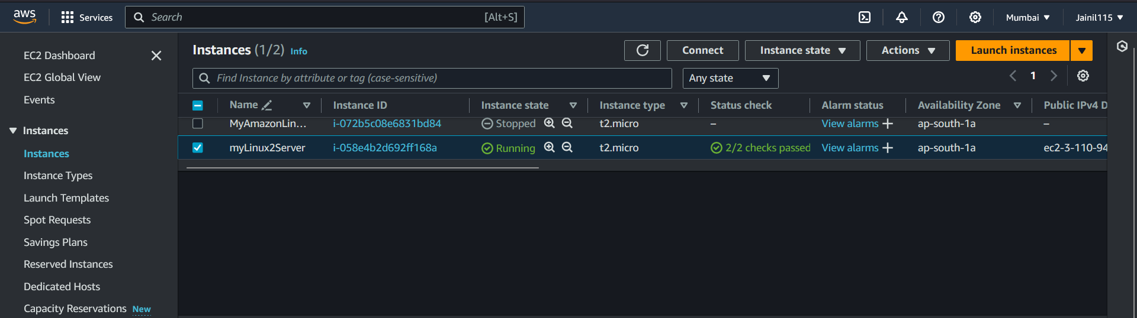

1. Enter the following command to create dump file.

pg_dump -h jainilsdatabase.cda0o0qm0yu8.ap-south-1.rds.amazonaws.com -U jainilpatel -Fc myDatabase > myDatabase_backup_114102032024.sql

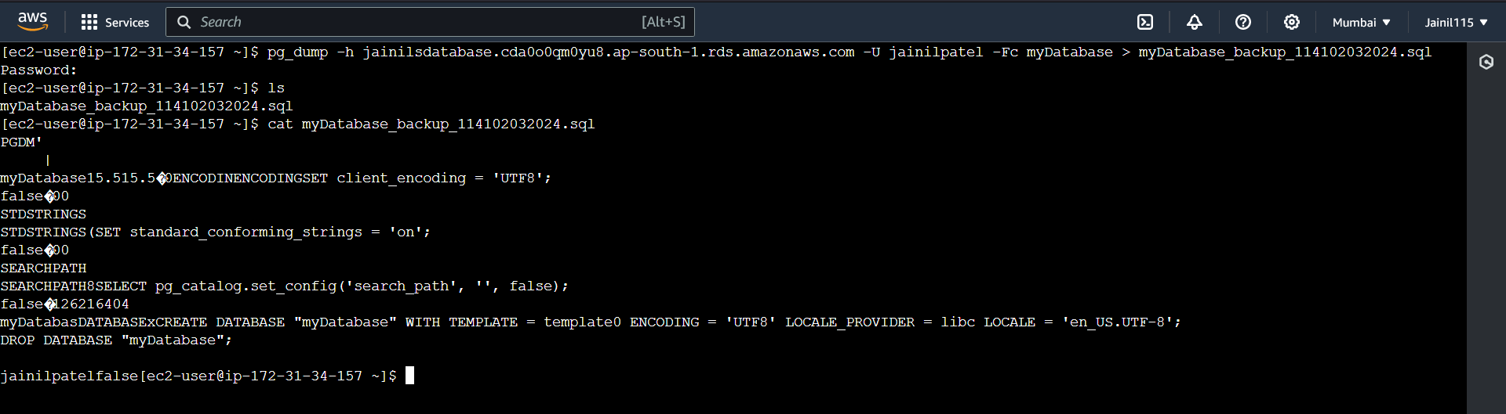

Steps to connect to database using connection string:

1. Navigate to the RDS > jainilsDatabase. Now in configuration tab you will be able to see the endpoint.



1. Now go to EC2 Instance an connect to an instance that is inside default VPC.



1. Enter the following command to connect to the database.

psql -h jainilsdatabase.cda0o0qm0yu8.ap-south-1.rds.amazonaws.com -U jainilpatel -d myDatabase

