**TASK 2:** **Create a DynamoDB Table:**

1. **Create a new DynamoDB table with a primary key of your choice.**
2. **Define the provisioned throughput for the table.**
3. **Run CRUD operation in the in DB table using Queries.**

**Steps to create a new DynamoDB Table with a primary key of your choice:**

1. First go to AWS console and search for DynamoDB.

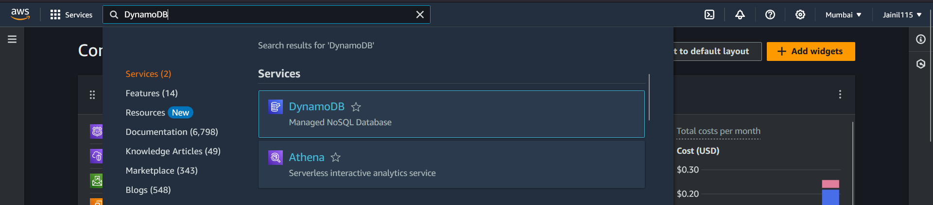

1. Inside DynamoDB dashboard click on "create table".

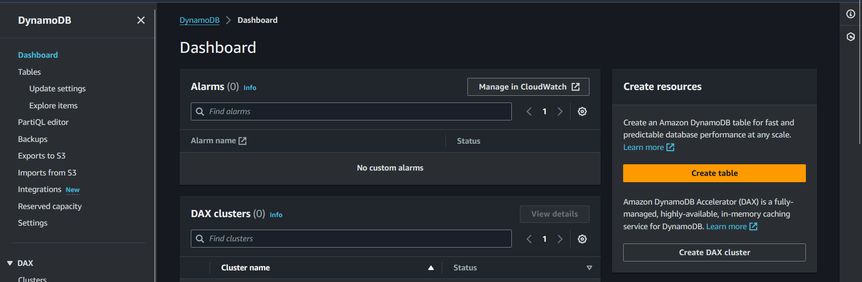

1. Inside create table form, Enter the following detais.
   1. Table Name: Books
   2. Partition Key: BookID, Type: String
   3. Sort Key: Author, Type: String

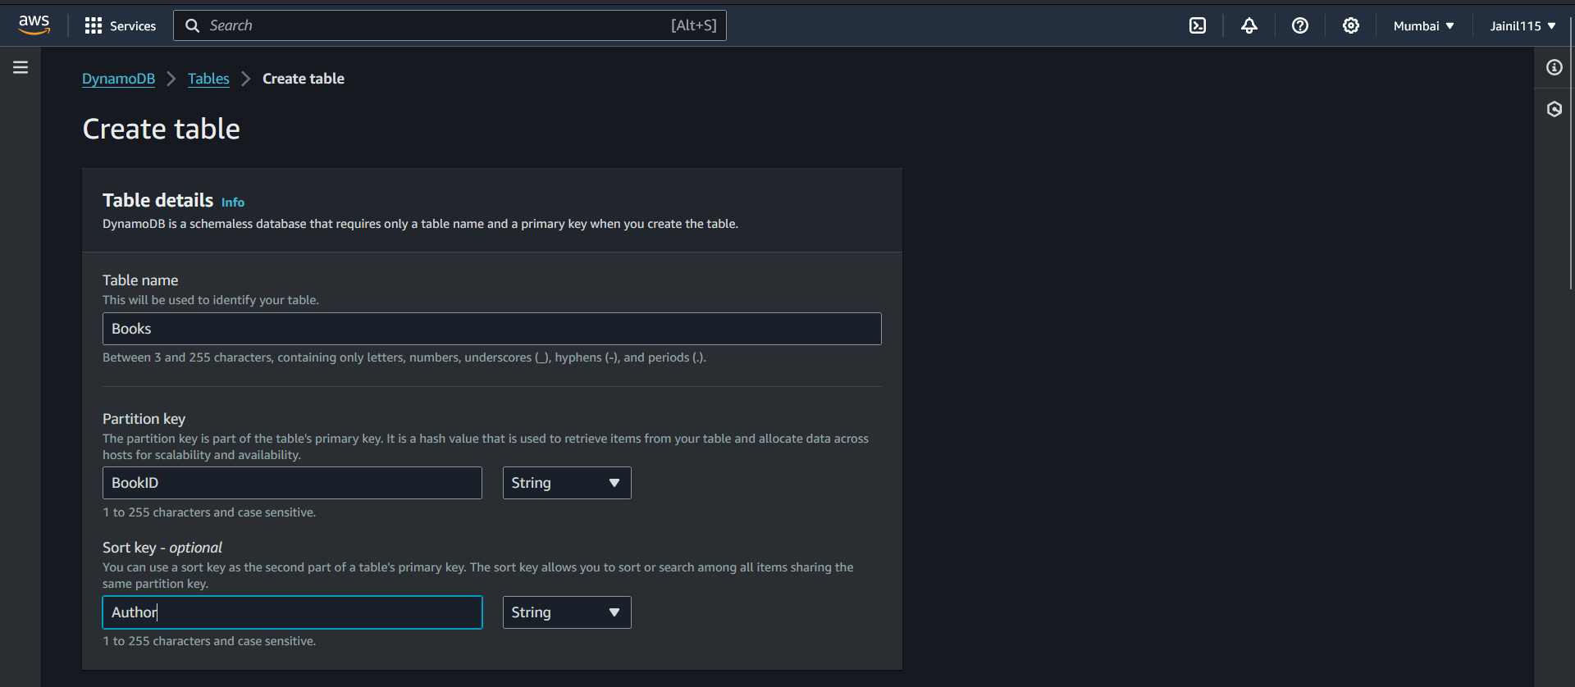

1. Then select Default settings under Table settings and click on Create Table

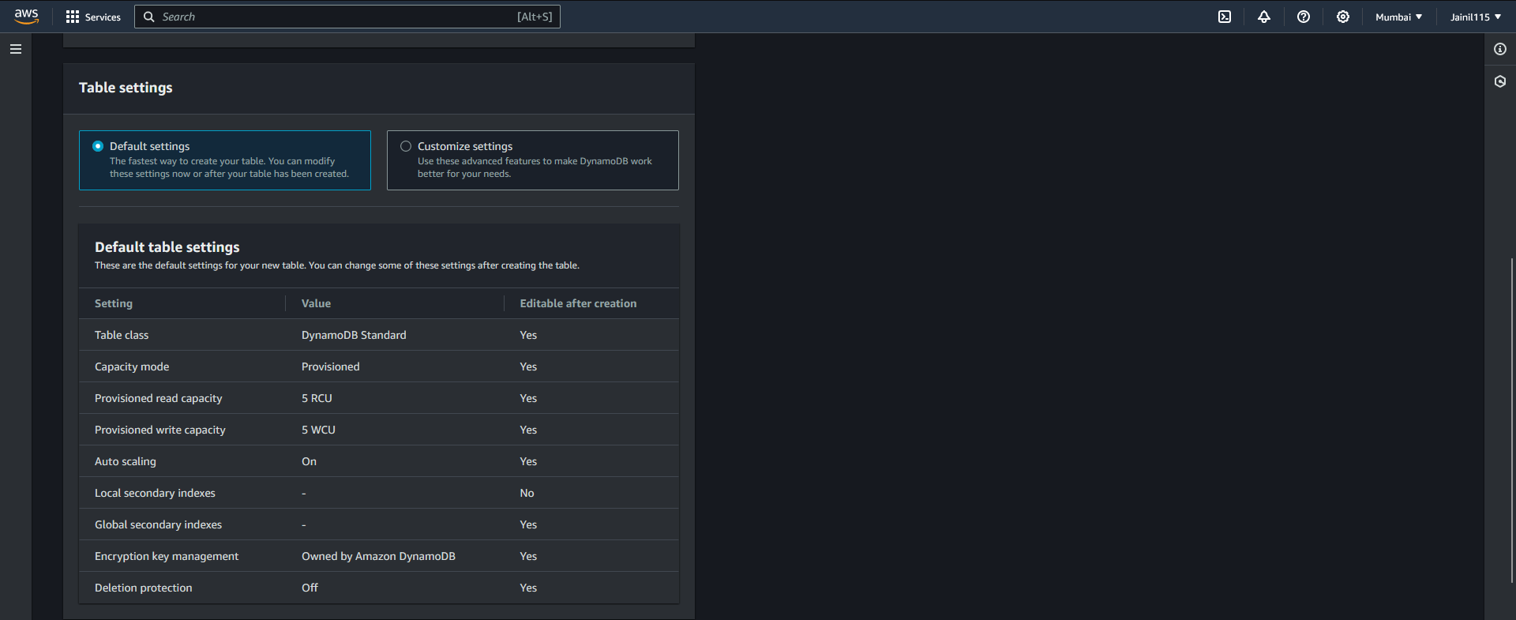

1. Now in DynamoDB Table Dashboard you will be able to see that Books Table has been created.

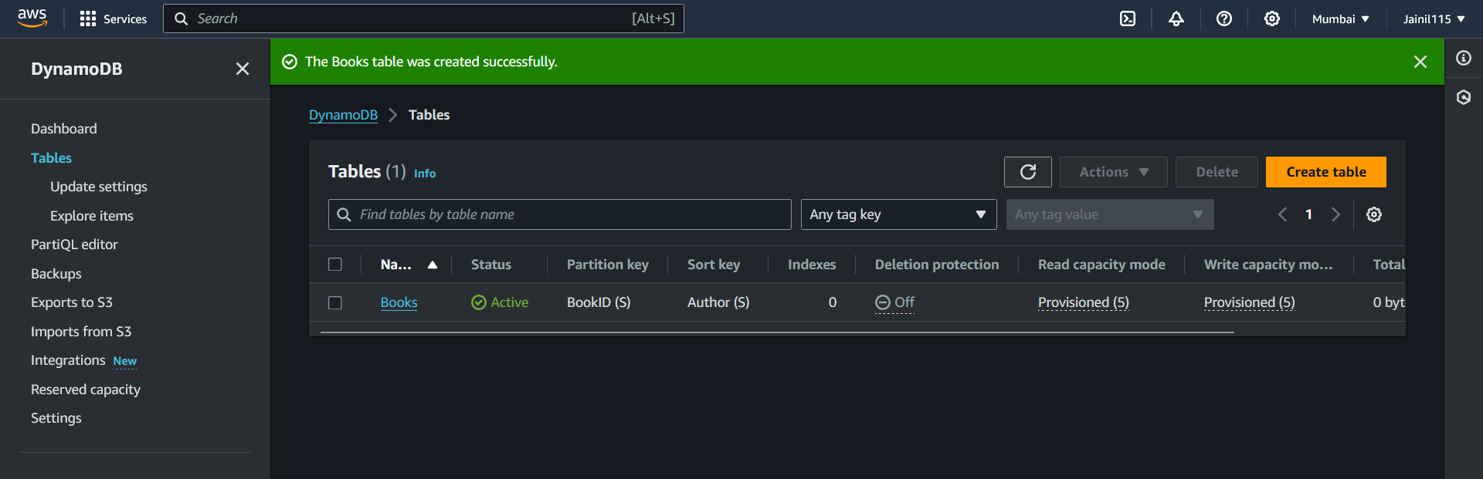

**Steps to define the provisioned throughput for the table:**

1. Go to Tables under DynaomoDB dashboard and then clickN Books table.

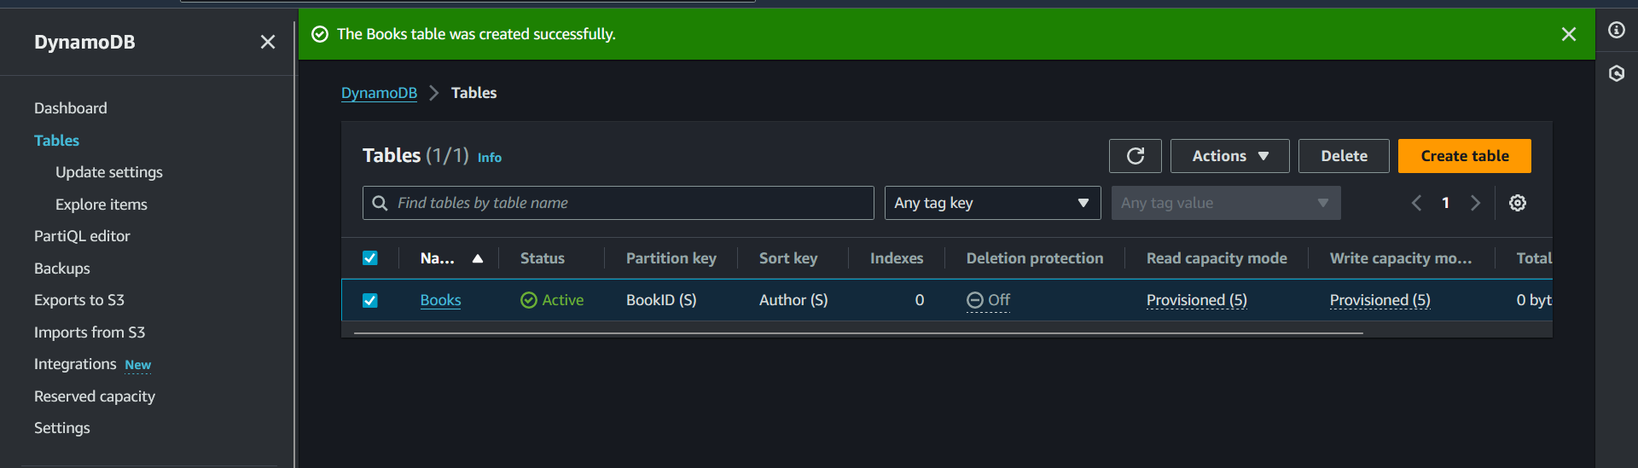

1. Now inside DynamoDB > Table > Books go to additional settings. Where we can see the provisioned capacity for the table.

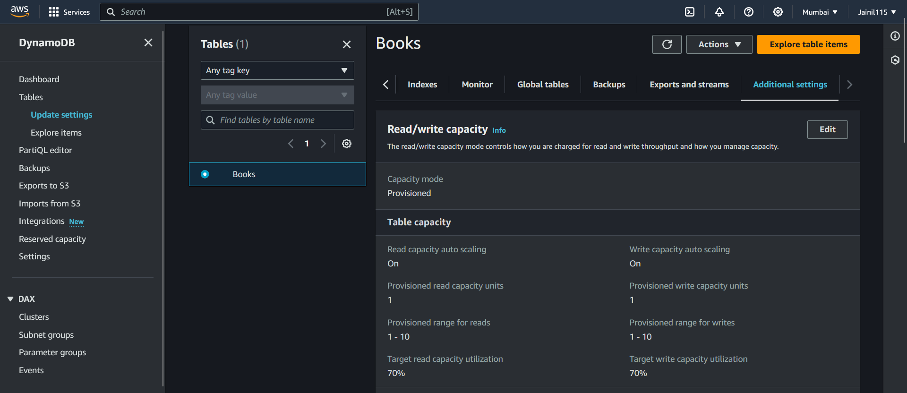

1. Click on edit read/write capacity, Now we can change table provisioned read write capacity. After that turn off Auto Scaling. And then enter the provisioned capacity units. In my case I will keep it as 1 (because I don’t want to incur any additional charges). And then click on save changes.

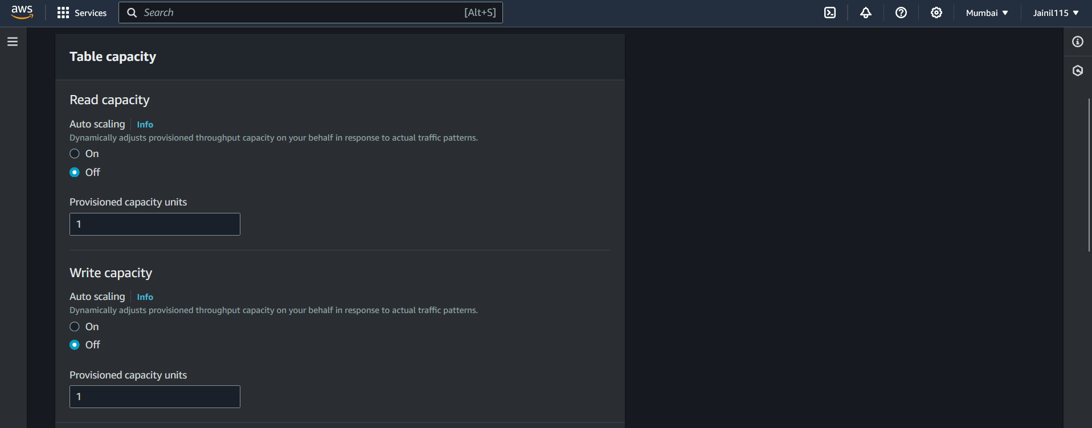

**Steps to run** **CRUD operation in the in DB table using Queries:**

1. Go to DynamoDB > Table > Books and then click on "Explore table items".

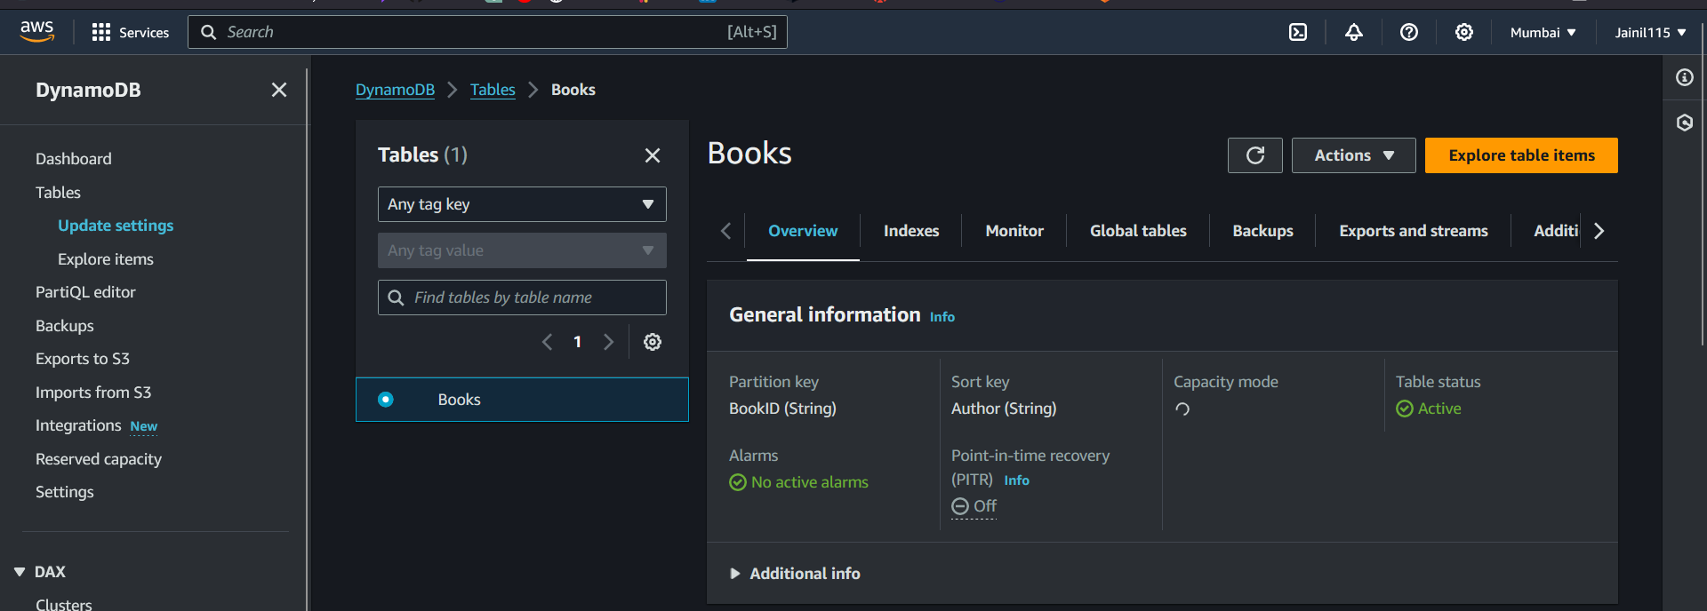

1. Then scroll down and click on create item.

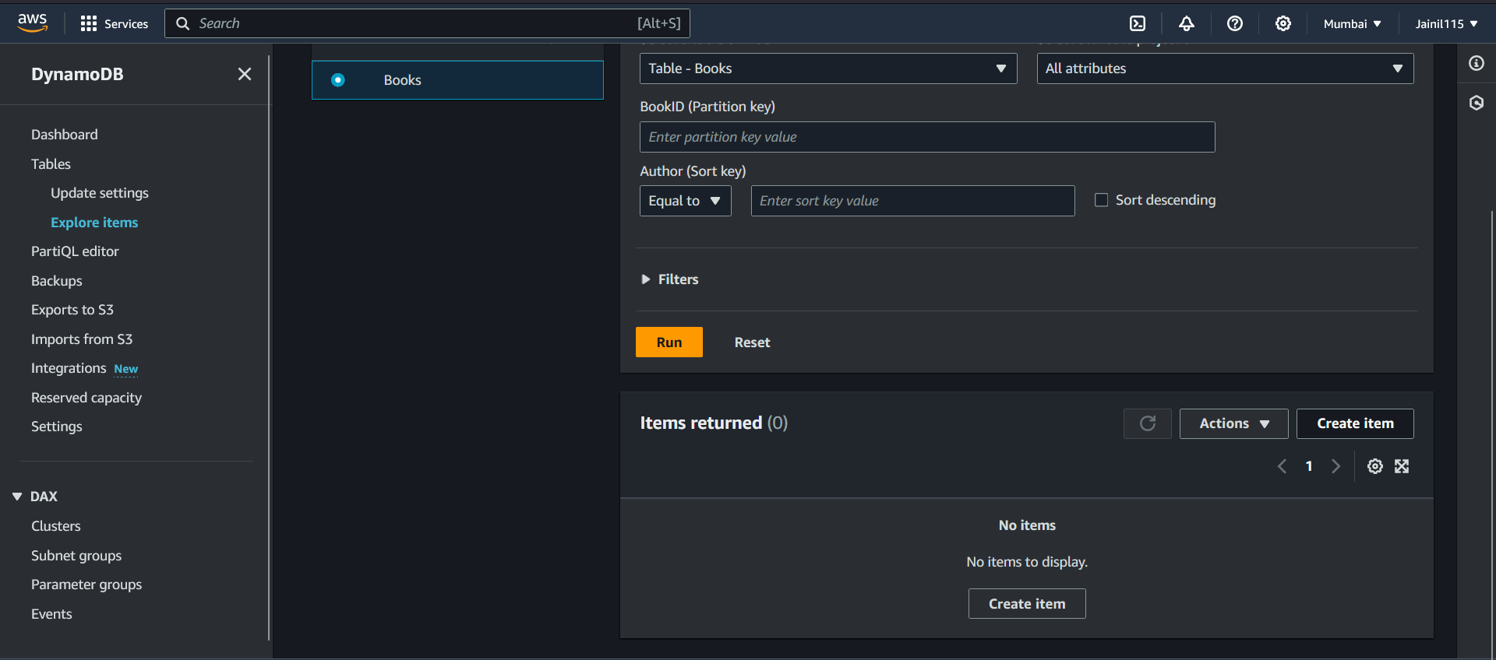

1. Now select JSON View, and then enter the item details. Then click on create item.

{

"BookID": {"S": "1"},

"BookName": {"S": "The Adventures of Sherlock Holmes"},

"Publisher": {"S": "Penguin Books"},

"Author": {"S": "Arthur Conan Doyle"},

"ReleaseDate": {"S": "1892-10-14"}

}

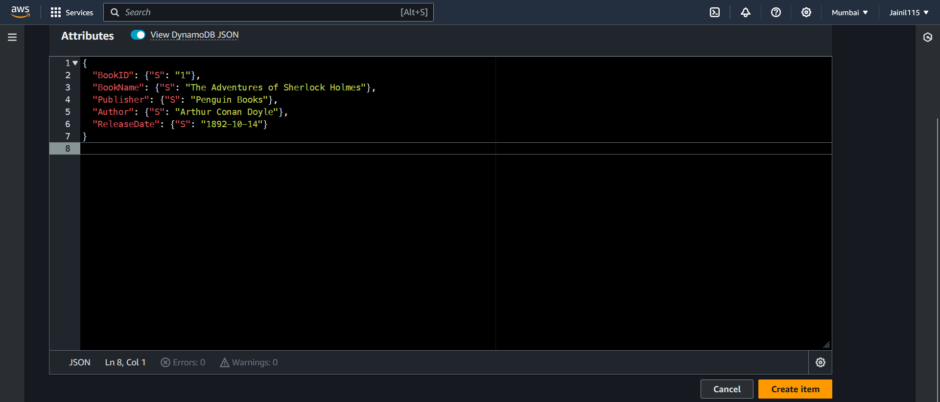

**To Read Item using AWS console:**

* 1. Inside DynamoDB > Explore Items > Books. Click on query and enter the BookID = 1. You will be able to see book details with BookID = 1.

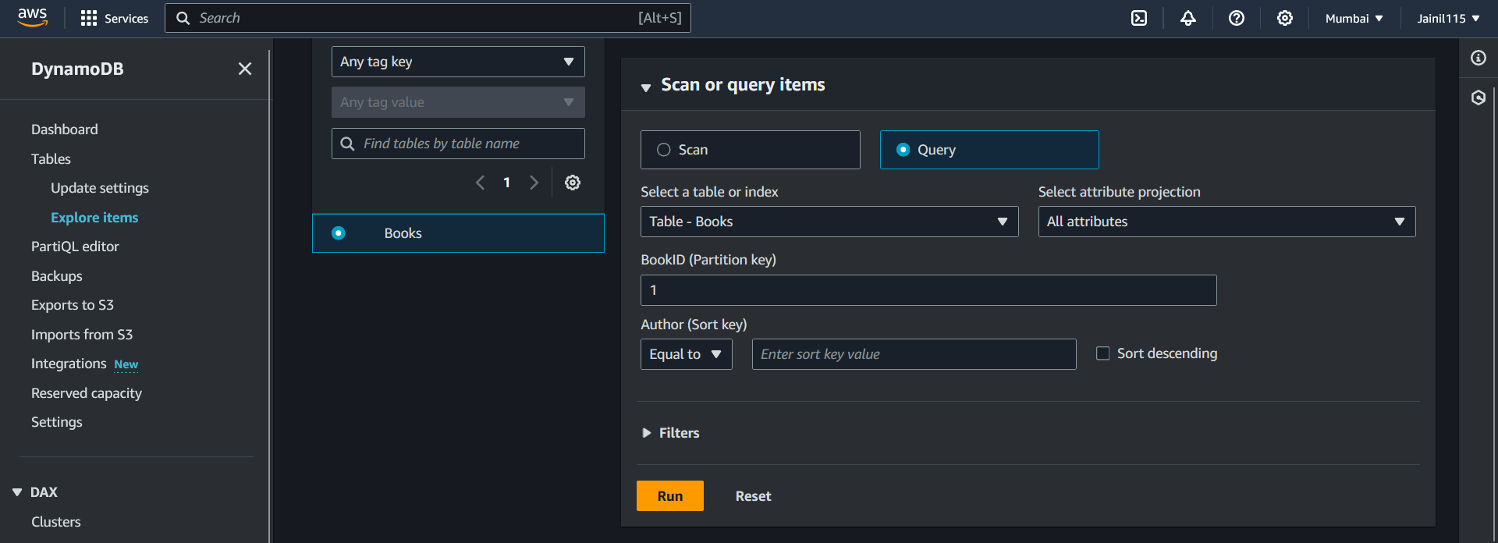

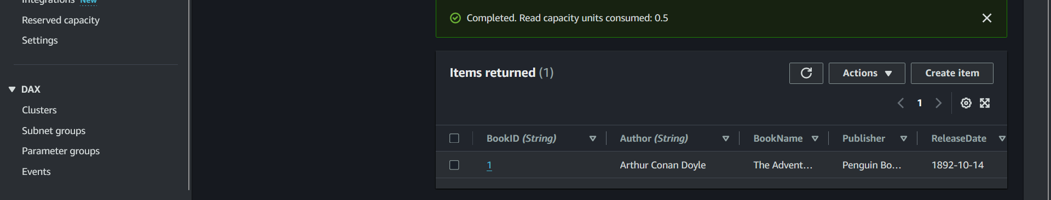

**Update Items using AWS Console:**

1. Select the item you want to update and then click on action, under action select edit item.

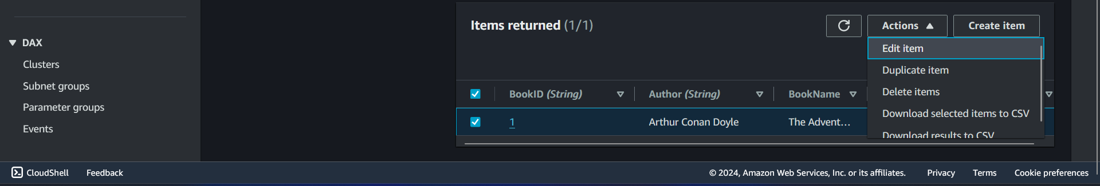

1. Now select JSON View, and change the details that needs to be updated, In my case I change the releaseDate form 1892 to 1895. After that click on save and close to update the item.

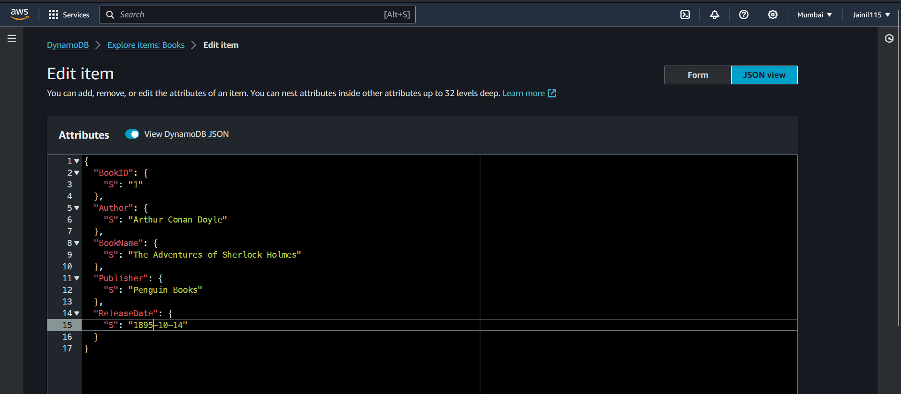

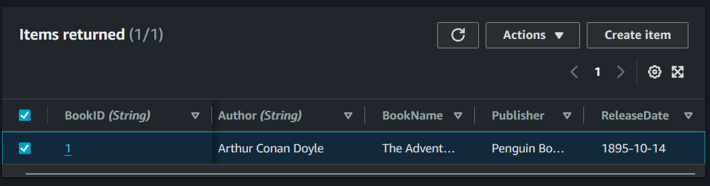

**Delete item using AWS Console:**

1. Select the item you want to delete, and then click on action and then select delete items to delete selected item.

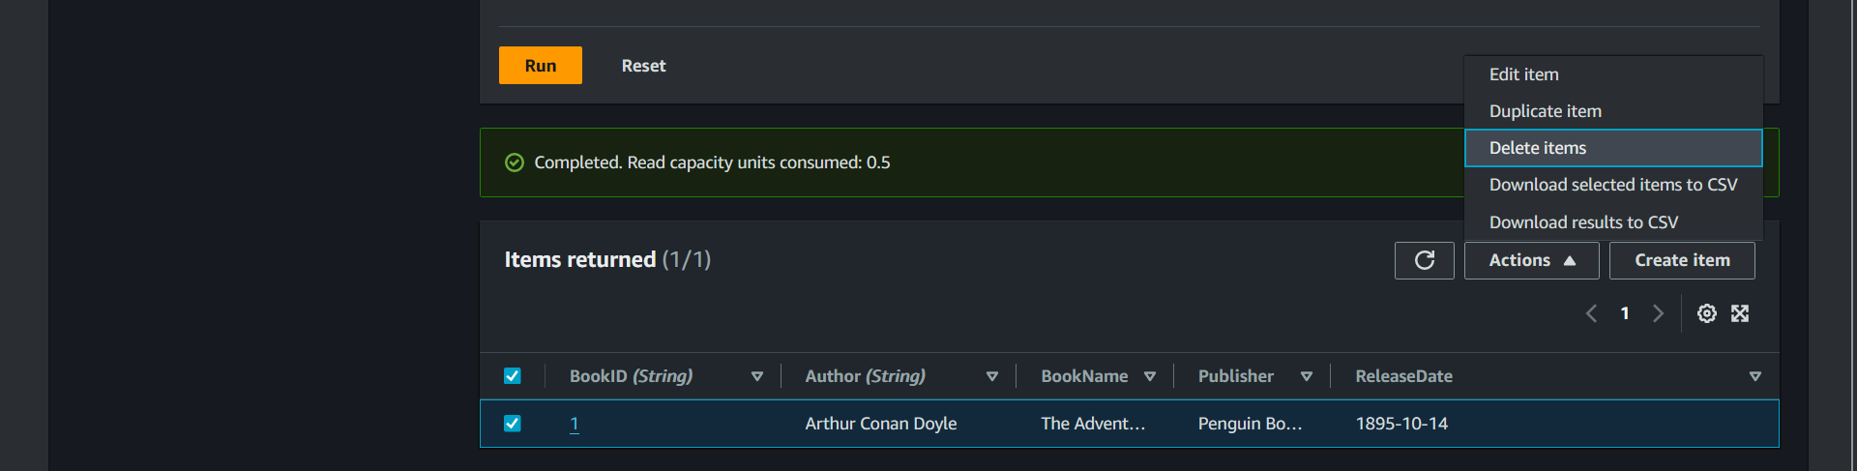

1. After that you will be able to see that my item with BookID=1 is deleted.

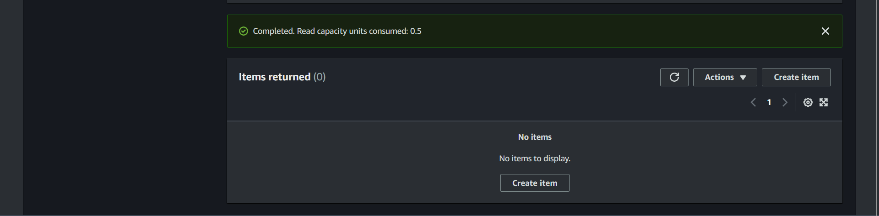

Steps for CRUD Operations using AWS CLI.

1. Open Powershell/Command Prompt on windows and enter the following for creating items in Books table.

aws dynamodb put-item --table-name Books --item '{\"BookID\": {\"S\": \"1\"}, \"BookName\": {\"S\": \"The Adventures of Sherlock Holmes\"}, \"Publisher\": {\"S\": \"Penguin Books\"}, \"Author\": {\"S\": \"Arthur Conan Doyle\"}, \"ReleaseDate\": {\"S\": \"1892-10-14\"}}'

aws dynamodb put-item --table-name Books --item '{\"BookID\": {\"S\": \"2\"}, \"BookName\": {\"S\": \"The Great Gatsby\"}, \"Publisher\": {\"S\": \"Scribner\"}, \"Author\": {\"S\": \"F. Scott Fitzgerald\"}, \"ReleaseDate\": {\"S\": \"1925-04-10\"}}'



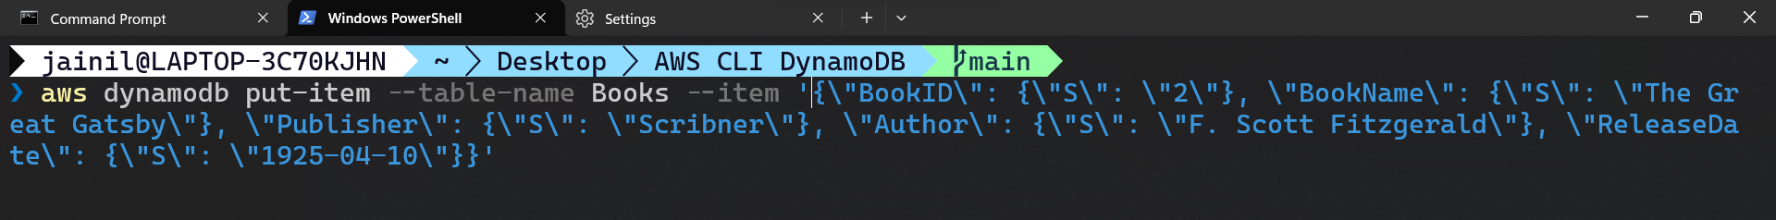

1. Check that the item is created.

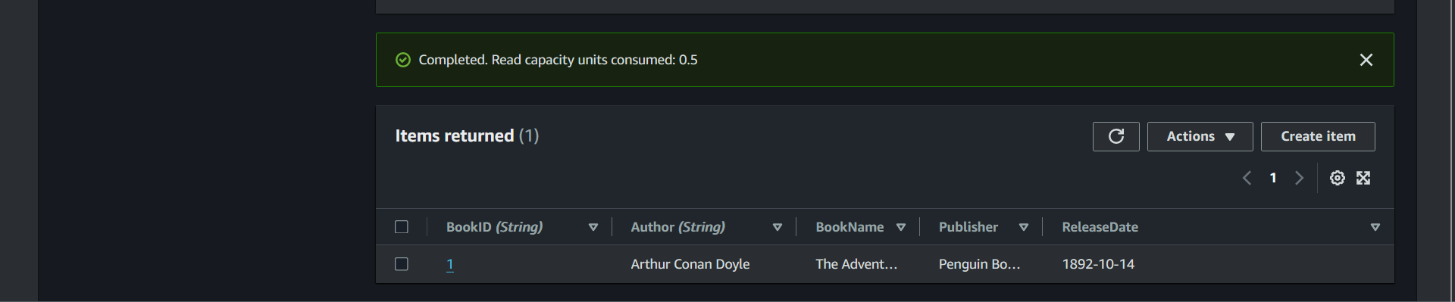

**Steps to create READ operation:**

1. Enter the following code in the command line

aws dynamodb get-item --table-name Books --key '{\"BookID\": {\"S\": \"1\"}, \"Author\": {\"S\": \"Arthur Conan Doyle\"}}'

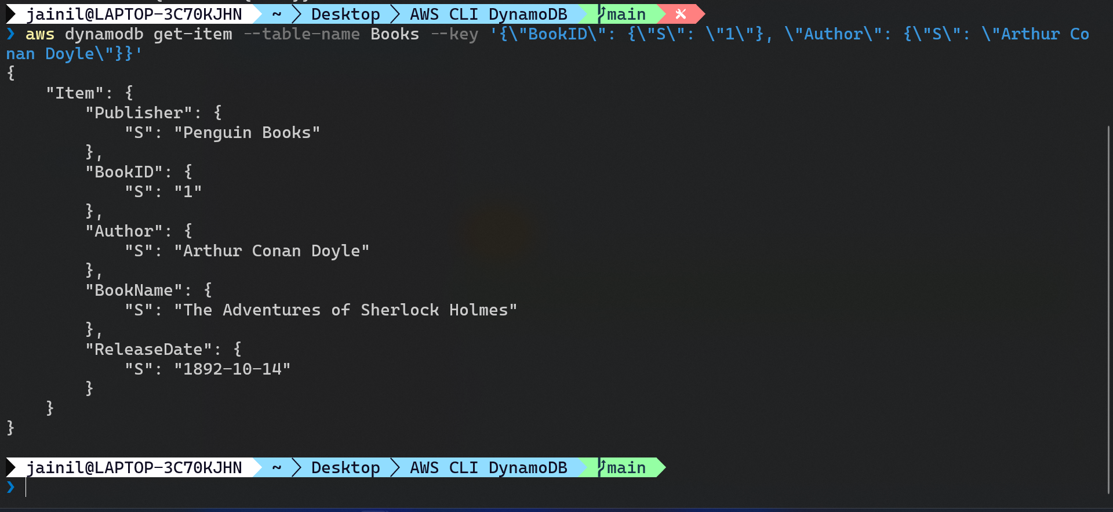

**Steps to update items in Books table:**

1. Enter the following command to update BookName.

aws dynamodb update-item --table-name Books --key '{\"BookID\": {\"S\": \"1\"}, \"Author\": {\"S\": \"Sir Arthur Conan Doyle\"}}' --update-expression "SET BookName = :value" --expression-attribute-values '{\":value\": {\"S\": \"The Shinning\"}}' --return-values UPDATED_NEW

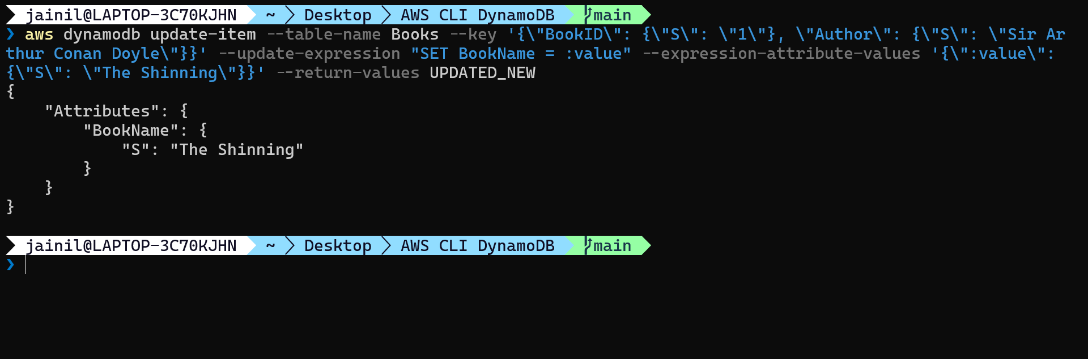

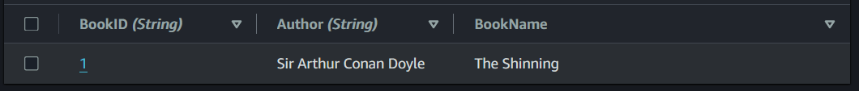

**Steps to delete item in DynamoDB:**

1. Enter the following command to delete item from the table:

aws dynamodb delete-item --table-name Books --key '{\"BookID\": {\"S\": \"1\"}, \"Author\": {\"Arthur Conan Doyle\"}}'



