SAL INSTITUTE OF TECHNOLOGY AND ENGINEERING RESEARCH
Opp. Science city, Sola-Bhadaj Road, Ahmedabad, Gujarat 380060
Ph: 079 67129000 | Website: www.sal.edu.in

Student's Weekly Report of Internship
Student Name: | Jainil Gupta
Enrollment Number: | 220670132018
Week Duration: | January 01, 2026 - January 7, 2026 (Week 1)
Name Of Organization: | Microsoft Elevate Program (via Edunet Foundation & FICE Education)
External Guide Name: | Adarsh Gupta
External Guide Contact: | 0124-4080107
Internal Faculty Guide: | Chintan Rana

Work done in last Week with description:

1. Microsoft Elevate Program Registration and Orientation

Description:
Completed the registration process for Microsoft Elevate - GTU Internship program. Attended the orientation session where program structure, 12-week roadmap, evaluation criteria, and platform access were explained.

Key Learnings:
- Overview of 12-week learning modules covering Data Analytics, ML, DL, Power BI, Azure Cloud
- Understanding of virtual lab environment and assignment submission process
- Introduction to Microsoft-certified trainers and mentorship structure

2. Week 1 Module: Introduction to Artificial Intelligence

Description:
Attended live session on "Introduction to Artificial Intelligence" covering fundamental AI concepts, types of AI (Narrow AI, General AI, Super AI), AI vs ML vs DL distinctions, and real-world AI applications.

Key Topics Covered:
- What is Artificial Intelligence? History and evolution of AI
- Types of AI: Reactive Machines, Limited Memory, Theory of Mind, Self-Aware AI
- AI applications in healthcare, finance, security, and automation
- Ethical considerations in AI development

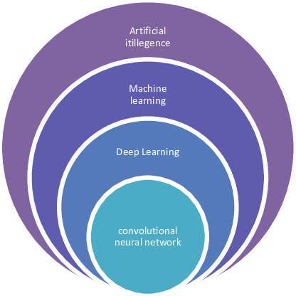
Figure 1: Relationship between AI, Machine Learning, and Deep Learning

3. Week 1 Module: Introduction to Data Analytics

Description:
Participated in "Introduction to Data Analytics" session. Learned about data analytics lifecycle, types of analytics (Descriptive, Diagnostic, Predictive, Prescriptive), and importance of data-driven decision making.

Key Topics Covered:
- Data Analytics vs Data Science vs Business Intelligence
- Data analytics workflow: Data Collection → Cleaning → Analysis → Visualization → Insights
- Tools and technologies in data analytics ecosystem
- Career opportunities in data analytics

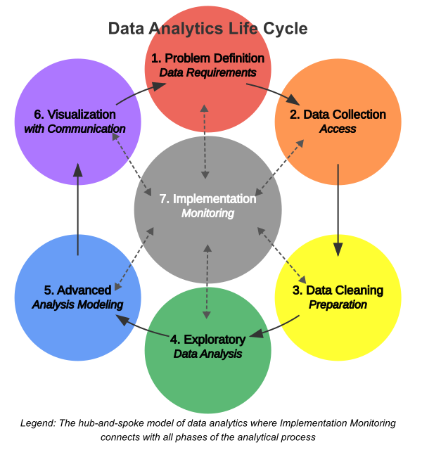

Figure 2: Data Analytics Workflow Process

4. GTU Internship Problem Domain Analysis

Description:
Reviewed GTU internship problem statements for 8th semester. Analyzed "Border Defence and Surveillance" domain as potential project area. Studied the challenges mentioned in problem statement:
- Large-scale monitoring requirements
- Delayed threat detection in manual systems
- High false alarm rates
- Resource constraints
- Poor data integration from sensors and cameras

Activity:
Read problem statement document multiple times, highlighted key requirements, and started thinking about possible AI/ML approaches.

5. Python Development Environment Setup

Description:
Setup local development environment for upcoming data analytics and ML work. Installed necessary tools and tested basic Python operations.

Installed Tools:
- Python 3.11 (latest stable version)
- VS Code with Python extension
- Jupyter Notebook for interactive analysis
- Basic libraries: numpy, pandas, matplotlib (testing installation)

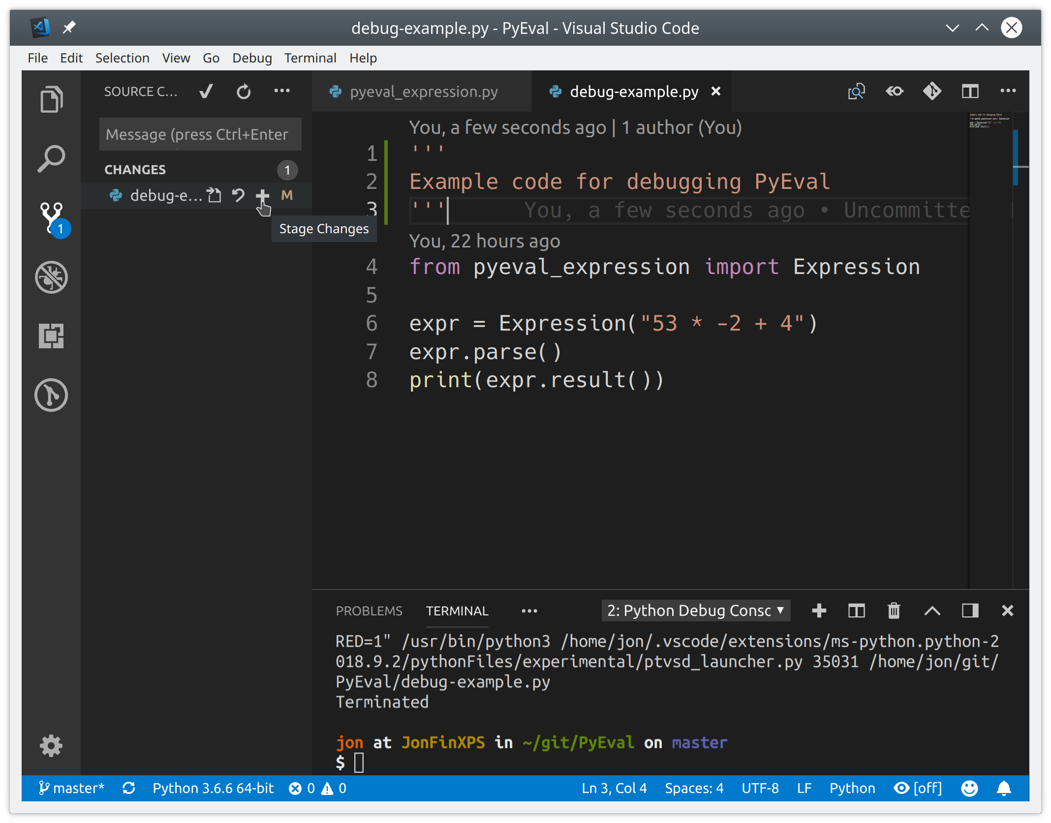
Figure 3: Python Development Environment and Libraries

Plans for next week (Feb 3-8, 2026):

1. Complete Week 2 Microsoft Elevate Modules
- Attend "Data Cleaning & Preprocessing" live session
- Participate in "Exploratory Data Analysis (EDA)" session
- Complete "Data Visualization with Matplotlib & Seaborn" module
- Submit Week 2 hands-on assignments

2. Finalize Project Idea for Border Defence Domain
- Research existing surveillance systems and AI-based solutions
- Define clear project scope and objectives
- Identify public datasets for training (UCF-Crime, xView, etc.)
- Create initial project proposal document

3. Learn OpenCV Basics
- Complete online tutorials for video processing with OpenCV
- Practice frame extraction from videos
- Understand basic image manipulation operations

4. Explore Azure Free Student Account
- Register for Azure free student account (₹15,600 credits)
- Explore Azure portal and available services
- Understand Azure Blob Storage and Azure Functions basics

Total Working Hours: 30 hours
Signature of Student: _____________________
The above entries are correct, and the grading of work done by Trainee is:
Excellent | Very Good | Good | Fair | Below Average | Poor
☐ | ☐ | ☐ | ☐ | ☐ | ☐

Signature of External Guide with Company Seal: _____________________
Date: ___________
Signature of Internal Guide: _____________________
Date: ___________

