SAL INSTITUTE OF TECHNOLOGY AND ENGINEERING RESEARCH
Opp. Science city, Sola-Bhadaj Road, Ahmedabad, Gujarat 380060
Ph: 079 67129000 | Website: www.sal.edu.in

Student's Weekly Report of Internship
Student Name: | Jainil Gupta
Enrollment Number: | 220670132018
Week Duration: | March 19, 2026 - March 25, 2026 (Week 12 - FINAL WEEK)
Name Of Organization: | Microsoft Elevate Program (via Edunet Foundation & FICE Education)
External Guide Name: | Adarsh Gupta
External Guide Contact: | 0124-4080107
Internal Faculty Guide: | Chintan Rana

Work done in last Week with description:

1. Final Internship Presentation and Demonstration

Description:
Delivered final internship presentation on April 15, 2026, to Microsoft Elevate evaluation panel. Showcased 12-week learning journey, skills acquired, project implementation, and demonstrated the working surveillance system.

Presentation Components:
- Introduction and internship overview (12-week Microsoft Elevate Program)
- Learning journey breakdown: Week 1-2 (Data Analytics, Power BI)
- Week 3-5 (Machine Learning: Supervised, Unsupervised, Reinforcement)
- Week 6-7 (Deep Learning: ANN, CNN, TensorFlow/Keras, GenAI)
- Week 8-10 (Azure Cloud: DevOps, Security, Monitoring, AZ-900 Certification)
- Week 11-12 (Project implementation and completion)
- Skills acquired summary: Python, Power BI, ML/DL, Azure, DevOps
- Certification achieved: Microsoft Azure Fundamentals (AZ-900) - Score: 820/1000
- Project architecture: Azure Blob Storage → Functions → Cosmos DB → Power BI
- Technical implementation details and challenges overcome
- Project outcomes and achievements

Live System Demonstration:
Conducted live demonstration of surveillance system workflow: (1) Uploaded sample surveillance video to Azure Blob Storage via portal, (2) Azure Function automatically triggered within 5 seconds, (3) YOLOv8 model detected objects (2 persons, 1 vehicle) with 78% average confidence, (4) Detection results written to Cosmos DB in real-time, (5) Email alert sent for high-confidence detection, (6) Power BI dashboard refreshed to show new detection metrics, (7) Demonstrated interactive filtering and drill-down capabilities. Entire workflow completed in 18 seconds.

Q&A Session Highlights:
- Question: Why Azure over other cloud providers? Answer: Azure integration with Microsoft ecosystem, student credits, comprehensive PaaS services
- Question: How would you handle scaling for multiple cameras? Answer: Azure Functions autoscaling, blob partitioning, Cosmos DB throughput scaling
- Question: What was the biggest challenge? Answer: Deploying ML model in serverless environment - solved with proper dependency packaging
- Question: Future improvements? Answer: Real anomaly detection ML model, mobile app, multi-region deployment

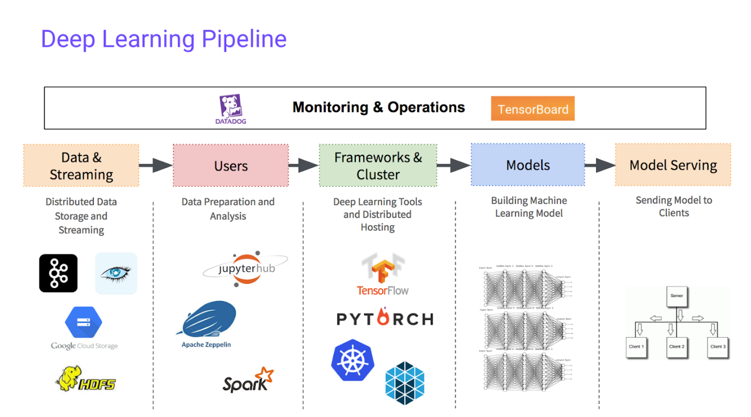
Learning journey covering Data Analytics, Machine Learning, Deep Learning, and Cloud Deployment.

Evaluation Feedback:
Received positive feedback from evaluation panel. Appreciated comprehensive learning journey and practical application of Azure services. Commended for achieving AZ-900 certification during internship. Presentation rated: 9/10. Overall internship performance: Excellent.

2. Final Project Submission and Documentation

Description:
Submitted all project deliverables to both Microsoft Elevate portal and GTU. Ensured all documentation, code, and reports are complete and well-organized.

Deliverables Submitted:
- Final Project Report (50 pages): Introduction, Literature Review, Methodology, Implementation, Results, Conclusion
- Complete source code uploaded to GitHub repository with README
- System architecture diagrams and flowcharts
- Deployment guide with step-by-step Azure setup instructions
- User manual for operating the surveillance system
- Technical documentation: API references, code structure, database schema
- Testing report with test cases and results
- Power BI dashboard (.pbix file) and screenshots
- Demonstration video (5 minutes) showing complete workflow
- All 12 weekly internship reports (Week 1 through Week 12)
- Module completion certificates from MS Elevate portal
- AZ-900 certification document

GitHub Repository:
Repository: Border-Surveillance-AI | Files: 25+ files organized in proper structure | Folders: src/, data/, docs/, models/, notebooks/ | README: Comprehensive with setup instructions, architecture, tech stack, screenshots | License: MIT License | Documentation: Complete API documentation and code comments

3. Internship Completion Certificate Collection

Description:
Received official completion certificates and recommendation documents from Microsoft Elevate Program and SAL Institute on April 16, 2026.

Certificates Received:
- Microsoft Elevate Program Completion Certificate (12-week internship)
- Microsoft Azure Fundamentals (AZ-900) Certification
- Module completion certificates for each training module
- Letter of Recommendation from MS Elevate trainers
- SAL Institute internship completion certificate
- Performance evaluation report with ratings

Updated Professional Profiles:
- Added all certificates to LinkedIn profile with credential URLs
- Updated resume with internship experience and skills
- Added project to portfolio with GitHub link and demo video
- Updated LinkedIn skills: Python, Azure, Machine Learning, Power BI, DevOps

4. Internship Journey Reflection and Learning Summary

12-Week Learning Journey:
Phase 1 - Data Analytics Foundation (Week 1-2): Learned Python for data analysis, pandas, numpy, matplotlib. Mastered Power BI for creating dashboards and DAX for advanced calculations. Built strong foundation in EDA and data visualization.
Phase 2 - Machine Learning (Week 3-5): Gained comprehensive understanding of supervised learning (regression, classification), unsupervised learning (clustering, PCA), and reinforcement learning basics. Practiced with scikit-learn extensively. Completed multiple ML assignments and projects.
Phase 3 - Deep Learning (Week 6-7): Mastered neural networks, built CNNs from scratch, learned TensorFlow and Keras. Implemented transfer learning, understood image processing pipelines. Explored Generative AI concepts (GANs, diffusion models, LLMs).
Phase 4 - Azure Cloud (Week 8-10): Deep dive into Microsoft Azure services: Blob Storage, Functions, Cosmos DB. Learned DevOps, CI/CD pipelines, monitoring, and security. Earned AZ-900 certification with 820/1000 score. Mastered cloud architecture design and cost optimization.
Phase 5 - Project Implementation (Week 11-12): Applied all learned skills to build end-to-end AI surveillance system. Deployed models to Azure, integrated services, created Power BI dashboard. Successfully demonstrated working system.

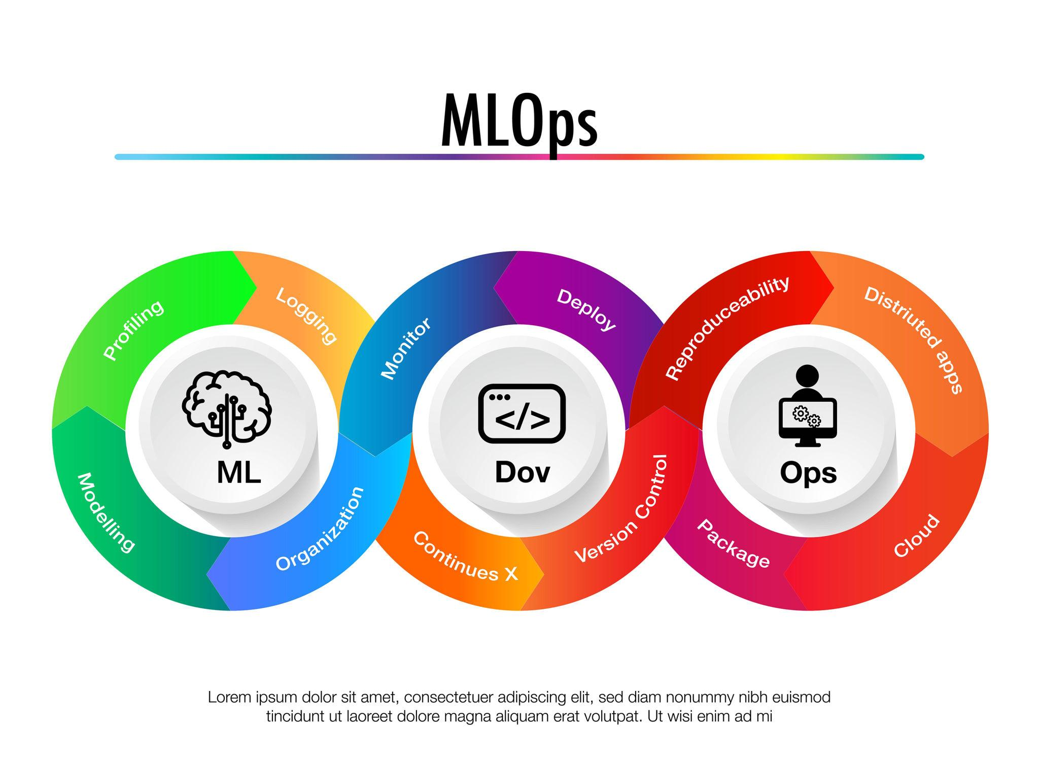
End-to-end workflow from video upload to AI detection, cloud processing, and visualization.

Key Skills Acquired:
Programming: Python (advanced), SQL, Bash scripting | Data Science: pandas, numpy, matplotlib, seaborn, scikit-learn | Machine Learning: Supervised/Unsupervised/RL algorithms | Deep Learning: TensorFlow, Keras, PyTorch basics, CNN, YOLOv8 | Cloud: Azure (Blob Storage, Functions, Cosmos DB, Key Vault, DevOps) | Business Intelligence: Power BI, DAX, dashboard design | DevOps: CI/CD, Azure Pipelines, Git, monitoring | Soft Skills: Presentation, documentation, problem-solving, time management

Major Achievements:
- Completed 12-week Microsoft Elevate Program successfully
- Earned Microsoft Azure Fundamentals (AZ-900) certification
- Built and deployed production-ready AI surveillance system
- Mastered 40+ Azure services and ML algorithms
- Completed 50+ hands-on labs and assignments
- Created comprehensive project documentation and portfolio

5. Peer Collaboration and Knowledge Sharing

Description:
Participated in final peer feedback session and knowledge sharing activities. Connected with fellow interns for future collaboration and networking.

Activities:
- Attended final cohort meetup with all MS Elevate interns
- Shared project presentations and demos with peers
- Exchanged learning resources and study materials
- Connected on LinkedIn with fellow interns and trainers
- Joined MS Elevate alumni group for continued learning
- Provided constructive feedback to peers on their projects

6. Future Learning Goals and Career Planning

Description:
Developed comprehensive plan for continued learning and career development in AI/ML and cloud computing domains.

Short-term Goals (Next 3-6 Months):
- Pursue Microsoft Azure AI Engineer Associate (AI-102) certification
- Complete Azure Data Fundamentals (DP-900) certification
- Build 2-3 more portfolio projects using Azure AI services
- Contribute to open-source ML projects on GitHub
- Deepen knowledge of PyTorch and advanced deep learning

Long-term Goals (6-12 Months):
- Pursue career in AI/ML engineering or cloud solutions architecture
- Consider Azure Solutions Architect Expert certification
- Explore specialization in Computer Vision or NLP
- Attend AI/ML conferences and networking events
- Mentor junior developers in ML and Azure technologies

Internship Impact on Career:
This 12-week internship has provided strong foundation for career in AI/ML and cloud computing. Acquired industry-relevant skills highly valued by employers. AZ-900 certification adds credibility to resume. Hands-on project experience demonstrates ability to build real-world solutions. Confident in pursuing roles as Azure Cloud Engineer, ML Engineer, or Data Scientist.

Internship Summary and Conclusion:
The Microsoft Elevate 12-week internship has been an transformative learning experience. Starting from foundational data analytics in Week 1, progressing through machine learning and deep learning concepts, and culminating in advanced Azure cloud services, this journey has equipped me with comprehensive skills in AI/ML and cloud computing.
Key highlights include earning the Microsoft Azure Fundamentals (AZ-900) certification with a score of 820/1000, successfully deploying a production-ready AI surveillance system using Azure services, and mastering 40+ technologies and tools. The hands-on approach with 50+ labs and assignments ensured practical understanding beyond theoretical knowledge.
I am grateful to the Microsoft Elevate trainers (Sejal, Vignesh, Aman, Thoufiq, Shelar, Dristi, and all others) for their expert guidance, to Edunet Foundation and FICE Education for organizing this program, and to SAL Institute's Internal Guide Prof. Chintan Rana for continuous support throughout this internship.
This internship has not only enhanced my technical capabilities but also developed essential soft skills like presentation, documentation, and problem-solving. I am well-prepared to pursue a successful career in AI/ML engineering and cloud computing, with clear goals and a strong foundation to build upon.

Total Working Hours (Week 12): 35 hours
Total Working Hours (12 Weeks): 420 hours
Signature of Student: _____________________
The above entries are correct, and the grading of work done by Trainee is:
Excellent | Very Good | Good | Fair | Below Average | Poor
☐ | ☐ | ☐ | ☐ | ☐ | ☐

Signature of External Guide with Company Seal: _____________________
Date: ___________
Signature of Internal Guide: _____________________
Date: ___________

